Tutorial 1: Understanding the OpenCPI Application Development Workflow

This tutorial demonstrates the OpenCPI application development workflow and gives a general overview of the process. It shows you how to:
- Create an FSK loopback (FPGA internal) OpenCPI Application Specification (OAS) XML with the Eclipse ANGRYVIPER (AV) IDE. An OAS XML describes an application’s component connections and initial component property settings. Using the AV IDE helps to generate this XML graphically.
- Run the FSK loopback application with the OpenCPI ocpirun utility on a simulated SDR platform. The OpenCPI ociprun utility uses the generated OAS XML during the execution of the application on the target platform.
The goal of this tutorial is to send an image over a wire using the FSK protocol.
The FSK application is an OpenCPI demo application that performs FSK modulation/demodulation:
Modulation: Read Input File → FSK Symbol Mapper → Zero-pad → Pulse Shape → FM Modulate → Interpolate
Demodulation: Decimate → Demodulate → Filter → Baud Track → Digitize → Write Output File
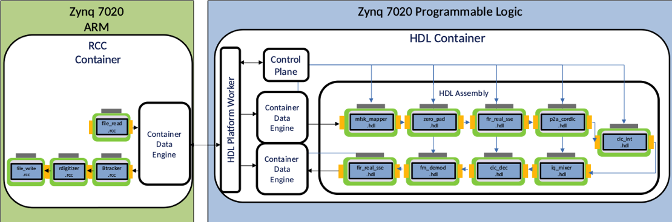
For more information about the FSK demo application, see the OpenCPI FSK App Guide and the OpenCPI FSK App Getting Started Guide. For more information about OpenCPI OAS and ocpirun, see the OpenCPI Application Development Guide. For more information about OpenCPI components, see the OpenCPI Component Development Guide.

Prerequisites
To perform this tutorial, you must first:
- Set up OpenCPI and the ANGRYVIPER GUI for Eclipse.
- Read Briefing 1, “Introduction to OpenCPI”, Briefing 2, “Introduction to OpenCPI Development” and Briefing 3, “OpenCPI Concepts”.

Step 2: Launch Eclipse
Choose an Eclipse workspace that does not already have the core, assets and bsp_e310 projects in it:
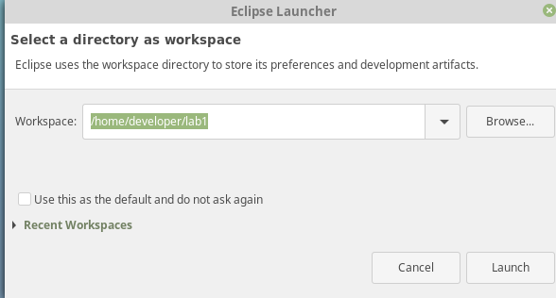

Step 3: Import Projects into Workspace
Go to File → Import (Located on the top left of Eclipse) and you will see the following dialog. Select Existing Projects into Workspace.

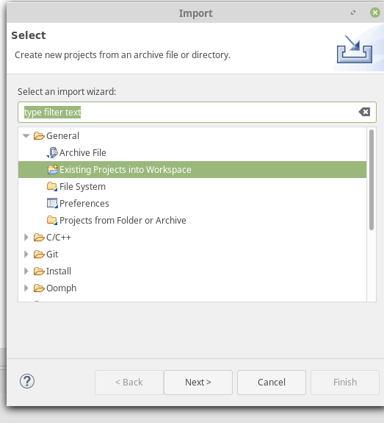

Choose the directory where your core and assets projects are located.
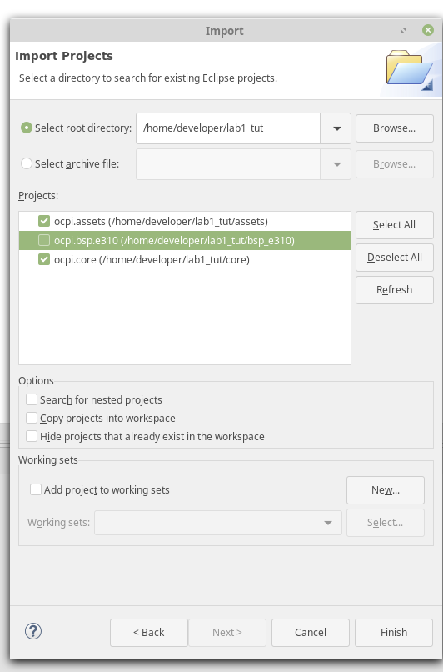

Click Refresh. The following dialog is displayed.
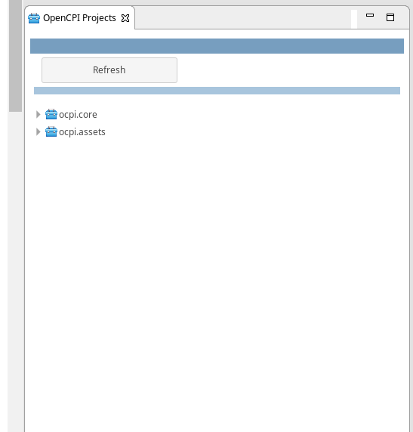

Step 4: Build the Simulator Assembly
Right-click on your assets project and then use the > to move it over to the Operations panel. Do the same with core.
In the Project Operations tab, select centos7 for the RCC platform and xsim for the HDL platform.
Check build assemblies.

Step 5: Create the FSK Data
Navigate to the idata directory of your assets project’s FSK application. lab1_tut should be replaced with the directory in which your workspace resides.
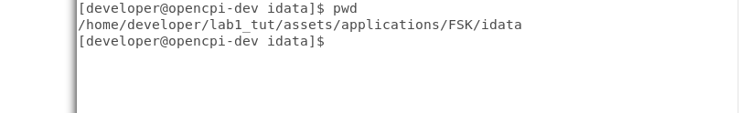
Create a file called rx_rrcos_taps.dat with the values below. MAKE SURE THERE ARE NO TABS OR SPACES in the lines where the numbers reside. Copy this file and then rename it to tx_rrcos_taps.dat. We will reference these files later in the tutorial. Also note that there is an Os.jpeg in idata that we will use as an input file to send over the wire.
Here are the values to supply (lines 1-64):
85
96
105
111
115
116
114
109
100
88
72
53
31
6
-21
-50
-81
-113
-145
-177
-207
-235
-259
-280
-295
-305
-307
-302
-287
-263
-229
-184
-128
-60
20
112
217
334
462
602
752
912
1081
1257
1441
1629
1821
2015
2209
2402
2593
2779
2958
3130
3292
3443
3581
3705
3814
3906
3981
4038
4076
4096

Step 6: Register Your Projects
Right-click on the assets and core projects to register them. If you see the unregister option when you right-click them, the projects are already registered.
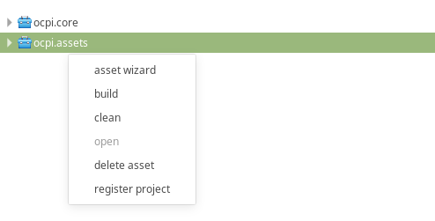

Step 7: Create the FSK Application
Now right-click on assets and select the asset wizard:
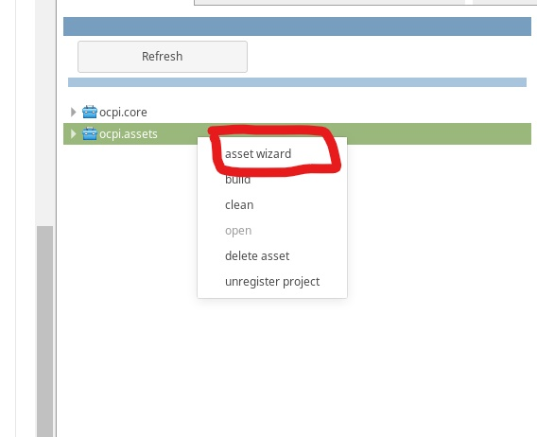
Name your application fsk_loopback and make it XML only.
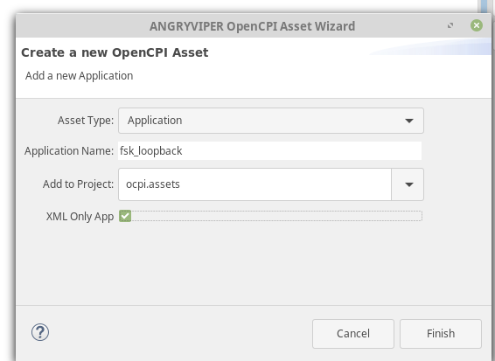

Now you see the OAS diagram for this XML. Note: You can delete the ocpi.core.nothing component. This worker is automatically placed by the framework to ensure that the generated OAS can be executed without editing the generated file.
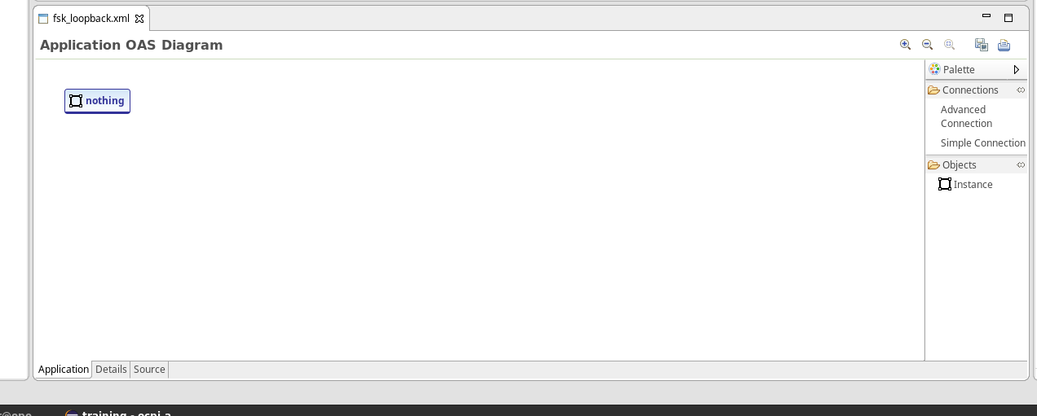

The following image shows all of the component specs that will be placed in our OAS diagram XML:
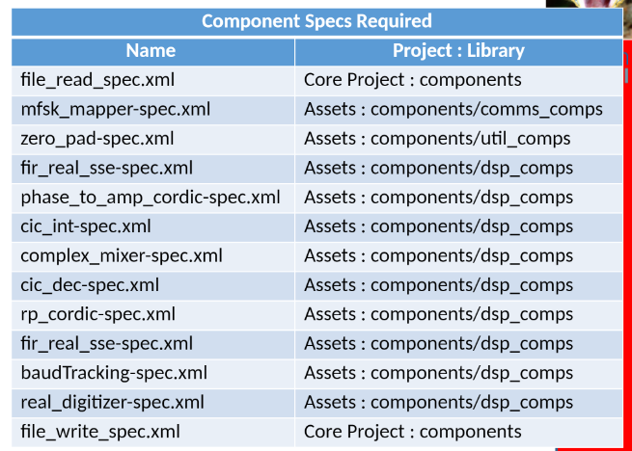

Step 8: Create rile_read Component Instance
Right-click on the OAS diagram and click Add Instance.
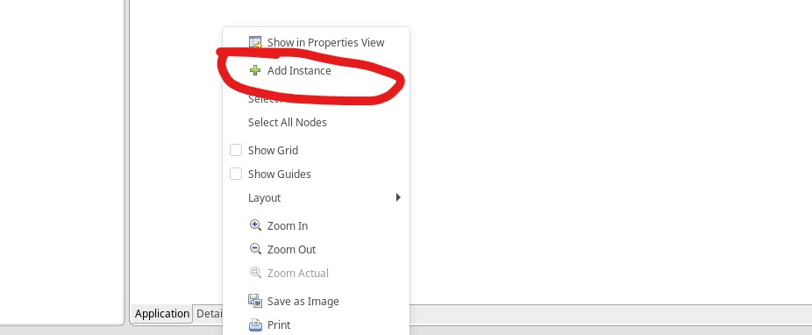
NOTE: instances are ordered alphabetically so the instance zero_padding appears before anything else because it starts with a z. You may have an instance called zero_padding or something else that is not one of the instances required.
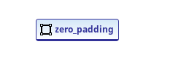
NO WORRIES! we can change this by double-clicking on the instance we just created.

Notice how an arrow appears. Click it to show a drop down menu of available instances.
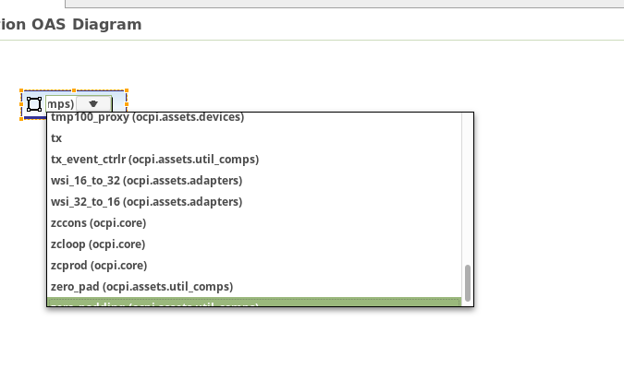

Let’s select file_read for our first instance in this project.


Step 9: Add Property Values to Components
Now we need to add property values to our components. The following image contains all of the property values we need to edit for each of the components listed in Step 7.

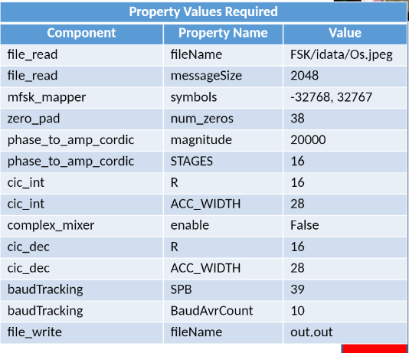

NOTE: The value of file_read is dependent on where the Os.jpeg image is located. Consider your environment when you mount the folders to run on the hardware platform. You would probably have a value of /mnt/ocpi_assets/applications/FSK/idata/Os.jpeg.
Now if we click on our instance, we see that two paper tabs are displayed on the right side. Click the bottom one to show this instance in the Properties view.
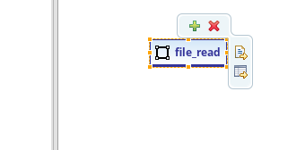

Alternatively, you can right-click on the instance to get the following drop-down menu.
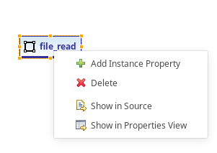

On the right side of your screen, a Properties tab should be displayed.
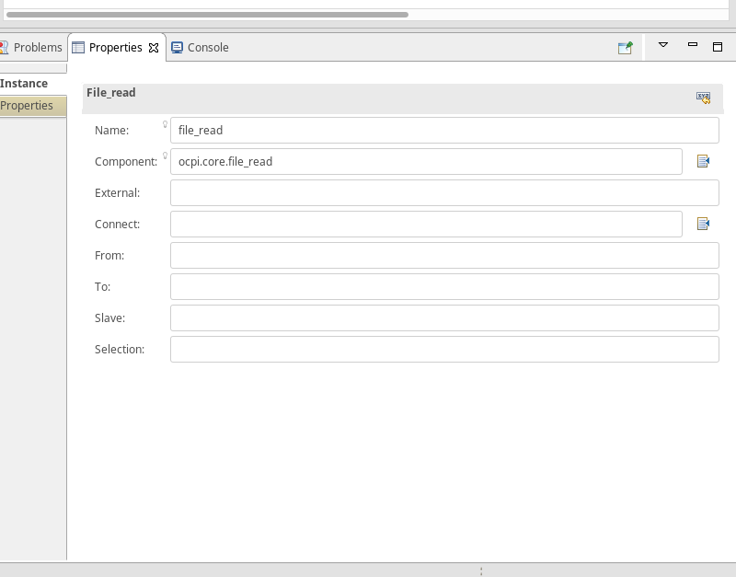

NOTE: Notice the component parameter. ocpi.core.file_read is the component you are using. You can change the name if you need more than one file_read for an application with no effect on the component parameter.
Click the Properties tab to change the properties of the instance you created.
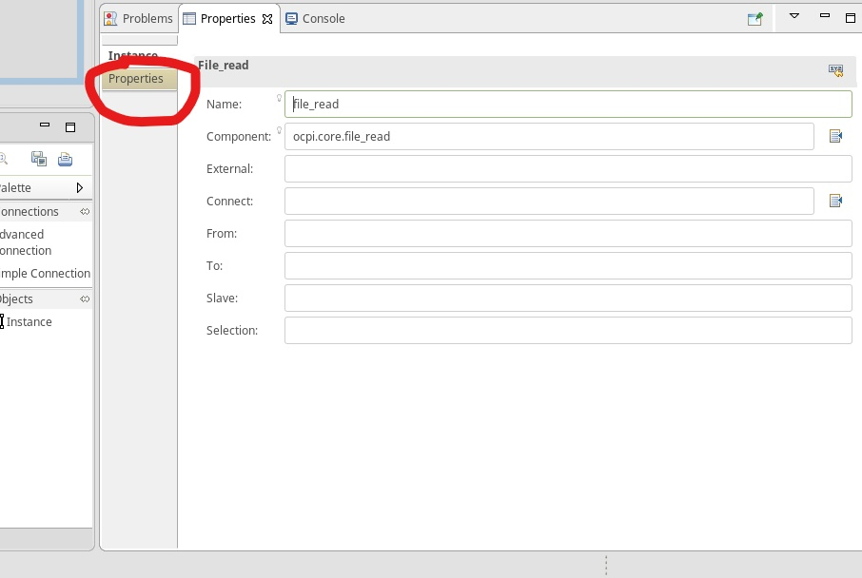

You get a blank screen:
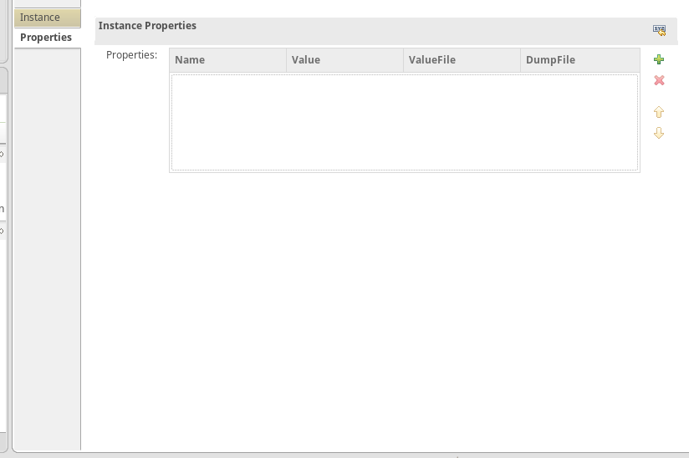

Click the green plus button to add a property:
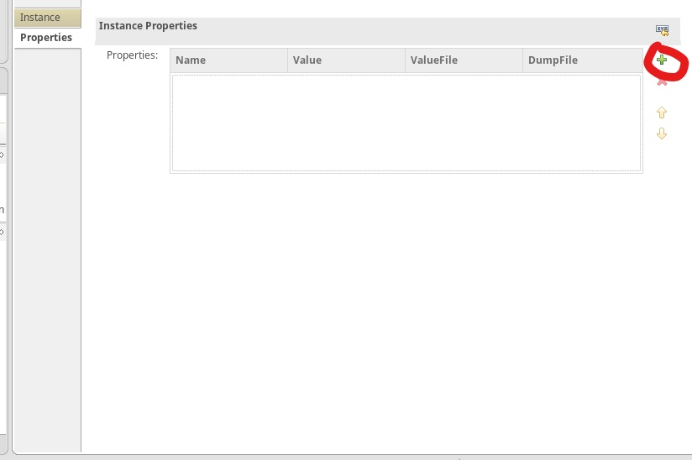

Based on the property values shown in the previous Property Values Required image, you should have something like this for your file_read instance:

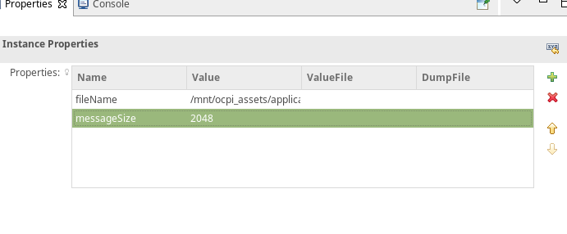

In your OAS diagram, you should see something like this:
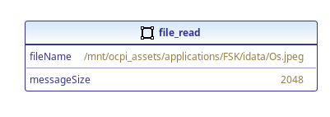f

In this project, we need to add two fir_real_sse instances to our OAS diagram. Notice the little 'x' on the instance. This is happening because these two instances we created have the same name. This is bad.
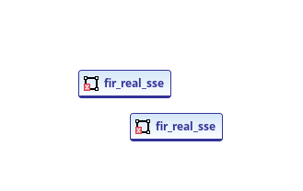

To fix this problem, click on the instance and then change the name in the Properties view to rx_fir for one instance and tx_fir for the other instance.
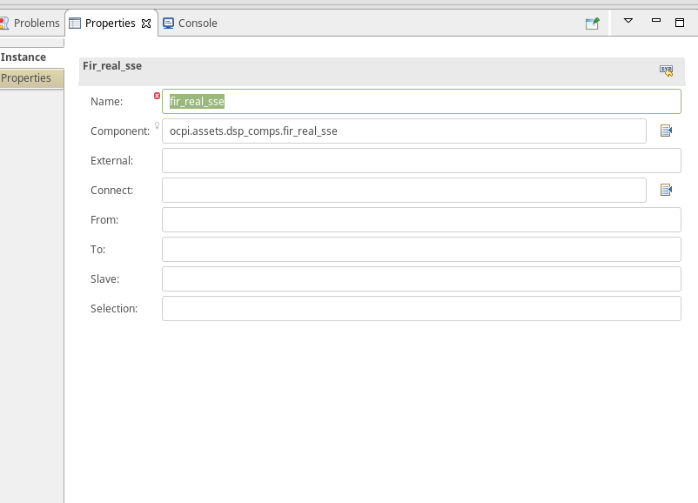

Now we have no errors.
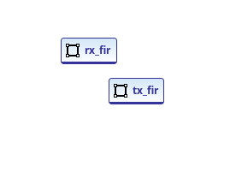
The fir_real_sse instances have a property called taps:
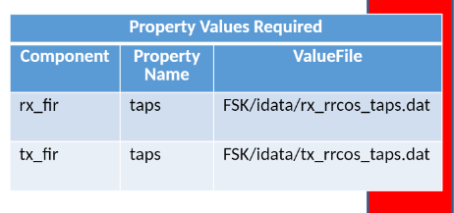
Change the items shown in the figure above in each of the respective instances we just created. The value of ValueFile is going to be the directory where rx_rrcos_taps.dat and tx_rrcos_taps.dat are stored. We created these files in Step 5.
Also consider that you are going to be mounting these files over a network. So it would look something like this:
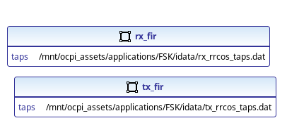
Now, looking at the following table, repeat the steps you did for file_read for the remaining instances.

Once you do this, you have will have something like this image:
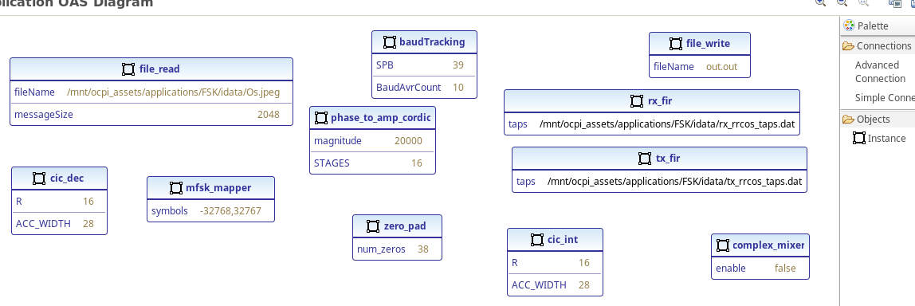
This looks messy. Let’s reorder it so it’s easier to make connections.
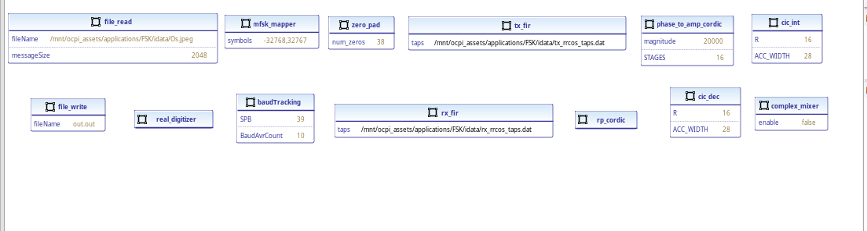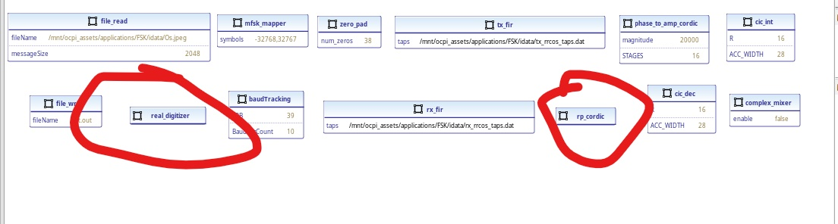
Notice the new components real_digitizer and rp_cordic. Don’t worry about editing their properties.

Step 10: Make Connections
To make connections, click the Advanced Connection tab in the OAS view and then click the start of the connection and the end of the connection. Don’t worry about connection names for this project.
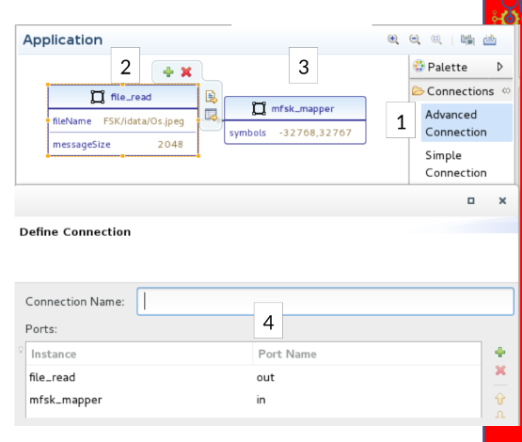
The result will look like something similar to this:
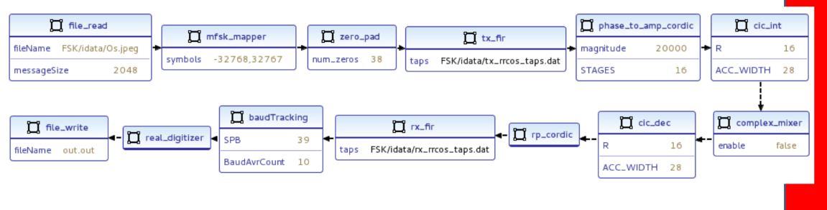

NOTE: The only unique values should be fileName for the file_read instance, because it’s a path to your Os.jpeg and the two taps values for tx_fir and rx_fir respectively, because the data file location is unique to your setup.

Step 11: End the Application
Now we need to application to end. Click on the white space of the OAS view and you will get something like this:
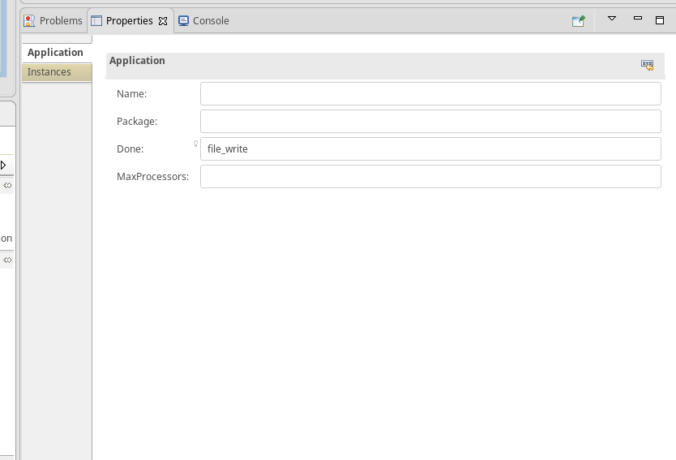
Your Done: parameter will be blank. Replace it with file_write. If you don’t do this, the FSK application will go into an infinite loop.

Step 12: Run the Application
Now, on your CentOS7 development host, navigate to the directory where your fsk_loopback application resides.
Set the OCPI_LIBRARY_PATH to where your exports are located for your core and assets projects:
Execute ocpirun to start the application:
ocpirun -v fsk_loopback.xml
On your host machine, go to your assets applications folder.
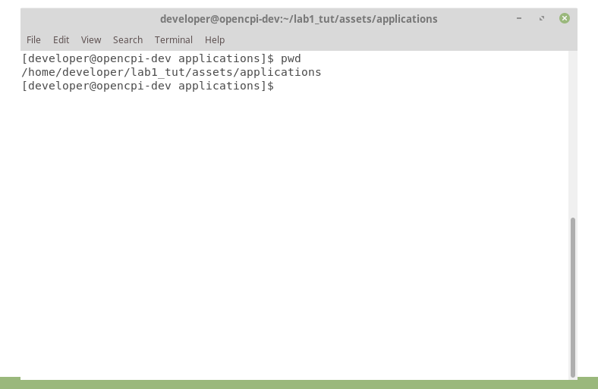

Run eog out.out. If an image appears, the tutorial is successful.
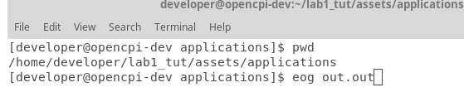

Troubleshooting
$ export OCPI_LOG_LEVEL=8 to view a detailed log while running on your hardware platform.
When building ocpi.core and ocpi.assets, be sure the Build Assemblies checkbox is checked.
Double-check your spelling for typos inside the component properties.
Problems regarding library entries not found:
- .gz library files were missing from the assets/exports.
- dsp_comps assemblies were cleaned and rebuilt to resolve missing .gz libraries.
- OCPI_LIBRARY_PATH export may not be referencing the correct exports path for assets and core.

