OpenCPI
Tutorial 5: Using Multiple Opcodes in RCC Workers
OpenCPI Release: v2.4.6
Revision History
Revision | Description of Change | Date
1.0 | Creation | 2019-12-12
1.1 | Update to complete tutorial from rough draft, add new OpenCPI GUI instructions | 2022-01-04
1.2 | Update GUI screenshots, revise per external review | 2022-02-10
1.3 | Update for release 2.4.3 (fix discrepancies) | 2022-08-31
1.4 | Update language regarding CentOS7 to make it clear that there are other available platforms | 2023-01-20
1.5 | Update file names and contents for release 2.5 | 2023-01-25
Table of Contents
1 Overview 4
1.1 Tutorial Objectives 5
1.2 What’s Provided for This Tutorial 6
1.3 Prerequisites to Using This Tutorial 7
1.4 Documentation References 8
2 Create New Project 9
3 Create Components Library 11
4 Create Component 12
4.1 Create Component Spec 13
4.2 Add Properties and Ports 15
5 Create Worker 17
5.1 Create Worker OWD and Skeleton File 18
5.2 Edit Worker OWD 19
5.3 Update RCC Worker Skeleton File 20
5.4 Build Worker 24
6 Create Unit Test 25
6.1 Edit Test Suite Description 26
6.2 Copy Unit Test Scripts from Tutorial Project 27
6.3 Build Unit Test 28
7 Run Unit Test 29
8 Tutorial Summary 30

Overview
This tutorial shows you how to create a time demux component. The time demux component receives I/Q sample data that has time stamps interleaved within it. It recovers the original data stream and writes it out while also providing a second stream that contains only the timestamps. Having the data separated allows additional processing by tools expecting "just data”; for example, plotting an FFT. The example RCC platform used in this tutorial is centos7, but different development hosts can be used. If you are using a development host other than CentOS7, replace centos7 with the relevant name (example, ubuntu20_04).

Tutorial Objectives
The purpose of this tutorial is to demonstrate how to use multiple opcodes in an RCC worker and builds on OpenCPI Tutorial 4, “Using Third Party Libraries in RCC Workers”.
This tutorial shows you how to:
- Create the time demux component specification (properties and ports).
- Create the time demux worker C++ code using a skeleton file and build the worker for the target platform.
- Create, build, and run the unit test for the RCC worker on the target platform.
It demonstrates how to use the RCC authoring model to:
- Create a worker OWD XML file
- Create a worker start method
- Access worker data ports
- Use worker method result values to communicate worker states to the OpenCPI framework
The objectives of this tutorial are to learn how RCC workers can:
- Use different protocols on different ports with a nonstandard input:output port ratio (1:2 vs. 1:1)
- Process incoming data based on message type (OpCode); in this case, I/Q data with timestamps
This tutorial also reiterates:
- C++ conventions for accessing port data and properties
- Framework interactions: RCC_ADVANCE vs. RCC_OK
After running this tutorial, you should understand how to use the RCC authoring model, manage multiple opcodes in an RCC worker, and use the OpenCPI unit test suite on an RCC worker implementation of a simple OpenCPI component.

What’s Provided for This Tutorial
The OpenCPI built-in tutorial project ocpi.tutorial provides source code for the following tutorial items:
- The time_demux.rcc worker, written according to the API for the RCC (C++ source code) authoring model.
- The unit test file test_data_generator.cxx written in C++.
- The unit test Makefile
- The unit test bash shell script verify.sh
The ocpi.tutorial tutorial project also provides the XML source for all of the assets used to build and run the example component, worker and tests.
Instructions for copying these items from the ocpi.tutorial project into the “demo” tutorial project are provided in the relevant sections of this document. The source code for these items is also available as text in the relevant sections of this document that you can copy and paste into the relevant files following the instructions given in the section.
Note: when copying and pasting text from this document, be sure to remove any line breaks in code or command lines.

Prerequisites to Using This Tutorial
This tutorial (Tutorial 5) has the same system prerequisites as Tutorial 1, “Component-based Development”. See the prerequisites section in Tutorial 1 for details.
Before you begin this tutorial, you should have successfully completed Tutorials 1 through 4.

Documentation References
The documents listed in the following table provide detailed information about subjects discussed in this tutorial. The documents listed here are not required reading for this tutorial but will likely be of interest for more in-depth learning.
Table 1 - OpenCPI Reference Documentation
Title | Published By | Public URL
OpenCPI User Guide | OpenCPI | https://opencpi.gitlab.io/releases/v2.4.2/docs/OpenCPI_User.pdf
OpenCPI Application Development Guide | OpenCPI | https://opencpi.gitlab.io/releases/latest/docs/OpenCPI_Application_Development.pdf
OpenCPI Component Development Guide | OpenCPI | https://opencpi.gitlab.io/releases/latest/docs/OpenCPI_Component_Development.pdf
OpenCPI HDL Development Guide | OpenCPI | https://opencpi.gitlab.io/releases/latest/docs/OpenCPI_HDL_Development.pdf
OpenCPI RCC Development Guide | OpenCPI | https://opencpi.gitlab.io/releases/latest/docs/OpenCPI_RCC_Development.pdf

Create New Project
As we did in Tutorials 3 and 4, we’ll create a new, clean project for Tutorial 5; we’ll call it DemoProject5. This project has the same requirements as the project we created for Tutorial 3 and 4.
To create DemoProject5 project using the OpenCPI GUI:
- Start the OpenCPI GUI.
- From the GUI menu bar at the top of the window, select Create > Project...
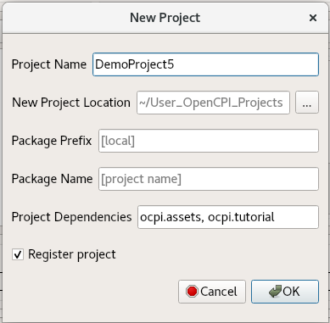
- In the New Project dialog, enter DemoProject5. In Project Dependencies, enter ocpi.assets, ocpi.tutorial.
- Check Register project.
- Leave all of the other fields as they are and click OK.
- You should now see DemoProject5 displayed in the OpenCPI Project Explorer panel. Like the other tutorials, subsequent sections show both ways to perform the steps described in the section: with the GUI and with the CLI. You can use either method; using both methods is redundant.
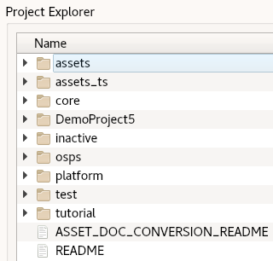
Notice that the GUI executes ocpidev commands to carry out its operations and that they are visible in the Console view on the bottom right. You can follow along and familiarize yourself with the ocpidev commands by checking the console window after you perform an operation.
To create the new project with ocpidev, use the following command:
ocpidev -D ocpi.assets -D ocpi.tutorial create project DemoProject5 --register

Create Components Library
We can use the top-level components/ directory as our library like we did in Tutorials 3 and 4.
To create the components library with the OpenCPI GUI:
- From the GUI menu bar at the top of the window, select Create > Component Library...
- In the Associated Project drop-down list, select DemoProject5. Click OK to create the component library.
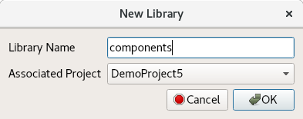
- The components library is displayed in the Project Explorer panel.
To create the components library with ocpidev, run the following command in the DemoProject5 directory:
ocpidev create library components

Create Component
Like we did in Tutorials 3 and 4, we need to create the OCS (OpenCPI Component Specification) for our time demux function that defines its properties and ports.

Create Component Spec
As we did for the peak_detector and complex_mixer components, we’ll create the time demux component spec in the components library.
To create the time_demux component spec with the OpenCPI GUI:
- From the GUI menu bar at the top of the window, select Create > Component Spec…
- In Component Name, enter time_demux.
- Choose DemoProject5 from the Associated Project drop-down list.
- The drop-down menu for Associated Library should automatically select components.
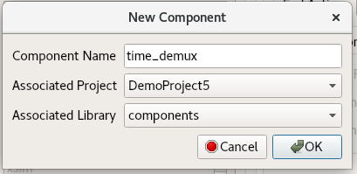
- Click OK. When the operation completes, you should see a time_demux.comp sub-directory in the components directory displayed in the Project Explorer view.
- Use the Project Explorer or OpenCPI Projects panel to expand the time_demux.comp/ directory. You should see the component spec you just created time_demux-comp.xml.
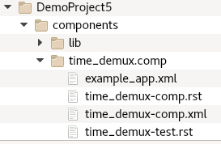
To create the component spec with ocpidev, run the following command from the DemoProject5/components directory:
ocpidev create component time_demux
The command creates the component spec time_demux-comp.xml in components/time_demux.comp. We’ll add properties and ports to the component spec in the next step.

Add Properties and Ports
The time_demux component function needs to define these properties:
- The Current_Second property, which indicates the current second of the minute according to the system clock, from 0 to 59.
- The Message_Read property, which keeps track of the number of messages read by a worker.
- The Bytes_Read property, which keeps track of the number of bytes read by a worker.
All of these status properties will be written by the component’s worker implementation, so they are all volatile properties. You can read more about how the framework interprets these attributes in the OpenCPI Component Development Guide.
The time_demux component has a somewhat more complex port configuration than the components we’ve worked with in previous tutorials. It requires one “mux” input port that receives both time and data input, one “time” output port for passing the time data to other components using the iqstream_with_sync OPS and one “data” output port that passes the data to other components using the iqstream OPS.
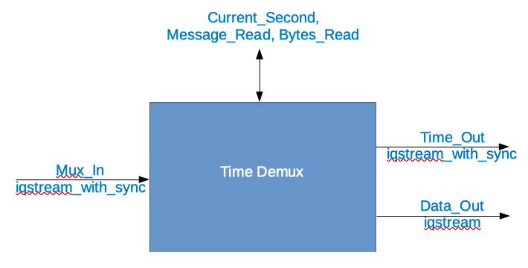
Figure 1: Time Demux Port Configuration
The incoming combined (in-band timestamp) data format is described in the ocpi.core OPS iqstream_with_sync_protocol.xml, found in $OCPI_ROOT_DIR/projects/core/specs/.
The outgoing data format is described in the ocpi.core OPS iqstream_protocol.xml, found in $OCPI_ROOT_DIR/projects/core/specs/.
The outgoing time format is also iqstream_with_sync.
Note that:
- There are volatile flags on all status properties
- Most attributes don't need to be set if "False"
- Output ports are producers
To add the properties and ports to the component spec using the OpenCPI GUI:
- Navigate to the time_demux-comp.xml file in the Project Explorer view.
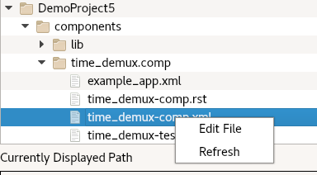
- Right-click it and then select Edit File. This action opens the XML file using your system's default handler for XML files, where you can edit the file if the GUI supports that function for the handler. Make the changes described below. When you finish editing the file, click Save and then close the file.
To add the properties and ports to the component spec using the command line, open the component spec components/time_demux.comp/time_demux-comp.xml with a text editor.
Now replace the contents with the following XML:
<ComponentSpec>
<!-- Add property and port elements here -->
<Property name="Current_Second" type="ULong" volatile="true"></Property>
<Property name="Messages_Read" type="ULongLong" volatile="true"></Property>
<Property name="Bytes_Read" type="ULongLong" volatile="true"></Property>
<Port name="Mux_In" protocol="iqstream_with_sync_protocol"></Port>
<!-- Port order matters here - first port in the SPEC file -->
<Port name="Time_Out" producer="true" protocol="iqstream_with_sync_protocol"></Port>
<Port name="Data_Out" producer="true" protocol="iqstream_protocol"></Port>
</ComponentSpec>

Create Worker
Recall from Tutorial 3 that we implemented a run method for the peak_detector worker. This is the only required method in the RCC authoring model. We also implemented a start method for the worker; this method, along with the initialize, release and stop methods, is optional. Our time demux component also needs to implement a start method.
In Tutorial 3, we created an RCC worker, which generated an rcc/ subdirectory with the worker’s OWD XML file and a “skeleton” source code file in the C++ language that we updated to include the C++ code for the worker. We’ll do the same thing here for our time_demux worker. And, because the OpenCPI framework needs to know about any optional “Control Plane” methods that exist in worker source code and because we need to supply a start method in our time demux worker code, we also need to update the RCC worker OWD after we create it to indicate the presence of this method.
For the time_demux worker, the steps, then, are as follows:
- Create the worker OWD and skeleton file
- Edit the worker OWD to indicate the presence of a start method
- Write the C++ code that uses the RCC authoring model
- Edit the worker skeleton file to add the C++ code
- Build the worker for target platform

Create Worker OWD and Skeleton File
To create the time demux RCC worker with the OpenCPI GUI:
- From the GUI menu bar at the top of the window, select Create > Worker...
- In Worker Name, enter time_demux.rcc.
- Choose DemoProject5 from the Associated Project drop-down list.
- Choose time_demux from the Component Spec drop-down list.
- We want to use RCC as the authoring model and C++ as the language, so leave all the other fields as they are.
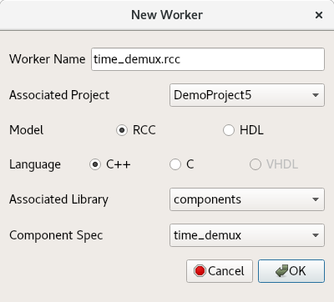
- Click OK. When the operation completes, you should see a new directory appear in the Project Explorer panel.
To create the time_demux worker with ocpidev, run the following command in the DemoProject5/components/ directory:
ocpidev create worker time_demux.rcc

Edit Worker OWD
Recall from Tutorial 1 that RCC worker OWDs generated by ocpidev don’t generally need to be updated. In this case, however, we need to add the ControlOperations attribute that indicates our worker will have a start method; because the run method is mandatory, its presence is assumed. You can read more about this attribute and the Control Plane in general in the OpenCPI Component Development Guide.
To add these attributes with the OpenCPI GUI:
- Navigate to the time_demux-rcc.xml file in the Project Explorer view.
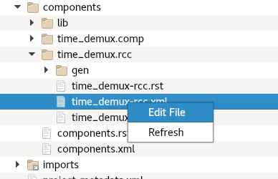
- Right-click it and then click Edit File. This action opens the XML file using your system's default handler for XML files, where you can edit the file if the GUI supports that function for the handler. Make the changes described below. When you finish editing the file, click Save and then close the file.
To add these attributes to the OWD from the command line, in DemoProject5, open
components/time_demux.rcc/time_demux-rcc.xml with a text editor.
Now replace the contents with the following XML:
<RccWorker language='c++' spec='time_demux-spec.xml' controlOperations="start" version="2">

</RccWorker>

Update RCC Worker Skeleton File
Now we’ll add the C++ source code to the time_demux.cc skeleton file. To do this, you can either:
- Copy the tutorial project's time_demux.cc reference file directly into your DemoProject5/components/time_demux.rcc/ subdirectory, overwriting the skeleton file.
- Open the skeleton file for editing and copy/paste the code provided below to it.
You can choose to do one or the other. Doing both is redundant.

Copy Tutorial Project Reference File
To copy the file directly from the tutorial project, navigate to the time_demux.rcc/ subdirectory in DemoProject5 and then use the command:
cp $OCPI_ROOT_DIR/projects/tutorial/components/time_demux.rcc/time_demux.cc .

Edit Worker Skeleton File
If you’re using the OpenCPI GUI, you can use the Project Explorer to locate the worker skeleton file and open it for editing.
To edit the worker skeleton file using the OpenCPI GUI:
- Navigate to the time_demux.cc file in the Project Explorer view.
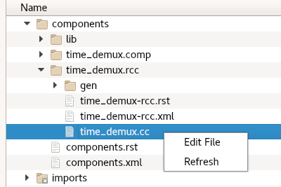
- Right-click it and then click Edit File. This action opens the XML file using your system's default handler for XML files, where you can edit the file if the GUI supports that function for the handler. Make the changes described below. When you finish editing the file, click Save and then close the file.
To edit the worker skeleton file from the command line, navigate to the components/time_demux.rcc/time_demux.cc file and open it with a text editor.
Now replace the contents with the following code:
// Note: This file uses C++11; you must add the proper compiler command line to the Makefile
// for each target platform, e.g:
// RccExtraCompileOptionsCC_centos7+=--std=c++11

#include <cstring>
#include <iostream>
#include "time_demux-worker.hh"

using namespace OCPI::RCC; // for easy access to RCC data types and constants
using namespace Time_demuxWorkerTypes;

class Time_demuxWorker : public Time_demuxWorkerBase {
static const bool verbose = false;

RCCResult start() {
// Guarantee that only Time opcode is sent on Time_Out port:
Time_Out.setDefaultOpCode(Iqstream_with_syncTime_OPERATION);
return RCC_OK;
}
// Internal helper function to manipulate counters
void increment_counters(size_t bytecount) {
++properties().Messages_Read;
properties().Bytes_Read += bytecount;
}

RCCResult run(bool /*timedout*/) {
// determine if end of file
if (Mux_In.eof()) {
Data_Out.setEOF();
Time_Out.setEOF();
return RCC_FINISHED;
}
// Determine opcode
switch (Mux_In.opCode()) {
case Iqstream_with_syncIq_OPERATION:
{
const size_t num_of_elements = Mux_In.iq().data().size();
// Insert IQ opcode logic here (update properties, allocate output, copy sequence, send)
if (verbose) std::cerr << "Received " << num_of_elements << " " << sizeof(IqstreamIqData) << "-byte values." << std::endl;
increment_counters(Mux_In.length());
Data_Out.iq().data().resize(num_of_elements);
const auto *iptr = Mux_In.iq().data().data();
/* ^ ^ ^ ^------ The Iqstream_with_syncIqData structs
* | | \------------- The argument of the IqOp (returns Mux_InPort::IqOp::DataArg object)
* | \------------------ The opcode (returns Mux_InPort::IqOp object)
* \------------------------- The port
*/
auto *optr = Data_Out.iq().data().data();
/* ^ ^ ^ ^------ The IqstreamIqData structs
* | | \------------- The argument of the IqOp (returns Data_OutPort::IqOp::DataArg object)
* | \------------------ The opcode (returns Data_OutPort::IqOp object)
* \--------------------------- The port
*/
for (size_t i = 0; i < num_of_elements; ++i, ++iptr, ++optr) {
// *optr++ = *iptr++; // Does not work; structs are different type!
optr->I = iptr->I;
optr->Q = iptr->Q;
}

The operators highlighted in red are the ports, with the input ports ending in _In and the output ports ending in _Out. The operators highlighted in Blue are the opcodes. If you read through the comments, it should be clear how to access ports and perform operations using opcodes.
Data_Out.advance();
} // case statement anonymous block for stack variables
break;
case Iqstream_with_syncTime_OPERATION:
// Insert Time opcode logic here (update properties, copy scalar, send)
increment_counters(sizeof(uint64_t));
properties().Current_Second = static_cast<uint32_t>(Mux_In.Time().time() >> 32);
if (verbose) std::cerr << "Timestamp: " << properties().Current_Second << std::endl;
Time_Out.Time().time() = Mux_In.Time().time();
/* ^ ^ ^------ The single uint64_t (no need for wrapper class providing length, etc.)
* | \------------- The opcode (returns Time_Out::TimeOp object)
* \---------------------- The port
*/
Time_Out.advance();
break;
default: // Iqstream_with_syncSync_OPERATION and any unknowns
// do nothing (but record message received)
increment_counters(0);
} // opcode switch
Mux_In.advance();
return RCC_OK; // Cannot use RCC_ADVANCE because both output ports never used in a single cycle.
}
}; // end class Time_demuxWorker

Build Worker
Now we need to compile the time_demux worker for the platform on which we want to run it; for this tutorial, it’s our development host.
To build the worker with the OpenCPI GUI:
- In the Platforms panel, check RCC and select centos7.
- In the Project Explorer panel, select the time_demux.rcc worker directory.
- Right-click and select Build.
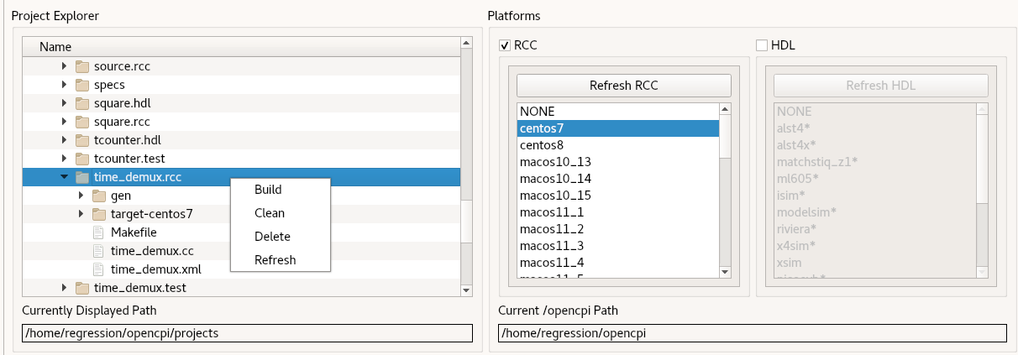
- If the build succeeds, you’ll see a message in the Job Manager panel with what you’ve built (time_demux, in this case) highlighted in green.
To build the worker with ocpidev, run the following command from the DemoProject5 directory:
ocpidev build worker time_demux.rcc --rcc-platform centos7

Create Unit Test
Like we did in Tutorials 3 and 4, we’ll generate an OpenCPI test suite (aka “unit test”) for our time demux worker.
To create the unit test for the time_demux worker with the OpenCPI GUI:
- From the GUI menu bar at the top of the window, select Create > Component Test Suite…
- In the Associated Project drop-down list, select DemoProject5.
- In the Component Spec drop-down list, select time_demux.
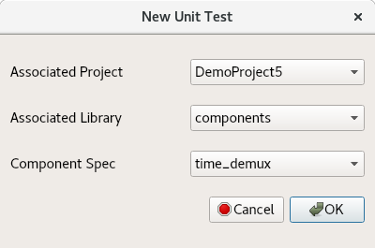
- Click OK. When the operation completes, you’ll see a new time_demux.test subdirectory in components in the Project Explorer panel.
To create the unit test with ocpidev, run the following command from the DemoProject5/components directory:
ocpidev create test time_demux

Edit Test Suite Description
Like we did for the worker tests in Tutorial 3 and 4, we need to add the script names and the necessary parameter values for the scripts to the OpenCPI test suite description (OTSD) (aka “unit test description”) for the time demux worker. This worker uses different scripts than what we’ve seen in Tutorial 3 and 4. This is done in order to use two different opcodes, because the Time() data is separated from the .iq() data using Time_Out and Data_Out.
To edit the test suite description using the OpenCPI GUI:
- Navigate to the time_demux-test.xml file in the Project Explorer view.
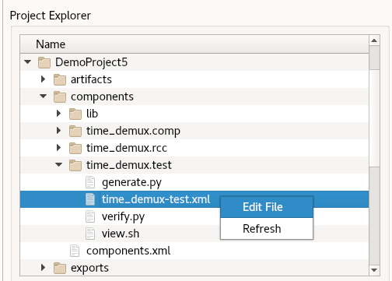
- Right-click it and then click Edit File. This action opens the XML file using your system's default handler for XML files, where you can edit the file if the GUI supports that function for the handler. Make the changes described below. When you finish editing the file, click Save and then close the file.
To edit the test suite description on the command line, open the components/time_demux.test/time_demux-test.xml file with a text editor.
Now replace the contents with the following XML:
<!-- This is the test xml for testing component "time_demux" -->
<tests useHDLFileIo='false'>
<input port='Mux_In' script='test_data_generator' messagesInFile='true'/>
<output port='Data_Out' script='verify.sh'/>
<output port='Time_Out' script='verify.sh'/>
<property test='true' name='START' value='0'/>
<property test='true' name='SAMPLES' value='256'/>
<property test='true' name='IFILE' type="String" value='gen/mytestdata'/>
</tests>

Copy Unit Test Scripts from Tutorial Project
Now we'll copy the following reference test scripts from the ocpi.tutorial project that are required for our unit test suite:
- verify.sh – the file that has a copy of the results that should be generated by the operation. The results that are generated are compared against it to verify that the test ran correctly.
- Makefile – the file that provides ocpidev information necessary for the test to run on certain operating systems.
- test_data_generator.cxx – the file that generates the I/Q sample data that has time stamps interleaved within it. That data is processed by time_demux.cc.
To copy these files:
- Open a second tab in your terminal.
- Navigate to the /components/time_demux.test/ directory in DemoProject5:
cd components/time_demux_test/
- Use the following commands to copy the test files from the ocpi.tutorial project’s components/time_demux.test/ directory to your local DemoProject5/components/time_demux.test/ directory:
cp $OCPI_ROOT_DIR/projects/tutorial/components/time_demux.test/verify.sh .

cp $OCPI_ROOT_DIR/projects/tutorial/components/time_demux.test/Makefile .

cp $OCPI_ROOT_DIR/projects/tutorial/components/time_demux.test/test_data_generator.cxx .

Build Unit Test
Now we’ll build the unit test for the target platform, which is our development host for this tutorial.
To build the unit test with the OpenCPI GUI:
- In the Project Explorer panel, select time_demux.test.
- In the Platforms view, make sure RCC is checked and centos7 is highlighted.
- Right-click time_demux.test and then select Build.
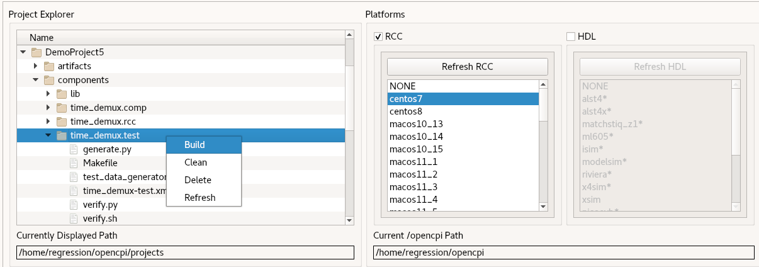
To build the unit test with ocpidev, run the following command from the components/time_demux.test/ directory in DemoProject5:
ocpidev build test --rcc-platform centos7

Run Unit Test
Now we’ll run the unit test for the time demux worker.
To run the unit test and view the results with the OpenCPI GUI:
- In the Project Explorer, select time_demux.test.
- In Platforms, make sure RCC is checked and centos7 is highlighted.
- Click Run Unit Test.
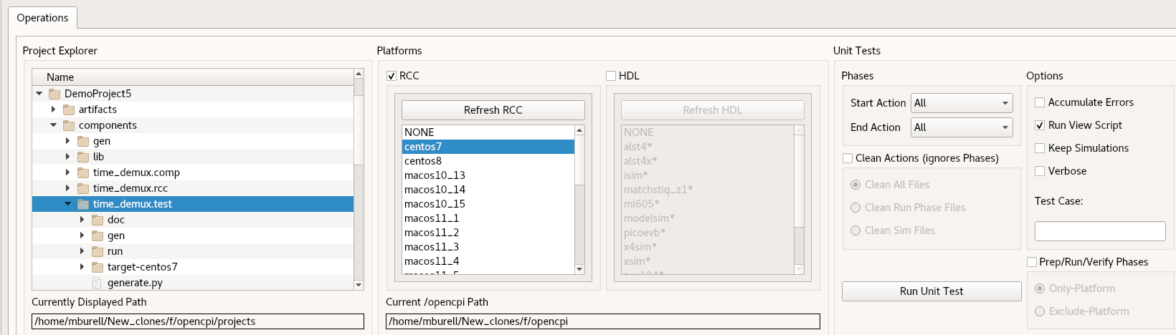
To run the test and view the output from the command line, browse to time_demux.test/ and run the following ocpidev command:
ocpidev run test --only-platform centos7
If the unit test runs successfully, the following text is displayed:
======== Preparing for execution on available platforms with available built workers and assemblies for time_demux:
Probing for available local platforms:
Local platforms are: rcc-0-centos7
Generating execution scripts for each platform that can run.
Generating run script for platform: centos7
======== Running and verifying test outputs on available platforms for time_demux:
Performing test cases for local.DemoProject5.time_demux on platform centos7. Functions are: run verify
Executing case case00.00 using worker time_demux.rcc on platform centos7...
Execution succeeded, time was 00:00:01 (1 seconds).
Verifying case case00.00 for worker time_demux.rcc using script on output file: case00.00.time_demux.rcc.Time_Out.out
Checking time:
Verification for port Time_Out: PASSED
Verifying case case00.00 for worker time_demux.rcc using script on output file: case00.00.time_demux.rcc.Data_Out.out
Checking data:
Verification for port Data_Out: PASSED

Tutorial Summary
Now that you’ve completed this tutorial, you should be able to create and program a worker with one or more opcodes. In other existing OpenCPI projects, you should also be able to understand how the RCC workers communicate and operate even if they have more than two opcodes.

