OpenCPI
Tutorial 1: Introduction to OpenCPI Application Development
OpenCPI Release develop

Revision History
Revision | Description of Change | Date
1.0 | Creation from Lab 1 developed by CNF | 2019-10-01
1.1
1.2
1.3
1.4
1.5
1.6
1.7
1.8
1.9
2.0
2.1
Table of Contents
1 Overview 4
1.1 What’s Provided for This Tutorial 5
1.2 Prerequisites to Running This Tutorial 6
1.3 Documentation References 7
2 Create FSK Data Files 8
3 Create FSK Application 11
4 Create Component Instances 14
5 Add Property Values to Components 16
6 Make Connections 26
7 End Application 27
8 Run FSK Application 28
9 Troubleshooting 29

Overview
This tutorial demonstrates the OpenCPI application development workflow and gives a general overview of the process. It shows you how to:
- Create an App XML file (called an OpenCPI Application Specification or OAS) for the OpenCPI Frequency-Shift Keying (FSK) reference application. An App XML file describes an application’s component connections and initial component property settings. This tutorial shows how to develop the application OAS with the AV Eclipse-based GUI development tool, which helps to generate the XML graphically.
- Run the FSK reference application on the Xilinx XSIM simulator with the ocpirun command.
The goal of this tutorial is to send an image over a wire using the FSK protocol.
The FSK reference application is an OpenCPI demo application that performs FSK modulation/demodulation:
Modulation: Read Input File → FSK Symbol Mapper → Zero-pad → Pulse Shape → FM Modulate → Interpolate
Demodulation: Decimate → Demodulate → Filter → Baud Track → Digitize → Write Output File
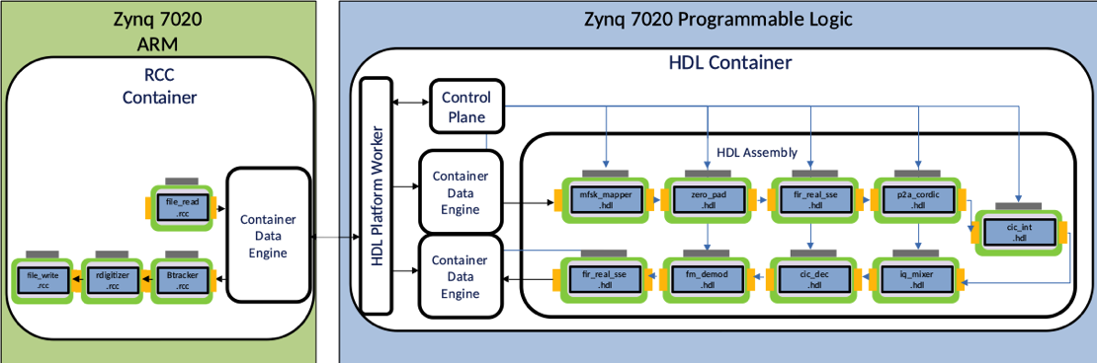
For more information about the FSK reference application, see the OpenCPI FSK App Guide and the OpenCPI FSK App Getting Started Guide. For more information about the OpenCPI Application Specification, ocpidev and ocpirun, see the OpenCPI Application Development Guide. For more information about OpenCPI components, see the OpenCPI Component Development Guide.

What’s Provided for This Tutorial
The tutorial provides data for the following tutorial items:
- Input data for the FSK application.
The data is available as text in the relevant sections of this document that you can copy and paste into the relevant files following the instructions given in the section.
Note that all of the OpenCPI built-in projects described in the OpenCPI User Guide are built for the CentOS 7 and Xilinx Vivado® XSim platforms as part of the OpenCPI installation process. You do not need to build or import these projects in order to use them in this tutorial.
This means that the FSK application assets, which reside in the OpenCPI assets project, are also pre-built for the CentOS 7 and XSim platforms.

Prerequisites to Using This Tutorial
This tutorial is designed to be run on a machine that has:
- The default OpenCPI source code installation (the latest OpenCPI source installed and built on CentOS 7)
- The default third-party FPGA simulator xsim installation (the simulator installed with the free, unlicensed variant of the Xilinx Vivado Design Suite HLx Edition tool set)
- The AV Eclipse-based GUI development tool (optionally installed with OpenCPI as a GUI alternative to the OpenCPI command-line tools)
The OpenCPI Installation Guide describes how to install these items. This tutorial assumes that you have, at a minimum, this OpenCPI environment set up on your development host.
To be able to use the OpenCPI tools, you need to run the OpenCPI environment setup script opencpi-setup.sh on your development host. If you have not already done so, follow the procedure in the OpenCPI User Guide to run this script.
Finally, we recommend reading the following briefings before getting started with the tutorial:
- Briefing 1, “Introduction to OpenCPI”. This briefing introduces OpenCPI positioning, priorities and background as well as component and application terminology.
- Briefing 2, “Introduction to Application Development with OpenCPI”. This briefing discusses OpenCPI elements and concepts from an application development perspective and introduces OpenCPI tools and building blocks for application development.

Documentation References
The documents listed in the following table provide detailed information about subjects discussed in this tutorial. The documents listed here are not required reading for this tutorial but will likely be of interest for more in-depth learning.
Table 1 - OpenCPI Reference Documentation
Title | Published By | Public URL
OpenCPI Overview | OpenCPI | https://opencpi.gitlab.io/releases/v2.4.0/docs/Overview.pdf
OpenCPI User Guide | OpenCPI | https://opencpi.gitlab.io/releases/v2.4.0/docs/OpenCPI_User.pdf
OpenCPI Application Development Guide | OpenCPI | https://opencpi.gitlab.io/releases/v2.4.0/docs/OpenCPI_Application_Development.pdf
OpenCPI Component Development Guide | OpenCPI | https://opencpi.gitlab.io/releases/v2.4.0/docs/OpenCPI_Component_Development.pdf
OpenCPI HDL Development Guide | OpenCPI | https://opencpi.gitlab.io/releases/v2.4.0/docs/OpenCPI_HDL_Development.pdf
OpenCPI RCC Development Guide | OpenCPI | https://opencpi.gitlab.io/releases/v2.4.0/docs/OpenCPI_RCC_Development.pdf

Create FSK Data Files
First, we need to create the FSK data for the application.
Navigate to the idata directory of your assets project’s FSK application. For example:
~/opencpi/projects/assets/applications/FSK/idata
Create a file called rx_rrcos_taps.dat with the values below. Make sure there are no tabs or spaces in the lines where the numbers reside. Copy this file and then rename it to tx_rrcos_taps.dat. We will reference these files later in the tutorial. Notice that there is an Os.jpeg file in the idata directory. We’ll use this file later on as an input file to send over the wire.
Here are the values to supply (lines 1-64):
85
96
105
111
115
116
114
109
100
88
72
53
31
6
-21
-50
-81
-113
-145
-177
-207
-235
-259
-280
-295
-305
-307
-302
-287
-263
-229
-184
-128
-60
20
112
217
334
462
602
752
912
1081
1257
1441
1629
1821
2015
2209
2402
2593
2779
2958
3130
3292
3443
3581
3705
3814
3906
3981
4038
4076
4096

Create FSK Application
An OpenCPI application consists of an OpenCPI Application Specification (OAS), which is an XML file that specifies the components that should be instantiated, how the resulting workers should be connected, and how they should be configured via their properties. We’ll create an OAS for our FSK application in the OpenCPI assets project.
The easiest way to create an application OAS is to use the OpenCPI tools to create a template OAS in an applications directory and then edit this XML file with our XML definitions. We’ll call our application fsk_loopback.
To create the template application OAS with AV:
- In the OpenCPI Projects view, right-click on ocpi.assets and then select asset wizard:
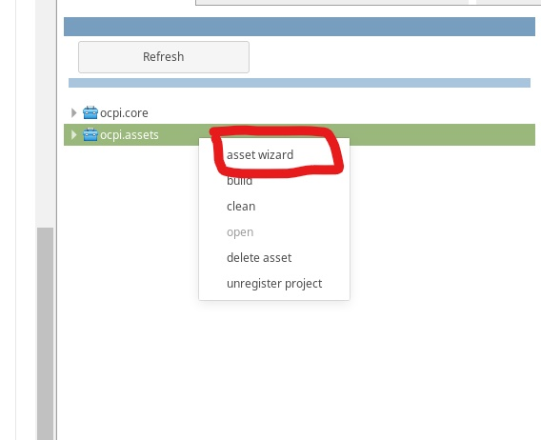
- In the drop-down list, select the Application asset type. The application creation dialog appears.
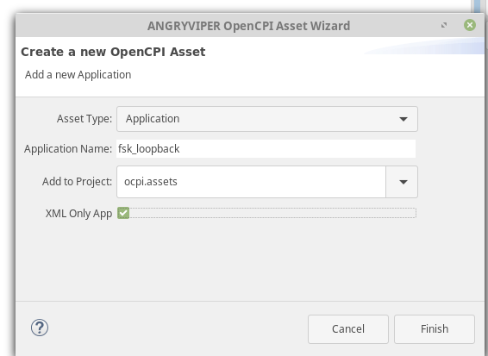
- In Application Name, enter fsk_loopback.
- Check XML only.
- Click Finish.
The fsk_loopback application OAS is displayed in the OAS Design Editor:
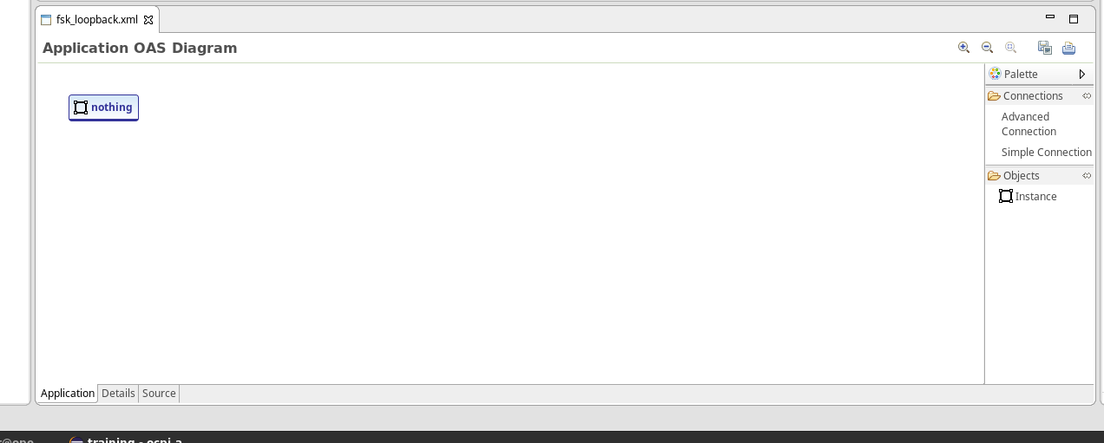
Note: You can delete the ocpi.core.nothing component. The OpenCPI framework automatically includes this worker to ensure that the generated OAS can be executed without editing the generated file.

Create Component Instances
The following table shows all of the component specs that we need to add to our application OAS.
Table 2 - Component Specifications Required for fsk_loopback
Component Specs Required
Name | Project : Library
file_read_spec.xml | Core : components
mfsk_mapper-spec.xml | Assets : components/comms_comps
zero_pad-spec.xml | Assets : components/util_comps
fir_real_sse-spec.xml* | Assets : components/dsp_comps
phase_to_amp_cordic-spec.xml | Assets : components/dsp_comps
cic_int-spec.xml | Assets : components/dsp_comps
complex_mixer-spec.xml | Assets : components/dsp_comps
cic_dec-spec.xm | Assets : components/dsp_comps
rp_cordic-spec.xml | Assets : components/dsp_comps
fir_real_sse-spec.xml* | Assets : components/dsp_comps
baudTracking-spec.xml | Assets : components/dsp_comps
real_digitizer-spec.xml | Assets : components/dsp_comps
file_write_spec.xml | Core : components
We need to add these components as instances to our fsk_loopback OAS.
To add component instances with the AV OAS Design Editor:
- Right-click on the OAS diagram and click Add Instance.
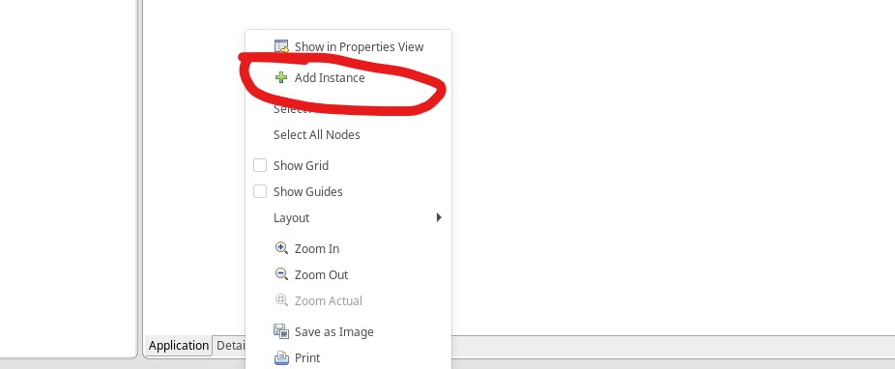
- Instances are ordered alphabetically so the instance zero_padding appears before anything else because it starts with a z. You may have an instance called zero_padding or something else that is not one of the instances required.

- If this is the case, you can change this by double-clicking on the instance we just created. You’ll this dialog.

- Click the drop-down arrow to the right to show a drop-down menu of available instances:
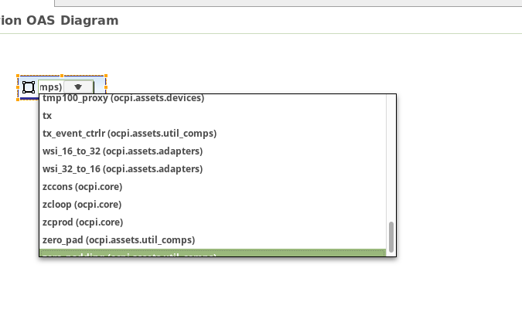
- Let’s select file_read for our first instance in this project.

- Now add instances for the remaining components listed in the table of required component specifications.

Add Property Values to Components
Now you need to add property values to your components. The following table contains all of the property values you need to edit for each of the components listed in the table in “Create the FSK Application”.
Table 3 - Required Component Property Values
Property Values Required
Component | Property Name | Value
file_read | fileName | FSK/idata/Os.jpeg
file_read | messageSize | 2048
mfsk_mapper | symbols | -32768, 32767
zero_pad | num_zeros | 38
phase_to_amp_cordic | magnitude | 20000
phase_to_amp_cordic | STAGES | 16
cic_int | R | 16
cic_int | ACC_WIDTH | 28
complex_mixer | enable | False
cic_dec | R | 16
cic_dec | ACC_WIDTH | 28
baudTracking | SPB | 39
baudTracking | BaudAvrCount | 10
file_read | fileName | out.out
NOTE: The value of file_read is dependent on where the Os.jpeg image is located.
In the AV OAS Editor:
- Click on our instance. We see that two paper tabs are displayed on the right side. Click the bottom one to show this instance in the Properties view.
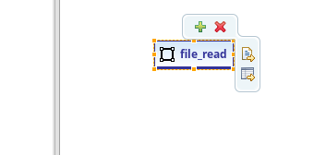
Alternatively, you can right-click on the instance to display the following drop-down menu.
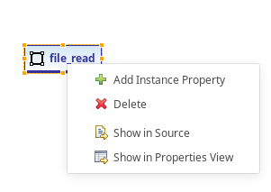
Click Show in Properties View.
- On the right side of your screen, a Properties tab should be displayed.
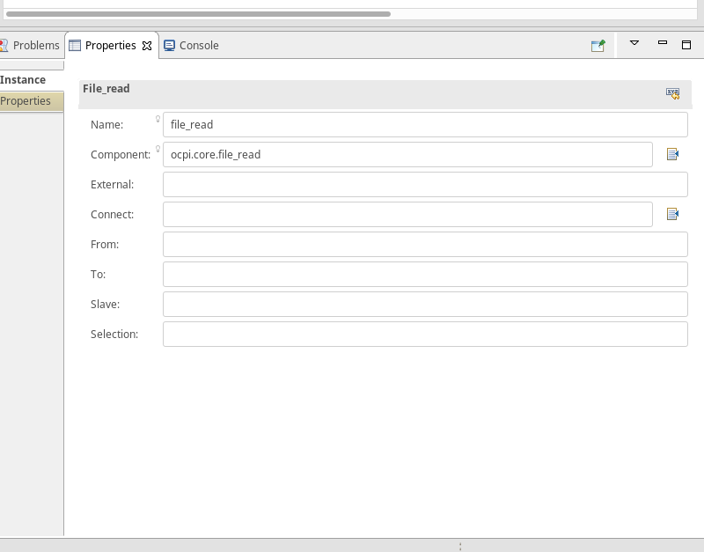
- Notice the component parameter. ocpi.core.file_read is the component you are using. You can change the name if you need more than one file_read for an application with no effect on the component parameter.
- Click the Properties tab to change the properties of the file_read instance.
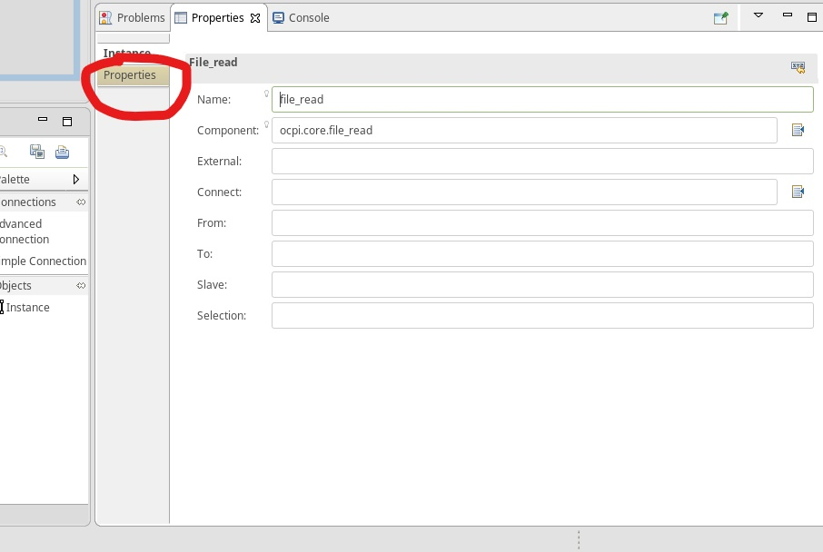
- An empty dialog is displayed:
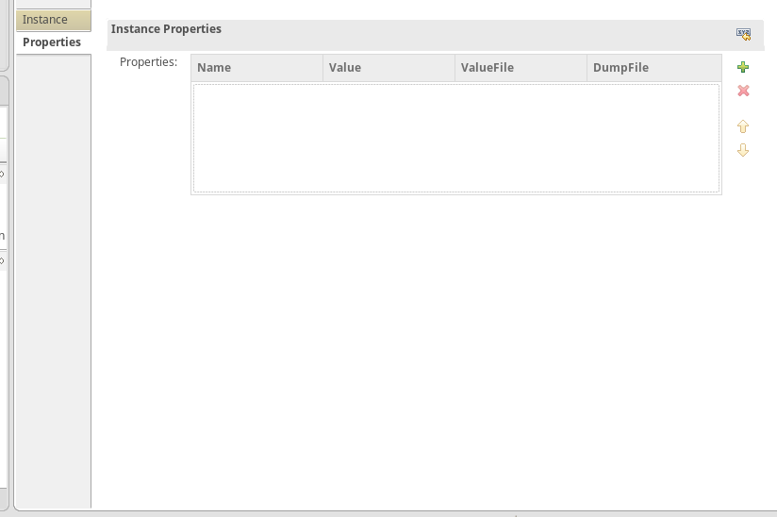
- Click the green plus button to add a property:
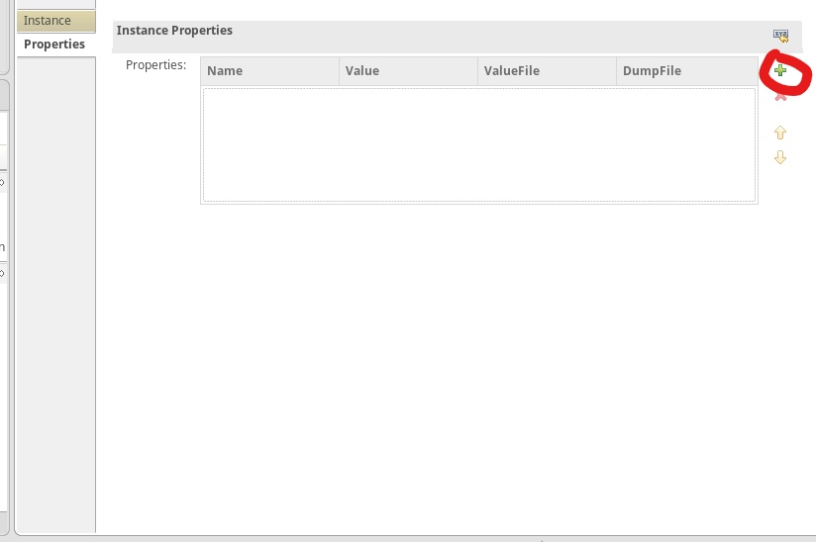
- Based on the property values shown in the Propery Values Required table, you should have something like this for your file_read instance:
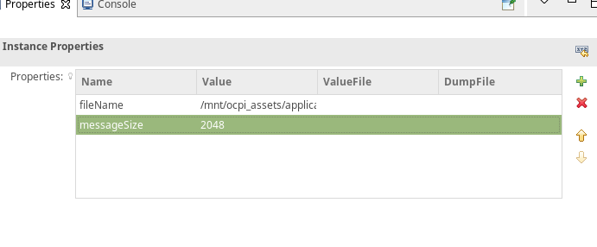
- In your OAS diagram, you should see something like this:
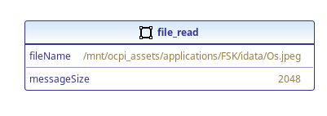f
- Now let’s move to the fir_real_sse instances we added. When we created our component instances, we added two fir_real_sse instances to our OAS diagram. Notice the little red 'x' on each instance’s icon. This is happening because these two instances that we created have the same name. This is a problem.
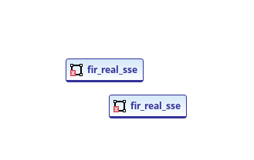
- To fix this problem, click on the instance and then change the name in the Properties view to rx_fir for one instance and tx_fir for the other instance.
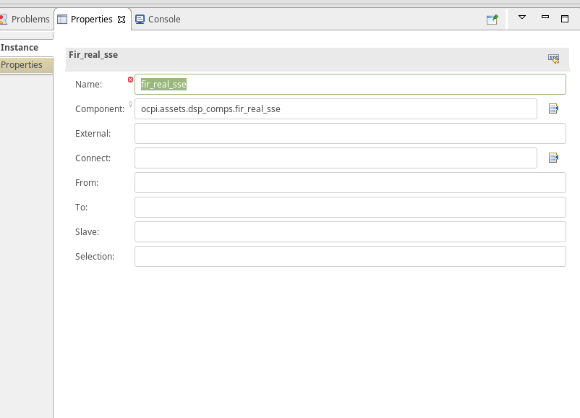
- Now we have no errors.
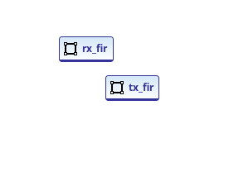
The fir_real_sse instances, now named rx_fir and tx_fir, have a property called taps, described in the following table:
Table 4 - fir_real_sse Component Required Property Values
Property Values Required
Component | Property Name | ValueFile
rx_fir | taps | FSK/idata/rx_rrcos_taps.dat
tx_fir | taps | FSK/idata/tx_rrcos_taps.dat
- Change the items shown in the table in each of our instances. The value of ValueFile is going to be the directory where the rx_rrcos_taps.dat and tx_rrcos_taps.dat files we created earlier are stored.
- Now, looking at the required component properties table, repeat the steps you did for file_read for the remaining component instances.
Once you do this, you have will have something like this image:
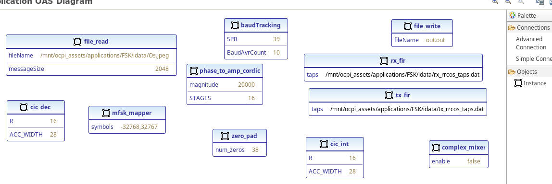
This looks messy. Let’s reorder it so it’s easier to make connections.
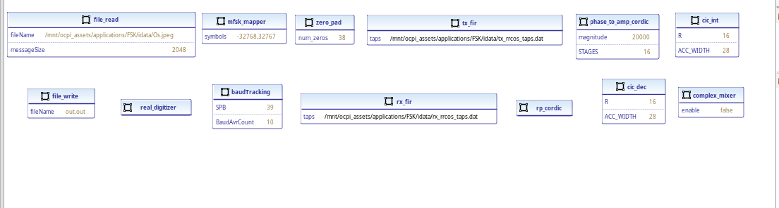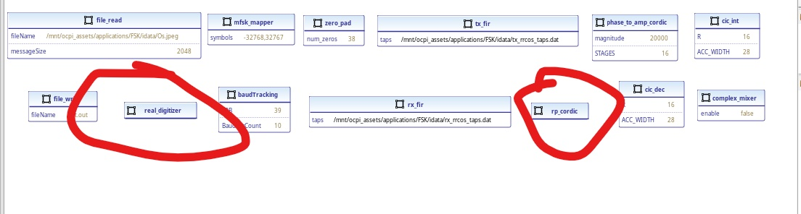
Notice the new components real_digitizer and rp_cordic. Don’t worry about editing their properties.

Make Connections
The next step is to make connections between components in the application. To make these connections with AV in the OAS Design Editor:
- In the Palette view, click Advanced Connection and then click the start of the connection and the end of the connection. Don’t worry about connection names for this tutorial.
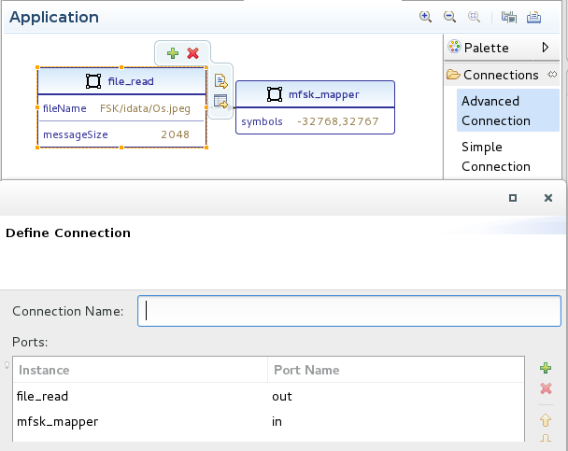
1
2
3
4
- The result should look something like this:
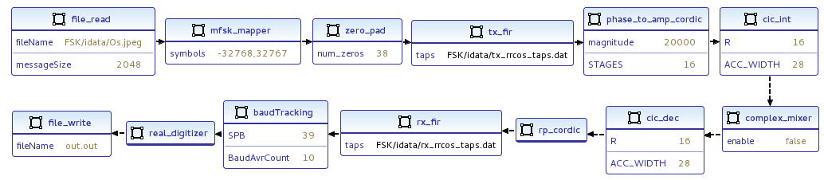
The only unique values should be fileName for the file_read instance, because it’s a path to your Os.jpeg file and the two taps values for tx_fir and rx_fir respectively, because the data file location is unique to your setup.

End Application
An important step is to make sure that you end the application so that it doesn’t go into an infinite loop.
To do this in the AV OAS Design Editor:
- Click on the white space of the OAS Design Editor. You should see something like this:
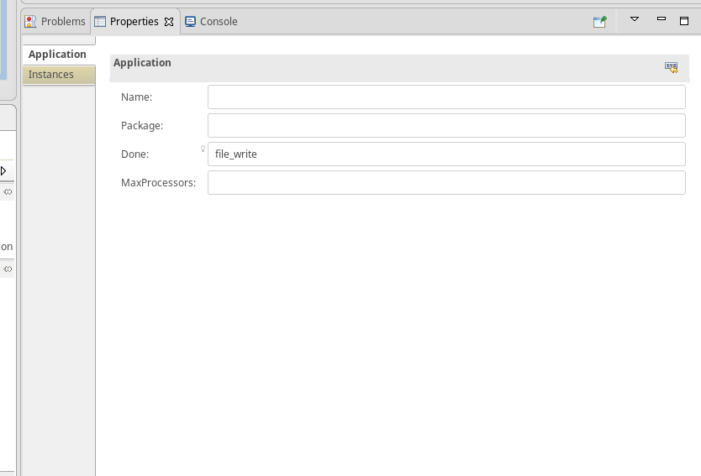
- Your Done: parameter will be blank. Replace it with file_write, as shown in the figure above.

Run FSK Application
Now you can run the FSK application on the xsim platform with the ocpirun utility.
In a terminal/shell window on your development host, navigate to the directory where your fsk_loopback application resides.
Set the OCPI_LIBRARY_PATH environment variable to the location at which your exports are located for your core and assets projects. For example:
export
OCPI_LIBRARY_PATH=$OCPI_ROOT_DIR/projects/core/exports/artifacts:$OCPI_ROOT_DIR/projects/assets/exports/artifacts
Execute ocpirun to start the application:
ocpirun -v fsk_loopback.xml
Now go to your assets project’s applications folder:
~/opencpi/projects/assets/applications
Run the following:
eog out.out
If an image appears, the application is successful.

Troubleshooting
$ export OCPI_LOG_LEVEL=8 to view a detailed log while running on your hardware platform.
Double-check your spelling for typos inside the component properties.
Problems relating to library entries not found:
- .gz library files were missing from the assets/exports.
- dsp_comps assemblies were cleaned and rebuilt to resolve missing .gz libraries.
- OCPI_LIBRARY_PATH export may not be referencing the correct exports path for assets and core.

