OpenCPI
Tutorial 9a: Using OpenCPI Debugging Tools
OpenCPI Release 1.6.0rc2

Revision History
Revision | Description of Change | Date
1.0 | Creation from Couse developed by BIA | 2019-10-01
1.1
1.2
1.3
1.4
1.5
1.6
1.7
1.8
1.9
2.0
2.1
Table of Contents
1 Overview 4
1.1 What’s Provided for This Tutorial 5
1.2 Prerequisites to Using This Tutorial 6
1.3 Documentation References 7
2 Using ocpihdl 8
2.1 Finding the Available HDL Devices on a Target FGPA-based Platform 9
2.2 Loading/Probing the Bitstream 10
2.3 Controlling Workers 11
2.4 Viewing Worker Information from the Bitstream 12
3 Debugging with ocpi_debug 14
4 Execution and Debug Utilities 15

Overview
This guide briefly describes how to use the debugging tools provided with OpenCPI to:
- Collect HDL device/worker information
- Review worker lifecycle
- Control worker state
- Change and view worker properties
- Debug workers
Tutorial 9: Debugging an HDL Worker on a Hardware Platform provides an example of how to debug OpenCPI applications with OpenCPI debugging utilities.

What’s Provided for This Tutorial
There are currently no items provided for this tutorial.

Prerequisites to Using This Tutorial
Before you begin this tutorial, you should have successfully completed Tutorial 1b, “Introduction to Component-based Development”.

Documentation References
The documents listed in the following table provide detailed information about subjects discussed in this tutorial. The documents listed here are not required reading for this tutorial but will likely be of interest for more in-depth learning.
Table 1 - OpenCPI Reference Documentation
Title | Published By | Public URL
OpenCPI Overview | OpenCPI | https://opencpi.gitlab.io/releases/v1.6.0-rc.0/docs/Overview.pdf
OpenCPI User Guide | OpenCPI | https://opencpi.gitlab.io/releases/develop/docs/OpenCPI_User.pdf
OpenCPI Application Development Guide | OpenCPI | https://opencpi.gitlab.io/releases/v1.6.0-rc.0/docs/OpenCPI_Application_Development.pdf
OpenCPI Component Development Guide | OpenCPI | https://opencpi.gitlab.io/releases/v1.6.0-rc.0/docs/OpenCPI_Component_Development.pdf
OpenCPI HDL Development Guide | OpenCPI | https://opencpi.gitlab.io/releases/v1.6.0-rc.0/docs/OpenCPI_HDL_Development.pdf
OpenCPI RCC Development Guide | OpenCPI | https://opencpi.gitlab.io/releases/v1.6.0-rc.0/docs/OpenCPI_RCC_Development.pdf

Using ocpihdl
We can use ocpihdl to:
- Probe the XML of the currently loaded bitstream
- Display currently loaded workers
- View/change worker status
- Set/change worker properties
- Reset workers
- Step through an application
When run without options, ocpihdl prints out all of its uses.

Finding the Available HDL Devices on a Target FGPA-based Platform
$ ocpihdl search
This command provides information for available HDL devices, including:
- Name
- Date of bitstream creation
- Platform
- Part
- UUID (unique identifier of the bitstream)

Loading/Probing the Bitstream
To examine the XML packaged into any artifact (including bitstreams):
$ ocpixml get <.so or .bitz artifact filename>
To load a bitstream:
$ ocpihdl load <path to bitstream>
To examine the XML packaged into a currently loaded bitstream:
$ ocpihdl getxml <output-file>
$ ocpihdl getxml <output-file>
$ grep controlOperation <output-file>
- What controlOperations are implemented by each worker?
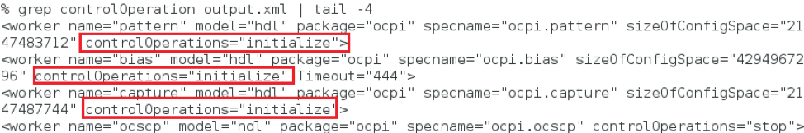
To remove the bitstream from the FPGA:
$ ocpihdl unload
This command is most commonly used when the system’s processor functions independently from the programmable logic.
CAUTION: Unloading an FPGA that implements a PCIe interface may result in the card being unusable and may require a system reboot.

Controlling Workers
The following figure shows the worker life cycle:
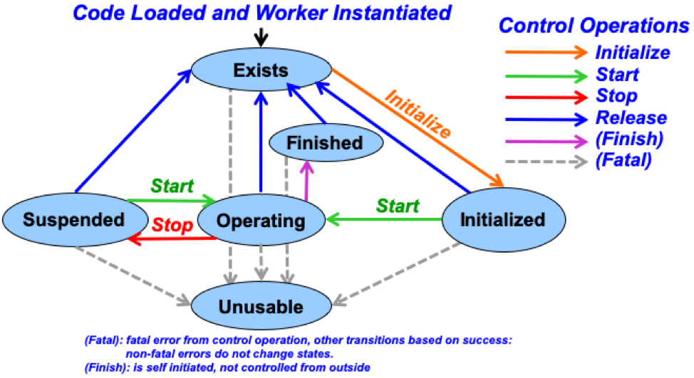
To find a worker index and other information, use:
$ ocpihdl get
You can specify <index/worker-name> (and even <property>) here.
To reset or unreset the control reset signal into workers, use:
$ ocpihdl wreset/wunreset <index>
To perform other control operations on workers, use”
$ ocpihdl wop <index> start/initialize/stop
To set worker properties, use:
$ ocpihdl set <index/worker-name> <property> <value>
To observe worker state, use:
$ ocpihdl status <index/worker-name>
Add the -v option to the command line to view worker properties.

Viewing Worker Information from the Bitstream
Use:
$ ocpihdl get
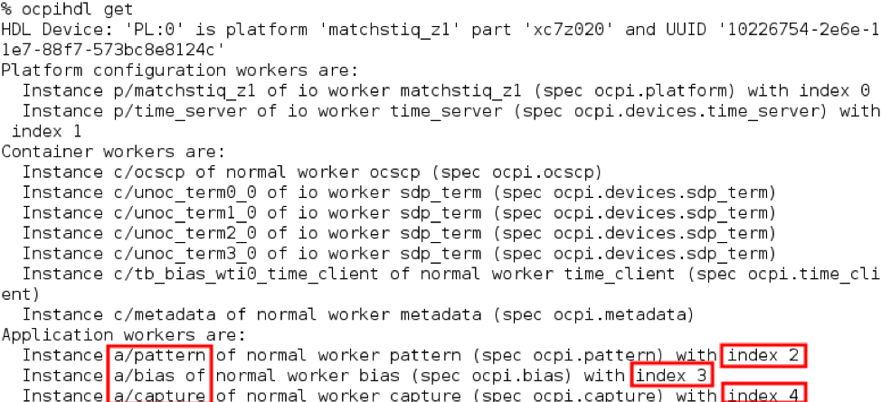
We can identify them by their indices.
If the worker is "RESET"
$ ocpihdl wunreset <index>
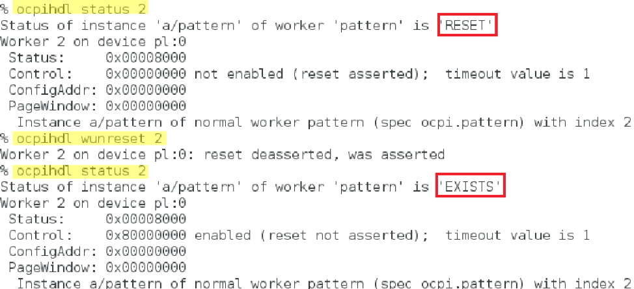
If the worker implements the "initialize" controlOperation:
$ ocpihdl wop <index> initialize
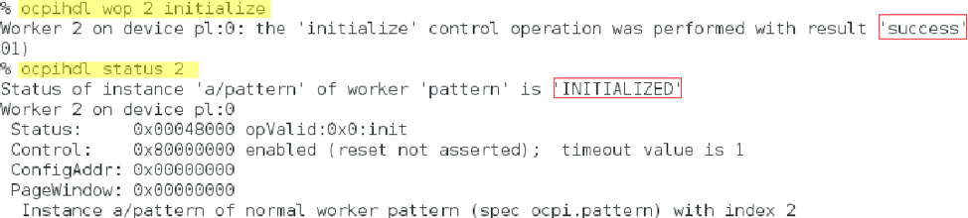
Ultimately, to bring the worker to "OPERATING":
$ ocpihdl wop <index> start
Writable worker properties can be changed:
$ ocpihdl set <index/worker-name> <property> <value>
Readable (the explicit flag, not the concept) / Volatile properties can be read:
$ ocpihdl status -v <index/worker-name>
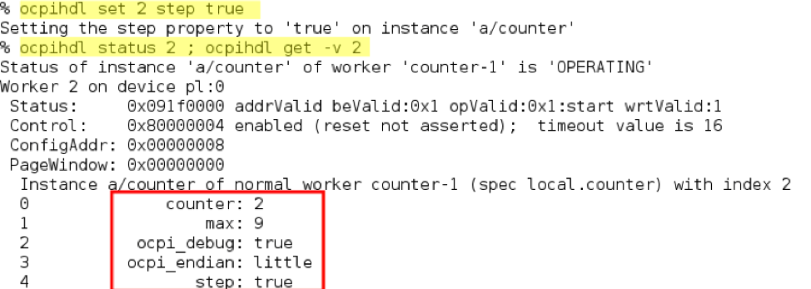

Debugging with ocpi_debug
There is a worker parameter that can enable debugging. Set this parameter to true in the OWD before building workers for debugging and add debugging functionality to worker the that depends on ocpi_debug.
In VHDL: "ocpi_debug":
In C++, "<WORKER_NAME>_OCPI_DEBUG":

Execution and Debug Utilities
- Log level:
export OCPI_LOG_LEVEL=8
ocpirun -l 8 (lowercase L)
OCPI_LOG_LEVEL=10 make tests
- "ocpirun -C" finds containers, including simulators.
- "ocpiview" is used to view simulation waveform results
- printf/cout
- ocpi_debug OWD parameter
- gdb

