OpenCPI
Tutorial 1b: Introduction to Component-based Development
OpenCPI Release 1.6.0rc2
Revision History
Revision | Description of Change | Date
1.0 | Creation | 2019-12-12
Table of Contents
1 Overview 4
1.1 What’s Provided for This Tutorial 6
1.2 Prerequisites to Using This Tutorial 7
1.3 Documentation References 8
2 Create Project 9
3 Create Component Library 13
4 Create Components 15
4.1 Create Component Specs 16
4.2 Define Component Ports 19
5 Create Workers 21
5.1 Create HDL Workers 22
5.2 Update HDL Worker Descriptions (OWDs) 26
5.3 Edit HDL Worker Skeleton Files 28
5.4 Build HDL Workers 30
6 Create Assembly 31
6.1 Create HDL Assembly 32
6.2 Update HDL Assembly Description 33
6.3 Build HDL Assembly 34
7 Create Application 35
7.1 Create Template App XML (OAS) 36
7.2 Update Template App XML (OAS) 37
8 Generate Input Data 39
9 Set Artifact Library Path and Run Simulation 40
9.1 Export OCPI_LIBRARY_PATH 41
9.2 Run Application 42
10 View Output Data 43

Overview
This tutorial introduces you to the process of component-based development with OpenCPI. It describes the steps to develop and run a simple OpenCPI application using OpenCPI tools and provided data and source code.
The application consists of both user-defined and OpenCPI-provided components with implementations for both software (RCC) and FPGA (HDL) processor types. The target application execution platforms are the Xilinx Xsim FPGA simulator for the FPGA implementation and the CentOS 7 development host for the software implementation.
The application will use three processing components – ramp, square, and ander – that you will specify from scratch and two OpenCPI built-in utility components – file_read and file_write – to read streaming input data from and write output data to files on the development host. The following figure illustrates the application:
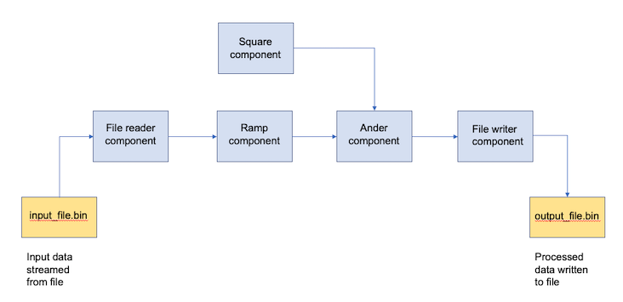
Simple Data Processing Application
The tutorial steps through the component-based application development process, including how to:
- Create an OpenCPI project in which to develop your OpenCPI assets
- Create a library for components and their workers
- Create component specs for the ramp, square and ander components and define their properties and ports
- Create and build the workers to be used to execute the components on the target platforms
- Create the application
- Generate the input data to the application
- Run the application
- View the generated output data
The tutorial first describes how to develop and run the application on the xsim platform using Hardware Definition Language (HDL) workers and then describes how to develop and run it on the development host using Resource-Constrained C/C++ (RCC) workers.

What’s Provided for This Tutorial
The tutorial provides source code for the following tutorial items:
- The ramp, square and ander workers. The provided source code is written according to the APIs for the HDL (VHDL source code) and RCC (C++ source code) authoring models.
- A Python script that generates the input data to be streamed to the application.
- A Python script that demultiplexes and plots the output data generated by the simple application.
This source code is available as text in the relevant sections of this document that you can copy and paste into the relevant files following the instructions given in the section.
Note that all of the OpenCPI built-in projects described in the OpenCPI User Guide are built for the CentOS 7 and Xilinx Vivado® XSim platforms as part of the OpenCPI installation process. You do not need to build or import these projects in order to use them in this tutorial.

Prerequisites to Using This Tutorial
This tutorial is designed to be run on a machine that has:
- The default OpenCPI source code installation (the latest OpenCPI source installed and built on CentOS 7)
- The default third-party FPGA simulator xsim installation (the Xilinx Vivado XSim simulator installed with the free, unlicensed variant of the Xilinx Vivado Design Suite HLx Edition tool set)
- (optional) The ANGRYVIPER (AV) Eclipse-based GUI development tool (optionally installed with OpenCPI as a GUI alternative to the OpenCPI command-line tools)
The OpenCPI Installation Guide describes how to install these items. This tutorial assumes that you have, at a minimum, this OpenCPI environment set up on your development host.
To be able to use the OpenCPI tools, you need to run the OpenCPI environment setup script opencpi-setup.sh on your development host. If you have not already done so, follow the procedure in the OpenCPI User Guide to run this script.
Finally, we recommend reading the following briefings before getting started with the tutorial:
- Briefing 1, “Introduction to OpenCPI”. This briefing introduces OpenCPI positioning, priorities and background as well as component and application terminology.
- Briefing 2, “Introduction to Application Development with OpenCPI”. This briefing discusses OpenCPI elements and concepts from an application development perspective and introduces OpenCPI tools and building blocks for application development.

Documentation References
The documents listed in the following table provide detailed information about subjects discussed in this tutorial. The documents listed here are not required reading for this tutorial but will likely be of interest for more in-depth learning.
Table 1 - OpenCPI Reference Documentation
Title | Published By | Public URL
OpenCPI Overview | OpenCPI | https://opencpi.gitlab.io/releases/v1.6.0-rc.0/docs/Overview.pdf
OpenCPI User Guide | OpenCPI | https://opencpi.gitlab.io/releases/develop/docs/OpenCPI_User.pdf
OpenCPI Application Development Guide | OpenCPI | https://opencpi.gitlab.io/releases/v1.6.0-rc.0/docs/OpenCPI_Application_Development.pdf
OpenCPI Component Development Guide | OpenCPI | https://opencpi.gitlab.io/releases/v1.6.0-rc.0/docs/OpenCPI_Component_Development.pdf
OpenCPI HDL Development Guide | OpenCPI | https://opencpi.gitlab.io/releases/v1.6.0-rc.0/docs/OpenCPI_HDL_Development.pdf
OpenCPI RCC Development Guide | OpenCPI | https://opencpi.gitlab.io/releases/v1.6.0-rc.0/docs/OpenCPI_RCC_Development.pdf

Create Project
The first step in the component-based application development process is to create a workspace environment, called a project, that you can use to develop your OpenCPI assets. A project is a standard directory structure that holds your assets in both source code form and built form, along with the makefiles that describe how they are built. It provides a place for collecting the assets you create for a specific application or assets that may be related to each other.
For our project, we’ll use the name DemoProject.
Right now, we don’t plan to share DemoProject or the assets we create in it with any other projects, so we don’t need provide any project identification information about it when we create it. However, we do need to register it in OpenCPI’s project registry so that we can use the command line tool ocpidev to display our project and its assets later on (the ocpidev show command currently displays only registered projects and their assets.)
To create the DemoProject project with AV:
- Place the cursor anywhere in the OpenCPI Projects view. Right click and then select asset wizard.
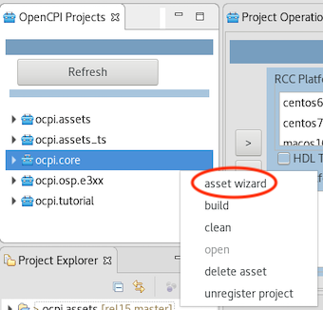
- In Asset Type, use the drop-down list to select the Project asset type. The asset creation dialog for a project is displayed.
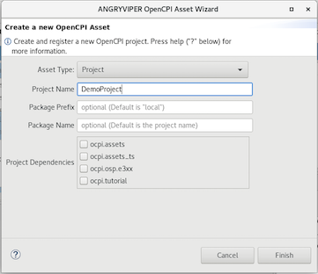
- In Project Name, enter Demo Project.
- Leave Package Prefix and Package Name blank so that AV uses the defaults.
- Click Finish. The new project is created in your workspace, registered in the OpenCPI project registry and displayed in the OpenCPI Projects view and the (Eclipse) Project Explorer view.
- Use the Project Explorer view to look at the directory structure and the files created. You should see something like:
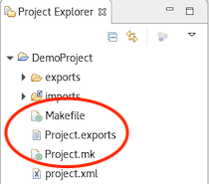
The files of interest are circled in red and described below.
Notice the Console tab and open window on the right. AV executes ocpidev commands to carry out its operations. You can see the output from the ocpidev command for the operations you just performed in the Console tab window, including error messages.
To create the DemoProject project with ocpidev:
- In a terminal/shell window, change directory to where you want to create the project.
- Use the command:
ocpidev create project --register DemoProject
The command creates the new project as a subdirectory of the directory you’re in and registers it with the OpenCPI project registry. To demonstrate this, use the command:
ocpidev show projects
The output should look something like this:
-------------------|---------------------------------|--------------
|Project Package-ID| Path to Project |Valid/Exists | |--------------------------------------------------- | ----------- | |ocpi.assets_ts | /opt/opencpi/projects/assets_ts |True | |ocpi.core | /opt/opencpi/projects/core |True | |local.DemoProject | /home/developer/DemoProject |True | |ocpi.assets | /opt/opencpi/projects/assets |True | |ocpi.tutorial | /opt/opencpi/projects/tutorial |True | --------------------------------------------------------------------
DemoProject is given the default package ID local. Notice the projects listed with the package ID ocpi. These are the OpenCPI projects that come with the default OpenCPI installation. This tutorial’s application uses the file_read and file_write components defined in the ocpi.core project. This tutorial doesn’t use anything in the ocpi.tutorial project. However, other tutorials do make use of this project.
Use the Linux tree command to observe the directory structure and the files created for DemoProject. Your output should look something like this:
$ tree DemoProject
|-- exports
| |-- imports -> ../imports
| ‘-- project-package-id
|-- imports -> /opt/opencpi/project-registry
|-- Makefile
|-- Project.exports
|-- Project.mk
‘-- project.xml
3 directories, 5 files
The files of interest here are:
- Makefile. All assets have a Makefile, which sets optional variables and uses a standard makefile fragment from the OpenCPI framework. The ocpidev tool uses a project’s Makefile when building the project’s assets.
- Project.exports. This file specifies the project’s assets and files that should be made visible, usable, and accessible from outside the project (usually by other projects).
- Project.mk. This file contains “make” variable settings that apply to the rest of the project.
You won’t need to make changes to any of these files in this tutorial; to read more about them, see the OpenCPI Component Development Guide.
The output highlighted in red indicates directories and files that are internal to the OpenCPI framework and should not be touched.
Now change directory to DemoProject.

Create Component Library
OpenCPI components are developed in libraries. OpenCPI component-based applications are defined as a composition of components, and the components are developed and built in component libraries.
In complex projects, a directory named components represents the top level of a hierarchy and individual component libraries are created underneath it.
In our case, we only need one component library, so we can use the top-level components directory as our library. We just need to create this directory.
To create the components library with AV:
- Place the cursor anywhere in the OpenCPI Projects panel. Right click and then select asset wizard.
- In the drop-down list, select the Library asset type. The asset creation dialog for a library is displayed. We want to use the defaults that AV presents, so click Finish to accept them.
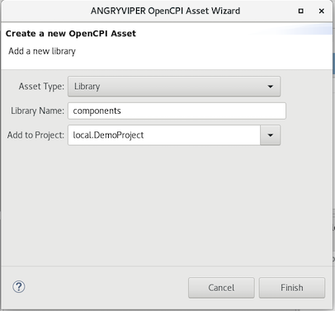
- The components library is displayed in the Project view and the Project Explorer view. Use either view to examine the directories and files created. You should see something like this (the files of interest are circled in red and described below):
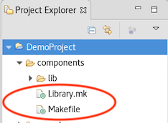
To create the components library with ocpidev, in DemoProjects, run the command:
ocpidev create library components
Run the tree command on DemoProject again to observe the directory structure and files that have been created:
DemoProject
|-- components
| |-- lib
| | |-- package-id
| | ‘-- workers
| |-- Library.mk
| ‘-- Makefile
|-- exports
| |-- imports -> ../imports
| ‘-- project-package-id
|-- imports -> /opt/opencpi/project-registry
|-- Makefile
|-- Project.exports
|-- Project.mk
‘-- project.xml
Notice the components directory and the Library.mk and Makefile files underneath it. These files are analogous to the project’s Makefile and *.mk file and don’t need to be changed in this tutorial.
The output highlighted in red indicates directories and files that are internal to the OpenCPI framework and should not be touched.

Create Components
A component is a defined function that has properties and ports. Properties configure and control the component. Ports are where data messages are sent and received. Ports support protocols, which define the allowed/expected messages.
A component is specified in a small XML document called a component spec (acronym OCS). A component spec defines its properties and ports and may refer to protocol specs (acronym OPS) that are common to different components.
The component spec is the basis for all of a component’s implementations. Each component spec includes the details that are to be consistent across authoring models; meaning that if there are various implementations of a single component – for example, a software (RCC) implementation and an FPGA (HDL) implementation – both implementations will expect the same input and both should have the same output regardless of which architecture they run on.
Creating a component spec is the first step in having a component implementation built and ready for use in an application. In this section, we’ll generate the component specs for the ramp, square and ander components and then edit them to define each component’s properties and ports.

Create Component Specs
Our application requires three components, so we need to generate three component specs.
To create the three template specs with AV:
- In the OpenCPI Projects panel, click on the components library. Right click and then select New component.
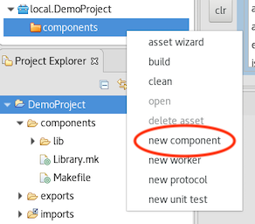
- The asset creation dialog for a component appears.
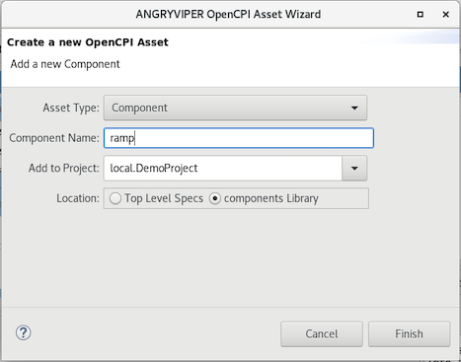
- In Component Name, enter ramp.
- Leave the other fields blank so that AV uses the default values.
- Click Finish. You should see a specs subdirectory in the components directory displayed in the Project Explorer and the ramp’s component spec file ramp-spec.xml file displayed in the OCS Editor in the text editor panel.
- Repeat these steps for the square and ander components.
- Use the Project Explorer or OpenCPI Projects view to expand the specs directory. You should see the three component specs you just created.
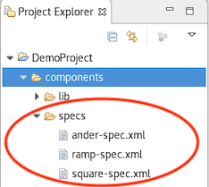
- The OCS Editor should have three tabs open, one for each spec file. Click a component spec tab and then click the Source tab at the bottom of the window to display the initial XML code for the component. Repeat this step for the other components.
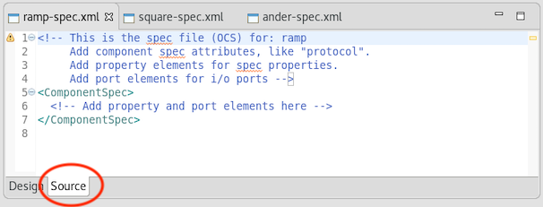
To create the three template specs with ocpidev, use the following commands:
ocpidev create component ramp
ocpidev create component square
ocpidev create component ander
Now use the tree command again to observe the directory structure and files created:
DemoProject
|-- components
| |-- lib
| |-- ander-spec.xml -> ../specs/ander-spec.xml
| |-- package-id
| |-- ramp-spec.xml -> ../specs/ramp-spec.xml
| |-- square-spec.xml -> ../specs/square-spec.xml
| ‘-- workers
| |-- Library.mk
| |-- Makefile
| ‘-- specs
| |-- ander-spec.xml
| |-- ramp-spec.xml
| ‘-- square-spec.xml
|-- exports
| |-- imports -> ../imports
| ‘-- project-package-id
|-- imports -> /opt/opencpi/project-registry
|-- Makefile
|-- Project.exports
|-- Project.mk
‘-- .project
The components directory now contains a specs subdirectory that contains the three generated component spec templates (aka the OCS files). You can easily identify them by the -spec.xml suffix that appears after the component name. We’ll edit these template files in the next step.
The output highlighted in red indicates directories and files that are internal to the OpenCPI framework and should not be touched.

Define Component Ports
Now we need to edit each component spec to define its properties and ports.
Our simple components don’t require any runtime configuration or control values for their worker implementations, so we don’t need to define any properties for them.
They do, however, need port definitions, because each component will communicate with other components when they are used in our application. Each component port must define the direction – input or output, consumer or producer – and the format – the protocol – of the messages they will send or receive. For our components, we will use the rstream protocol for all component ports except for the ander component’s output port, which will use the iqstream protocol. The difference between the two is that rstream is a stream of 16-bit "real" numbers, while iqstream is a stream of complex numbers, each of which is represented by a 16-bit I ("in-phase") value and a 16-bit Q ("quadrature") value.
To define the ports using the AV OCS Design Editor:
- Click the ramp-spec.xml tab and then click the Design tab. In Outline, click Ports and then click Add a Port.
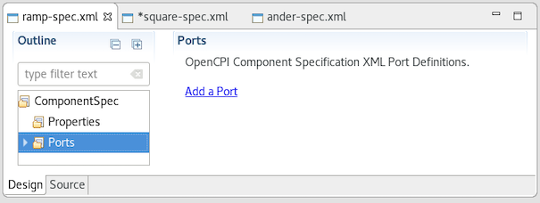
- The OCS Port Definition dialog is displayed. In Name, enter in. In Protocol, select rstream_protocol from the drop-down list.
- Click Ports > Add a Port again. In Name, enter out. In Protocol, select rstream_protocol from the drop-down list. Check Producer.
- Now click the Source tab. You can see the two ports defined in XML.
- Click the square-spec.xml tab and then click the Design tab. In Outline, click Ports and then click Add a Port.
- In Name, enter out. In Protocol, select rstream_protocol. Check Producer.
- Click the ander-spec.xml tab and then click the Design tab. In Outline, click Ports and then click Add a Port. In Name, enter in1. In Protocol, select rstream_protocol.
- Click Ports > Add a Port again. In Name, enter in2. In Protocol, select rstream_protocol from the drop-down list.
- Click Ports > Add a Port again. In Name, enter out. In Protocol, select iqstream_protocol from the drop-down list. Check Producer.
- Click Save All (the floppy disk icon) in the tool bar menu.
To define the ports inline in the XML, edit each component spec with a text editor as follows:
- For the ramp component (ramp-spec.xml in the specs subdirectory), insert the following XML snippet between the ComponentSpec XML tags in the template file:
<Port Name="in" Producer="false" Protocol="rstream_protocol.xml"/>
<Port Name="out" Producer="true" Protocol="rstream_protocol.xml"/>
Here, you’re declaring an input port (consumer) that uses the rstream protocol (defined by the rstream_protocol.xml OPS, which is an asset in the OpenCPI core project) and an output port (producer) that also uses the rstream protocol.
- For the square component (square-spec.xml in the specs subdirectory), insert the following XML snippet between the ComponentSpec XML tags in the template file:
<Port Name="out" Producer="true" Protocol="rstream_protocol.xml"/>
Here, you’re declaring an output port that uses the rstream protocol.
- For the ander component (ander-spec.xml in the specs subdirectory), insert the following XML snippet between the ComponentSpec XML tags in the template file:
<Port Name="in1" Producer="false" Protocol="rstream_protocol.xml"/>
<Port Name="in2" Producer="false" Protocol="rstream_protocol.xml"/>
<Port Name="out" Producer="true" Protocol="iqstream_protocol.xml"/>
Here, you’re declaring two input ports that use the rstream protocol and one output port that uses the iqstream protocol (defined by the iqstream_protocol.xml OPS, which is an asset in the OpenCPI core project).

Create Workers
Now that we’ve defined the component specs, we need to create the workers that implement them. A worker is a specific implementation of a component. More than one worker can implement a component.
Our example application uses only one implementation – one worker – per component. Right now, the authoring model we’re using for each worker is HDL, so each worker is an HDL worker. (We’ll create RCC versions of these same workers later on.) More details about HDL workers and how to develop them can be found in the OpenCPI HDL Development Guide.

Create HDL Workers
When we create a worker, we need to specify an authoring model to tell the OpenCPI framework what type of worker we want to create. In this step, we want to create HDL workers for our components so that we can run them on the xsim FPGA simulator platform.
To create the HDL workers with AV:
- In the OpenCPI Projects view, expand local.DemoProject and then navigate to components > specs.
- Select ramp-spec.xml. Right click and then select new worker from the context menu.
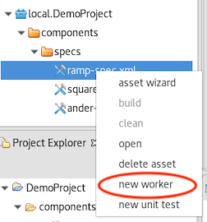
- The asset creation dialog for a worker appears.
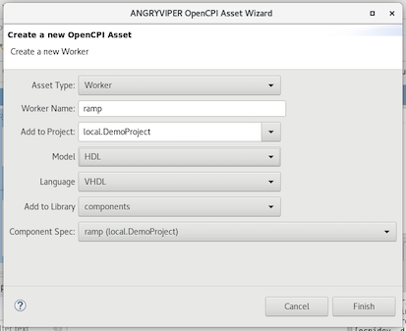
- In Worker Name, enter ramp. In Model, select HDL from the drop-down list. In the other fields, leave the displayed values as they are. Click Finish.
- In the OpenCPI Projects view, select square-spec.xml. Right-click and select new worker. In Worker Name, enter square. In Model, select HDL. Leave the other fields are they are and click Finish.
- In the OpenCPI Projects view, select ander-spec.xml. Right-click and select new worker. In Worker Name, enter ander. In Model, select HDL. Leave the other fields are they are and click Finish.
- The new workers are displayed in the OpenCPI Projects view and the Project Explorer view. In the text editor panel, notice that an OWD Editor is open for each new worker.
- Click on the Source tab for a worker to view its XML. Notice the HdlWorker XML definition elements with the VHDL language defined and a reference to the component spec. You’ll need to replace all of this XML with the XML given for each worker in the next step. After you do this, click Refresh to synchronize the file system project with the AV project.
To create the HDL workers with ocpidev, use the commands:
ocpidev create worker ramp.hdl
ocpidev create worker square.hdl
ocpidev create worker ander.hdl
Adding the suffix .hdl to the name of the worker in each ocpidev command line directs the tool to generate HDL workers.
Now run the command:
ocpidev show workers
The command displays all workers that reside in all libraries of all projects. The HDL workers you just created should be listed at the end of the output.
To view the directories and files created, run the tree command. The project should now look similar to this output:
DemoProject/
|-- components
| |-- ander.hdl
| | |-- ander.vhd
| | |-- ander.xml
| | |-- gen
| | | |-- ander-build.xml
| | | |-- ander-defs.vhd
| | | |-- ander-defs.vhd.deps
| | | |-- ander-impl.vhd
| | | |-- ander-impl.vhd.deps
| | | |-- ander.mk
| | | |-- ander-skel.vhd
| | | ‘-- ander-skel.vhd.deps
| | |‘-- Makefile
| | |-- lib
| | |-- ...
| | |‘-- workers
...
| |-- ramp.hdl
| | |-- gen
| | | |-- ramp-build.xml
| | | |-- ramp-defs.vhd
| | | |-- ramp-defs.vhd.deps
| | | |-- ramp-impl.vhd
| | | |-- ramp-impl.vhd.deps
| | | |-- ramp.mk
| | | |-- ramp-skel.vhd
| | | ‘-- ramp-skel.vhd.deps
| | |-- Makefile
| | |-- ramp.vhd
| | ‘-- ramp.xml
| |-- specs
| | |--ander-spec.xml
| | |--ramp-spec.xml
| | |--square-spec.xml
| ‘-- square.hdl
| | |-- gen
| | | |-- square-build.xml
| | | |-- square-defs.vhd
| | | |-- square-defs.vhd.deps
| | | |-- square-impl.vhd
| | | |-- square-impl.vhd.deps
| | | |-- square.mk
| | | |-- square-skel.vhd
| | | ‘-- square-skel.vhd.deps
| |-- Makefile
| |-- square.vhd
| ‘-- square.xml
...
Notice that creating the ramp, square, and ander HDL workers generated an .hdl directory for each one. Each worker’s .hdl directory contains two files of interest:
- <worker_name>.xml. This is the worker’s OpenCPI Worker Description (OWD). The OWD is where that worker’s specific properties and port protocols are defined. The definitions in the OWD are specific to each individual worker and may override some of the definitions specified in the OCS. Later on, we’ll edit the OWD for each worker.
- <worker_name>.vhd. This is the worker’s initial source code file, in the language associated with the authoring model specified when creating the worker; in our case, in the VHDL language because we specified an HDL worker. This file is a “skeleton” that can be compiled but has empty logic; it allows the worker to be test-built before any changes are made. We’ll edit the skeleton file for each worker later on to add the VHDL logic that makes the worker perform its intended function.
The gen subdirectory in <worker>.hdl contains code that is generated from the OpenCPI framework. Do not edit this code. For more details about the gen directory, see the OpenCPI Component Development Guide.

Update HDL Worker Descriptions (OWDs)
Now we’ll update each worker OWD files to provide any necessary implementation-specific information for the ports that the component spec defines abstractly. For our example workers, we need to add the following information to each OWD:
- The version of the HDL worker API in use. OpenCPI currently requires all new workers to be written in Version 2 HDL, so we need to specify version 2 in the worker OWDs. We’ll use the version attribute of the HDL worker to specify the version.
- The physical width of data ports for each worker. The protocol specified in the component OCS for the component ports (in our case, rstream) defines a default data width; we want to override this OCS default in our worker ports. We’ll use the DataWidth attribute of the StreamInterface element to specify each port’s data width. Specifying it this way means that the DataWidth value applies only to that port.
- Whether or not the end of message (EOM) signal in a worker’s output ports will be automatically asserted as necessary or asserted explicitly by the worker. We want to use the automatic assertion method for our worker output ports using the InsertEOM attribute of the StreamInterface element for each output port.
To update the worker OWD files with the AV OWD Source Editor, click on the Source tab for a worker and then replace the XML displayed in the tab with the XML described for each worker below. (The OWD Design Editor does not currently support creating Version 2 HDL workers.)
To update the worker OWD files from the command line, navigate to each worker’s OWD XML file. Open it with a text editor and make the following updates:
- For the ramp worker, replace the worker OWD in components/ramp.hdl/ramp.xml with this XML:
<HdlWorker language="vhdl" spec="ramp-spec" version="2">
<StreamInterface Name="in" DataWidth="16"/>
<StreamInterface Name="out" DataWidth="16" InsertEOM="true"/>
</HdlWorker>
- For the square worker, replace the worker OWD in components/square.hdl/square.xml with this XML:
<HdlWorker language="vhdl" spec="square-spec" version="2">
<StreamInterface Name="out" DataWidth="16" InsertEOM="true"/>
</HdlWorker>
- For the ander worker, replace the worker OWD in components/ander.hdl/ander.xml with this XML:
<HdlWorker language="vhdl" spec="ander-spec" version="2">
<StreamInterface Name="in1" DataWidth="16"/>
<StreamInterface Name="in2" DataWidth="16"/>
<StreamInterface Name="out" DataWidth="32" InsertEOM="true"/>
</HdlWorker>
You have now completed the worker OWDs for the ramp, square and ander workers.

Edit HDL Worker Skeleton Files
Now that you have defined the worker OWDs, the next step is to edit the VHDL skeleton files of each worker to add the VHDL code that implements that worker’s function.
If you’re using AV, you can use the Project Explorer to locate each worker skeleton file. Select it, then right-click and select Open to open it with a text editor.
Using a text editor, replace the VHDL architecture section in the ramp.vhd skeleton file in components/ramp.hdl/ramp.vhd with the following VHDL:
architecture rtl of worker is
signal do_work : bool_t;
signal out_data_i, buff_data : std_logic_vector(15 downto 0);
begin
-- When we are allowed to process data:
do_work <= out_in.ready and in_in.valid;
-- Outputs:
in_out.take <= do_work;
out_out.valid <= do_work;
out_data_i <= std_logic_vector(signed(in_in.data)
+ signed(buff_data));
out_out.data <= out_data_i;
-- Initialize or save off previous value when valid:
ramp : process(ctl_in.clk)
begin
if rising_edge(ctl_in.clk) then
if ctl_in.reset = '1' then
buff_data <= (others => '0');
elsif its(do_work) then
buff_data <= out_data_i;
end if;
end if;
end process ramp;
end rtl;
Replace the VHDL architecture section in the square.vhd skeleton file in components/square.hdl/square.vhd with the following VHDL:
architecture rtl of worker is
signal do_work : bool_t;
signal cnt : unsigned(7 downto 0);
begin
-- When we are allowed to process data:
do_work <= out_in.ready;
-- Outputs:
out_out.data <= (others => '1') when cnt < 32 else
(others => '0');
out_out.valid <= do_work;
-- Generate the square pulse's counter
square : process(ctl_in.clk)
begin
if rising_edge(ctl_in.clk) then
if ctl_in.reset = '1' then
cnt <= (others => '0');
elsif its(do_work) then -- advance when we are pushing
cnt <= cnt + 1;
if cnt = 63 then
cnt <= (others => '0'); end if;
end if;
end if;
end process square;
end rtl;
Replace the VHDL architecture section in the ander.vhd skeleton file in components/ander.hdl/ander.vhd with the following VHDL:
architecture rtl of worker is
signal do_work : bool_t;
begin
-- When we are allowed to process:
do_work <= out_in.ready and in1_in.valid and in2_in.valid;
-- Outputs:
in1_out.take <= do_work;
in2_out.take <= do_work;
out_out.valid <= do_work;
out_out.data(15 downto 0) <= in1_in.data and in2_in.data;
out_out.data(31 downto 16) <= in1_in.data;
end rtl;
You’ve now completed the HDL worker VHDL files.

Build HDL Workers
Now we need to compile the workers for the platform on which we want to run them; in our case, this is the xsim FPGA simulator. Workers are normally built as part of building an entire component library or as part of an entire project, although they can also be built separately. Since all of our workers reside in the components library, we’ll build this library for the xsim platform.
To build the components library and the workers in it with AV:
- In the OpenCPI Project view, select the components library.
- Click the > button in the Operations Panel to move the library to this panel.
- In HDL platforms, select xsim.
- Click Build.
To build the components library and the workers in it with the ocpidev command, from the DemoProject directory, run the command:
ocpidev build library components --hdl xsim
This command builds the three workers, which reside in the components library, for the xsim platform.
Note that HDL worker implementations for the OpenCPI file_read and file_write components already exist in the ocpi.core project and are already built for the xsim (and centos7) platforms as part of the OpenCPI installation process.

Create Assembly
Artifacts are binary executables compiled from one or more workers, built for a platform. OpenCPI applications require supporting artifacts in order to execute on platforms. We want our application to be able to execute on an FPGA (simulator) platform, so we need to transform the compiled/built HDL workers that implement the components that the application will use into artifacts that can be executed on an FPGA platform.
To do this, we’ll create an HDL assembly: a collection of connected HDL workers that are built into a complete FPGA configuration bitstream that acts as an artifact. The resulting bitstream is executed on an FPGA to implement a part or all of an application’s components. Although HDL assemblies are generally created with a particular application in mind, they can be designed for use by more than just one application.
More details about HDL assemblies and how to develop them can be found in the OpenCPI HDL Development Guide.

Create HDL Assembly
First, we’ll create the HDL assembly asset in DemoProject. We’ll name the HDL assembly demo_assembly.
To create the HDL assembly with AV:
- Place the cursor anywhere in the OpenCPI Projects panel. Right click and then select asset wizard.
- In the drop-down list, select the HDL Assembly asset type.
- In Assembly Name, enter demo_assembly.
- In Add to Project, leave DemoProject selected.
- Click Finish.
- When the process completes, the new assembly is displayed in both the OpenCPI Project view and the Project Explorer view. Use one of these views to observe the directories and files created. In the text editor panel, notice that an OpenCPI HDL Assembly Description (OHAD) Editor is open for the assembly. We’ll use this editor to update the HDL assembly description in the next step.
To create the HDL assembly with ocpidev, run the following command from the DemoProject directory:
ocpidev create hdl assembly demo_assembly
Run the tree command to view the directories and files created.
DemoProject/hdl/
|-- assemblies
| |-- demo_assembly
| | |-- demo_assembly.xml
| | ‘-- Makefile
| ‘-- Makefile
‘-- Makefile
Notice the hdl directory, an assemblies directory within it and a demo_assembly directory within the assemblies directory. Each HDL assembly is defined within its own directory. The demo_assembly directory contains two files of interest:
- demo_assembly.xml. This is the assembly’s OpenCPI HDL Assembly Description (OHAD). The OHAD is where the assembly’s HDL worker instances, property/parameter settings, connections and external ports are defined. We’ll edit this initial XML file next to specify the HDL workers to be included and the connections between them.
- Makefile. This is the assembly’s initial Makefile, similar to Makefiles of other assets. We won’t need to make any changes to this file.

Update HDL Assembly Description
Now we’ll update the initial HDL assembly description (OHAD) we just created to describe the worker instances and connections for our application’s use.
Most HDL assemblies describe a subset of the components (and thus HDL workers) that an application uses. We want to be able to run the processing components ramp, square and ander (and thus HDL workers) on the FPGA simulation platform. So, our HDL assembly specifies worker instances and connections for these workers, but not for file_read and file_write.
To update the assembly OHAD with the AV OHAD Source Editor, click on the Source tab for demo_assembly in the editor and then replace the XML displayed in the tab with the XML given below.
To update the assembly OHAD from the command line, navigate to the demo_assembly directory. Open demo_assembly.xml with a text editor and then replace the contents of the file with this XML:
<HdlAssembly>
<Instance Worker="ramp" externals='true'/>
<Instance Worker="square"/>
<Instance Worker="ander" externals='true'/>
<Connection>
<Port Instance="ramp" Name="out"/>
<Port Instance="ander" Name="in1"/>
</Connection>
<Connection>
<Port Instance="square" Name="out"/>
<Port Instance="ander" Name="in2"/>
</Connection>
</HdlAssembly>
Notice the use of the externals attribute in the ramp and ander worker instances. It means that any unconnected ports for the instance are made external to the assembly to whatever the application specifies. The OpenCPI Application Development Guide provides more information about this attribute.
The assembly OHAD is now complete. The next step is to generate an FPGA artifact for the xsim platform from the assembly OHAD.

Build HDL Assembly
In this step, we build the HDL assembly and create the FPGA artifact for the example application.
To build the HDL assembly with AV:
- In the OpenCPI Project view, select demo_assembly.
- In the Operations panel, click the > button to move demo_assembly into this panel.
- In HDL platforms, select xsim.
- Click Build.
To build the HDL assembly with ocpidev, run the following command:
ocpidev build hdl assembly demo_assembly --hdl-platform xsim
The build takes a couple of minutes to run. You can confirm that it succeeded by locating the *.bitz file in hdl/assemblies/demo_assembly/container-demo_assembly_xsim_base/target-xsim/.
The *.bitz file is the artifact file that is ready for loading and execution and can be used at runtime when executing the application on the FPGA platform.

Create Application
An OpenCPI application consists of an OpenCPI Application Specification (OAS), which is an XML file that specifies the components that should be instantiated (using some artifacts), how the resulting workers should be connected, and how they should be configured via their properties.
One of the easiest ways to create an OAS is to use the OpenCPI tool option to create a template OAS in an applications directory and then edit this initial XML file with our XML definitions. In our case, this option also creates the applications directory, since it doesn’t exist. The next sections describe these steps.

Create Template App XML (OAS)
We’ll use the name DemoApp for our application.
To generate the initial OAS with AV:
- Place the cursor anywhere in the OpenCPI Projects panel. Right click and then select asset wizard.
- In the drop-down list, select the Application asset type.
- In Application Name, enter DemoApp.
- Check XML Only App.
- Click Finish.
- When the process completes, the new application asset DemoApp is displayed in both the OpenCPI Project view and the Project Explorer view. The initial OAS is displayed in the OAS Editor in the text editor panel.
- Use the Project view or the Project Explorer view to observe the directories and files created.
To generate the initial OAS with ocpidev, run the following command from the DemoProject directory:
ocpidev -X create application DemoApp
Now run the tree command to view the created directories and files.
DemoProject
|-- applications
| |-- DemoApp.xml
| ‘-- Makefile
...
Notice that this command has generated the applications directory as well as the initial OAS file DemoApp.xml.

Update Template App XML (OAS)
Now we’ll edit DemoApp.xml with the necessary XML definitions. We need to supply the following values:
- The names of the component instances (Instance Component=) and their connections (the full Port Instance = definition in the Connections element or the Connect= shorthand in the component instance element, similar to the HDL assembly definition).
- For the file_read and file_write component instances, the values of the fileName property for each component. The fileName property specifies the file read by the file_read component for input data into the application (in our case, input_file.bin) and where the file_write component will write the output data out of the application (in our case, output_file.bin).
- The package ID for our project. The package= attribute tells the OpenCPI framework where to find the component specifications for the component instances in the application. We’ll specify our project (local.DemoProject) in this attribute to identify where ramp, square and ander are located, but we’ll also explicitly give the package ID (ocpi.core) for the file_read and file_read components.
- The component instance to be used to determine when the application is finished executing (done=). When the indicated instance is “done”, then the whole application is considered “done”. We’ll declare the application to be finished executing when the file_write component is finished executing.
To update the initial OAS with the AV OAS Source Editor, click on the Source tab for demo_assembly in the editor and then replace the XML displayed in the tab with the XML given below.
To update the initial OAS from the command line, navigate to the applications directory. Open applications/DemoApp.xml with a text editor and replace the contents with this XML:
<Application package='local.demoProject' done='file_write'>
<Instance Component="ocpi.core.file_read" Connect="ramp">
<Property Name="fileName" Value="input_file.bin"/>
</Instance>
<Instance Component="ramp"/>
<Instance Component="square"/>
<Instance Component="ander"
Connect="file_write"/>
<Instance Component="ocpi.core.file_write">
<Property Name="fileName" Value="output_file.bin"/>
</Instance>
<Connection>
<Port Instance="ramp" Name="out"/>
<Port Instance="ander" Name="in1"/>
</Connection>
<Connection>
<Port Instance="square" Name="out"/>
<Port Instance="ander" Name="in2"/>
</Connection>
</Application>
We have now created the application. Now we need to generate data to drive it. This task is described in the next section.

Generate Input Data
The OpenCPI file_read component will search for input_file.bin to drive the application. For this example, we’ll use a simple Python script to generate the expected input.
Create a file generate_input.py in the applications directory and insert the following Python code into the file:
#!/usr/bin/env python3
import numpy as np
import sys

# verify input arg count
if len(sys.argv) < 4:
print("Usage expected:\n\t"+sys.argv[0]+" filename val len\n")
sys.exit(1)

# create array of length "len" filled with "val"
data = np.empty(int(sys.argv[3]), dtype=np.int16)
data.fill(sys.argv[2])
# write data to output file
data.tofile(sys.argv[1])
To generate the expected input, run the following command from the applications directory:
python generate_input.py input_file.bin 128 2000
The first argument to the script is the output file. The second argument is the value by which the ramp accumulates. The last argument is simply the number of values written to the file. This means the ramp will end up accumulating 128 (or 0x80) 2,000 times.

Set Artifact Library Path and Run Simulation
Executing an application on a given platform requires the following items:
- The application itself, defined in an XML file that describes a collection of components. We supplied this item when we created the DemoApp OAS.
- Artifact libraries that consist of (binary/executable) artifacts compiled from workers that implement requested components. We supplied this item when we created the demo_assembly HDL assembly.
- Runtime environments called containers that can load and run the artifacts (and thus workers) needed by the application. This item is supplied with the OpenCPI installation, which provides an OpenCPI container for the xsim platform.
Now we need to:
- Point the OpenCPI framework to the application’s artifacts with the OCPI_LIBRARY_PATH environment variable
- Run the application with the ocpirun command
The next sections describe these steps.

Export OCPI_LIBRARY_PATH
The last step before running the application is to set the OCPI_LIBRARY_PATH environment variable. To run an application, the OpenCPI framework must know where to look for the built worker and/or assembly artifacts. This is the function of the OCPI_LIBRARY_PATH environment variable. All artifacts in a project are found in the artifacts subdirectory of the project. We need to set OCPI_LIBRARY_PATH to look in our new project and in the ocpi.core project.
To set OCPI_LIBRARY_PATH to find the artifacts that DemoApp needs, enter the following export command in a terminal/shell window:
export OCPI_LIBRARY_PATH=artifacts:$OCPI_CDK_DIR/../projects/core/exports/artifacts
For details on OCPI_LIBRARY_PATH usage, see the OpenCPI Application Development Guide.

Run Application
Now we’re ready to run the application. Execute the following command:
ocpirun -d applications/DemoApp
The application runs the simulation and then writes the output to the file output_file.bin.
For more details on ocpirun and running applications, see the OpenCPI Application Development Guide.

View Output Data
To observe the output generated by the application, we’ll use another Python script to demultiplex and plot the data. Create a file plot_output.py and then insert the following Python code into the file:
#!/usr/bin/env python2
import numpy as np
import matplotlib.pyplot as plt
import sys

# verify input args
if len(sys.argv) < 2:
print("Need data file name, ex:\n\t"+sys.argv[0]+" filename\n")
sys.exit(1)

# read data from input file
data=np.fromfile(sys.argv[1],dtype=np.int16)

# demultiplex data, odds to the upper 16-bits, evens to the
# lower 16-bits
upper16=data[1::2]
lower16=data[0::2]

# plot the upper 16-bits
plt.figure(1)
plt.plot(upper16)
plt.title("Output Data - Upper 16")
plt.grid()

# plot the lower 16-bits
plt.figure(2)
plt.plot(lower16)
plt.title("Output Data - Lower 16")
plt.grid()
plt.show()
To plot the generated output, run the following command from the odata directory:
python plot_output.py output_file.bin
The following figures show the upper and lower 16 bits of the ander output. The upper 16 bits are the output of ramp, passed through for display. The lower 16 bits are the result of “anding” this input with a square wave from square.
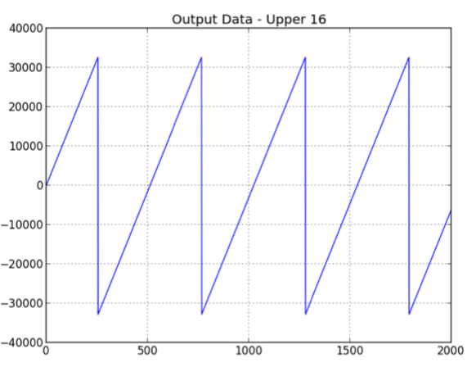
Figure 1: ramp Output (passed through by ander)
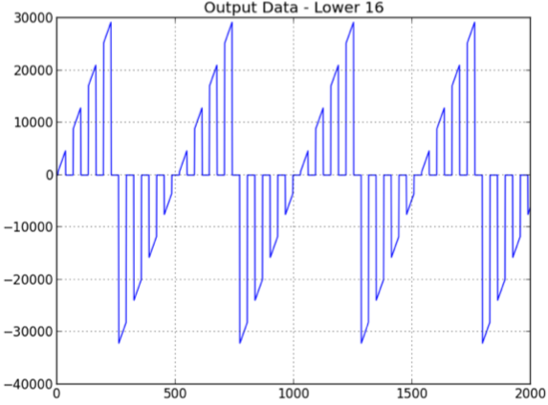
Figure 2: ander Output
For completeness, the last figure shows the output plot of the square component
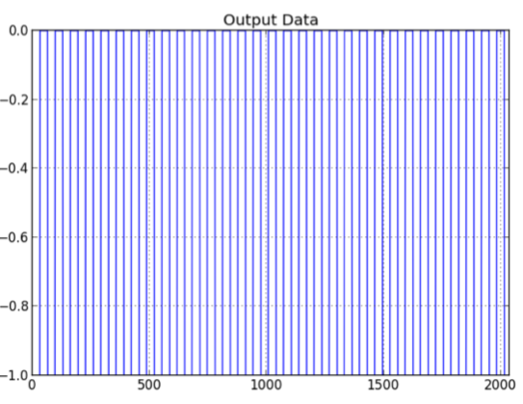
Figure 3: square Output = Input 2 to ander

