Tutorial 3: Creating a Peak Detector Worker
The goal of this tutorial is to design, build and test an RCC worker that implements the peak detector function, which reports signed min/max peaks and routes data/messages through the worker (pass-through).
Given an input of complex numbers, the peak detector component is meant to find the biggest I or Q sample and the smallest I or Q sample. The basic idea is:
- current_biggest = max(current_biggest,max(I,Q))
- current_smallest = min(current_smallest,min(I,Q))
- Pass input of complex numbers to the output ports
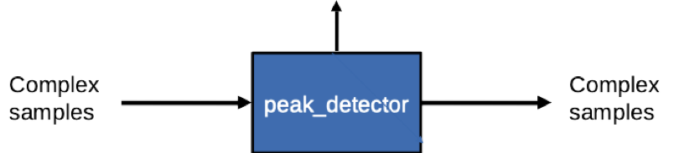

This tutorial shows you how to:
- Create the peak detector component, ports and properties.
- Create the peak detector worker and build it for the target platform (CentOS7 and xsim).
- Create, build and run the component unit test on CentOS7 and Xilinx Vivado 2017.1 simulator platform (xsim).
Before you begin this tutorial, we recommend that you read the following briefings:
- Briefing 4, “Component and Worker Overview”
- Briefing 5, “Automated Test Suite – Introduction”
- Briefing 6, “OpenCPI RCC Development”

Prerequisites
Before you begin this tutorial:
- Unregister and delete the tutorial-project you created in Tutorial 2. We will be making the same project with the same names.
- If you haven’t already done so, build the projects for CentOS 7 and the xsim simulator.

Step 1: Create New Project
In Eclipse, use the asset wizard to create a new tutorial-project with the following parameters:
- Asset type: Project
- Project name: tutorial-project
- Package prefix: ocpi
- Package name: tutorial-project
- Project dependencies: ocpi.assets
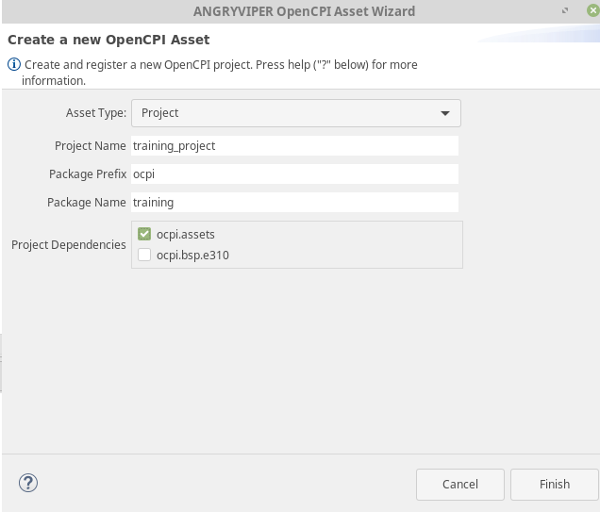

Step 2: Create scripts Directory and plotAandFft.py File
Create a directory called scripts in the training_project folder. Put a file called plotAandFft.py in it as shown below.

NOTE: Make sure that your scripts are executable by changing the settings in your terminal. Use the figure below for reference:
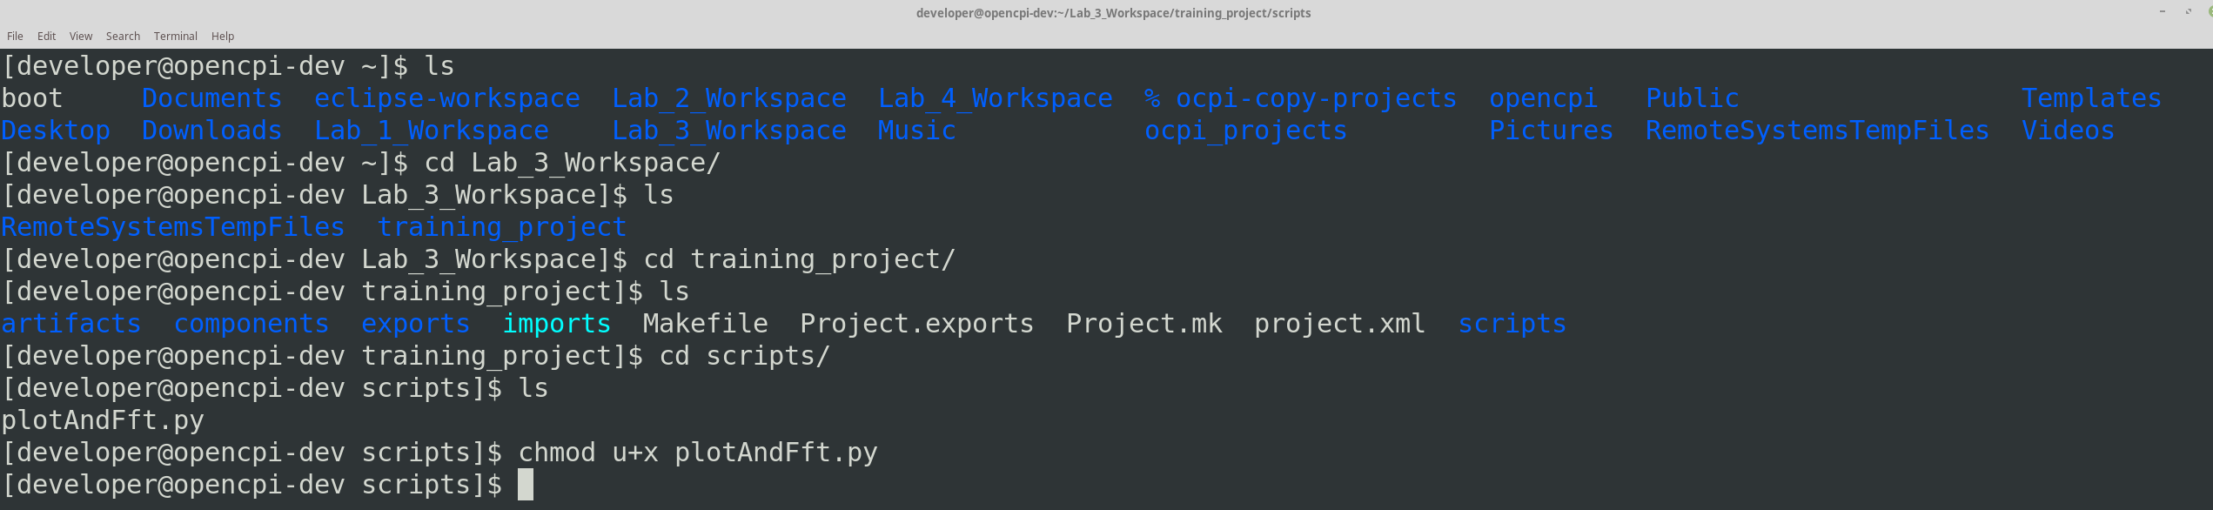

Step 3: Edit plotAndFft.py
Copy and paste the following text into plotAndFft.py:

#!/usr/bin/env python2

# This file is protected by Copyright. Please refer to the COPYRIGHT file

# distributed with this source distribution.

#

# This file is part of OpenCPI <http://www.opencpi.org>

#

# OpenCPI is free software: you can redistribute it and/or modify it under the

# terms of the GNU Lesser General Public License as published by the Free

# Software Foundation, either version 3 of the License, or (at your option) any

# later version.

#

# OpenCPI is distributed in the hope that it will be useful, but WITHOUT ANY

# WARRANTY; without even the implied warranty of MERCHANTABILITY or FITNESS FOR

# A PARTICULAR PURPOSE. See the GNU Lesser General Public License for more

# details.

#

# You should have received a copy of the GNU Lesser General Public License along

# with this program. If not, see <http://www.gnu.org/licenses/>.

import numpy as np

try:

import matplotlib.pyplot as plt

except (ImportError, RuntimeError):

print("******* Error: python matplotlib is unavailable or not installed")

sys.exit(1)

import sys

import os.path

import itertools

def main():

dataType = "real"

numSamples = -1

if len(sys.argv) < 2:

print("Exit: Enter input filename")

sys.exit(1)

elif len(sys.argv) < 3:

print("Exit: Enter data type: real or complex")

sys.exit(1)

elif len(sys.argv) < 4:

print("Exit: Enter number of samples")

sys.exit(1)

elif len(sys.argv) < 5:

print("Exit: Enter sample rate of input")

sys.exit(1)

elif len(sys.argv) > 6:

print("Exit: Wrong number of arguments")

sys.exit(1)

fig = plt.figure(1)

f = open(sys.argv[1], 'r')

dataType = sys.argv[2].lower()

numSamples = int(sys.argv[3])

sampleRate = float(sys.argv[4])

print "file is : " + f.name

print "data is : " + dataType

print "num samples is: " + str(numSamples)

print "sample rate is: " + str(sampleRate)

if dataType == "complex":

print "Input is complex data"

#I/Q pair in a 32-bit vector (31:0) is I(0) I(1) Q(0) Q(1) in bytes 0123 little-Endian

#Thus I is indexed at byte 0 and Q is indexed at byte 2

dt_iq_pair = np.dtype((np.uint32, {'real_idx':(np.int16,0), 'imag_idx':(np.int16,2)}))

data = np.fromfile(f, dtype=dt_iq_pair)

#Pull out I and Q and make lists for each

iList = data['real_idx']

qList = data['imag_idx']

iqList = []

iqList_mag = []

for a,data in enumerate(iList):

iqList.append(complex(int(iList[int(a)]),int(qList[int(a)])))

#Create time domain plot

fig = plt.figure(1)

ax1 = fig.add_subplot(2, 1, 1)

ax2 = fig.add_subplot(2, 1, 2)

ax1.plot(range(len(qList[0:numSamples])),iList[0:numSamples], c='r', label='I')

ax2.plot(range(len(qList[0:numSamples])),qList[0:numSamples], c='r', label='Q')

#Beautify plot

ax1.set_title('Time Domain Plot\n' + os.path.basename(f.name))

ax1.set_xlabel('Sample Index')

ax2.set_xlabel('Sample Index')

ax1.set_ylabel('Amplitude')

ax2.set_ylabel('Amplitude')

leg1 = ax1.legend()

leg2 = ax2.legend()

# sample spacing

T = 1.0 / sampleRate

#Generate FFT bins

xf = np.fft.fftfreq(numSamples, T)

xf = np.fft.fftshift(xf)

#Perform FFT

yf = np.fft.fft(iqList[0:numSamples])

yplot = np.fft.fftshift(yf)

yf_plot=1.0/numSamples * np.abs(yplot)

#Create FFT plot

fft_fig = plt.figure(2)

ax3 = fft_fig.add_subplot(1, 1, 1)

epsilon = pow(10, -10) #Error factor to avoid divide by zero in log10

ax3.plot(xf,20*np.log10(yf_plot+epsilon))

#Beautify plot

ax3.set_title(str(numSamples) + '-Point Complex FFT\n' + os.path.basename(f.name))

ax3.set_xlabel('Frequency (Hz)')

ax3.set_ylabel('Power (dBm)')

#ax3.set_ylim([-50, 150])

#Show plot

plt.grid()

plt.show()

print("End!")

else:

print "Input is real data"

data = np.fromfile(f, dtype=np.int16)

#Create time domain plot

fig = plt.figure(1)

ax1 = fig.add_subplot(1, 1, 1)

ax1.plot(data[0:numSamples], c='r', label='rData')

#Beautify plot

ax1.set_title('Time Domain Plot\n' + os.path.basename(f.name))

ax1.set_xlabel('Sample Index')

ax1.set_ylabel('Amplitude')

leg1 = ax1.legend()

# sample spacing

T = 1.0 / sampleRate

x = np.linspace(0.0, numSamples*T, numSamples)

#Generate FFT bins

xf = np.fft.fftfreq(numSamples, T)

xf = np.fft.fftshift(xf)

#Perform FFT

yf = np.fft.fft(data[0:numSamples])

yplot = np.fft.fftshift(yf)

yf_plot=1.0/numSamples * np.abs(yplot)

#Create FFT plot

fft_fig = plt.figure(2)

ax2 = fft_fig.add_subplot(1, 1, 1)

epsilon = pow(10, -10) #Error factor to avoid divide by zero in log10

ax2.plot(xf[xf.size/2:xf.size],20*np.log10(yf_plot[yf.size/2:yf.size]+epsilon))

#Beautify plot

ax2.set_title(str(numSamples) + '-Point Real FFT\n' + os.path.basename(f.name))

ax2.set_xlabel('Frequency (Hz)')

ax2.set_ylabel('Power (dBm)')

#ax2.set_ylim([-50, 150])

#Show plot

plt.grid()

plt.show()

print("End!")

if __name__ == '__main__':

main()

The following figure is an XML file of iqstream_protocol, which is located in the core project. We will reference this file in a component we are about to create.
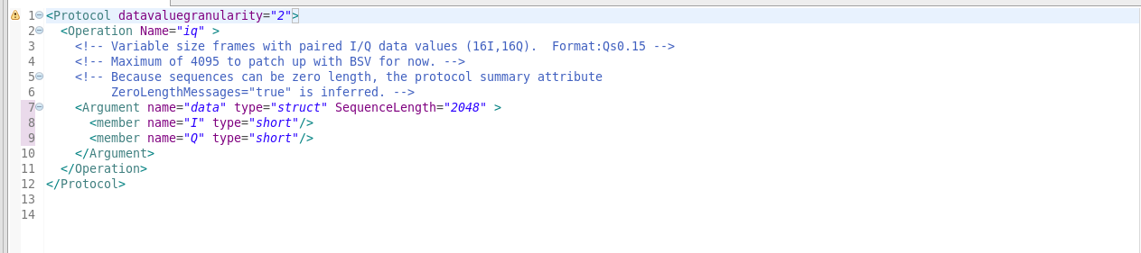

Step 4: Create peak_detector Component
Right-click on your tutorial-project and create a component called peak_detector with the following parameters:
- Asset Type: Component
- Component Name: peak_detector
- Add to project: tutorial-project
- Location: components library

Step 5: Create peak_detector Ports
Go into peak_detector-spec.xml and create the port in with the following values:
- Name: in
- Protocol: iqstream_protocol
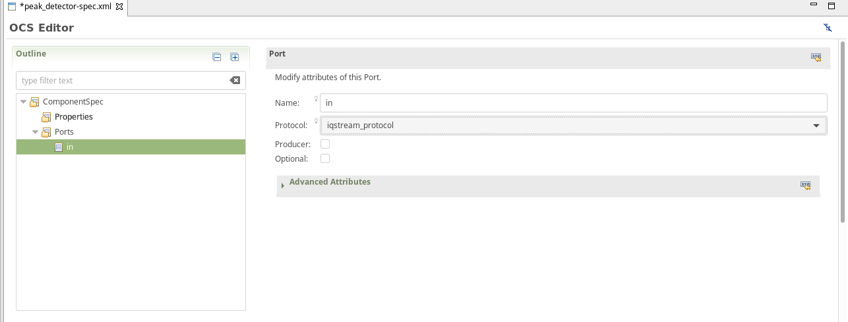
Create an out port, too with the following values:
- Name: out
- Protocol: iqstream_protocol
- Producer (check it)

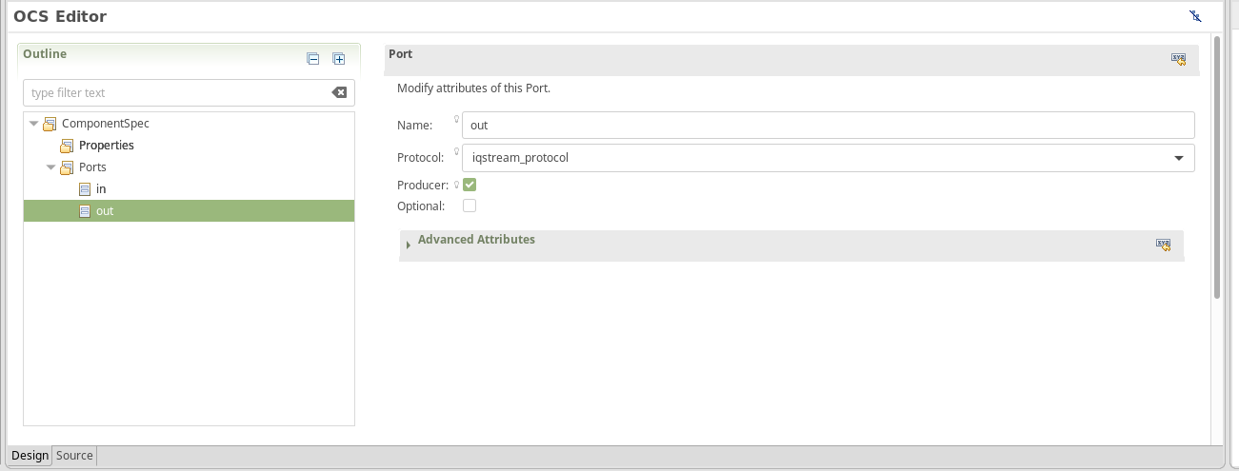

Step 6: Create max_peak Property
Create a property called max_peak with the following parameters:
- Name: max_peak
- Type: short
- Volatile: (check it)
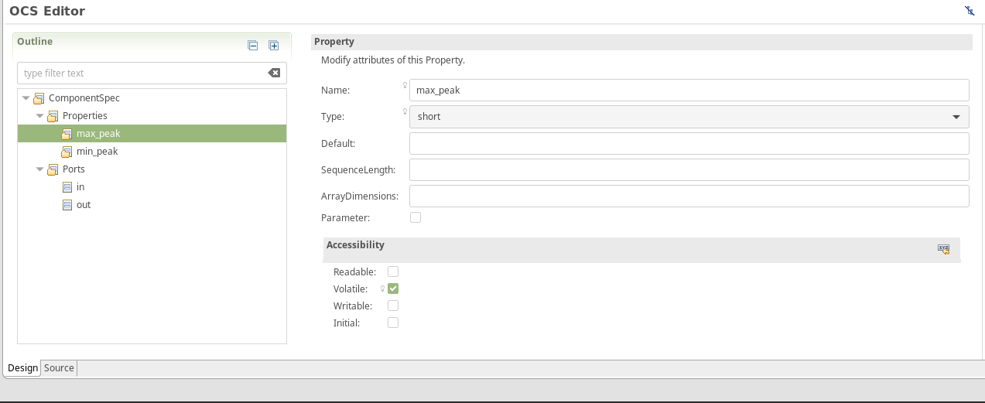
Create a property called min_peak with the following parameters:
- Name: min_peak
- Type: short
- Volatile: (check it)
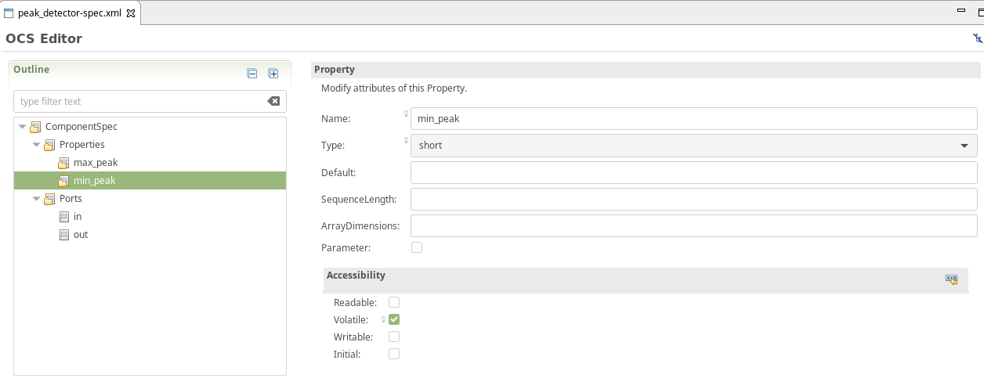

Step 7: Create peak_detector Worker
Create a new worker called peak_detector with the following parameters:
- Asset type: Worker
- Worker name: peak_detector
- Add to project: tutorial-project
- Add to library: components
- Component Spec: peak_detector (ocpi.tutorial-project)
- Model: RCC
- Language: C

Step 8: Build peak_detector.rcc Worker
Notice we have a peak_detector.rcc under our components directory. Build this RCC worker for CentOS 7.
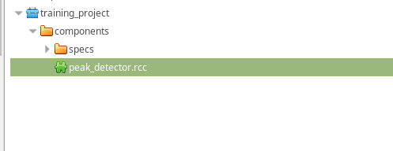

Step 9: Write the peak_detector Worker C++ Code
Use the file navigator to find the peak_detector.cc file. This is where we will be writing the C++ code for our worker.
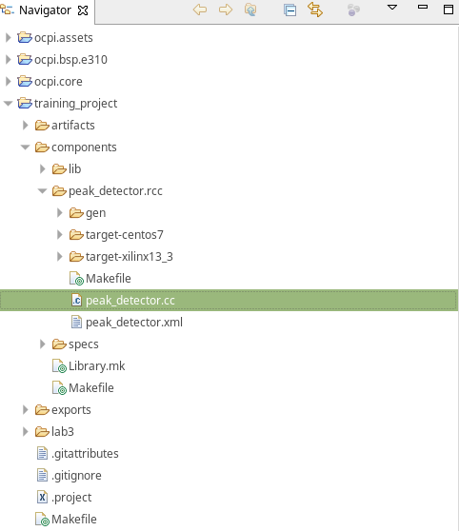
Copy and paste the code below into your peak_detector.cc file.

/*
* THIS FILE WAS ORIGINALLY GENERATED ON Wed Jul 31 13:11:53 2019 CDT
* BASED ON THE FILE: peak_detector.xml
* YOU *ARE* EXPECTED TO EDIT IT
*
* This file contains the implementation skeleton for the peak_detector worker in C++
*/

#include<algorithm>
#include "peak_detector-worker.hh"

using namespace OCPI::RCC; // for easy access to RCC data types and constants
using namespace Peak_detectorWorkerTypes;

class Peak_detectorWorker : public Peak_detectorWorkerBase
{

int16_t max_buff, min_buff;

RCCResult start()
{
max_buff = -32768; // initalize max to most neg
min_buff = 32767; // initalize min to most pos
return RCC_OK;
}

RCCResult run(bool /*timedout*/)
{
const size_t num_of_elements = in.iq().data().size();
out.iq().data().resize(num_of_elements);
out.setOpCode(in.opCode());

const IqstreamIqData *idata = in.iq().data().data();
IqstreamIqData *odata = out.iq().data().data();

for(unsigned n = num_of_elements; n; n--)
{
max_buff= std::max(std::max(idata->I,idata->Q),max_buff);
min_buff= std::max(std::min(idata->I,idata->Q),min_buff);
*odata++ = *idata++;
}

properties().max_peak = max_buff;
properties().min_peak = min_buff;
return num_of_elements ? RCC_ADVANCE : RCC_ADVANCE_DONE;

// change this as needed for this worker to do something useful
// return RCC_ADVANCE; when all inputs/outputs should be advanced each time "run" is called.
// return RCC_ADVANCE_DONE; when all inputs/outputs should be advanced, and there is nothing more to do.
// return RCC_DONE; when there is nothing more to do, and inputs/outputs do not need to be advanced.
}
};

PEAK_DETECTOR_START_INFO
// Insert any static info assignments here (memSize, memSizes, portInfo)
// e.g.: info.memSize = sizeof(MyMemoryStruct);
PEAK_DETECTOR_END_INFO

Step 10: Build the peak_detector RCC Worker
Build the RCC worker for CentOS 7.
You should have a target folder for CentOS 7 as follows:
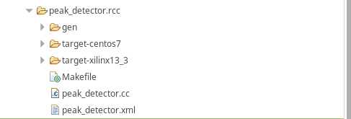

Step 11: Create Unit Test
Create a unit test with the following parameters:
- Asset type: Unit Test
- Add to Project: tutorial-project
- Add to Library: components
- Component Spec: peak_detector-spec.xml
You will have the following empty scripts:
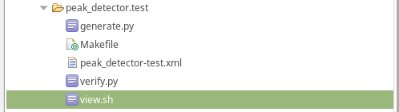

Step 12: Edit generate.py Script
Place the following text in the generate.py script from the unit test.

#!/usr/bin/env python

# This file is protected by Copyright. Please refer to the COPYRIGHT file

# distributed with this source distribution.

#

# This file is part of OpenCPI <http://www.opencpi.org>

#

# OpenCPI is free software: you can redistribute it and/or modify it under the

# terms of the GNU Lesser General Public License as published by the Free

# Software Foundation, either version 3 of the License, or (at your option) any

# later version.

#

# OpenCPI is distributed in the hope that it will be useful, but WITHOUT ANY

# WARRANTY; without even the implied warranty of MERCHANTABILITY or FITNESS FOR

# A PARTICULAR PURPOSE. See the GNU Lesser General Public License for more

# details.

#

# You should have received a copy of the GNU Lesser General Public License along

# with this program. If not, see <http://www.gnu.org/licenses/>.

"""Generate idata for Peak Detector (binary data file).

Generate args:

- amount to generate (number of complex signed 16-bit samples)

- target file

To test the Peak Detector, a binary data file is generated containing complex

signed 16-bit samples with a tone at 13 Hz. The input data is passed through

the worker, so the output file should be identical to the input file. The

worker measures the minimum and maximum amplitudes found within the complex

data stream. These values, reported as properties, are compared with min/max

calculations performed within the script.

"""

import struct

import shutil

import numpy as np

import sys

import os.path

class color:

PURPLE = '\033[95m'

CYAN = '\033[96m'

DARKCYAN = '\033[36m'

BLUE = '\033[94m'

GREEN = '\033[92m'

YELLOW = '\033[93m'

RED = '\033[91m'

BOLD = '\033[1m'

UNDERLINE = '\033[4m'

END = '\033[0m'

def generate(argv):

print "*** Generate input (binary data file) ***"

if len(argv) < 2:

print("Exit: Enter number of input samples (int:1 to ?)")

return

elif len(argv) < 3:

print("Exit: Enter an input filename")

return

filename = argv[2]

num_samples = int(argv[1])

#Create an input file with a single tone at 13 Hz; Fs=100 Hz

Tone13 = 13

Fs = 100

Ts = 1.0/float(Fs)

t = np.arange(0,num_samples*Ts,Ts,dtype=np.float)

real = np.cos(Tone13*2*np.pi*t)

imag = np.sin(Tone13*2*np.pi*t)

out_data = np.array(np.zeros(num_samples), dtype=np.dtype((np.uint32, {'real_idx':(np.int16,2), 'imag_idx':(np.int16,0)})))

#pick a gain at 95% max value - i.e. back off a little to avoid file

#generation overflow. This results in complex amplitudes that swing between

#+31k and -31k within an int16. We must use the same gain on both rails to

#avoid I/Q spectral image

gain = 32768*0.95 / max(abs(real))

out_data['real_idx'] = np.int16(real * gain)

out_data['imag_idx'] = np.int16(imag * gain)

#Save data file

f = open(filename, 'wb')

for i in xrange(0,num_samples):

f.write(out_data[i])

f.close()

print 'Output filename: ', filename

print 'Number of samples: ', num_samples

print '*** End of file generation ***\n'

def main():

print "\n","*"*80

print "*** Python: Peak Detector ***"

generate(sys.argv)

if __name__ == '__main__':

main()

Step 13: Edit verify.py Script
Place the following text in verify.py:
#!/usr/bin/env python

# This file is protected by Copyright. Please refer to the COPYRIGHT file

# distributed with this source distribution.

#

# This file is part of OpenCPI <http://www.opencpi.org>

#

# OpenCPI is free software: you can redistribute it and/or modify it under the

# terms of the GNU Lesser General Public License as published by the Free

# Software Foundation, either version 3 of the License, or (at your option) any

# later version.

#

# OpenCPI is distributed in the hope that it will be useful, but WITHOUT ANY

# WARRANTY; without even the implied warranty of MERCHANTABILITY or FITNESS FOR

# A PARTICULAR PURPOSE. See the GNU Lesser General Public License for more

# details.

#

# You should have received a copy of the GNU Lesser General Public License along

# with this program. If not, see <http://www.gnu.org/licenses/>.

"""Validate odata for Peak Detector (binary data file).

Validate args:

- amount to validate (number of complex signed 16-bit samples)

- target file

To test the Peak Detector, a binary data file is generated containing complex

signed 16-bit samples with a tone at 13 Hz. The input data is passed through

the worker, so the output file should be identical to the input file. The

worker measures the minimum and maximum amplitudes found within the complex

data stream. These values, reported as properties, are compared with min/max

calculations performed within the script.

"""

import struct

import shutil

import numpy as np

import sys

import os.path

import os

import re

class color:

PURPLE = '\033[95m'

CYAN = '\033[96m'

DARKCYAN = '\033[36m'

BLUE = '\033[94m'

GREEN = '\033[92m'

YELLOW = '\033[93m'

RED = '\033[91m'

BOLD = '\033[1m'

UNDERLINE = '\033[4m'

END = '\033[0m'

def validation(argv):

print "*** Validate output against expected data ***"

if len(argv) < 2:

print ("Exit: Need to know how many samples")

return

elif len(argv) < 3:

print("Exit: Enter an output filename")

return

num_samples = int(argv[1])

# strip off output extension and replace with 'log' ('.out.out'=>'.log')

logname = os.path.splitext(argv[2])[0]

logname = os.path.splitext(logname)[0] + ".log"

if not os.path.isfile(logname):

logname = os.path.splitext(logname)[0] + ".remote_log"

# Parse the logfile for the final values of max/min peaks

# Normally, we would access these via environment variables:

# OCPI_TEST_max_peak, OCPI_TEST_min_peak

# Due to an inconsistency in the unit test framework, the final values of

# these properties are captured correctly in the environment variables

# for RCC workers, but not HDL.

with open(logname, 'rb') as log:

for line in log:

max_obj = re.search("Property \d+: peak_detector.max_peak = \"(-?\d+)\".*", line)

if max_obj: #max_obj[1]:

max_peak = int(max_obj.group(1))

min_obj = re.search("Property \d+: peak_detector.min_peak = \"(-?\d+)\".*", line)

if min_obj: #[1]:

min_peak = int(min_obj.group(1))

if not min_peak or not max_peak:

print("Exit: log file does not contain max/min peak final values")

return

#Read all of input data file as complex int16

print 'File to validate: ', argv[2]

ofile = open(argv[2], 'rb')

dout = np.fromfile(ofile, dtype=np.dtype((np.uint32, {'real_idx':(np.int16,2), 'imag_idx':(np.int16,0)})), count=-1)

ofile.close()

#Ensure dout is not all zeros

if all(dout == 0):

print color.RED + color.BOLD + 'FAILED, values are all zero' + color.END

return

#Ensure that dout is the expected amount of data

if len(dout) != num_samples:

print color.RED + color.BOLD + 'FAILED, input file length is unexpected' + color.END

print color.RED + color.BOLD + 'Length dout = ', len(dout), 'while expected length is = ' + color.END, num_samples

return

# Calculate the maximum in python for verification

pymin = min(min(dout['real_idx']), min(dout['imag_idx']))

pymax = max(max(dout['real_idx']), max(dout['imag_idx']))

print 'uut_min_peak = ', min_peak

print 'uut_max_peak = ', max_peak

print 'file_min_peak = ', pymin

print 'file_max_peak = ', pymax

if (min_peak != pymin) or (max_peak != pymax):

print color.RED + color.BOLD + 'FAILED, min/max values do not match' + color.END

return

print 'Data matched expected results.'

print color.GREEN + color.BOLD + 'PASSED' + color.END

print '*** End validation ***\n'

def main():

print "\n","*"*80

print "*** Python: Peak Detector ***"

validation(sys.argv)

if __name__ == '__main__':

main()

Step 14: Edit view.sh Script
Copy and paste the following text into view.sh:

#!/bin/bash --noprofile

# This file is protected by Copyright. Please refer to the COPYRIGHT file

# distributed with this source distribution.

#

# This file is part of OpenCPI <http://www.opencpi.org>

#

# OpenCPI is free software: you can redistribute it and/or modify it under the

# terms of the GNU Lesser General Public License as published by the Free

# Software Foundation, either version 3 of the License, or (at your option) any

# later version.

#

# OpenCPI is distributed in the hope that it will be useful, but WITHOUT ANY

# WARRANTY; without even the implied warranty of MERCHANTABILITY or FITNESS FOR

# A PARTICULAR PURPOSE. See the GNU Lesser General Public License for more

# details.

#

# You should have received a copy of the GNU Lesser General Public License along

# with this program. If not, see <http://www.gnu.org/licenses/>.

# Use this script to view your input and output data.

# Args: <list-of-user-defined-args> <input-file> <output-file>

$OCPI_PROJECT_DIR/scripts/plotAndFft.py $2 complex 32768 100&

$OCPI_PROJECT_DIR/scripts/plotAndFft.py $1 complex 32768 100&

Step 15: Run Unit Test
Click on the unit test you just created. You will see the following dialog:
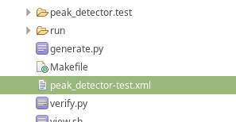
Click the highlighted blue add button in the inputs section. Create an input that has the following parameters:
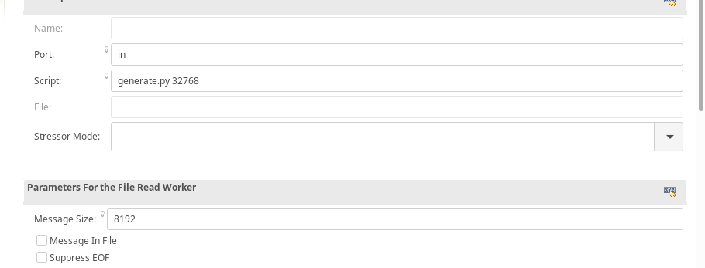
Click on the Outputs. You will see a dialog like this:
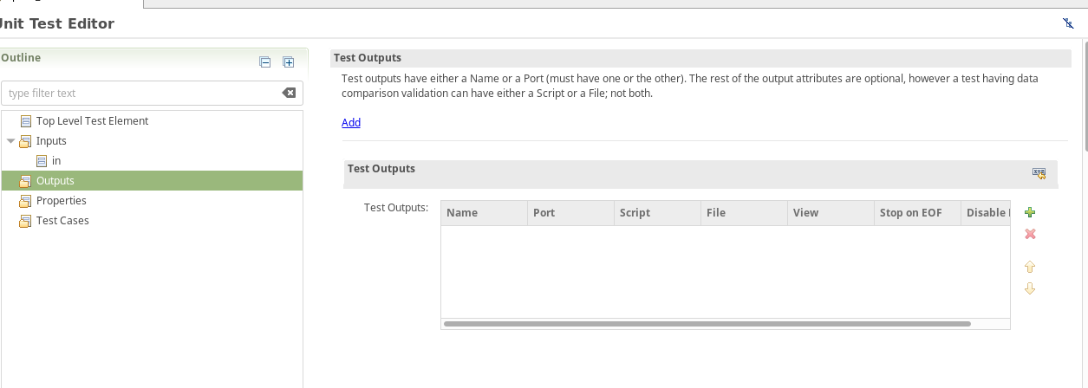

Enter view.sh for your output:
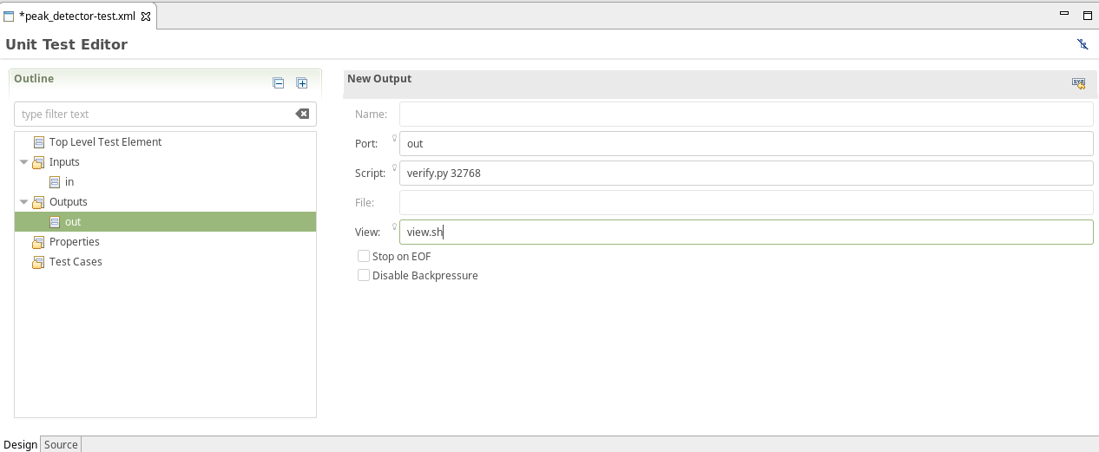
Click Tests:
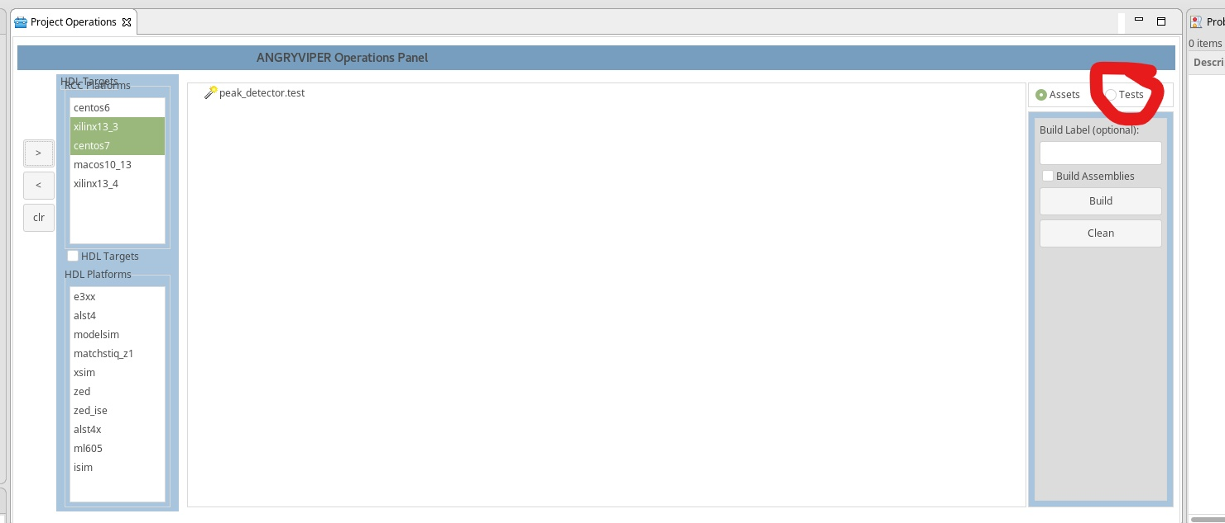
You should get a window like this:
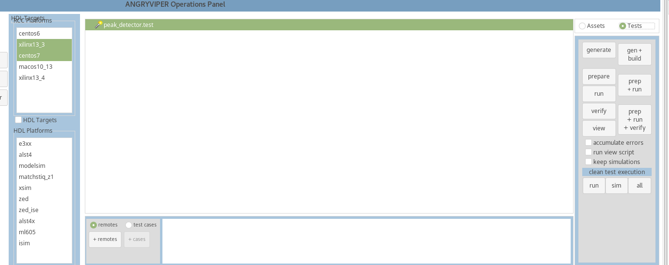

Click gen + build:
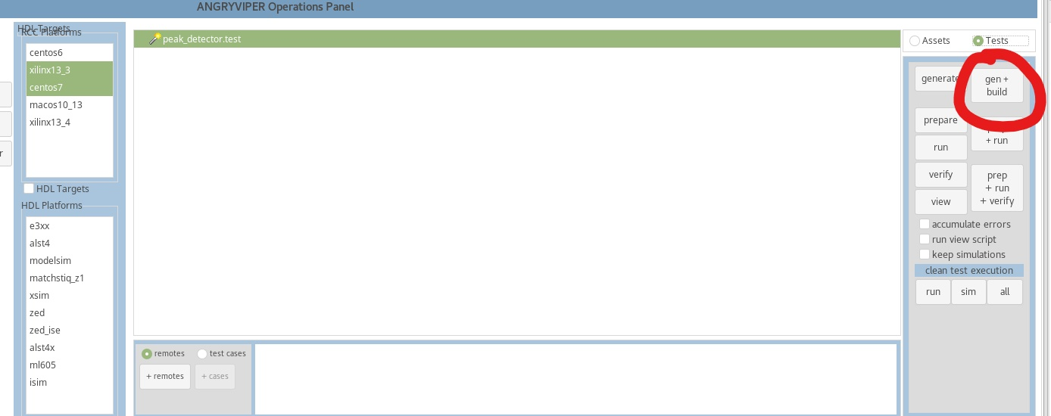

Click prep + run:
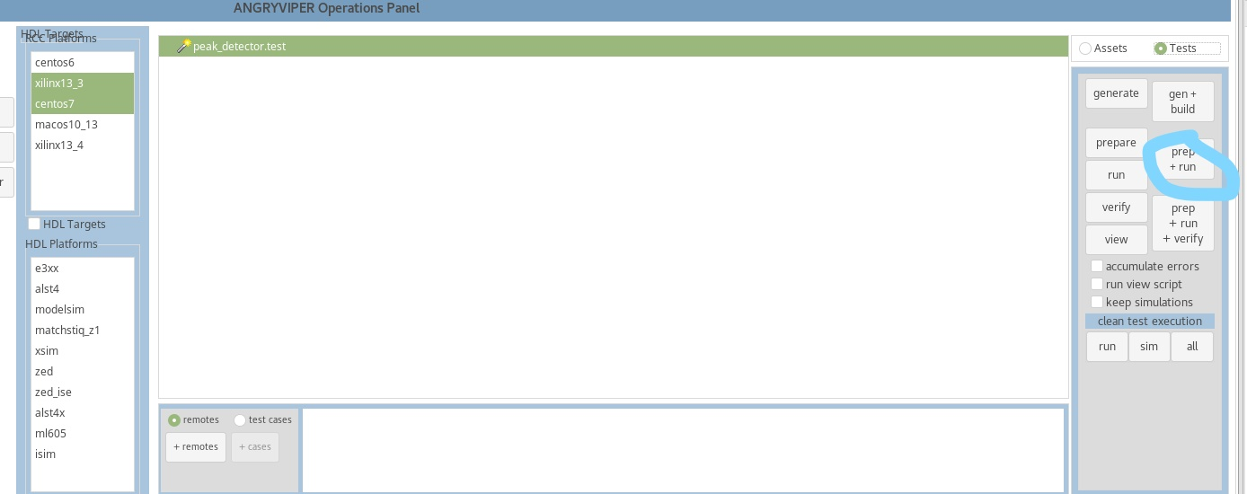

Click view:

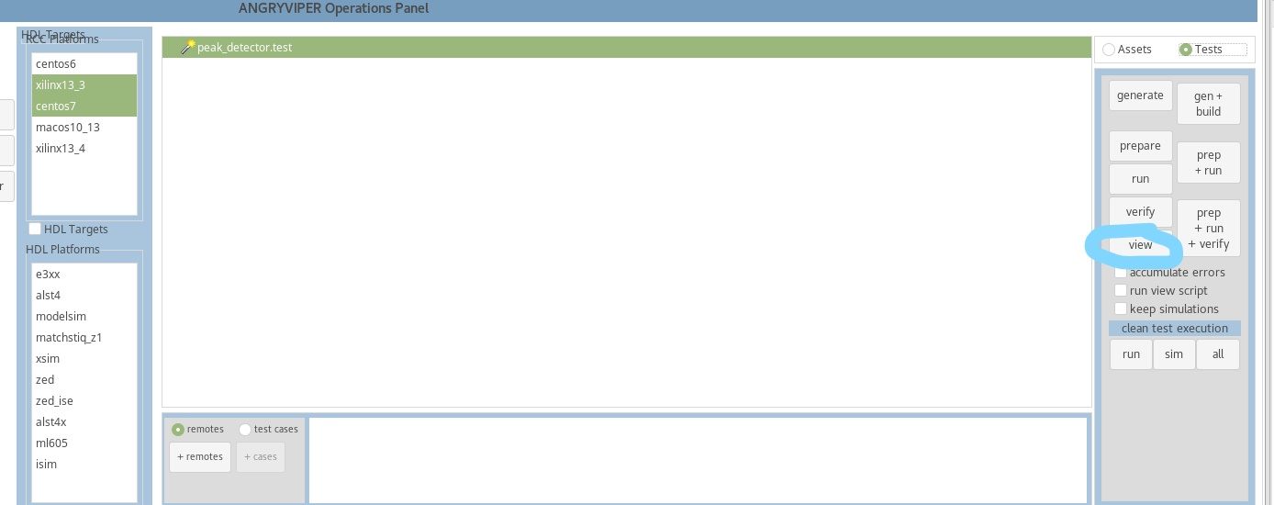

You should see this output:
