Tutorial: Using OpenCPI Debugging Tools
This guide briefly describes how to use the debugging tools provided with OpenCPI to:
- Collect HDL device/worker information: ocpihdl and ocpixml
- Review worker lifecycle
- Control worker state with ocpihdl
- Change and view worker properties
- Debug workers
Tutorial 9: Debugging an HDL Worker on a Hardware Platform provides an example of how to debug OpenCPI applications with OpenCPI debugging utilities.

Using ocpihdl
We can use ocpihdl to:
- Probe the xml of the currently loaded bitstream
- Display currently loaded workers
- View/change worker status
- Set/change worker properties
- Reset workers
- Step through an application
When run without options, ocpihdl prints out all of its uses.

Finding the Available HDL Devices on a Target FGPA-based Platform
$ ocpihdl search
This command provides information for available HDL devices, including:
- Name
- Date of bitstream creation
- Platform
- Part
- UUID (Unique identifier of the bitstream)

Loading/Probing the Bitstream
To examine the XML packaged into any artifact (including bitstreams):
$ ocpixml get <.so or .bitz artifact filename>
To load a bitstream:
$ ocpihdl load <path to bitstream>
To examine the XML packaged into a currently loaded bitstream:
$ ocpihdl getxml <output-file>
$ ocpihdl getxml <output-file>
$ grep controlOperation <output-file>
- What controlOperations are implemented by each worker?
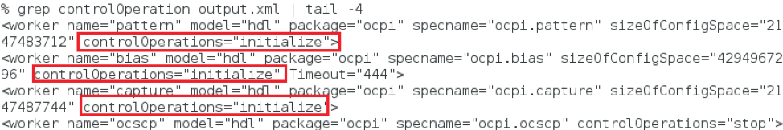
To remove the bitstream from the FPGA:
$ ocpihdl unload
This command is most commonly used when the system’s processor functions independently from the programmable logic.
CAUTION: Unloading an FPGA that implements a PCIe interface may result in the card being unusable and may require a system reboot.

Controlling Workers
The following figure shows the worker life cycle:
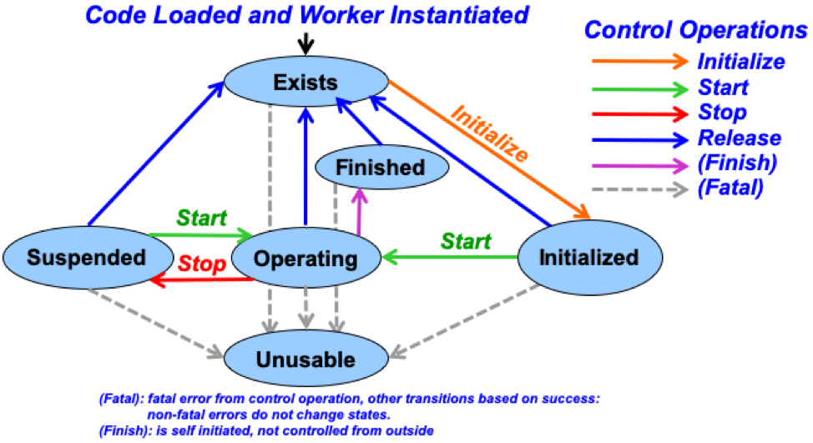
To find a worker index and other information, use:
$ ocpihdl get
You can specify <index/worker-name> (and even <property>) here.

To reset or unreset the control reset signal into workers, use”
$ ocpihdl wreset/wunreset <index>

To perform other control operations on workers, use”
$ ocpihdl wop <index> start/initialize/stop
To set worker properties, use:
$ ocpihdl set <index/worker-name> <property> <value>
To observe worker state, use:
$ ocpihdl status <index/worker-name>
Add the -v option to the command line to view worker properties.

Viewing Worker Information from the Bitstream
Use:
$ ocpihdl get
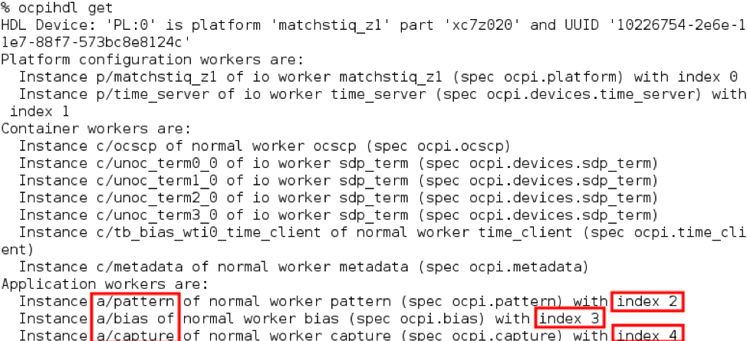
We can identify them by their indices.
If the worker is "RESET"
$ ocpihdl wunreset <index>
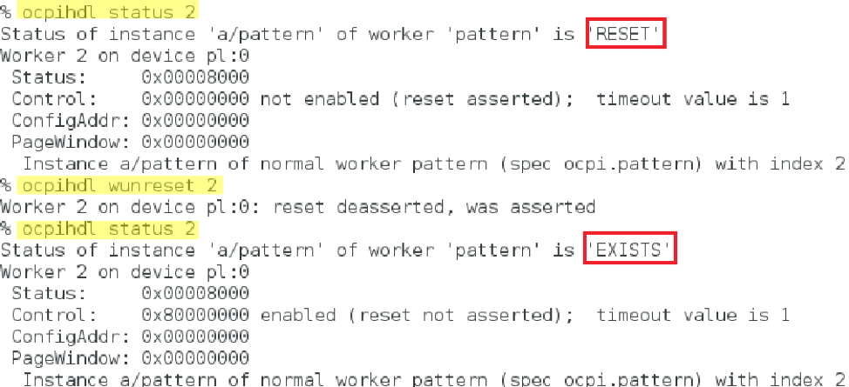
If the worker implements the "initialize" controlOperation:
$ ocpihdl wop <index> initialize
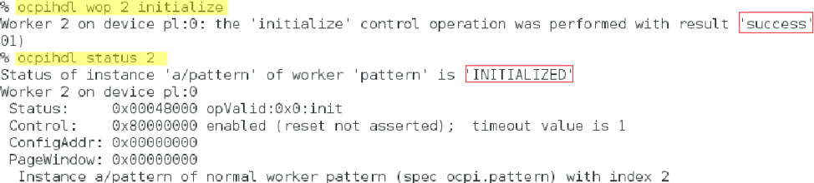
Ultimately, to bring the worker to "OPERATING":
$ ocpihdl wop <index> start
Writable worker properties can be changed:
$ ocpihdl set <index/worker-name> <property> <value>
Readable (the explicit flag, not the concept) / Volatile properties can be read:
$ ocpihdl status -v <index/worker-name>
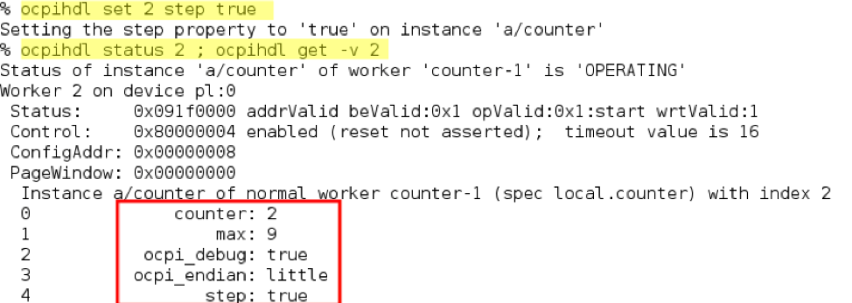

Debugging with ocpi_debug
There is a worker parameter that can enable debugging. Set this parameter to true in the OWD before building workers for debugging and add debugging functionality to worker the that depends on ocpi_debug.
In VHDL: "ocpi_debug":
In C++, "<WORKER_NAME>_OCPI_DEBUG":

Execution and Debug Utilities
- Log level:
export OCPI_LOG_LEVEL=8
ocpirun -l 8 (lowercase L)
OCPI_LOG_LEVEL=10 make tests
- "ocpirun -C" finds containers, including simulators.
- "ocpiview" is used to view simulation waveform results
- printf/cout
- ocpi_debug OWD parameter
- gdb

