
SOROTI UNIVERSITY
SCHOOL OF ENGINEERING AND TECHNOLOGY
DEPARTMENT OF ELECTRONICS AND COMPUTER ENGINEERING
SMART ENERGY METER: A PREDICTIVE EDGE-ML PLATFORM FOR REMOTE MULTI-TENANT PREPAID ELECTRICITY MONITORING
WSN2100 — WIRELESS SENSOR NETWORKS / IoT CAPSTONE PROJECT
Deliverable 2: Baseline and Functional Prototype
Submitted by
DAVIS TWINOMUGISHA
SARAH ASINGWIIRE
OPUCHE SAMSON
PHILLIP OKWANY
in partial fulfilment of the requirements for the degree of
BACHELOR OF ENGINEERING IN ELECTRONICS AND COMPUTER ENGINEERING
NOVEMBER 2026
TABLE OF CONTENTS
1 REVISED RESEARCH QUESTION AND SCOPE 1
2 HYPOTHESIS 1
3 DATASET AND PREPROCESSING 1
4 FEATURES AND BASELINES 2
5 ML MODELS AND MODEL SELECTION 2
6 EVALUATION METRICS 2
7 PRELIMINARY CONSUMPTION RESULTS 3
8 CONDITIONAL DEPLETION-WARNING EXPERIMENT 3
9 EDGE PREPARATION 4
10 IOT COMMUNICATION AND SOFTWARE INTERFACE 4
11 LIMITATIONS 5
12 REVISED EXPERIMENTAL PLAN 5
REFERENCES 5
1 REVISED RESEARCH QUESTION AND SCOPE
Can a compact model prepared for edge deployment reduce next-hour electricity-demand forecast error relative to a 24-hour consumption mean, and support conditional depletion warnings when a starting balance is independently known?
Scope: the first intended user is a landlord or caretaker managing a shared prepaid connection in Soroti; tenants are potential beneficiaries. Commercial demand and willingness to pay have not been validated. The minimum viable product is one aggregate consumption stream with an advisory warning; per-room billing, relays, GSM and a full property portal are deferred.
Response to Deliverable 1 feedback [4]: the public dataset holds measured consumption but no prepaid balances or depletion labels [1], so a “hours until balance reaches zero” model cannot be trained from it. The learned target is therefore next-hour energy in kWh. Hours remaining are calculated separately from an entered starting balance and the forecast consumption, assuming no top-ups. Account names and meter numbers do not supply a balance to this software.
Implemented in this deliverable: the data pipeline, three baselines, two ML model families, a frozen evaluation, portable C exports of the models, and an HTTP interface with a browser dashboard.
2 HYPOTHESIS
Fixed before model fitting. H₁: the validation-selected ML model reduces held-out next-hour MAE by at least 10% relative to the 24-hour mean. H₀: it does not reach that practical improvement. The threshold is a project criterion, not a claim of formal preregistration. Depletion warnings are a secondary, constructed-scenario analysis.
3 DATASET AND PREPROCESSING
The UCI Individual Household Electric Power Consumption archive [1] holds one-minute measurements from one household in Sceaux, France (December 2006 to November 2010). It is a software benchmark, not Ugandan rental data. Only date, time and minute-averaged Global_active_power (kW) are used.
Audit item | Observed count
Raw minute records | 2,075,259
Missing or invalid active-power entries | 25,979
Hourly bins / complete hours | 34,589 / 34,085
Incomplete hourly bins | 504
Eligible hourly feature/target rows | 32,449
Values imputed / duplicate timestamps | 0 / 0

The pipeline verifies the archive SHA-256, orders timestamps, rejects duplicates, and marks missing, non-numeric, non-finite or negative power invalid. Hourly energy is the sum of its 60 valid minute kW values divided by 60; incomplete hours stay missing. No zero-fill, interpolation or global normalization is used. A forecast row needs 24 consecutive complete previous hours and a complete target hour. The original timezone-naive clock is retained.
Partition | Eligible rows | Target-hour range
Train | 22,818 | 17 Dec 2006 18:00 to 20 Sep 2009 12:00
Validation | 4,826 | 20 Sep 2009 13:00 to 24 Apr 2010 16:00
Test | 4,805 | 24 Apr 2010 17:00 to 26 Nov 2010 20:00
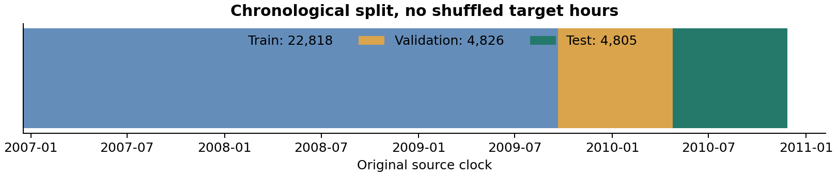
Fig. 1. Chronological 70/15/15 split of the hourly timeline; no shuffling. Label hours do not overlap and no future energy enters a feature.
4 FEATURES AND BASELINES
At forecast hour t the target is the energy consumed during [t, t + 1 h). Inputs are completed observations before t plus calendar values known at t. One feature function is shared by the experiment and the API, and a matching C version exists.
Feature group | Definition | Count
Energy lags | 1, 2, 3, 6, 12 and 24 hours before t | 6
Moving means | Previous 3, 6 and 24 complete hours | 3
Recent variation | Population standard deviation of the previous 24 hours | 1
Calendar | Sine/cosine of target hour and weekday; weekend flag | 5

Baselines (all causal): the main baseline is the mean of the preceding 24 hours. Persistence predicts the last completed hour. Same-hour-yesterday predicts the value 24 hours earlier. For multi-hour scenarios the mean and persistence stay constant and the previous daily profile is replayed.
5 ML MODELS AND MODEL SELECTION
Model | Fixed search grid | Configs
Decision-tree regressor | Depth 3, 5, 7 or 9; minimum leaf 12 or 48 | 8
Random-forest regressor | 16 or 32 trees; depth 6 or 8; minimum leaf 12 | 4

Tree regressors need no feature scaling and convert directly to C [2], [3]. The grid, split, seed (20261106), metrics and secondary balance assumptions were written to experiment_protocol.json before fitting. Each candidate is fitted on training rows only; validation MAE selects the best configuration per family and the overall winner. Family winners are then refitted on training plus validation and scored once on the untouched test targets. The selected model is a 32-tree random forest, depth 8, minimum leaf 12. No neural model or broad automated search was needed at this stage.
6 EVALUATION METRICS
Metric | Meaning
MAE, RMSE (kWh) | Average and large-miss-weighted next-hour error; MAE is the primary metric
R², WAPE (%) | Residual variance against a constant mean; total absolute error over total observed energy
Paired bootstrap | Resamples test days 2,000 times for the uncertainty of the relative MAE improvement, keeping within-day dependence
Depletion-time MAE (h) | Error of the predicted versus constructed time the balance reaches zero
6 h precision / recall | Warnings issued within six hours of depletion, correct versus missed; plus 24 h misses and false alarms

This is one fixed chronological holdout; repeated tuning on these test results would require a new test period.
7 PRELIMINARY CONSUMPTION RESULTS
Method | MAE, kWh | RMSE, kWh | R² | WAPE, %
24-hour mean | 0.5344 | 0.6830 | 0.0837 | 55.99
Persistence | 0.3887 | 0.5877 | 0.3216 | 40.72
Same hour yesterday | 0.5078 | 0.7584 | -0.1298 | 53.20
Decision tree | 0.3451 | 0.5004 | 0.5081 | 36.15
Random forest (selected) | 0.3294 | 0.4758 | 0.5553 | 34.51

On 4,805 held-out hours the forest reduces MAE by 38.36% relative to the 24-hour mean and 15.24% relative to persistence. The daily-block bootstrap interval for the improvement over the mean is 36.17% to 40.59%, so the predeclared 10% target is met for this source household.
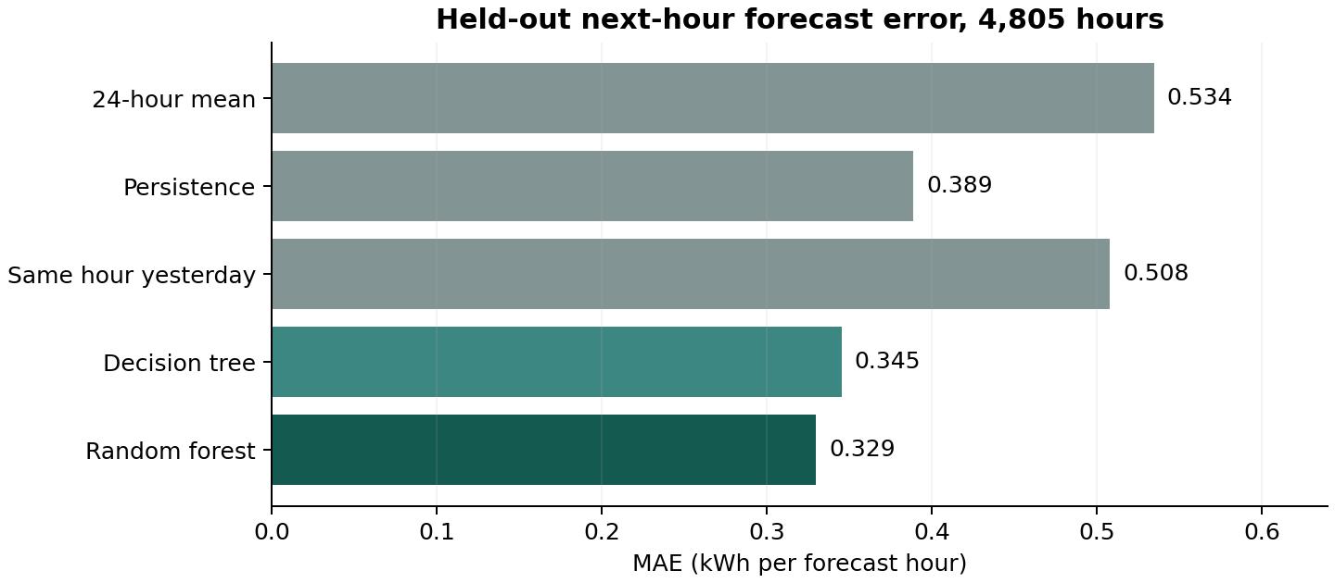
Fig. 2. Held-out next-hour MAE for each method (lower is better).
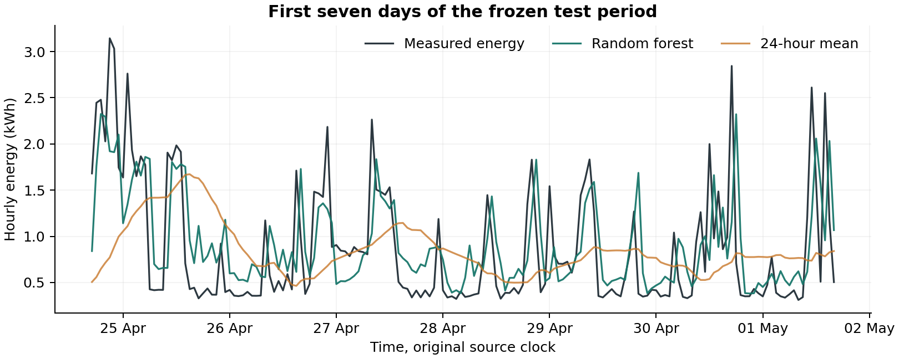
Fig. 3. First seven test days. Forecasts smooth some peaks; a lower average error does not remove large misses.
These results concern future observations of the same French household. They do not establish Ugandan accuracy or separate-household generalization.
8 CONDITIONAL DEPLETION-WARNING EXPERIMENT
No observed prepaid labels exist. At 193 test origins spaced 24 hours apart, starting balances of 2, 5, 10 and 20 kWh are assigned, giving 772 scenarios per method. Measured future hourly energy gives a constructed reference crossing; forecast energy gives the predicted crossing. No top-ups and uniform use within the crossing hour are assumed. The forest trajectory is recursive (each predicted hour becomes history for the next) and never sees future measured values. A crossing beyond 24 hours is right-censored.
Method | Time MAE, h | 6 h precision | 6 h recall | Miss / false, 24 h
24-hour mean | 1.956 | 91.69% | 80.76% | 23 / 21
Persistence | 4.183 | 92.68% | 61.79% | 136 / 22
Same hour yesterday | 2.132 | 86.92% | 86.45% | 23 / 21
Random forest | 2.010 | 81.62% | 92.68% | 1 / 56

Time MAE uses the 553 scenarios with a constructed crossing and an in-horizon forecast crossing from every method (696 of 772 reference crossings fall within 24 hours). Six-hour precision and recall use all 772 cases.
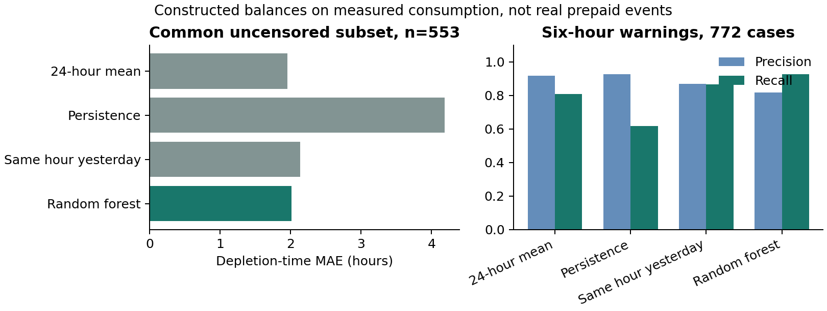
Fig. 4. Constructed balances on measured consumption; not independently observed prepaid-meter events.
Interpretation: the 24-hour mean slightly beats the forest on depletion-time MAE (1.956 h versus 2.010 h). The forest catches more six-hour events (342 true warnings, 77 false, 27 missed) than the mean (298, 27, 71), but with lower precision. Real prepaid warning improvement has not been demonstrated. The six-hour threshold is experimental, and balances sharing one origin are dependent.
9 EDGE PREPARATION
Both fitted models are exported to portable C tree traversal with float32 features and constants, int16 child indices and double accumulation (a float export, not integer quantization). A host g++ build checks the C predictions against Python, and a C feature function mirrors all 15 Python features.
Checked item | Result
Forest / compact-tree nodes | 13,024 / 249
Forest / compact-tree constant arrays | 169,312 / 3,237 bytes
C versus Python, forest (32,449 rows) | Maximum difference 1.71e-07 kWh
C versus Python, compact tree (32,449 rows) | Maximum difference 1.81e-07 kWh
Combined C feature and prediction checks | 150 histories; maximum feature difference 0
Host batch-average inference time | 1.214 µs (median of 12 batches of 100,000 calls)

The timing is a host-computer measurement and the array payload is not compiled flash size. The forest’s constant arrays exceed the 100 KB aspirational storage budget, so the 3.2 KB compact tree is supplied as a lower-storage alternative. An ESP32 sketch embeds the C forest, the C features and three recorded histories; it computes a local next-hour prediction and posts history plus prediction to the HTTP endpoint every five seconds (a demonstration schedule, not the source sampling rate).
10 IOT COMMUNICATION AND SOFTWARE INTERFACE
The software demonstration follows recorded data, preprocessing, ML prediction and HTTP communication. A local dashboard accepts 24 completed hourly kWh values and a forecast timestamp, compares the baselines, plots a 24-hour trajectory and calculates a conditional warning for an entered balance.
Interface | Function
GET /api/status | Model, dataset scope and metrics
GET /api/examples | Three recorded held-out histories with assigned balances
POST /api/predict | Validates history; forecasts the next hour and a recursive 24-hour path
POST /api/telemetry | Requires provenance; compares the supplied C prediction; logs a receipt

Executed software check | Result
Unit and HTTP integration tests | 21 passed, 0 failures, 0 errors
Host-loopback replay requests | 20 / 20 successful
HTTP request JSON body size | 533 to 548 bytes
Host-loopback HTTP RTT, median / p95 | 38.30 / 42.35 ms
Maximum C-prediction / HTTP-host difference | 2.73e-08 kWh

The server binds to 127.0.0.1:8765 by default and rejects malformed, non-finite, negative, short-history and oversized input. This research demo implements no authentication, TLS or production alert service. Artifacts supplied: source code, fitted models, executed notebook, raw archive, processed data, full validation search and test predictions, C exports, ESP32 source, figures, tests and a Git repository (GitHub: https://github.com/davis-twinomugisha/smart-energy-meter-D2.git.
11 LIMITATIONS
The primary hypothesis is supported only for next-hour error on one historical single-household benchmark. Direct prepaid depletion labels are absent, so warning results rest on constructed balances; local (Ugandan) validity is unknown; recursive error accumulates over the 24-hour path; and the warning experiment shows a precision/recall trade-off rather than a clear win. The selected forest exceeds the storage budget, and the demo server has no authentication. No billing-accuracy, utility-integration or commercialization claim follows from these results.
12 REVISED EXPERIMENTAL PLAN
Next experiment | Design and evidence required
1. Physical demonstration | Live demonstration of the chain sensor/data, preprocessing, ML, edge device, prediction and wireless communication.
2. Consented local data | One shared connection or 2–3 monitored rooms, ideally four weeks of complete-hour energy; record outages, clock convention and missing coverage.
3. Balance ground truth | Independently observed remaining kWh, with every top-up and correction timestamped. If this cannot be obtained, consumption forecasting stays the primary testable task.
4. Local evaluation | Freeze models or local recalibration on earlier data; keep the final local period untouched; compare all baselines on kWh error, warning precision/recall, missed events, false warnings, lead time and per-site results.

REFERENCES
[1] G. Hebrail and A. Berard, “Individual Household Electric Power Consumption,” UCI Machine Learning Repository, 2006. https://doi.org/10.24432/C58K54. CC BY 4.0.
[2] scikit-learn, “DecisionTreeRegressor,” scikit-learn 1.8 documentation (experiment uses version 1.8.0).
[3] scikit-learn, “RandomForestRegressor,” scikit-learn 1.8 documentation.
[4] Group 2 feedback on Smart Energy Meter Deliverable 1, supplied assessment, 10.5/15.

