ECE 5390 Practicum Assignment 2

Introduction to Simulink

Griffin Davis

February 3, 2022

# FIGURE 1: Response of Multiple Systems

# FIGURE 2: Response of Nonlinear System

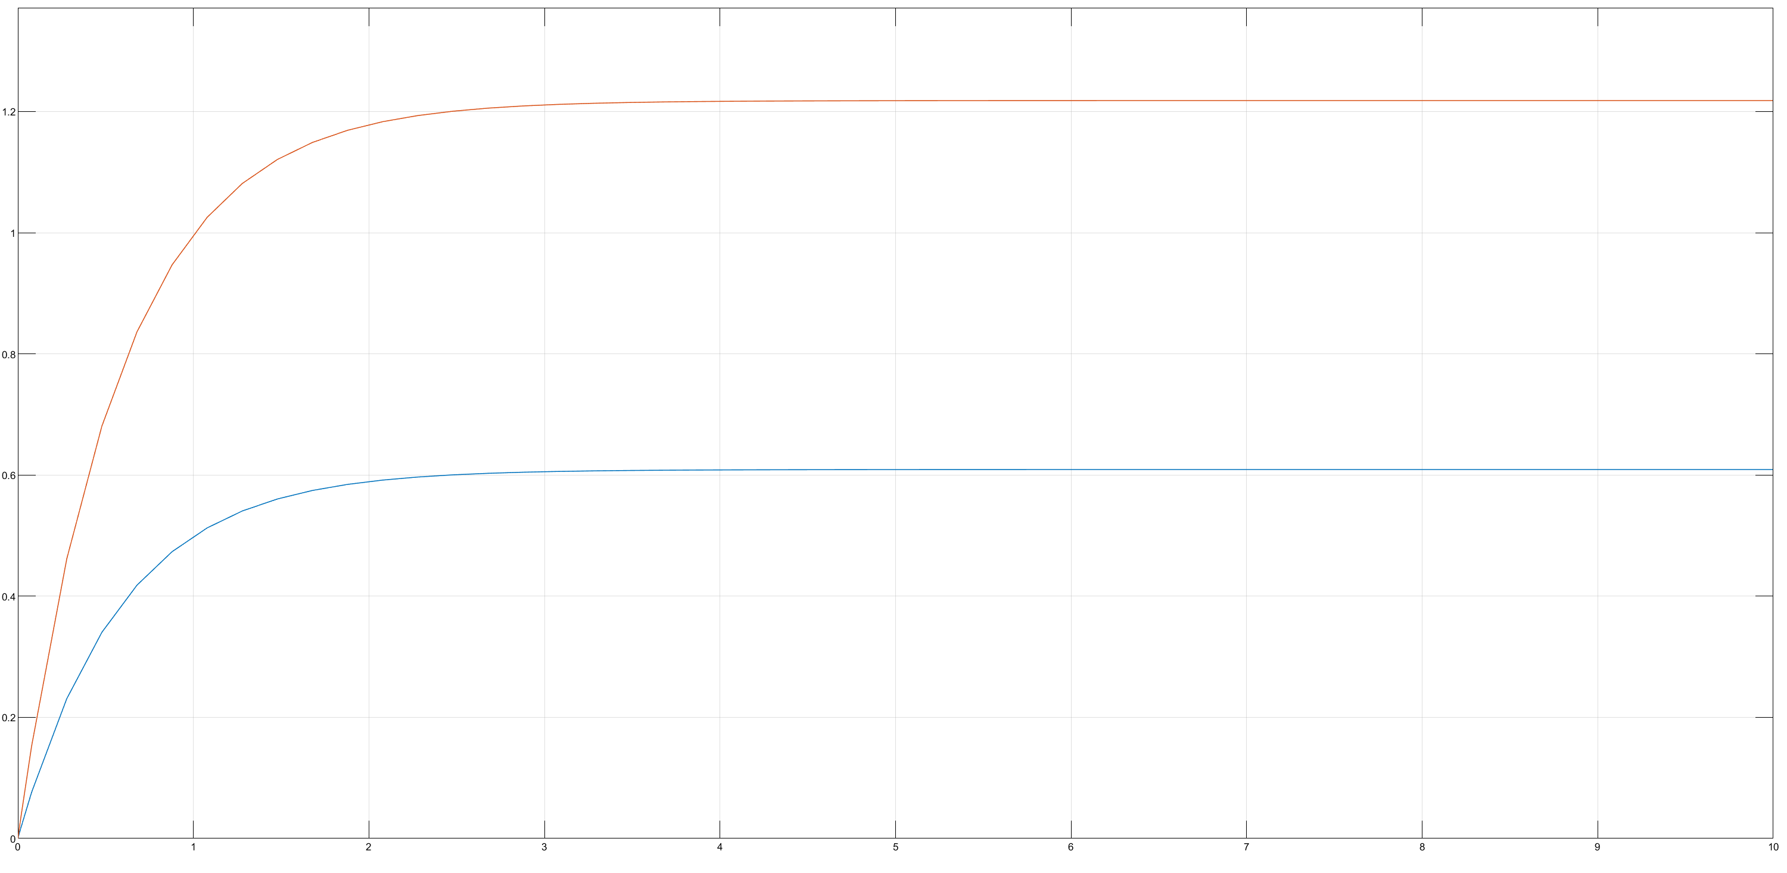

# FIGURE 3: Closed Loop System

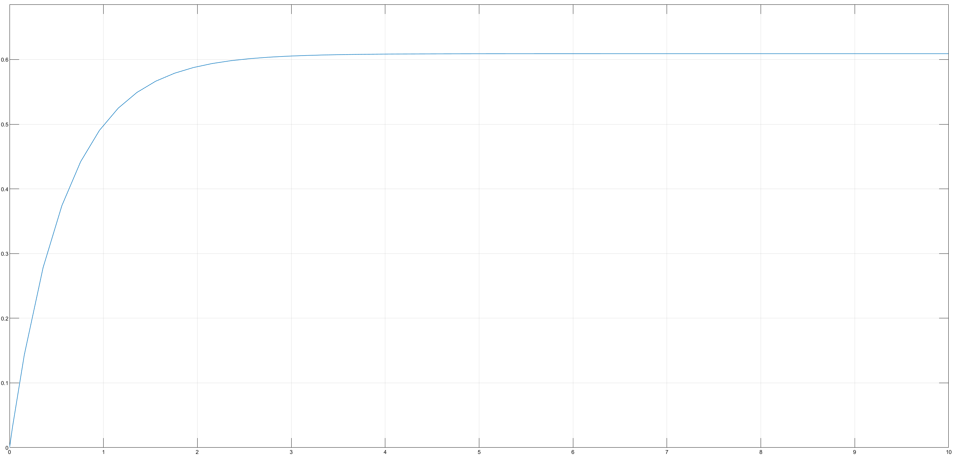

# FIGURE 4: Discrete Response

