ECE 5390 Practicum Assignment 3

Simulation Using the Frequency and Time Domains

Griffin Davis

February 10, 2022

# Introduction

Practicum 3 explores the modeling of a cascading system with initial conditions in both the time and frequency domain using Simulink.

The rest of this report is organized as follows. Section 2 covers finding the differential equations to be used as initial conditions in the frequency domain. Section 3 discusses simulating system 1 and Section 4 simulating system 2. Section 5 interconnects both systems for a cascading system while Section 6 reverses the order. Finally, Section 7 discusses the practicum as a whole and draws conclusions.

# Finding the Differential Equations

Practicum 1 calls for finding the differential equation that relates *y(t)* to *f(t)* for the cascading system with transfer functions:

$H_{1}\left(s\right)= \frac{1}{s+2}$

$H_{2}\left(s\right)= \frac{3}{(s+4)(s+5)}$

The relation between System and System 2 can be seen in **Figure 1**.

The MATLAB code in **Appendix A** is used to find the following time domain differential equations for each system:

$f_{1}\left(t\right)=e^{-2t}$

$f_{2}\left(t\right)={3(e}^{-4t}-e^{-5t})$

$f_{net}\left(t\right)=\frac{e^{-2t}}{2}-3\frac{e^{-4t}}{2}+e^{-5t}$

**Equations 1** and **2** are used for the frequency domain simulations while **Equations 3, 4,** and **5** are used for the time domain representation of the system.

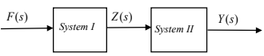

Fig. : Cascade system configuration

# Simulating System 1

Simulink is used to for all simulations in this report.

## Time Domain

**Figure 2** shows the time domain representation of **Equation 1** using an integrator with initial condition $z\left(0\right)=1$. **Figure 3** shows the scope output of the system response to a step input $f\left(t\right)=u(t)$. **Figure 4** is the system response to input .

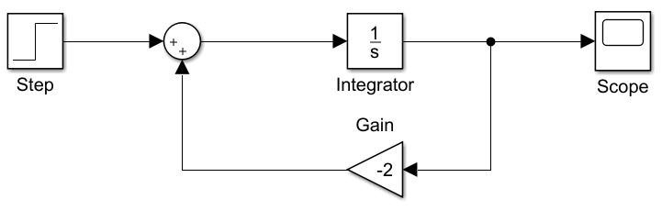

Fig. : System 1 time domain, z(0) = 1

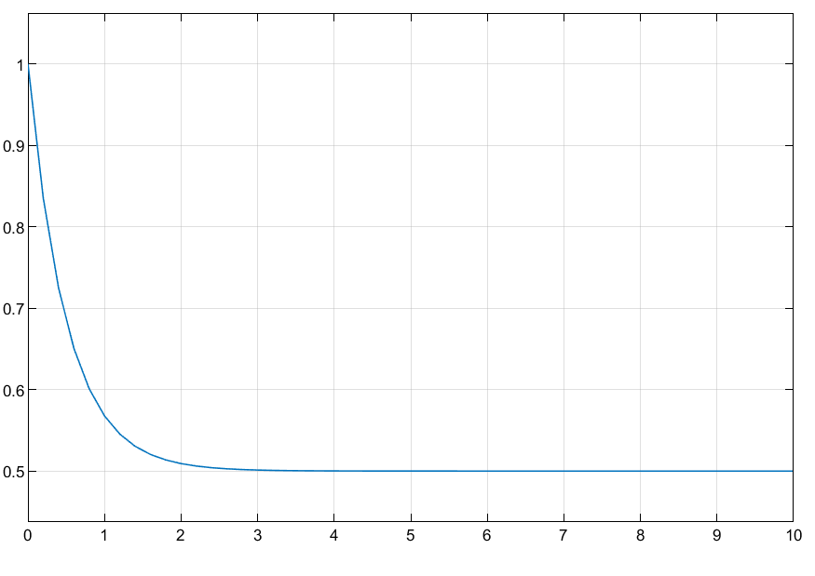

Fig. : z(t) in response to f(t) = u(t)

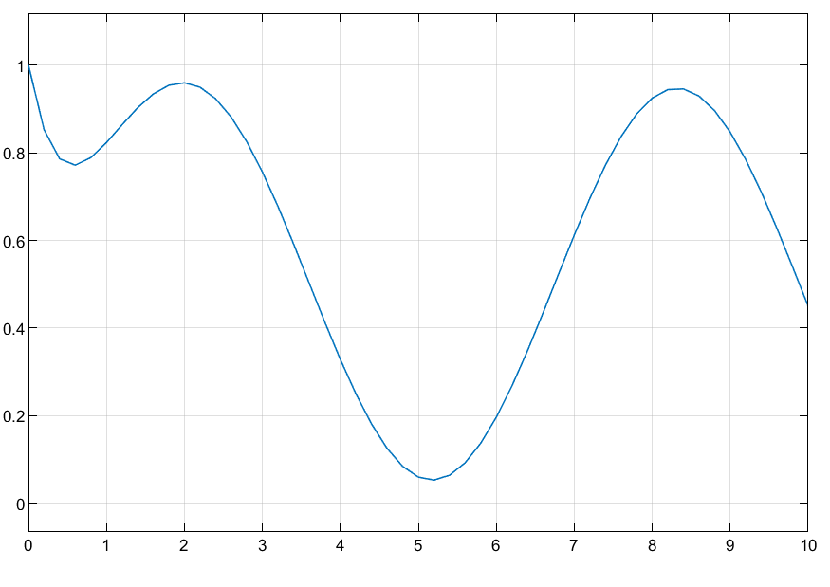

Fig. : z(t) in response to f(t) = u(t) + sin(t)

## Frequency Domain

**Figure 5** shows the frequency domain representation of **Equation 1** using function blocks to incorporate the initial conditions of the time domain. **Figure 6** shows the scope output of the system response to a step input $F\left(s\right)=\frac{1}{s}$. **Figure 7** is the system response to input .

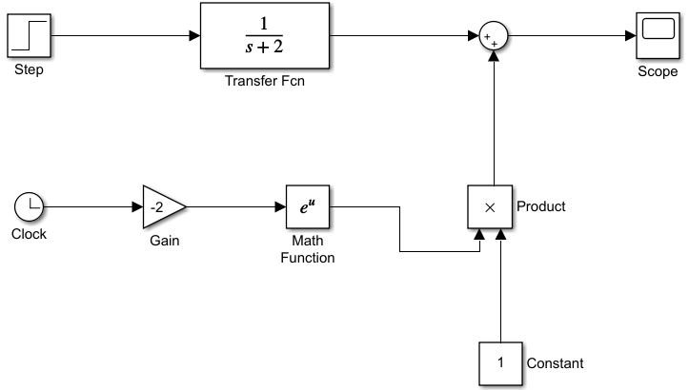

Fig. : System 1 frequency domain, z(0) = 1

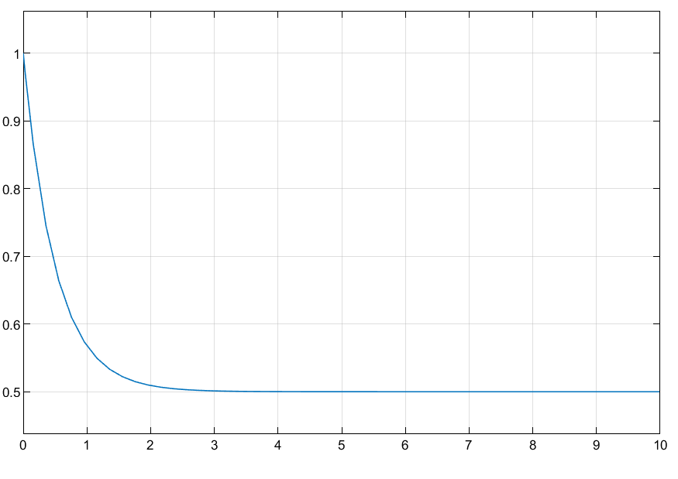

Fig. : Z(s) in response to

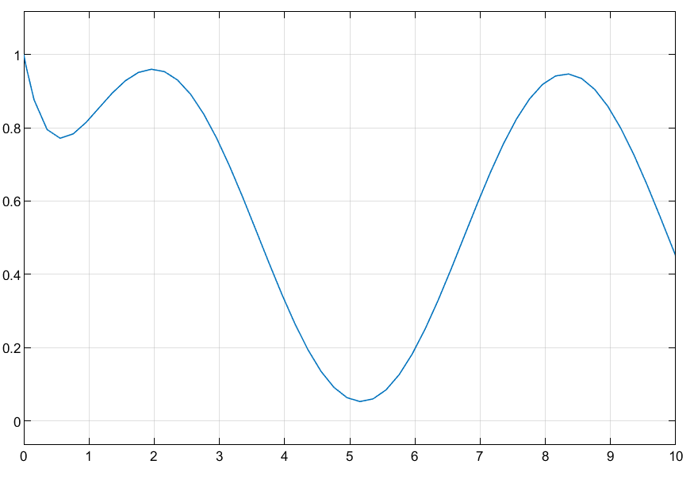

Fig. : Z(s) in response to $F\left(s\right)=\frac{1}{s}+\frac{1}{s^{2}+1}$

# Simulating System 2

## Time Domain

**Figure 8** shows the time domain representation of **Equation 1** using an integrator with initial conditions

$y\left(0\right)=2;y^{'}\left(0\right)=3$. **Figure 9** shows the scope output of the system response to a step input $f\left(t\right)=u(t)$. **Figure 10** is the system response to input .

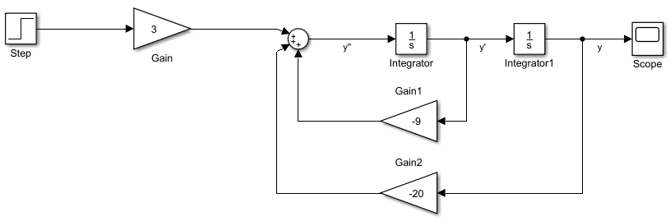

Fig. : System 2 time domain, y(0) = 2; y'(0) = 3

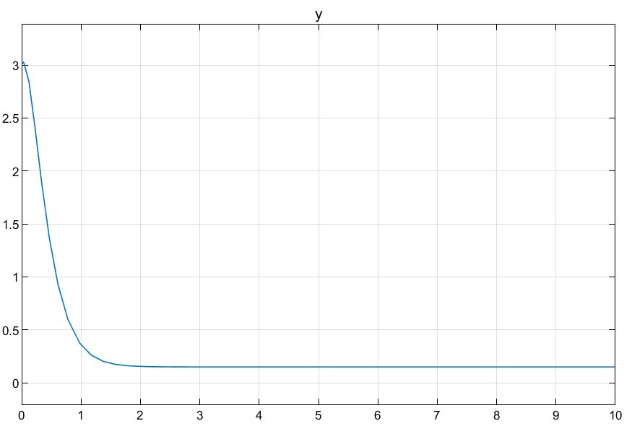

Fig. : y(t) in response to z(t) = u(t)

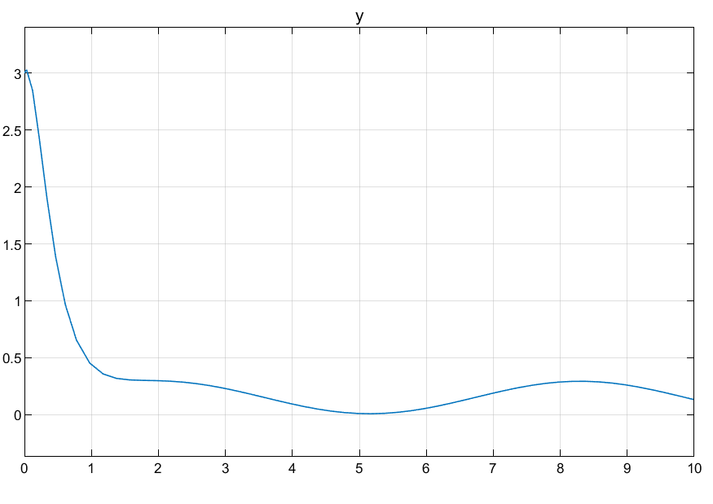

Fig. : y(t) in response to z(t) = u(t) + sin(t)

## Frequency Domain

**Figure 11** shows the frequency domain representation of **Equation 1** using function blocks to incorporate the initial conditions of the time domain. **Figure 12** shows the scope output of the system response to a step input $F\left(s\right)=\frac{1}{s}$. **Figure 13** is the system response to input .

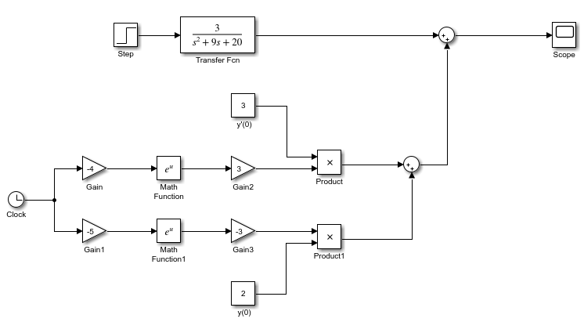

Fig. : System 2 frequency domain, y(0) = 2; y'(0) = 3

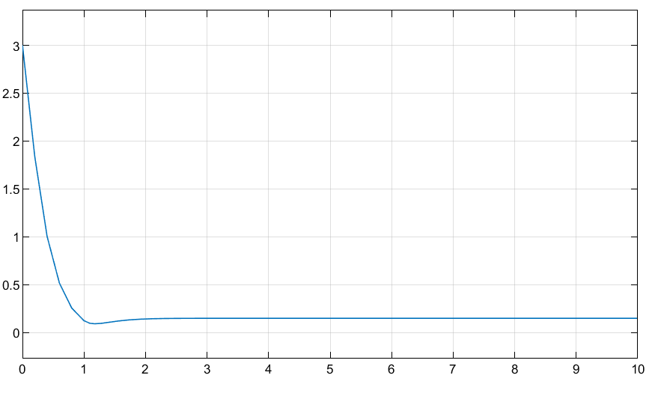

Fig. : Y(s) in response to

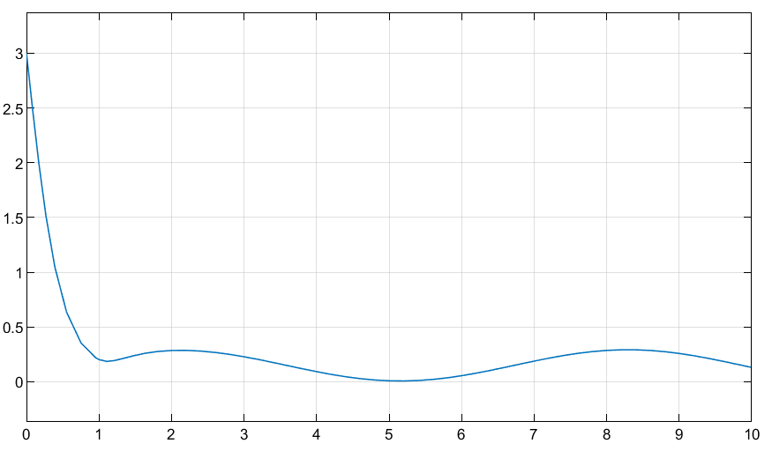

Fig. : Y(s) in response to $Z\left(s\right)=\frac{1}{s}+\frac{1}{s^{2}+1}$

# Simulating the Cascading System

When interconnected as in **Figure 1,** the resulting time domain simulation is shown in **Figure 14** and frequency domain simulation in **Figure 15**.

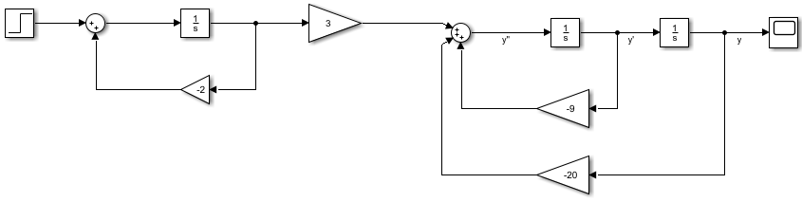

Fig. : Cascading time domain simulation

Figure 15 stuff

The time domain response of **Figure 14** can be seen in **Figures 14** and **16** for both *f(t)*, and that of the frequency domain in **Figure 17** in **Figures 18** and **19**.

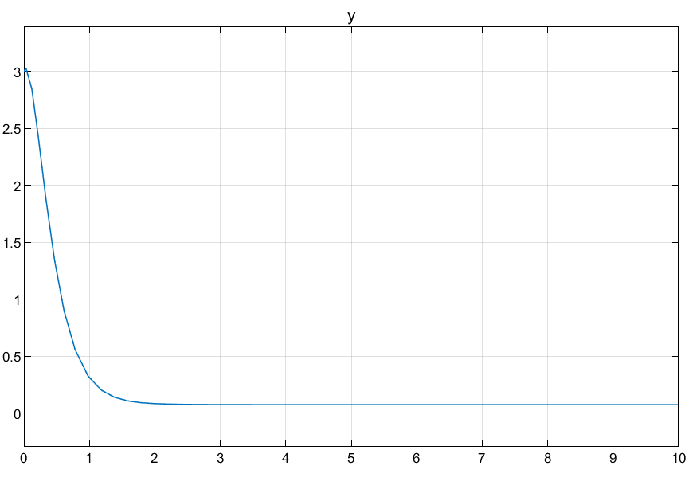

Fig. : Time domain response to f(t) = u(t)

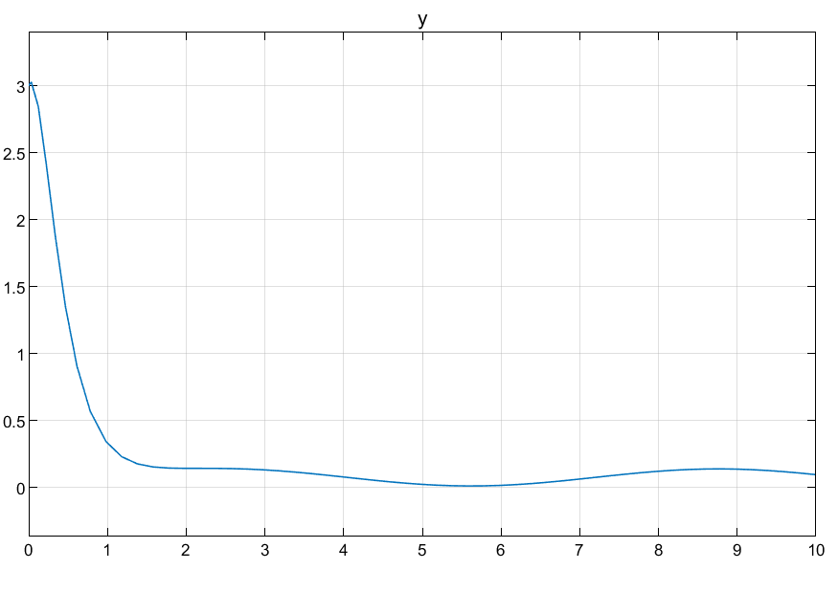

Fig. : Time domain response to f(t) = u(t) + sin(t)

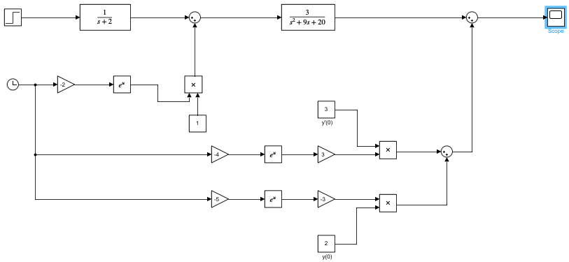

Fig. : Cascading frequency domain simulation

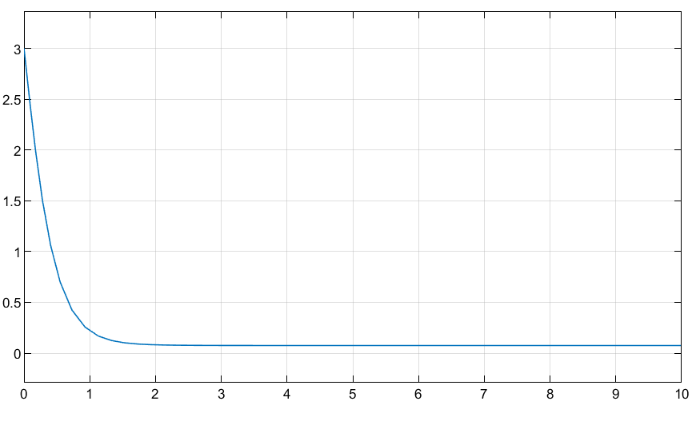

Fig. : Frequency response to

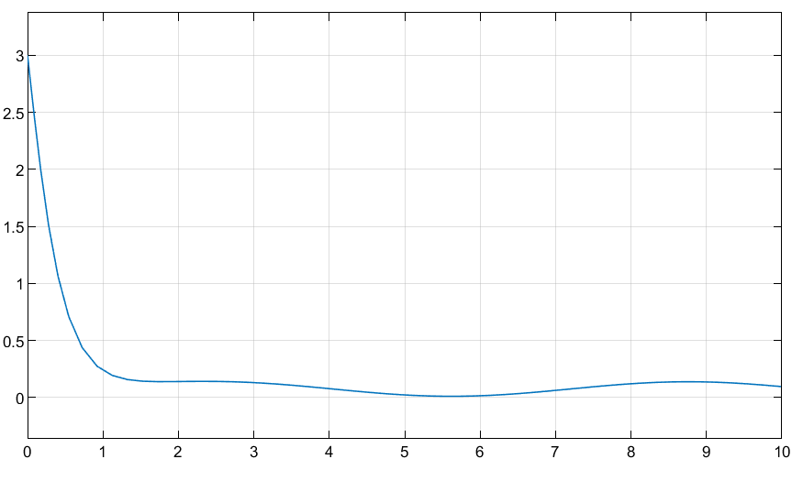

Fig. : Frequency response to $F\left(s\right)=\frac{1}{s}+\frac{1}{s^{2}+1}$

# Reverse Order

Reversing the order of System 1 and 2 would not have an impact if initial conditions were zeroed. The convolution of the two systems would be the same as multiplication, and the cumulative property states the order of operations is unimportant. With initial conditions there is an expected change in response seen in **Figure 20**.

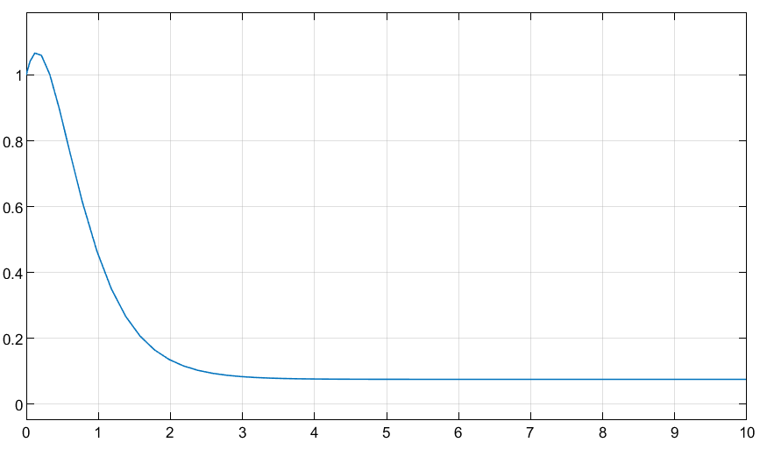

Fig. : Response of System 2 → System 1

# Discussion and Conclusion

Practicum 3 is a great introduction to system modeling in both the frequency and time domain and incorporating initial conditions. It expands on the tutorials of Practicum 2 and is challenging enough to require independent research and exploration by students.

# Appendices

### Appendix (A): Finding Differential Equations

tf1 = 1/(s+2);

de1 = ilaplace(tf1);

pretty(de1)

tf2 = 3/((s+4)*(s+5));

de2 = ilaplace(tf2);

pretty(de2)

tf_net = tf1*tf2;

de_net = ilaplace(tf_net);

pretty(de_net)