ECE 5390 Practicum Assignment 4

Dynamic Response of Linear Mechanical Translational Systems

Griffin Davis

February 17, 2022

# Introduction

Practicum 4 explores the modeling of a linear mechanical translational system with initial conditions in both the time and frequency domain using Simulink. Several conceptual questions considering such a system are also addressed.

The remainder of this report is organized as follows. Sections 2, 3, and 4 study the motion of the mass with respect to the enclosure in different scenarios. Section 5 attempts to study the motion of the enclosure with respect to the mass. Finally, Section 6 discusses the practicum as a whole and draws conclusions.

# Collision of Box and Mass

The system in consideration is composed of a suspended enclosure and a mass suspended within it, fixed to the top of the enclosure with a spring and damper. The system can be seen in **Figure 1**.

The first consideration is finding a step amplitude $A$ for $x_{1}(t)$ such that the bottom of mass M (2kg) just touches the bottom of the enclosure. With viscous damper $f_{v}=0$, any value of $A≥2$ will result in a collision due to an ideal, lossless spring of $K=2 N/m$. $A≡2$ will result in the mass only *just* touching the enclosure as the bottom of the enclosure will be elevated 2m and the spring will return to its initial position (2m).

Considering the transfer function of the system without a damper,

$$\frac{X_{2}(s)}{X_{1}(s)}=\frac{K}{Ms^{2}+K}=\frac{2}{4s^{2}+2}$$

the model seen in **Figure 2** can be constructed to generate the plot of **Figure 3** where the mass continuously returns to the bottom of the enclosure.

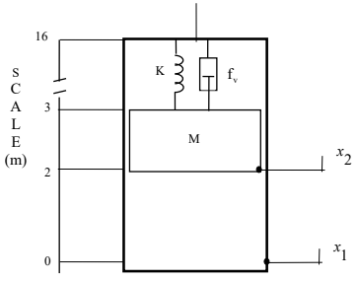

Fig. 1: Linear mechanical translational system in question

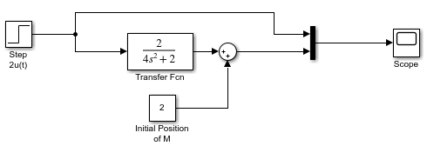

Fig. 2: Simulink model of Figure 1 without damper

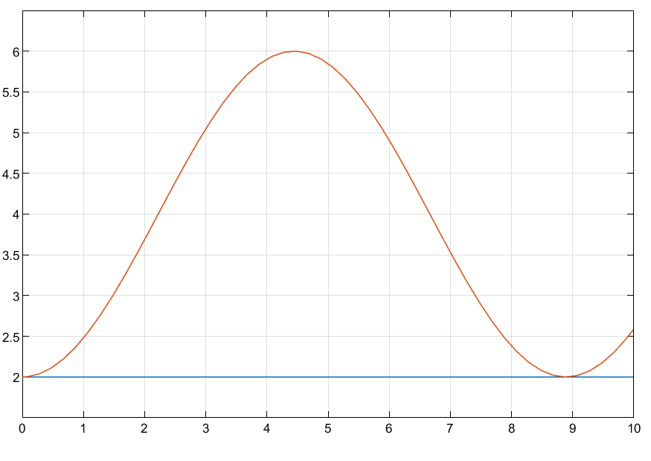

Fig. 3: Motion of X2(s) (red) and X1(s) (blue)

# Opening the Enclosure

The second exercise of the practicum covers opening the enclosure and finding $f_{v}$ such that the position of the mass will just touch the 2-meter mark in response to $x_{1}\left(t\right)=4u(t)$. The 2-meter mark can be seen as the initial position of the mass in **Figure 1**, and so just as in Section 1 a viscosity of $f_{v}=0$ is required for the mass to return to its initial position. **Figure 4** reflects the change in input and the mass can be seen to continue returning to the 2-meter mark while reaching higher heights within the enclosure.

# Preventing the Collision

Another point of study is attempting to prevent the collision between the mass and enclosure—now closed—considering an input of $x_{1}\left(t\right)=Au\left(t\right), A∈R^{+}$. A step input is an infinite force. The enclosure will immediately appear at position $A$ and so there is infinite acceleration. No viscous damper exists that can dampen an infinite force, so any value $A≥2$ will result in collision.

# Considering the Enclosure with Respect to the Mass

The transfer function of this system is:

$$\frac{X_{2}(s)}{X_{1}(s)}=\frac{sf_{v}+K}{Ms^{2}+sf_{v}+K}$$

To determine $x_{1}(t)$ as a function of $x_{2}(t)$, the transfer function can be flipped:

$$\frac{X_{1}(s)}{X_{2}(s)}=\frac{Ms^{2}+sf_{v}+K}{sf_{v}+K}$$

The resulting transfer function consists of a higher order numerator than denominator and has more zeros than poles. It is not a physically realizable system. Despite this, MATLAB's ilaplace function can be used to derive:

$$x_{1}\left(t\right)=\left[\frac{M\ddot{t}}{f_{v}}-\frac{(-f_{v}^{2}+Mk)\dot{t}}{f_{v}^{2}}+\frac{Mk^{2}e^{-\frac{kt}{f_{v}}}}{f_{v}^{3}}\right]x_{2}(t)$$

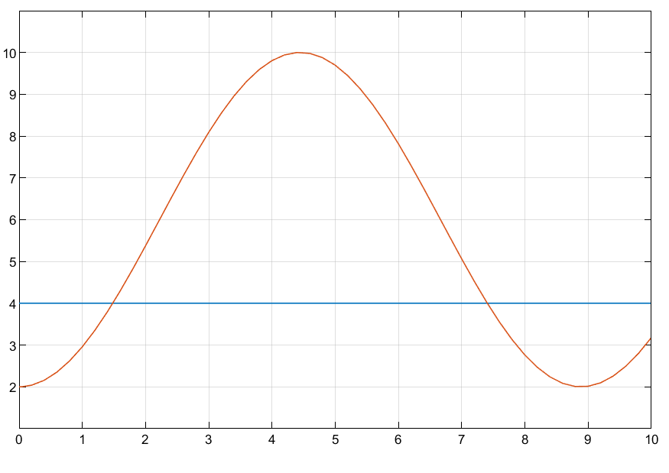

Fig. 4: Response of x2 with an open enclosure

# Discussion and Conclusion

Practicum 4 is more conceptual than previous practicums, and on top of being an introduction to linear mechanical translational system, also poses several questions that makes students think twice.