ECE 5390 Practicum Assignment 5

Dynamic Electromechanical Suspension System Compensation Design

Griffin Davis

March 10, 2022

# Introduction

Practicum 5 expands on the material of Practicum 4, exploring a linear, translational electromechanical system rather than a solely mechanical system.

The rest of this report is organized as follows. Section 2 analyzes the extremes of such a system, while Section 3 derives the transfer function to derive the best dampening for given inputs. Section 5 concludes on the safety and comfort of each design.

# Analysis of the Dynamic, Electromechanical Suspension System

The system in question can be seen in **Figure 1**, a mass in an enclosure with a wire fixed to it, passing through a magnetic field fixed to the mass. System parameters include

The first consideration is an analysis of only the mechanical components of the system in **Figure 1** by treating terminals A and B as an open circuit. The behavior of this system follows the original examples of the system from Practicum 4, with dampening . The position of the mass can be seen in **Figure 2**. This system’s short coming is it will not reach steady state and will continue to *just* touch the enclosure.

The second extreme is a short circuit between terminals A and B leading to infinite current, infinite force, and therefore an overdamped system. This response can be seen in **Figure 3**. This system’s short coming is the mass will experience the full impact.

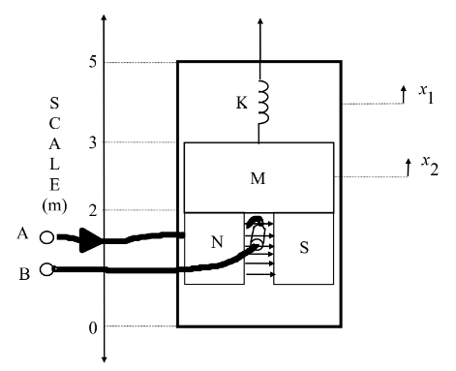

Fig. : Electromechanical suspension system

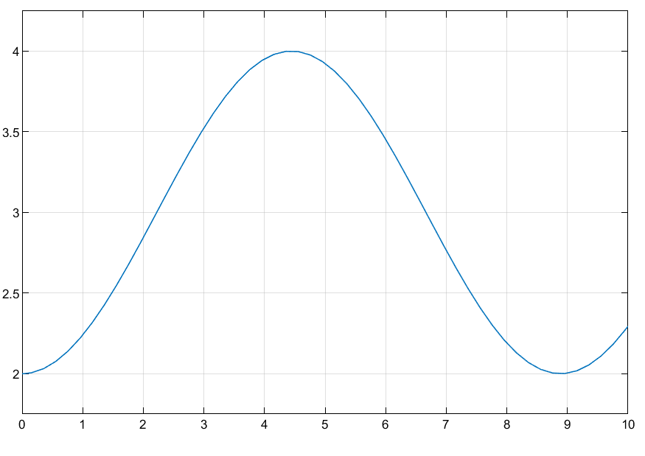

Fig. : Response of x2 to u(t) while open circuited

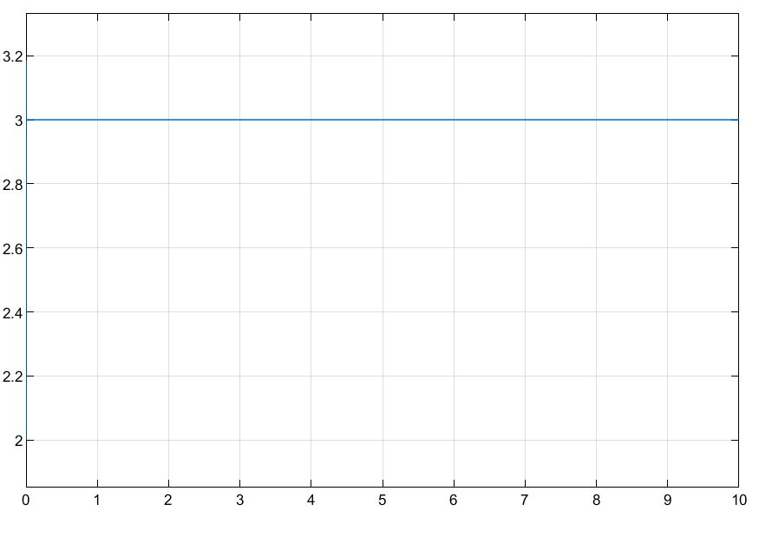

Fig. : Response of x2 to u(t) while short circuited

# System Design

To study the dampening, , as a function of a resistor connected across terminals A and B, the transfer function is derived as:

To match the normalized form of a second order unit response :

The damping coefficient can be found by relating values and :

Choosing a spring constant ,

# Discussion and Conclusion

Due to the lower least squares error of 0.0636809 found in the second order approximation of the step response, the system is more likely to be a second order system than a first order system. It can also be seen in **Figures 1 & 2** that the second order system reaches steady state at close to the same period of *4*τ than the first order system. The second order system comes closer to an initial start of 0 as well and thus more accurately represents a system step response.

Practicum 1 is a great introduction to system modeling and parametric identification through the relatively complex algorithm required to accurately calculate the parameters through N-search.

# Appendices

## Appendix (A):