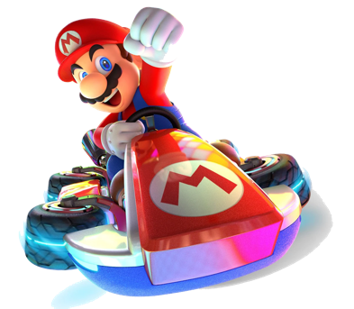Mario Kart Robot Report

# Introduction

As part of a six-week engineering challenge, my team of four designed and built from scratch, **R.O.B.erto**, a fully autonomous robot tailored for a Mario Kart-themed competition. The primary objective was to create a robot capable of navigating a dynamic racecourse filled with diverse challenges, including sharp turns outlined by black tape, rocky terrain, a “Rainbow Road”, and even a zipline, as seen in Figure 1 below. Beyond completing laps, the ultimate goal was to maximize our points by outperforming opponents in head-to-head races.

*Figure 1: the competition surface*

Points were earned by completing laps, collecting item boxes (3D-printed cubes), and gathering coins located exclusively on the zipline. However, the course presented strategic hurdles—some item boxes concealed hidden “bombs,” identifiable by their red tops and magnetic interiors, which deducted points if collected. This meant our design needed to not only navigate the course efficiently but also avoid penalties while outscoring the opposing robot.

This competitive environment required an interdisciplinary approach, blending mechanical engineering, electrical circuit design, and advanced software development. By the end of the competition, R.O.B.erto distinguished itself as the only robot among 17 teams to successfully complete the zipline challenge and collect the zipline-exclusive coins, securing a strong competitive edge.

# Our Design

To meet the demands of the competition, we developed an integrated solution that combined robust mechanical systems, custom-designed electrical circuits, and sophisticated software algorithms. Each subsystem was carefully engineered to address specific challenges on the course, from navigating the black-tape paths to avoiding point-deducting bombs and achieving the unique zipline challenge.

## Mechanical Design

The mechanical systems of R.O.B.erto were carefully crafted to meet the demands of the competition, prioritizing functionality, robustness, and creativity. At the heart of the design was the chassis, which I personally designed and constructed using the CAD tool Onshape. The full CAD model can be viewed via the link above while a snapshot of the assembly can be seen in Figure 2. The chassis was built primarily using laser-cut hardboard, with a press-fit design to minimize the need for adhesives. Its sturdy construction ensured it could withstand collisions during head-to-head races while efficiently housing all essential components, including motors, batteries, electrical circuits, object storage, and additional mechanical systems like the Elasti-Grab and the scissor lift.

*Figure 2: CAD assembly of the chassis*

To further optimize the design, several custom components were 3D-printed. These included vertical mounts for the circuit boards, allowing efficient use of limited space, and stands for the camera and sonar, which ensured precise alignment for detecting bombs and avoiding collisions. The thoughtful integration of these components contributed to the compact and organized layout of the robot.

One of the standout mechanical features was the Elasti-Grab, a system inspired by a combine harvester. This mechanism used a spinning ring of elastic bands to collect item boxes efficiently. Powered by a motor connected via 3D-printed gears to a rotary encoder, the Elasti-Grab was equipped with a jam prevention system. By monitoring the encoder, the robot could detect when the mechanism stalled. In such cases, the motor would briefly reverse its direction before resuming, ensuring uninterrupted operation and reliable object collection.

Another key feature was the scissor lift located at the back of the robot, which was essential for zipline traversal. The lift was powered by a motor connected to an encoder, enabling precise control over its height. This ensured the mechanism could reliably attach to the zipline hook, a task that set R.O.B.erto apart from other robots in the competition.

Adding a touch of creativity to the design, the team engraved “sponsors” onto the chassis, emulating the branding seen in professional NASCAR vehicles, as seen in Figure 3. These small details highlighted the blend of technical precision and playful design that defined R.O.B.erto.

*Figure 3: R.O.B.erto’s “sponsors”*

## Electrical

To be completed…

## Software

To be completed…

# Challenges and Learning

To be completed…