

COLLEGE OF COMPUTING AND INFORMATION SCIENCES

DEPARTMENT OF NETWORKS

BACHELOR OF SCIENCE IN SOFTWARE ENGINEERING

PROFESSIONAL MIN SE PROJECT PRACTICAL

PROJECT ONE RECESS TERM 2018/2019

SUPERVISOR

MARY NSABAGWA

GROUP

G-14

GROUP MEMBERS

|  |  |  |  |  |
| --- | --- | --- | --- | --- |
| **FULL NAME** | **STUDENT NUMBER** | **REGISTRATION NUMBER** | **EMAILS** | **SIGNATURE** |
| KAZIBWE DAVIS | 216007850 | 16/U/5821/EVE | kazibwedavis6@gmail.com |  |
| DOMBO NASSER | 215008391 | 15/U/4898/EVE | dombonasser52@gmail.com |  |
| GAVOOLA JUMA | 216012520 | 16/U/4817/EVE | jgavoola95@gmail.com |  |
| OLARA SAMUEL OBADIA | 217013103 | 17/U/9634/EVE | obadz.99@gmail.com |  |
| WAMALA EDGAR WATSON | 217022321 | 17/U/20633/EVE | edgarwamala@gmail.com |  |

Contents

List of Tables iii

List of figures iv

1. INTRODUCTION 1

1.1 Purpose 1

1.1.1 Intended Audience 1

1.2 Scope 2

1.2.1 Description and Scope of the system 2

1.2.2 The goal 2

1.2.3 Main Objective 2

1.3 Overview 3

1.4 Definitions and Acronyms 3

2. SYSTEM OVERVIEW 4

3. SYSTEM ARCHITECTURE 6

3.1 Architectural Design 6

3.1.1 Module design 7

3.2 Decomposition Description 7

3.2.1 Decomposition diagram 8

3.2.2 Data flow diagrams 8

3.3Design Rationale 9

4. DATA DESIGN 10

4.1 Data Description 10

4.2 Data Dictionary 10

5. COMPONENT DESIGN 12

6. HUMAN INTERFACE DESIGN 13

6.1 Overview of User Interface 13

6.2 Screen Images 13

6.3 Screen Objects and Actions 16

# List of Tables

**Table 1. 1 Definitions and Acronyms** 3

**Table 4. 1 Data entry for Donors** 9

***Table 4. 2 New Member entry*** 9

***Table 4. 3 Data entry for Agent registration*** 10

# List of figures

Figure 3. 1 client/server architecture of the UFT member enrollment system 6

Figure 3. 2 decomposition diagram of the UFT member enrollment system. 8

Figure 3. 3 level 1 data flow diagram 9

Figure 6. 1 user authentication login menu 12

Figure 6. 2 entering credentials for payment 13

Figure 6. 3 visualizations menu 14

Figure 6. 4 command-line prompt 15

# 1. INTRODUCTION

This document describes the design of the United Front for Transformation (UFT) member enrollment system developed for member enrollment and data management of United Front for Transformation (UFT) Uganda. It is assumed that the reader has read the SRS, since this document also defines the implementation details of the desired behavior given the requirements within it. This document will build heavily on the project proposal and so knowledge of the general system architecture is recommended prior to commencing this document.

## 1.1 Purpose

This software design document describes the architecture and system design of UFT member enrollment system. It is a living document that evolves throughout the architecting and design of the UFT system. The goal of this document is to cover the high-level system architecture and detailed design of the UFT system. The design description defined in this document serves multiple purposes:

* It describes the functional structure, data and plots to be implemented.
* It identifies the required system resources.
* It will be used to assess the impact of UFT member enrollment system.
* It will assist in producing test cases for example it will be used to verify compliance with the

requirements specified in the SRS.

* It will be used to aid in maintenance activities.

### 1.1.1 Intended Audience

In contrast to the Software Requirements Specification, most of this Software Design Description is

written for knowledgeable software professionals and designers. Thus, the agents, agent-heads and administrators of UFT Uganda will not be within the intended audience for this document, which is:

* Supervisor
* Auditors and Reviewers
* Testers
* Developers
* System maintainers

## 1.2 Scope

This SDD describes the detailed structure of the components of the United Front for Transformation (UFT) member enrollment system and the precise implementation details required to satisfy the requirements as specified in the Software Requirements Specification (SRS).

### 1.2.1 Description and Scope of the system

UFT member enrollment system analyses data about payments including their sources, variances in amounts collected, enrolling new members by agents and storing their data to databases and the agent services operator including the waiting time in minutes and seconds for validating and accepting member details that have been enrolled to the system , link in form of visual diagrams (i.e. graphs, word cloud) that will provide a clear review and analysis of this data.

For example, it will produce:

* A bar graph indicating the amount of money generated from well-wishers.
* Bar graphs of the different field names against their counter parts for example a bar graph of districts versus agents or agent heads and enrolled members per district
* Pie charts of the different field names for example a pie chart indicating agents and the number of new members they have enrolled for the party.
* Scatter plot indicating variations in payments to agents, head agents and various administrators
* Bar graph showing variations in amounts of money collected from different well-wishers in various months

### 1.2.2 The goal

To develop a data analysis and data management system that will produce visual diagrams and store data that can simplify the task of data analysis and management on district level during UFT member enrollment, fund generations and making payments.

### 1.2.3 Main Objective

To develop a member enrollment system for reviewing, analyzing, visualizing and storing data for newly enrolled members, sums of money generated, payments made and managing existing data for United Front for Transformation Uganda.

#### 1.2.3.1 Specific Objectives

* To collect and analyze requirements for United Front for Transformation member enrollment system.
* To design a model for an integrated UFT member enrollment system.
* To implement UFT member enrollment system basing on the design models
* To test the system with people generally UFT administrators, agents and agent-heads.

## 1.3 Overview

This document has been organized into sections as described below.

Section 1: described the project scope, purpose of this document, definitions and acronyms used with their meanings.

Section 2: Describes the system overview i.e. the general description of the functionality, context and design of UFT member enrollment system.

Section 3; describes the system architecture, which comprises of the system architecture design, decomposition of the system and justification for the choice of the design.

Section 4: Data design with data descriptions is described which shows how the information domain of the system is transformed into data structures.

Section 5: There is the description of the component design.it gives the functional description of each component in detail.

Section 6: Describes the human interfaces; screen objects, images and actions and the way users interact with the system.

Section 7: contains the Requirements matrix for tracing the requirements defined in the SRS.

## 1.4 Definitions and Acronyms

For a complete list of the definitions and acronyms used in the remainder of this document, refer to

the Glossary.

**Table 1. 1 Definitions and Acronyms**

|  |  |
| --- | --- |
| **UFT** | United Front for Transformation |
| **GUI** | Graphical User Interface |
| **UI** | User Interface |
| **I/O** | Input Output |
| **API** | Application Programming Interface |
| **SRS** | Software Requirements Specification |

# 2. SYSTEM OVERVIEW

United Front for Transformation (UFT) is a new political party which was recently formed and registered in Uganda. In order to compete and catch up with other political parties, UFT has embarked on acquiring a member enrollment system to automate and speed up its services and operations.

UFT member enrollment system is made up of two major components: The client and server part (written in C), and the graphical component (written in PHP Laravel). The client and server component form the core of United Front for Transformation (UFT) member enrollment system. It’s where agents and agent-heads feed data (enter member details) to the server. It performs all of the analysis and data storage required to guide administrative tasks of UFT Uganda through offering faster decision-making techniques and better data analysis tools. The graphical component, as the name implies, is simply the graphical user interface. It provides all of the buttons, table panels, and other onscreen elements which allow the administrators to access all of the features provided by the application.

We took an initiative of breaking down the two major components (the client and server part) into four modules which included: the server, web interface, the database and the command line interface.

The server performs the tasks and returns the results for those that get processed. The agents are allocated to the districts as they are registered and once registered via the web application by the administrator, the system automatically allocates the agent to a district that either lacks agents or has the fewest agents.

On registering an agent, a signature will be supplied and should be a single character. The same character should have been stored in the database during registration

Each district should have a head of the agents if they are more than one attached to that district. Else, if there is one agent, the agent automatically becomes the head. An enrolled member will be upgraded to an agent by the system’s administrator via a web interface. If a member introduces more than 40 new members, and there is an available position in any district, the web interface recommends the member to be upgraded to an agent.

The funds of the UFT will be declared and registered via the web interface by the administrator as received from the well-wishers. The agents use a command-line client socket program to submit details of members who have been enrolled. The member details are stored in the system database.

Enrollment information is saved in a file (a file for each district) for validation by the agent head. Every 5 minutes, a scheduled job runs in the background, checking the files for each district for completeness and validity. In case an agent logs into the system via the C client, they should see status of the file, indicating who has and who has not signed.

The administrator will use the web application to view the following;

1. List of members enrolled in a given period of time, organized by district, agent, month etc as selected by the administrator.
2. The distribution of money to each of the agents in the different districts.
3. Graph showing donations by month, well-wisher as selected by the administrator.
4. Graph, showing variation in Percentage change in enrollment figures i.e. if March=40, April = 50, May=15 percentage change in March = (50 – 40) /40 and percentage change in May = (15- 50)/ 50

# 3. SYSTEM ARCHITECTURE

## 3.1 Architectural Design

The design of this UFT member enrollment system will follow the client/server architecture where by the client in our case represented by user Interface will send requests to the server which the server will

respond to.

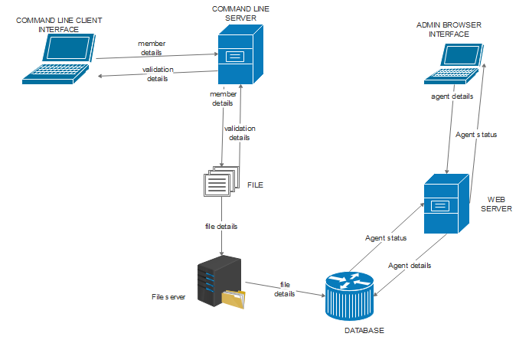

Figure 3. 1 **client/server architecture of the UFT member enrollment system**

In this UFT member enrollment system, the command line client gets data from the user and sends it to the command line server. The server manipulates the data and stores it into the database. The administrator then uses the web browser to access the data from UFT member enrollment system databases. The administrator can also send data to the database using the web browser interface.

### 3.1.1 Module design

The SDD of the UFT Member enrollment system contains a detailed description of the modules within our system. It will attempt to define methods, properties, to a certain extent, provide algorithms or ways of approaching the coding process.

Below are the process specifications/modules and functional primitives of the system.

**1.Register Agents**

1.1 Choose register module

1.2 Enter Agent details

1.3 Store to database

1.4 View agent details

**2. Enroll Members**

2.1 Establish connection to server

2.2 Enter member details

2.3 Submit to database

**3. Declare/ register funds**

3.1 Select payment module

3.2 Make payments

3.3 Visualize payment data

## 3.2 Decomposition Description

This section of this document decomposes each use-case feature into its data flow processes by

examining its data flow diagram and its process. These assist us in determining the preliminary

members and methods of the modules that need to be implemented, or the modifications to existing

modules to implement the feature. This document uses the names of the use cases in the Software

Requirement Specification document as the names of the features. This section includes the

description of the intended design to meet the requirements. When appropriate, the use cases will be

expanded to include system requirements. This section also incorporates a decomposition diagram

providing the segments involved in each process.

### 3.2.1 Decomposition diagram

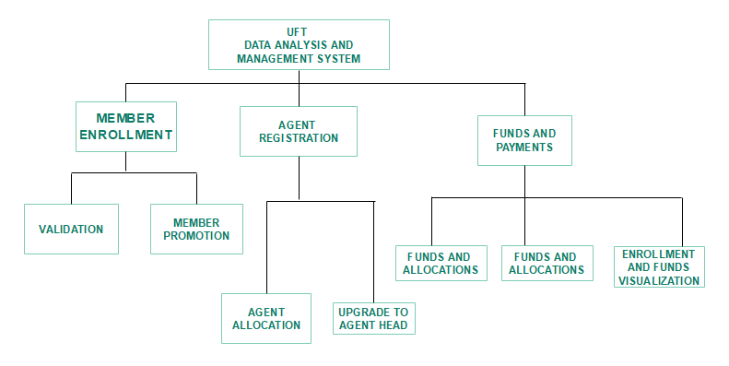

Figure 3. 2 decomposition diagram of the UFT member enrollment system.

It describes the hierarchy within the UFT member enrollment system and the modules of the system.

### 3.2.2 Data flow diagrams

These diagrams provide a description of how data flows within the UFT member enrollment system. There is a level 1 data flow diagram obtained from the level 0 or context O diagram, it consists of all the processes within the UFT member enrollment system. This diagram is further divided into child diagrams

which provide steps involved in each process thus every process has its own child diagram.

**Level 1 DFD**

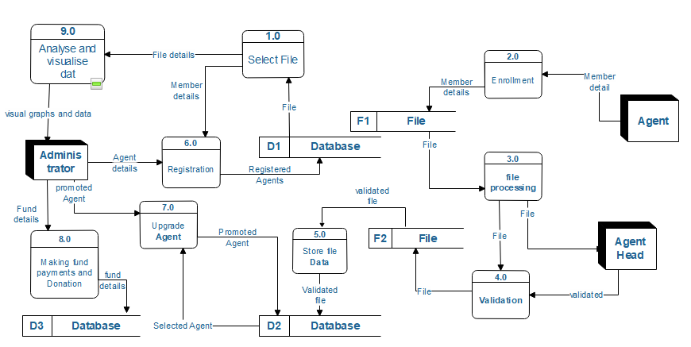

Figure 3. 3 **level 1 data flow diagram**

## 3.3Design Rationale

We have chosen to use client/server architecture because we need to provide the agent with an

interactive interface. Most of the work will be done in the server and this makes the user/operator’s

interaction with the system easier since he /she will only have to send requests to which the server

will process and store results to database.

# 4. DATA DESIGN

## 4.1 Data Description

UFT member enrollment system uses data about agents, agents head, payments made between new members enrolled to the system and money generated from well-wishers. This data will be provided by the agent heads, administrators and will also be obtained from the interaction between the agents and members enrolled to the system. It will be collected from various districts and then sent to the server for processing through client application by agents.

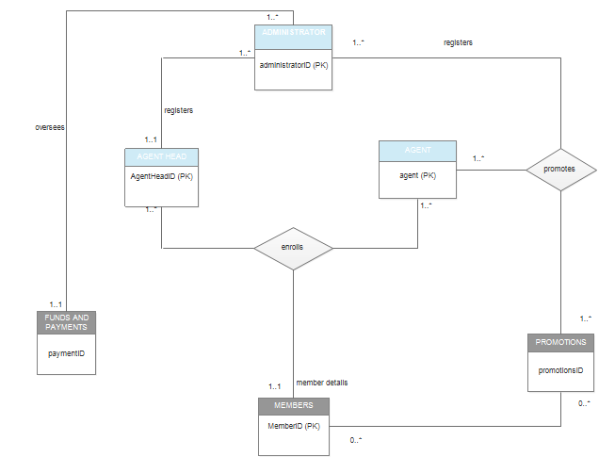

Figure 4. 1 Entity Relationship Diagram

## 4.2 Data Dictionary

**Table 4. 1 Data entry for Donors**

|  |  |  |
| --- | --- | --- |
| **Attributes** | **Types** | **Description** |
| Donor Details | VARCHAR (20) | Member details that are sent to server by agents |
| IP | VARCHAR (20) | Internet protocol address of the router of the agent |
| Link | VARCHAR (20) | Link of the page |
| Date | Date | Date of data entry to the system |
| Came.from | VARCHAR (20) | Where data entered to the system came from |
| Wait.time | TIME | Wait time (in seconds) for data validation and verification |

***Table 4. 2 New Member entry***

|  |  |  |
| --- | --- | --- |
| **Attributes** | **Types** | **Description** |
| Name Of Member | VARCHAR (20) | Name of enrolled new member to the system |
| ID of Member | VARCHAR (20) | ID assigned to new enrolled member |
| Date of enrollment | Date | Date when a member is enrolled to the system |
| Recommender | VARCHAR (20) | Member who recommended the person being enrolled |
| User name | VARCHAR (20) | User name of agent who is enrolling the new member to the party |

***Table 4. 3 Data entry for Agent registration***

|  |  |  |
| --- | --- | --- |
| **Attributes** | **Types** | **Description** |
| Name | VARCHAR (20) | Name of the agent |

# 5. COMPONENT DESIGN

**Agent registration**

**Algorithm**

Run the system

Choose a registration module

Enter agent details

Save to database

**Member Enrollment**

**Algorithm**

Run the client application

Establish connection to the server

Send member details to the server

Analyze and validates data

Store to the database

**Managing funds**

**Algorithm**

Run the system

Choose payment module

Enter payment details

**Visualize data**

**Algorithm**

Run the system

Select visualizations

Choose details to visualize

# 6. HUMAN INTERFACE DESIGN

This section provides a complete description of the actual user interfaces of the United Front for Transformation (UFT) member enrollment system. It includes screen images of these interfaces with brief explanation on the importance and how to interact with particular interfaces.

## 6.1 Overview of User Interface

The user interface consists of a tab set panel with a set of tab panels, and a left side bar with a set of

buttons through which the user can interact with the system. The buttons on the left side bar include

the browse button and the tab panels on the tab set panel include, visualizations, view registered members, view payments, Make payments, view Funds, Add New Generated funds, Register Agents.

These GUI components will be arranged in such a way that the administrator will be able to quickly grasp the purpose of each one of them and perform whatever task it is designed for efficiently. A detailed description of this side bar and tab set panel and their interactions with each other will be described in section 6.3.

## 6.2 Screen Images

**SCREEN IMAGE SHOWING LOGIN INTERFACE OF THE SYSTEM**

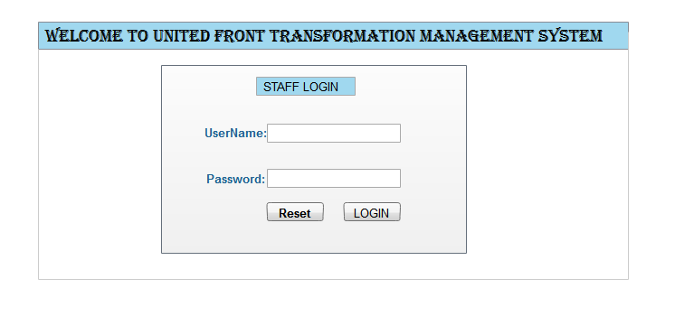

Figure 6. 1 **user authentication login menu**

On loading the software, this page is loaded to prompt the user to login into the system. Only the administrator and the agent-head will be allowed to login using their credentials.

**SCREEN IMAGE SHOWING ADMINISTRATIVE INTERFACE FOR THE SYSTEM**

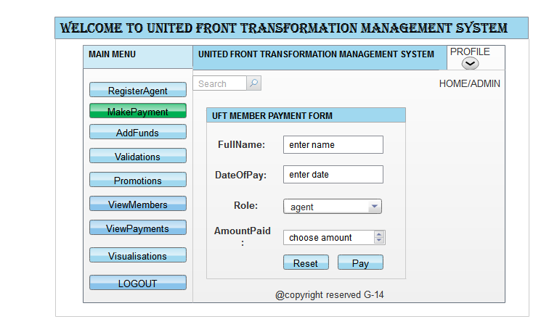

Figure 6. 2 **entering credentials for payment**

This page appears when the user selects the makepayment module. This is where a payment is made to the system.

**SCREEN IMAGE SHOWING ADMINISTRATIVE VISUALISATION MODULE**

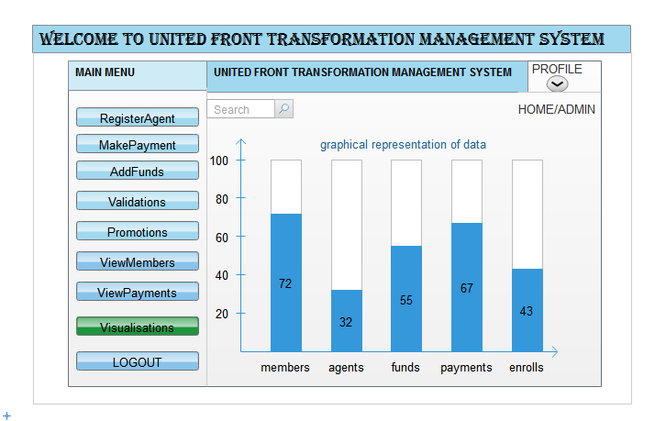

Figure 6. 3 **visualizations menu**

To produce this graph, the administrator or agent heads will have to first click on the visualization’s analysis table panel on the table set panel and he/she will be prompted to choose item to be visualized. After choosing the file the system will analyze the chat content and visualize a bar graph like the one in figure 6.3

**SCREEN IMAGE SHOWING THE AGENTS CLIENT SERVER INTERAFCE**

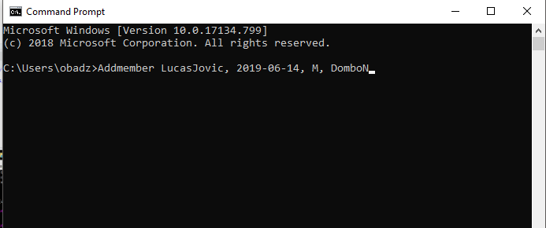

Figure 6. 4 **command-line prompt**

On loading the software this terminal will be displayed and only agents and agents-heads will use this terminal to sender newly enrolled member data to the server which processes it and later stores it to the database.

## 6.3 Screen Objects and Actions

The system provides a plenty of useful GUI components. The screen objects and actions with in the

**United Front for Transformation (UFT) member enrollment system includes the following:**

**1. Tab set panel**

This displays most of the system’s useful tab panels which include visualizations, view registered members, view payments, make payments, view Funds, Add New Generated funds, Register Agents.

* Register Agents - displays a form for registering new agents
* Visualizations – displays various graph for analyzed data
* Make payments – displays panel for making payments.
* View Payments – displays records of payments of previous months
* Add Funds- displays form for registering collected funds from well-wishers.
* View Enrolled Members-displays total number of members
* Validations-validates enrolled member information
* Upgrades-upgrades enrolled member to an agent

**2. Left side bar**

This includes the search buttons

**3.Client-Server**

This is used by agents to enroll new members to the system through sending details to the store which stores them to the database