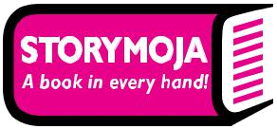

Creative Content Brief

Client | Storymoja Book Categorised digital artworks
Team | Shiro Gicharu, Dawn Makena, Gregory Omondi
Business Objective  (Include conversion rate and be specific when defining business objective, Timeline, What do you hope to achieve?) | Objective: Create digital artworks in order to promote the different categorised books we have for our CBC collections, which are :  - Kiswahili  - Psychomoter & Creative Activites  - Environment  - Art & Craft  - Hygiene & Nutrition  - Christian Religious Education (CRE)  Timeline of Banner: These posts will run on social media throughout the year & will be used on WhatsApp bulk services to promote our variety of products.  Why we need it: We need these posts in order to promote the variety of CBC books in high quality that resonates with our high end target audience.  What we hope to achieve: We are hoping that because we are promoting these posts across social media and using the What’sApp bulk messaging service, we can increase our sales of the CBC categorized books.
Target Audience  - Gender  - Age bracket  - Location  - Which social media handles to they use?  - What kind of content do they consume (what books do they want to buy?) (video, text, pics etc)  - Where do they live?  - Where do they socialize? | Male and Female (but mostly female)  Age – 18 - 45  Location – Nairobi  They are focused on Facebook and Twitter (especially in targeted groups) and enjoy vibrant, adventurous content that showcases a variety of products, giving them options.  They work and live around Nairobi, but are located mainly in Westlands, Kilimani, Kileleshwa, Lavington, they are the upper middle class therefore, content should be clean and high quality.  They socialize in malls around their neighborhood including; The Junction Mall, Sarit Centre, Lavington Mall, ABC Plaza, WestGate Mall, Greenhouse Mall, Prestige Plaza, Yaya Centre and AdLife Plaza.  This means that the content we are creating needs to be high resolution, clear and vibrant.
Communication Objective  (What should the content look and feel like? Emotional/Rational) | We want to create a post that showcases our wide range of categories for the Storymoja CBC collection. As such, we would need a post for EACH of the categories which are:  - Kiswahili  - Psychomoter & Creative Activites  - Environment  - Art & Craft  - Hygiene & Nutrition  - Christian Religious Education (CRE)  - One post with all the variety of books  *To reiterate we need a banner for EACH*
Visual References | The following graphic was presented to us by Makena who was suggesting that we create something like this but much better to resonate with our target audience.  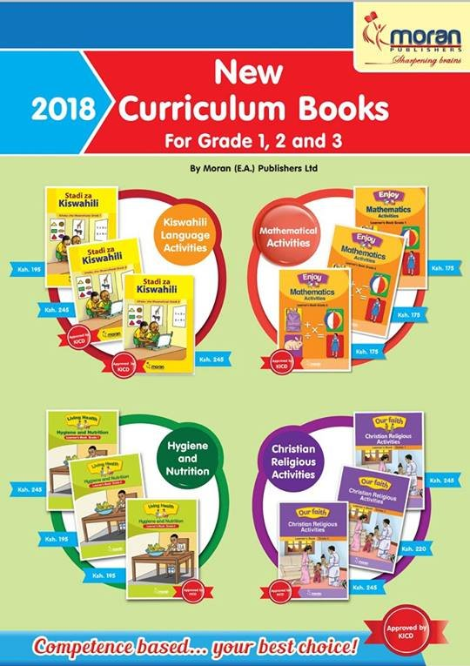
Media Outlets  (social media, traditional, website etc.) | Social media : Facebook, Instagram & Twitter Posts
Budget Required?  (Yes/No) | No
If Budget is Required, add amount here | 0, N/A
Mandatory Inclusions  (Logos,Dimensions,format – MP3, MP4, PDF etc. ) | Storymoja Logo should be located on the banners, social media posts, and social media templates on the bottom left or right hand corner.  Facebook Post Dimensions : 600 x 600  Instagram Post Dimensions : 600 x 600
Schedule/Deadline  (Timeline and delivery required date.)  Content Draft date & Final Draft date | Draft Ready by: To be confirmed  Deadline : To be confirmed

Confirmation:

Submitted by:

Full Name: Wanjiru Gicharu Date Received: 05-07-18

Received by Creative Department:

Full Name: Samira Matthews Date received:

