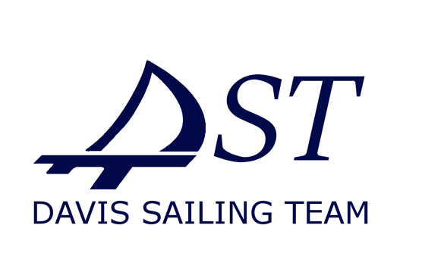

Personal Protective Equipment for

Fiberglass Repairs

The Davis Sailing Team at UC Davis has an extensive history of fiberglass and gelcoat repair of team boats. When appropriate, advice and assistance should be sought by LWSC members.

Fiberglass repair typically involves: sanding of gelcoat, sanding of glass fibers and cured resin, mixing of resin and flox (silica or fiber filler). **These activities present significant respiratory hazards.**

**Any: fiberglass repair, sanding, mixing of resin and flox (silica filler) MUST be done with proper personal protective equipment (PPE).**

At a minimum,

1. Use an N95 respirator.
   1. Ensure the respirator shape provides a proper seal around the face, otherwise it will not provide protection.
   2. A university-issued, fitted respirator is preferred.
2. Safety glasses or goggles.
3. Nitrile gloves.
   1. Do not use latex or rubber gloves.
4. Access to running water in case of skin or eye contact.

Take care to remove flox, silica, or fibers from hair and clothing before removing respirator.

Observers not wearing PPE should not walk downwind while sanding or mixing is taking place, and should maintain a reasonable distance from the repair activities to eliminate respiratory hazards.