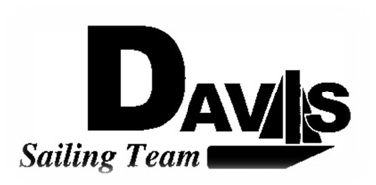
*Officers Meeting Agenda*
Wednesday, October 27th 2009
Sail House
9:00 pm to 10:00 pm
Open to the Public

- Call to Order:

- Roll Call
  - Quorum Check – 4 board members without the President
  - Early Report Check

- Reading and Approval of Minutes:

- Adoption of the Agenda:

- Executive Reports:
  - President – Ryan-Sandy Lee: ICSA update, Turkey Shoot Status
  - Captain – Michael Lazzaro: North South Info
  - Treasurer – Anthony Crans: San Diego Profit
  - Vice President – Liz Thome: Recruitment Day Nov7, NPO Stuff
  - Secretary – Christopher Hagerman:

- Information Items: (Maximum five minutes per topic)
  - Welcome New Board Members
  - Stanford Organization?
  - LWSC Work Day

- Discussion Items: (Maximum of five minutes per topic):
  - Email Password-need to change for new board
  - Regatta Organization- Should we do PRO’s or Committees?
      - Frosh/Soph Stanford-Leadership Times dues logistics
      - Turkey Shoot- Leadership Times dues logistics
      - Santa Barbara-Leadership Times Dues Logistics
  - Spring North South Dates- Stanford needs dates
  - Form Repair Committee-Sub committees: prep, layup, hardware
  - Practice Days

- Action Items: (Maximum of two minutes per topic)
  - Vote on Password
  - Vote on Regatta details
  - Vote on North South Dates
  - Elect Repair Committee and sub committees

- Members Reports & Public Comment:

- Open Forum:

  - Dollies
  - Trailer Committee

- Additions to the next meeting’s agenda: Next Meeting, Wednesday, 2009, 9:00 – 10:00 pm, Sail House

- Adjournment:
The Agenda was typed by the President at 3:30 pm 10/21/09. Revised by the President on 10/26/09 at 9:00pm. Any questions please contact Davis Sailing Team at davis.sailingteam@gmail.com.

