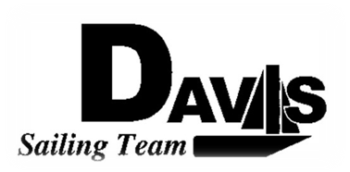
General Team Meeting
Date 12/02/09
Sail House
Time 9:00pm to 10:00pm
- Call to Order
- Roll Call
  - Officers Present & Quorum Check
    - Two Officers required
  - Early Report
- Minutes and Adoption of Agenda
  - Continuing Business
- Information Items
  - Last Meeting of Quarter
    - Next meeting 01/06/2010
  - Sail off Information
    - Time: 1 pm
    - Format
  - Rose Bowl Information
    - Leave Friday Jan 1
    - Staying at ABYC
    - Fee increase
- Discussion and Action Item
  - Bylaw Approval
- Executive Reports:
  - President – Ryan-Sandy Lee: Work Day people
  - Captain – Michael Lazzaro:
  - Treasurer – Anthony Crans:
  - Vice President– Liz Thome: Jackets
  - Secretary – Christopher Hagerman:
- Members Reports & Open Forum
- Additions to next week’s agenda
  - 01/06/2010
- Adjournment
Typed by the team President at 10:00am 11/11/09. Any questions please contact davis.sailingteam@gmail.com

