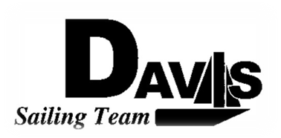
Officers Meeting
Date 2/1/10
at Sail House
Time 8:00pm to 9:00pm
- Call to Order
- Roll Call:
  - Officers Present & Quorum Check
    - Three Officers required
  - Early Report
- Approval of Minutes and Adoption of Agenda:

- Informational Items:
  - Ryan’s Address
- Discussion and Action Item:
  - Picnic Day
    - Informational booth
    - Collect Money
  - North’s Check-in
    - Housing
    - Logistics
    - Other Stuff
  - Harbor Cup Check-in
    - Housing
    - CMA Practice
    - Practice Recap & Crew Placement
      - Gas reimbursement?
- Executive Reports:
  - Executive Officer – Ryan-Sandy Lee:
  - Executive Sailing Officer – Michael Lazzaro:
  - V.P. Finances – Anthony Crans:
  - V.P.P.R.– Liz Thome:
  - V.P. Records – Christopher Hagerman:
- Members Reports & Open Forum
- Additions to next agenda
  - 2/8/10
- Adjournment
Typed by the team President at 9:45pm on 1/31/10. Any questions please contact davis.sailingteam@gmail.com

