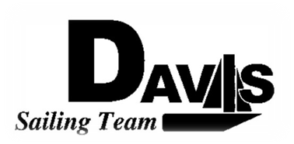
Officers Meeting
Date 3/29/10
at Sail House
Time 8:00pm to 9:00pm
- Call to Order
- Roll Call:
  - Officers Present & Quorum Check
    - Three Officers required
  - Early Report
- Approval of Minutes and Adoption of Agenda:

- Executive Reports:
  - Executive Officer – Ryan-Sandy Lee: LWSC Docks, Charity Regatta
  - Executive Sailing Officer – Michael Lazzaro:
  - V.P. Finances – Anthony Crans:
  - V.P.P.R.– Liz Thome:
  - V.P. Records – Christopher Hagerman:
- Informational Items:
  - South 5 Recap
- Discussion and Action Item:
  - Meeting Time
  - St. Francis
    - Housing
    - Sailors
  - Hawaii
    - Check in
  - Summer Sailing Lessons
    - Should we do it?
  - News Letter
  - Website
  - Logo
  - LWSC Dockstuff
  - Boat Repair
- Members Reports & Open Forum

- Additions to next agenda
  - 4/5/10
- Adjournment

