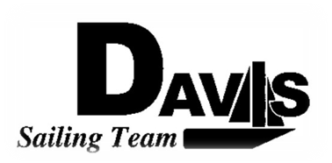
Officers Meeting
Date 1/25/10
at Sail House
Time 8:00pm to 9:00pm
- Call to Order
- Roll Call:
  - Officers Present & Quorum Check
    - Three Officers required
  - Early Report
- Approval of Minutes and Adoption of Agenda:
  - Dolly
  - 5.3.5 Nort #3-4
    - Date wants to be moved to 3/6-3/7
    - Can remove scrimmages and drop regatta
    - Need to let Stanford Coach know
- Informational Items:
- Discussion and Action Item:
  - PCCSC Meeting Recap
  - Team Roster
    - E-Contact
    - Membership Dues
  - Regattas
    - Elect Organizing Officer
    - Set Price
    - North #1
      - Stanford
      - 2/6(scrimmage)-2/7
    - North #2
      - CAL
      - 2/13 Scrimmage
        - Beginner Stanford
        - Intermediate CAL
      - 2/14 Regatta CAL
    - North #3-4
      - CSUMB
      - 2/27-28
    - CAL Team Race
      - CAL
      - 3/6-3/7
      - Going?
    - South #5
      - USC
      - 3/27-3/28
    - St. Francis Invite
      - SFYC
      - 4/3-4/4
  - Amend Schedule
    - Work Day
    - Keelboat Practices
  - Harbor Cup Check In
    - Who’s going
    - Money Collected
  - Sunday(1/24) Issues
    - Work Day (Mike)
      - Issue Invoices
    - Practices (Ryan)
- Executive Reports:
  - Executive Officer – Ryan-Sandy Lee: Officers Issues
  - Executive Sailing Officer – Michael Lazzaro:
  - V.P. Finances – Anthony Crans:
  - V.P.P.R.– Liz Thome:
  - V.P. Records – Christopher Hagerman:
- Members Reports & Open Forum
- Additions to next agenda
  - 2/1/2010
- Adjournment
Typed by the team President at 7:30pm 1/24/09. Any questions please contact davis.sailingteam@gmail.com

