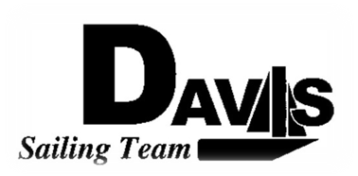
Officers Meeting
Date 11/24/09
at the Boat Yard
(Formally known as Sail House)
Time 9:00pm to 10:00pm
- Call to Order
- Roll Call:
  - Officers Present & Quorum Check
    - Three Officers required
  - Early Report
- Approval of Minutes and Adoption of Agenda:
- Informational Items:
  - SPAC Update Form
- Discussion and Action Item:
  - PCCSC Annual Meeting Jan 23 (Ryan)
    - Anyone want to go?
    - $10 per person @ Stanford.
  - Create Winter Calendar
    - Regatta Calendar (Mike)
      - Harbor Cup
      - St. Francis
      - North/South Series
      - Others Not Listed
      - Sail Off dates
    - PR Calendar (Liz)
      - Recruitment Days
      - Work Day
      - End of Quarter BBQ Day
      - Snow Sailing?
  - NPO Jobs (Liz)
- Executive Reports:
  - President – Ryan-Sandy Lee: New LWSC Board
  - Captain – Michael Lazzaro:
  - Treasurer – Anthony Crans:
  - Vice President– Liz Thome:
  - Secretary – Christopher Hagerman:
- Members Reports & Open Forum
- Additions to next week’s agenda
  - 11/22/2009
- Adjournment
Typed by the team President at 10:00am 11/11/09. Any questions please contact davis.sailingteam@gmail.com

