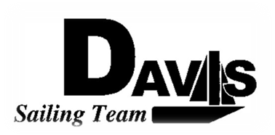
General Team Meeting
Date 1/20/10
Sail House
Time 9:00pm to 10:00pm
- Call to Order
- Roll Call
  - Officers Present & Quorum Check
    - Two Officers required
  - Early Report
- Minutes and Adoption of Agenda
  - Continuing Business
- Information Items
  - Harbor Cup
    - Details
    - Logistics
  - Practice & Schedule
    - NO Saturday Practice
    - Work Day Sunday
    - Yes Sunday Practice
  - Jacket Pick up
- Discussion and Action Items
- Executive Reports:
  - Executive Officer – Ryan-Sandy Lee: Boats
  - V.P. Finances – Anthony Crans:
  - V.P. Public Relations– Liz Thome: Jackets
  - V.P. Records – Christopher Hagerman:
  - Executive Sailing Officer – Michael Lazzaro: Boat Handling
- Members Reports & Open Forum
- Additions to next week’s agenda
  - 01/27/2010
- Adjournment
Typed by the team President at 11:00pm 1/18/10. Any questions please contact davis.sailingteam@gmail.com

