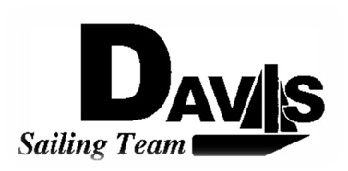
*General Meeting Agenda*
Wednesday, November 4rd 2009
Sail House
9:00 pm to 10:00 pm
Open to the Public

- Call to Order

- Roll Call:
  - Officer’s Present:
  - Quorum Check – Two officers required.
  - Early Report Check

- Reading and Approval of Minutes

- Adoption of the Agenda:

- Information Items
  - This week’s practice: No Thursday.
  - Turkey Shoot
    - Date: 11/08
    - Time: 9:00am meet 9:30 report. Skippers responsible for rigging
    - Format: Right now no rotations. Possible changes. Take a lunch.
  - Champs (Santa Barbara)
    - Date: 11/14-15
    - Time: 3:00pm meet 3:00 leave
    - Housing: William’s Place
    - Format: One Varsity non-rotating fleet. One Varsity Lazer Fleet. Normal JV.
  - Rose Bowl Introduction
  - Work Day
    - Time: 11/21 meet here at 9:00
    - Format: BBQ and Team Picture later
  - By Laws Discussion
    - Date: Moved to Wednesday 11/18

- Discussion & Action Items
  - General Contact Sheet

- Executive Reports:
  - President – Ryan-Sandy Lee:
  - Captain – Michael Lazzaro:
  - Treasurer – Anthony Crans:
  - Director of Fundraising and Membership– Liz Thome: T-Shirts
  - Secretary – Christopher Hagerman:

- Members Reports & Open Forum:

- Additions to the next meeting’s agenda: Next Meeting, Wednesday, Nov 11th 2009, 9:00 – 10:00 pm, Sail House

- Adjournment:
The Quote- “ When in doubt, let it out.” ~ Sailing Tip
The Agenda was typed by Team President at 10:30 pm 11/03/09. Any questions please contact Davis Sailing Team at davis.sailingteam@gmail.com.

