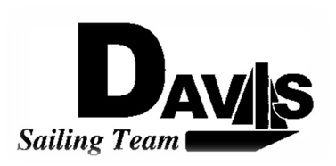
*Officers Meeting Agenda*
Tuesday, November 10th 2009
Sail House
9:00 pm to 10:00 pm
Open to the Public

- Call to Order:

- Roll Call
  - Quorum Check – 4 board members without the President
  - Early Report Check

- Reading and Approval of Minutes:

- Adoption of the Agenda:

- Information Items: (Maximum five minutes per topic)

- Discussion & Action Items: (Maximum of five minutes per topic):
  - Turkey Shoot Recap
  - Santa Barbara
    - Eligibility & Head Count
    - RSVP: Sail numbers (on Laser)
    - Housing: Get Will’s address.
    - Departure Time:
      - 3pm leave at 3:30pm
      - Later Car?
    - Transportation Logistics:
      - Boats
      - Cars
  - Work Day
  - Rest or quarter Practices and Meetings
  - Change Logo

- Executive Reports:
  - President – Ryan-Sandy Lee: No show fee
  - Captain – Michael Lazzaro:
  - Treasurer – Anthony Crans:
  - Vice President – Liz Thome:
  - Secretary – Christopher Hagerman:

- Members Reports & Public Comment:

- Additions to the next meeting’s agenda: Next Meeting, Wednesday, 2009, 9:00 – 10:00 pm, Sail House
  - Make schedule for winter quarter

- Open Forum:

- Adjournment:
The Agenda was typed by the President at 10:50 pm 11/10/09. Any questions please contact Davis Sailing Team at davis.sailingteam@gmail.com.

