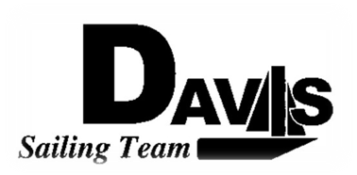
Officers Meeting
Date 02/08/2010
at Sail House
Time 8:00pm to 9:00pm
- Call to Order
- Roll Call:
  - Officers Present & Quorum Check
    - Three Officers required
  - Early Report
- Approval of Minutes and Adoption of Agenda:

- Informational Items:
  - North 1 Recap
    - Money Matters
    - Sailors
- Discussion and Action Item:
  - North 2
    - Saturday moved to Berkley
    - Housing Status
    - Boat Loading Time
  - North 3-4
    - Housing Status
    - Boat Loading Time
  - Harbor Cup
    - Mandatory Day?
    - Other Keelboat status?
  - Bad Weather Boat Committee
    - LWSC Request
  - Pizza Party
- Executive Reports:
  - Executive Officer – Ryan-Sandy Lee: LWSC Meeting Input
  - Executive Sailing Officer – Michael Lazzaro:
  - V.P. Finances – Anthony Crans:
  - V.P.P.R.– Liz Thome:
  - V.P. Records – Christopher Hagerman:
- Members Reports & Open Forum
- Additions to next agenda

- Adjournment
Typed by the team President at 9:00 pm on 2/07/2010. Any questions please contact davis.sailingteam@gmail.com

