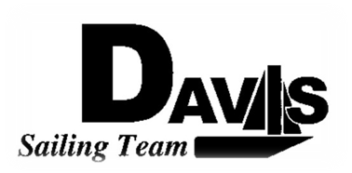
Officers Meeting
Date 2/22/2010
at Sail House
Time 8:00pm to 9:00pm
- Call to Order
- Roll Call:
  - Officers Present & Quorum Check
    - Three Officers required
  - Early Report
- Approval of Minutes and Adoption of Agenda:

- Executive Reports:
  - Executive Officer – Ryan-Sandy Lee: Wednesday Address Overview
  - Executive Sailing Officer – Michael Lazzaro:
  - V.P. Finances – Anthony Crans: Budget
  - V.P.P.R.– Liz Thome: Apparel/Bowling Party
  - V.P. Records – Christopher Hagerman: E-contact sheet
- Informational Items:
  - North 3-4 recap
  - Scrapped Snow Bonding
  - Hawaii
- Discussion and Action Item:
  - Website
  - Practice
    - Saturday Details
    - Workday Details
    - Sunday Details
  - Harbor Cup Check-in (3 weeks countdown)
    - Housing
    - Registration
    - Practices on 3/6-3/7
  - South 5 preliminary planning
- Members Reports & Open Forum
  - Aggie Article
- Additions to next agenda
  - 3/1/2010
- Adjournment

