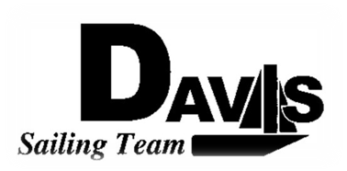
General Team Meeting
Date 11/11/09
Sail House
Time 9:00pm to 10:00pm
- Call to Order
- Roll Call
  - Officers Present & Quorum Check
    - Two Officers required
  - Early Report
- Minutes and Adoption of Agenda
  - Continuing Business
- Information Items
  - Turkey Shoot Recap
  - Santa Barbara
    - Head Count
    - Cars & Departure Times
    - Directions
    - Boats and Rotations
  - Work Day
    - 11/21/2009
    - 9:00am – 1:00pm
    - BBQ, Sailing and Team Pictures after 1:00pm
  - Turkey Dinner
    - Sign Up
  - Logo Change
    - December 2
  - New Practice Times
    - Cancelling Thursday, Friday from now on
    - Emphasis on Saturday
  - Meeting Cancelled 11/25/2009
  - Bylaws Meeting 11/18/2009
- Discussion and Action Item
- Executive Reports:
  - President – Ryan-Sandy Lee:
  - Captain – Michael Lazzaro:
  - Treasurer – Anthony Crans:
  - Vice President– Liz Thome:
  - Secretary – Christopher Hagerman:
- Members Reports & Open Forum
- Additions to next week’s agenda
  - 11/18/2009
- Adjournment
Typed by the team President at 10:00am 11/11/09. Any questions please contact davis.sailingteam@gmail.com

