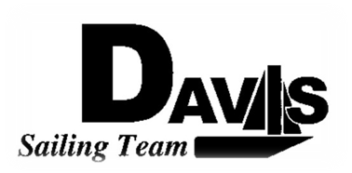
General Team Meeting
Date 1/13/10
Sail House
Time 9:00pm to 10:00pm
- Call to Order
- Roll Call
  - Officers Present & Quorum Check
    - Two Officers required
  - Early Report
- Minutes and Adoption of Agenda
  - Continuing Business
- Information Items
  - Practices
    - Great Turnout
    - Sat & Sunday
  - Work Day Changed
    - February 28th (Sunday NOT Saturday)
  - Make up Workday
    - TBA – See Mike
- Discussion and Action Items:
  - Keelboat Team – Chris
    - Information
    - Vote to form
- Executive Reports:
  - Executive Officer – Ryan-Sandy Lee: LWSC Stuff
  - V.P. Finances – Anthony Crans:
  - V.P. Public Relations – Liz Thome: Jackets
  - V.P. Records – Christopher Hagerman:
  - Executive Sailing Officer – Michael Lazzaro: Boat Handling
- Members Reports & Open Forum
- Additions to next week’s agenda
  - 01/12/2010
- Adjournment
Typed by the team’s Ex.O. at 11:00pm 1/12/10. Any questions please contact davis.sailingteam@gmail.com

