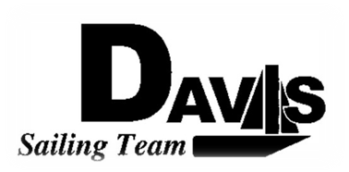
General Team Meeting
Date 3/31/10
Sail House
Time 9:00pm to 10:00pm
- Call to Order
- Roll Call
  - Officers Present & Quorum Check
    - Two Officers required
  - Early Report
- Minutes and Adoption of Agenda
  - Continuing Business
- Information Items
  - North 5
    - @ St. Francis
    - Logistics
    - Come Support your team
  - PCC
    - @ Hawaii
    - Check in Updates
  - Dock Building
    - April 10th & 11th 10am-1pm
  - Picnic Day
    - Booth Overview
    - Sign Up Sheet
  - LWSC Open House
    - April 24th
    - Mandatory Attendance
    - Booth Overview
    - Sign up
  - Practice
    - April 10th & 11th
    - 1pm-6pm
- Discussion and Action Items
  - Change Logo
    - Vote to change to Burgee
- Executive Reports:
  - Executive Officer – Ryan-Sandy Lee:
  - V.P. Finances – Anthony Crans:
  - V.P. Public Relations– Liz Thome:
  - V.P. Records – Christopher Hagerman:
  - Executive Sailing Officer – Michael Lazzaro: Boat Handling
- Members Reports & Open Forum
- Additions to next week’s agenda
  - 4/7/10
- Adjournment

