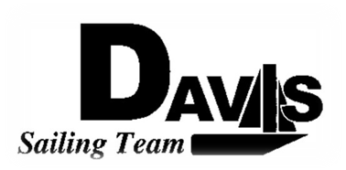
General Team Meeting
Date 2/01/10
Sail House
Time 9:00pm to 10:00pm
- Call to Order
- Roll Call
  - Officers Present & Quorum Check
    - Two Officers required
  - Early Report
- Minutes and Adoption of Agenda
  - Continuing Business
- Information Items
  - North 1
    - Departure Time
    - Cars
  - North 2, 3 &4
    - Head count
  - Snow Bonding
    - Moved to 3/22-25
    - Head count
  - Harbor Cup Practice Recap
- Discussion and Action Items
- Executive Reports:
  - Executive Officer – Ryan-Sandy Lee:
  - V.P. Finances – Anthony Crans:
  - V.P. Public Relations– Liz Thome:
  - V.P. Records – Christopher Hagerman:
  - Executive Sailing Officer – Michael Lazzaro: Boat Handling
- Members Reports & Open Forum
- Additions to next week’s agenda
  - 02/10/2010
- Adjournment

