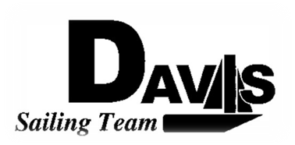
General Team Meeting
Date 2/24/10
Sail House
Time 9:00pm to 10:00pm
- Call to Order
- Roll Call
  - Officers Present & Quorum Check
    - Two Officers required
  - Early Report
- Minutes and Adoption of Agenda
  - Continuing Business
  - Bowling Party Sign Up
- Information Items
  - Practice
    - Saturday Keelboat
    - Sunday Dingy (usual time)
  - Upcoming Workday
    - Sunday 2/28 8:00am
  - South 5
    - Varsity Only
    - 1-2 alternates submit resume & fill out form
- Discussion and Action Items
  - North 3-4 Recap
  - Hawaii
- Executive Reports:
  - Executive Officer – Ryan-Sandy Lee:
  - V.P. Finances – Anthony Crans:
  - V.P. Public Relations– Liz Thome: Bowling Party / Apparel
  - V.P. Records – Christopher Hagerman:
  - Executive Sailing Officer – Michael Lazzaro: Boat Handling
- Members Reports & Open Forum
- Additions to next week’s agenda
  - 03/03/2010 (Bowling Party)
- Adjournment

