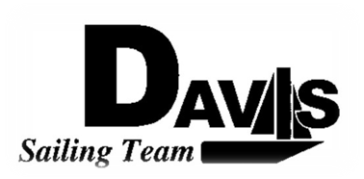
General Team Meeting
Date 1/27/10
Sail House
Time 9:00pm to 10:00pm
- Call to Order
- Roll Call
  - Officers Present & Quorum Check
    - Two Officers required
  - Early Report
- Minutes and Adoption of Agenda
  - Continuing Business
- Information Items
  - Harbor Cup (Mike)
    - Final Deadline
    - Mandatory Practice day 2/21
    - New RP form
    - Take team picture (so wear your jackets)
    - Chris in charge of crew placements
  - Schedule Adjustments (Me)
    - 1/30 Dingy Sail Off
    - 1/31 Keelboat
    - 2/20 Dingy WORKDAY
    - 2/21 Keelboat Mandatory
    - 2/27 Dingy
    - 2/28 Keelboat
    - 3/06 North #3
    - 3/07 North #4
    - Snow bonding?
  - Art Committee (Liz)
    - Need poster for tabling
    - Organize Interest time
  - Workday Recap (Me)
    - Owe money ($10): Eric, Jules, Sam, Chris, Jeff, Kelly, Noëlle, George
- Discussion and Action Items
  - Practice Communication
    - Improve Current System
- Executive Reports:
  - Executive Officer – Ryan-Sandy Lee:
  - V.P. Finances – Anthony Crans:
  - V.P. Public Relations– Liz Thome:
  - V.P. Records – Christopher Hagerman:
  - Executive Sailing Officer – Michael Lazzaro: Boat Handling
- Members Reports & Open Forum
- Additions to next week’s agenda
  - 01/27/2010
- Adjournment

