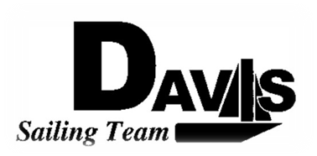
Officers Meeting
Date 2/15/10
at Sail House
Time 8:00pm to 9:00pm
- Call to Order
- Roll Call:
  - Officers Present & Quorum Check
    - Three Officers required
  - Early Report
- Approval of Minutes and Adoption of Agenda:

- Informational Items:
  - Budgetary Report
    - Total Funds
    - Funds Appropriated
    - Funds Liability
    - Funds Available
  - North 2 Recap
- Discussion and Action Item:
  - North 3/4
    - Boats required
      - Wednesday Meeting Location
    - Departure Times
    - Housing
  - Harbor Cup
    - Competitors Forms
      - Who needs to sign?
    - Practice Details
      - Feb 27
      - March 6 & 7
    - Housing Follow Up
  - Bowling Party
  - Snow Bonding
- Executive Reports:
  - Executive Officer – Ryan-Sandy Lee: LWSC Dock
  - Executive Sailing Officer – Michael Lazzaro:
  - V.P. Finances – Anthony Crans:
  - V.P.P.R.– Liz Thome: Apparel
  - V.P. Records – Christopher Hagerman:
- Members Reports & Open Forum
- Additions to next agenda

- Adjournment

