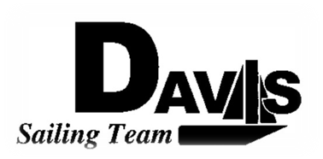
Officers Meeting
Date 1/11/09
at Sail House
Time 8:00pm to 9:00pm
- Call to Order
- Roll Call:
  - Officers Present & Quorum Check
    - Three Officers required
  - Early Report
- Approval of Minutes and Adoption of Agenda:
- Informational Items:
- Discussion and Action Item:
  - Current Balance
    - Who needs to pay
  - PCCSC Meeting
    - Departure time & Ride arrangements
- Executive Reports:
  - Executive Officer – Ryan-Sandy Lee: LWSC meeting tomorrow, any issues input
  - Executive Sailing Officer – Michael Lazzaro: Tool Box & Trailer
  - V.P. Finances – Anthony Crans:
  - V.P.P.R.– Liz Thome: Jackets
  - V.P. Records – Christopher Hagerman:
- Members Reports & Open Forum
- Additions to next agenda
  - 1/25/2009
- Adjournment
Typed by the team President at 5:30pm 1/11/09. Any questions please contact davis.sailingteam@gmail.com

