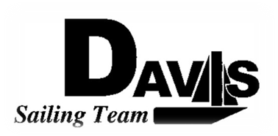
Officers Meeting
Date 3/08/10
at Sail House
Time 8:00pm to 9:00pm
- Call to Order
- Roll Call:
  - Officers Present & Quorum Check
    - Three Officers required
  - Early Report
- Approval of Minutes and Adoption of Agenda:

- Executive Reports:
  - Executive Officer – Ryan-Sandy Lee:
  - Executive Sailing Officer – Michael Lazzaro:
  - V.P. Finances – Anthony Crans:
  - V.P.P.R.– Liz Thome:
  - V.P. Records – Christopher Hagerman:
- Informational Items:

- Discussion and Action Item:
  - Harbor Cup
    - Departure Time
    - Sailor Placement
  - Hawaii
    - Progress Check-in
    - Rental Car
  - South 5
    - Who’s paid
    - Logistics
  - Practice
    - Saturday
    - Sunday
  - Banner
  - Lorenzo
- Members Reports & Open Forum

- Additions to next agenda

- Adjournment

