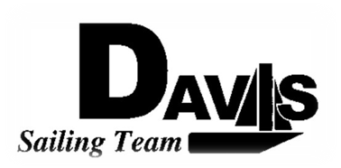
Officers Meeting
Date 12/01/09
at Sail House
Time 9:00pm to 10:00pm
- Call to Order
- Roll Call:
  - Officers Present & Quorum Check
    - Three Officers required
  - Early Report
- Approval of Minutes and Adoption of Agenda:
- Informational Items:
- Discussion and Action Item:
  - Approve Winter Calendar
  - Sunday Practice?
  - Next Quarter Officers Meetings
  - NPO
    - Current Finical Information
    - Inventory List
    - Filing Date
  - Sail Off Stuff
  - Rosebowl
- Executive Reports:
  - President – Ryan-Sandy Lee: SPAC updated
  - Captain – Michael Lazzaro:
  - Treasurer – Anthony Crans:
  - Vice President– Liz Thome: Jackets
  - Secretary – Christopher Hagerman:
- Members Reports & Open Forum
- Additions to next agenda
  - 1/05/2009
- Adjournment
Typed by the team President at 10:45am 12/1/09. Any questions please contact davis.sailingteam@gmail.com

