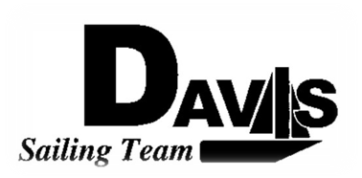
General Team Meeting
Date 2/10/10
Lake Washington
Time 9:00pm to 10:00pm
- Call to Order
- Roll Call
  - Officers Present & Quorum Check
    - Two Officers required
  - Early Report
- Minutes and Adoption of Agenda
  - Continuing Business
- Information Items
  - North 1 Recap
  - North 2 Details
    - Team racing scrimmage
    - North 2
    - Leave 8am from sail house Saturday
    - Stay on J-105
  - North 3-4
    - Sign Up for discount!
    - Same thing next week
- Discussion and Action Items
  - Harbor Cup
    - Move mandatory day to 3/6-3/7
    - Resign Form
    - Apparel Stuff
- Executive Reports:
  - Executive Officer – Ryan-Sandy Lee:
  - V.P. Finances – Anthony Crans:
  - V.P. Public Relations– Liz Thome:
  - V.P. Records – Christopher Hagerman:
  - Executive Sailing Officer – Michael Lazzaro: Boat Handling
- Members Reports & Open Forum
- Additions to next week’s agenda
  - 02/17/2010
  - Next meeting is at LWSC as well.
- Adjournment

