**Exercise 1**

SELECT c.customer_id,

c.customer_fname AS [customer_first_name],

c.customer_lname AS [customer_last_name],

COUNT(1) AS [customer_order_count]

FROM customers c JOIN orders o ON

c.customer_id = o.order_customer_id

WHERE FORMAT(o.order_date, 'yyyy-MM') LIKE '2014-01'

GROUP BY c.customer_id, c.customer_fname, c.customer_lname

ORDER BY customer_order_count DESC, c.customer_id;

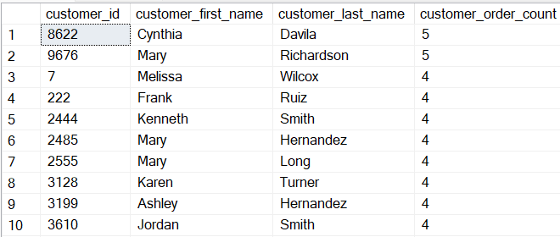

**Exercise 2**

SELECT DISTINCT c.*

FROM customers c JOIN orders o ON

c.customer_id = o.order_customer_id

WHERE o.order_customer_id NOT IN (SELECT order_customer_id

FROM orders

WHERE FORMAT(order_date, 'yyyy-MM') LIKE '2014-01')

ORDER BY c.customer_id

;

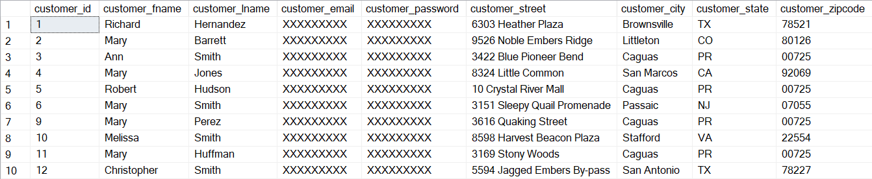

**Exercise 3**

SELECT c.customer_id, c.customer_fname AS [customer_first_name],

c.customer_lname AS [customer_last_name],

CASE WHEN SUM(oi.order_item_subtotal) IS NOT NULL

THEN SUM(oi.order_item_subtotal)

ELSE 0 END AS [customer_revenue]

FROM customers c LEFT JOIN orders o ON

c.customer_id = o.order_customer_id

LEFT JOIN order_items oi ON

o.order_id = oi.order_item_order_id

AND FORMAT(o.order_date, 'yyyy-MM') LIKE '2014-01'

AND o.order_status IN ('COMPLETE', 'CLOSED')

GROUP BY c.customer_id, c.customer_fname, c.customer_lname

ORDER BY customer_revenue DESC, c.customer_id;

;

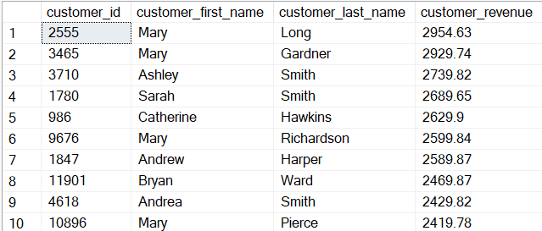

**Exercise 4**

SELECT c.category_id, c.category_department_id, c.category_name,

ROUND(SUM(oi.order_item_subtotal), 2) AS [category_revenue]

FROM orders o JOIN order_items oi ON

o.order_id = oi.order_item_order_id

JOIN products p ON

oi.order_item_product_id = p.product_id

JOIN categories c ON

p.product_category_id = c.category_id

WHERE FORMAT(o.order_date, 'yyyy-MM') LIKE '2014-01'

AND o.order_status IN ('COMPLETE', 'CLOSED')

GROUP BY c.category_id, c.category_department_id, c.category_name

ORDER BY c.category_id

;

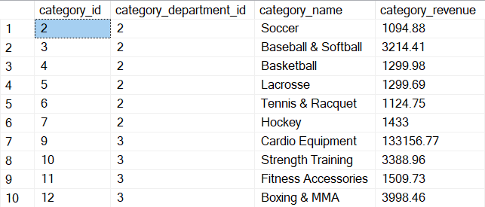

**Exercise 5**

SELECT d.department_id, d.department_name,

COUNT(p.product_id) AS [product_count]

FROM products p JOIN categories c ON

p.product_category_id = c.category_id

RIGHT JOIN departments d ON

c.category_department_id = d.department_id

GROUP BY d.department_id, d.department_name

ORDER BY d.department_id

;

