Smith & Nephew - Valuation Thesis
06 November 2025

Executive summary
We have evaluated Smith & Nephew through three approached: a whole company DCF, a sum of the parts, using the different segments’ costs and revenues, and a risk-adjusted NPV that prices and incorporates their upcoming pipeline
Valuation Method | Value Per ADR | Vs USD 36.82
DCF | $38.84 | 5.5%
SOTP | $41.03 | 11.4%
rNPV | $51.37 | 39.5%
Median / Average | $41.03 / $43.75 | 11.4% / 18.8%
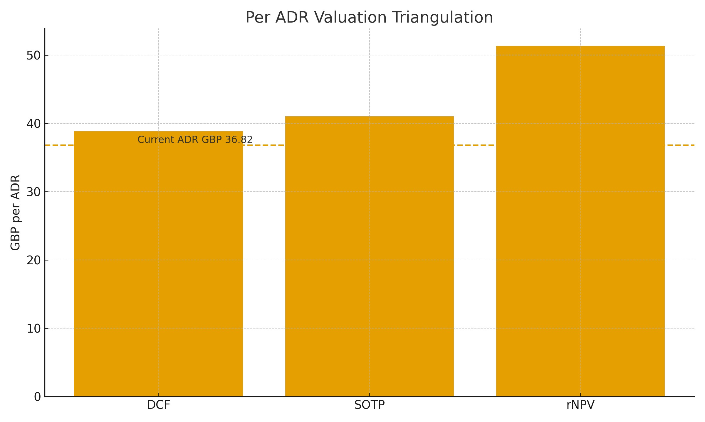

Context from recent disclosures and industry sources
Management reports the 12-point improvement plan largely complete with margin expansion across all units in 2024, and reiterated 2025 guidance for mid-single-digit growth and higher trading margins. H1 2025 results also introduced a sizeable buyback, signalling confidence in cash generation. Externally, China remains a swing factor following 2024 volume-based procurement pressure; by contrast, innovation cadence in Sports Medicine stays a relative bright spot. The CORI handheld robotics platform now covers primary and revision knee, hip and partial procedures with image-free mapping, which supports adoption, although capital intensity and training remain practical constraints.

Investment thesis - what we are paying for
- Resilient cash flows from procedure-linked demand and an attractive aftermarket in implants and consumables. - Margin repair as the primary near-term equity driver; every sustained one point of margin is meaningful for equity value. - Mix shift towards Sports Med and Advanced Wound is positive; Orthopaedics execution is the swing factor that will set the multiple. - Balance sheet strength provides strategic flexibility for tightly screened bolt-ons and buybacks without compromising resilience. - Pipeline optionality is real but must be earned through evidence of adoption and utilisation.

Operating discipline - signals in the model
Free cash flow to enterprise value steps up from 3.1% in 2025 to 4.2% by 2029. Capex runs at about -7.7% of sales on average, with depreciation and amortisation similar, suggesting sustaining needs are manageable. Working-capital drag moderates; EBIT-to-FCF conversion improves from
71.8% to 75.6% across the plan.
Metric | Observation
EBIT margin trajectorySettles in mid-teens by the outer years; upside | if Orthopaedics normalises and mix improves.
Capex as % of sales | Around -7.7% through the explicit period.
D and A as % of sales | Around 7.7%; broadly offsets sustaining capex.
Change in NWC as % of sales | Improves from -2.4% to -1.9%.
FCF yield on EV | 3.1% rising to 4.2% by 2029.
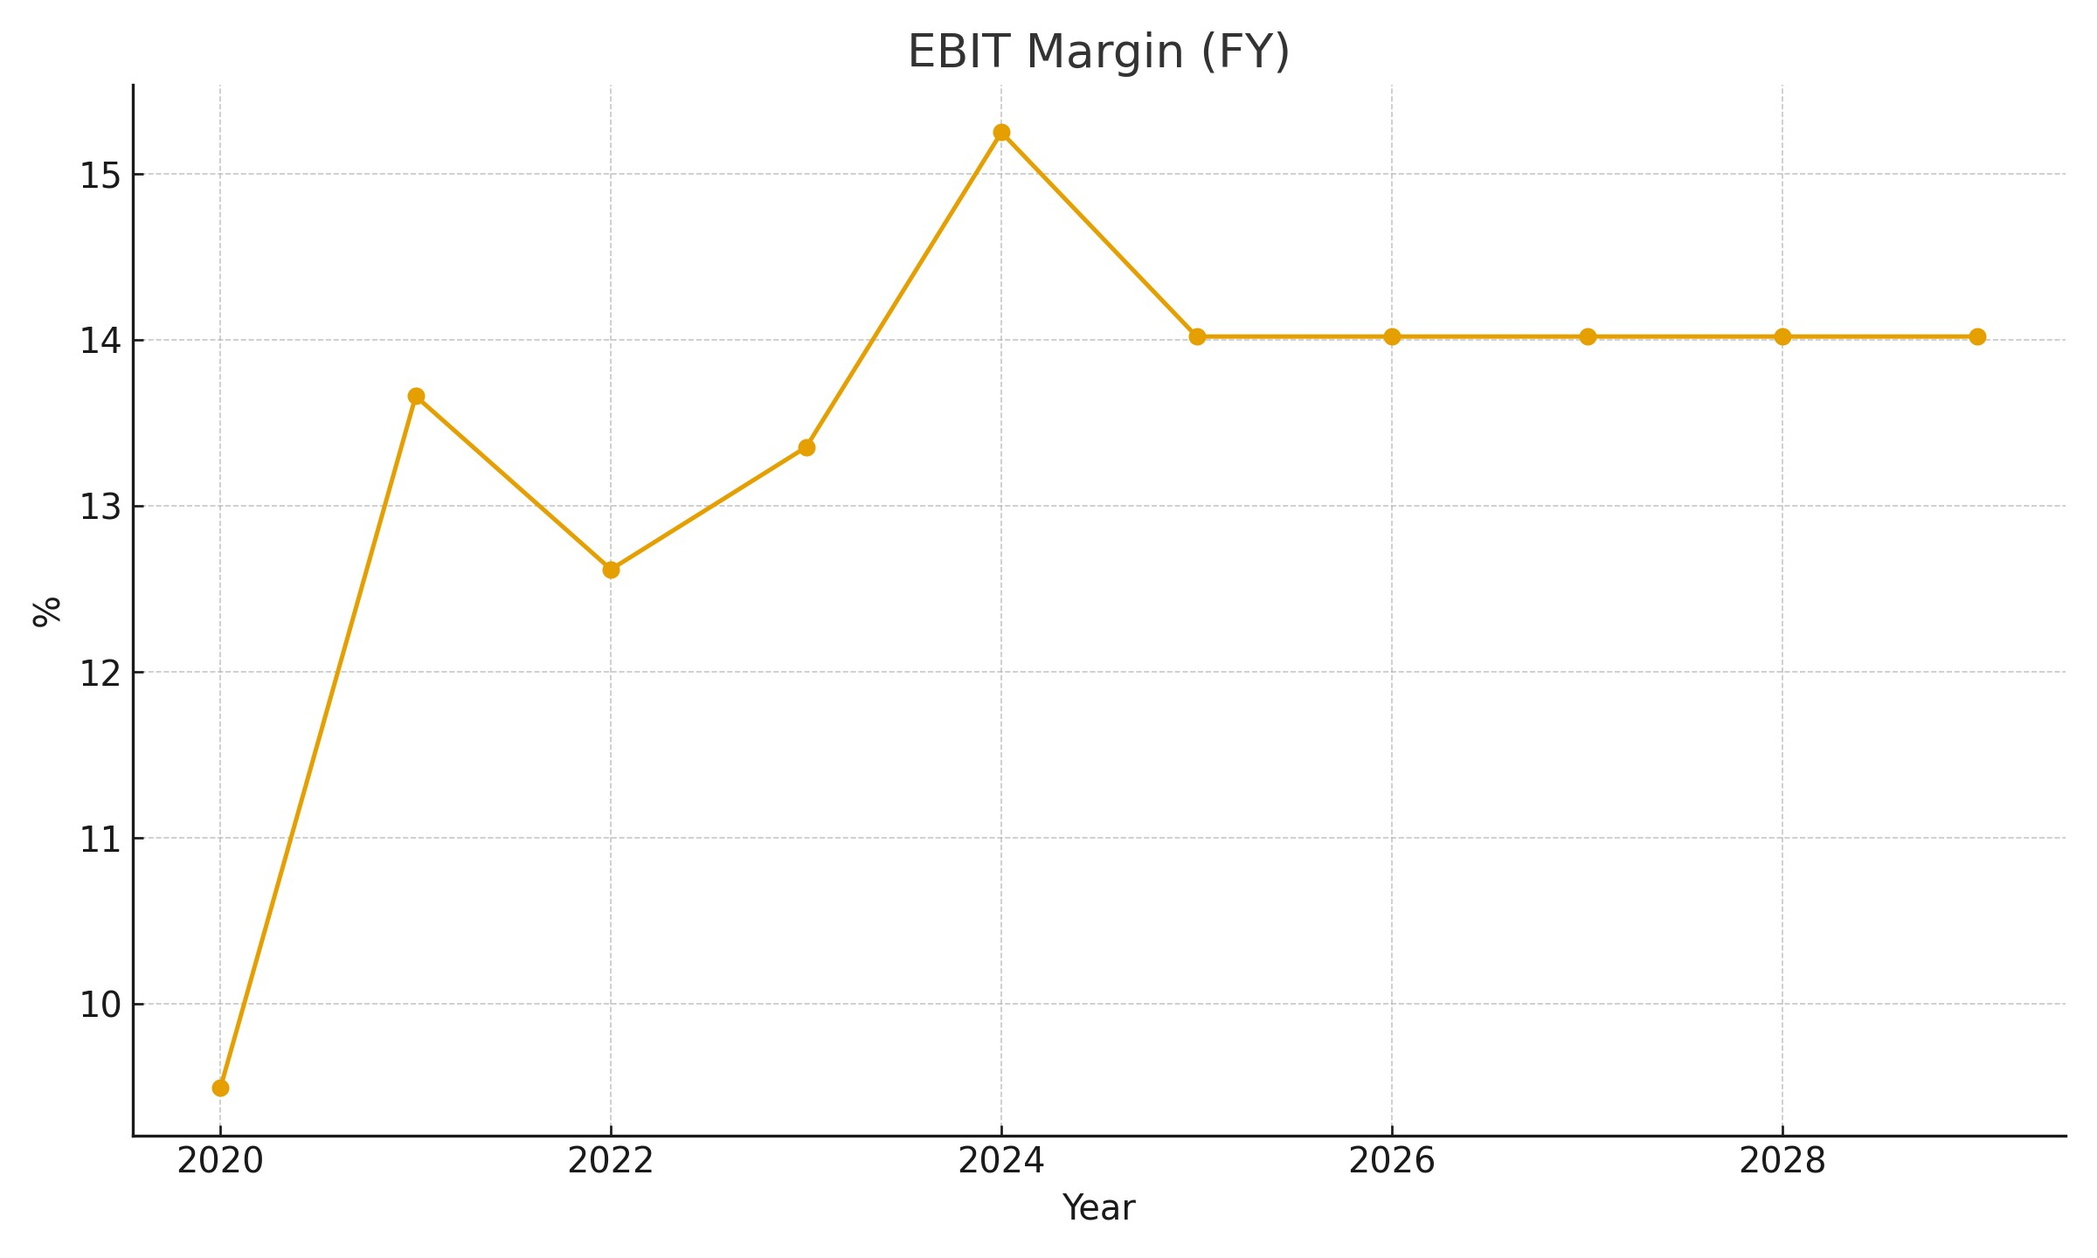

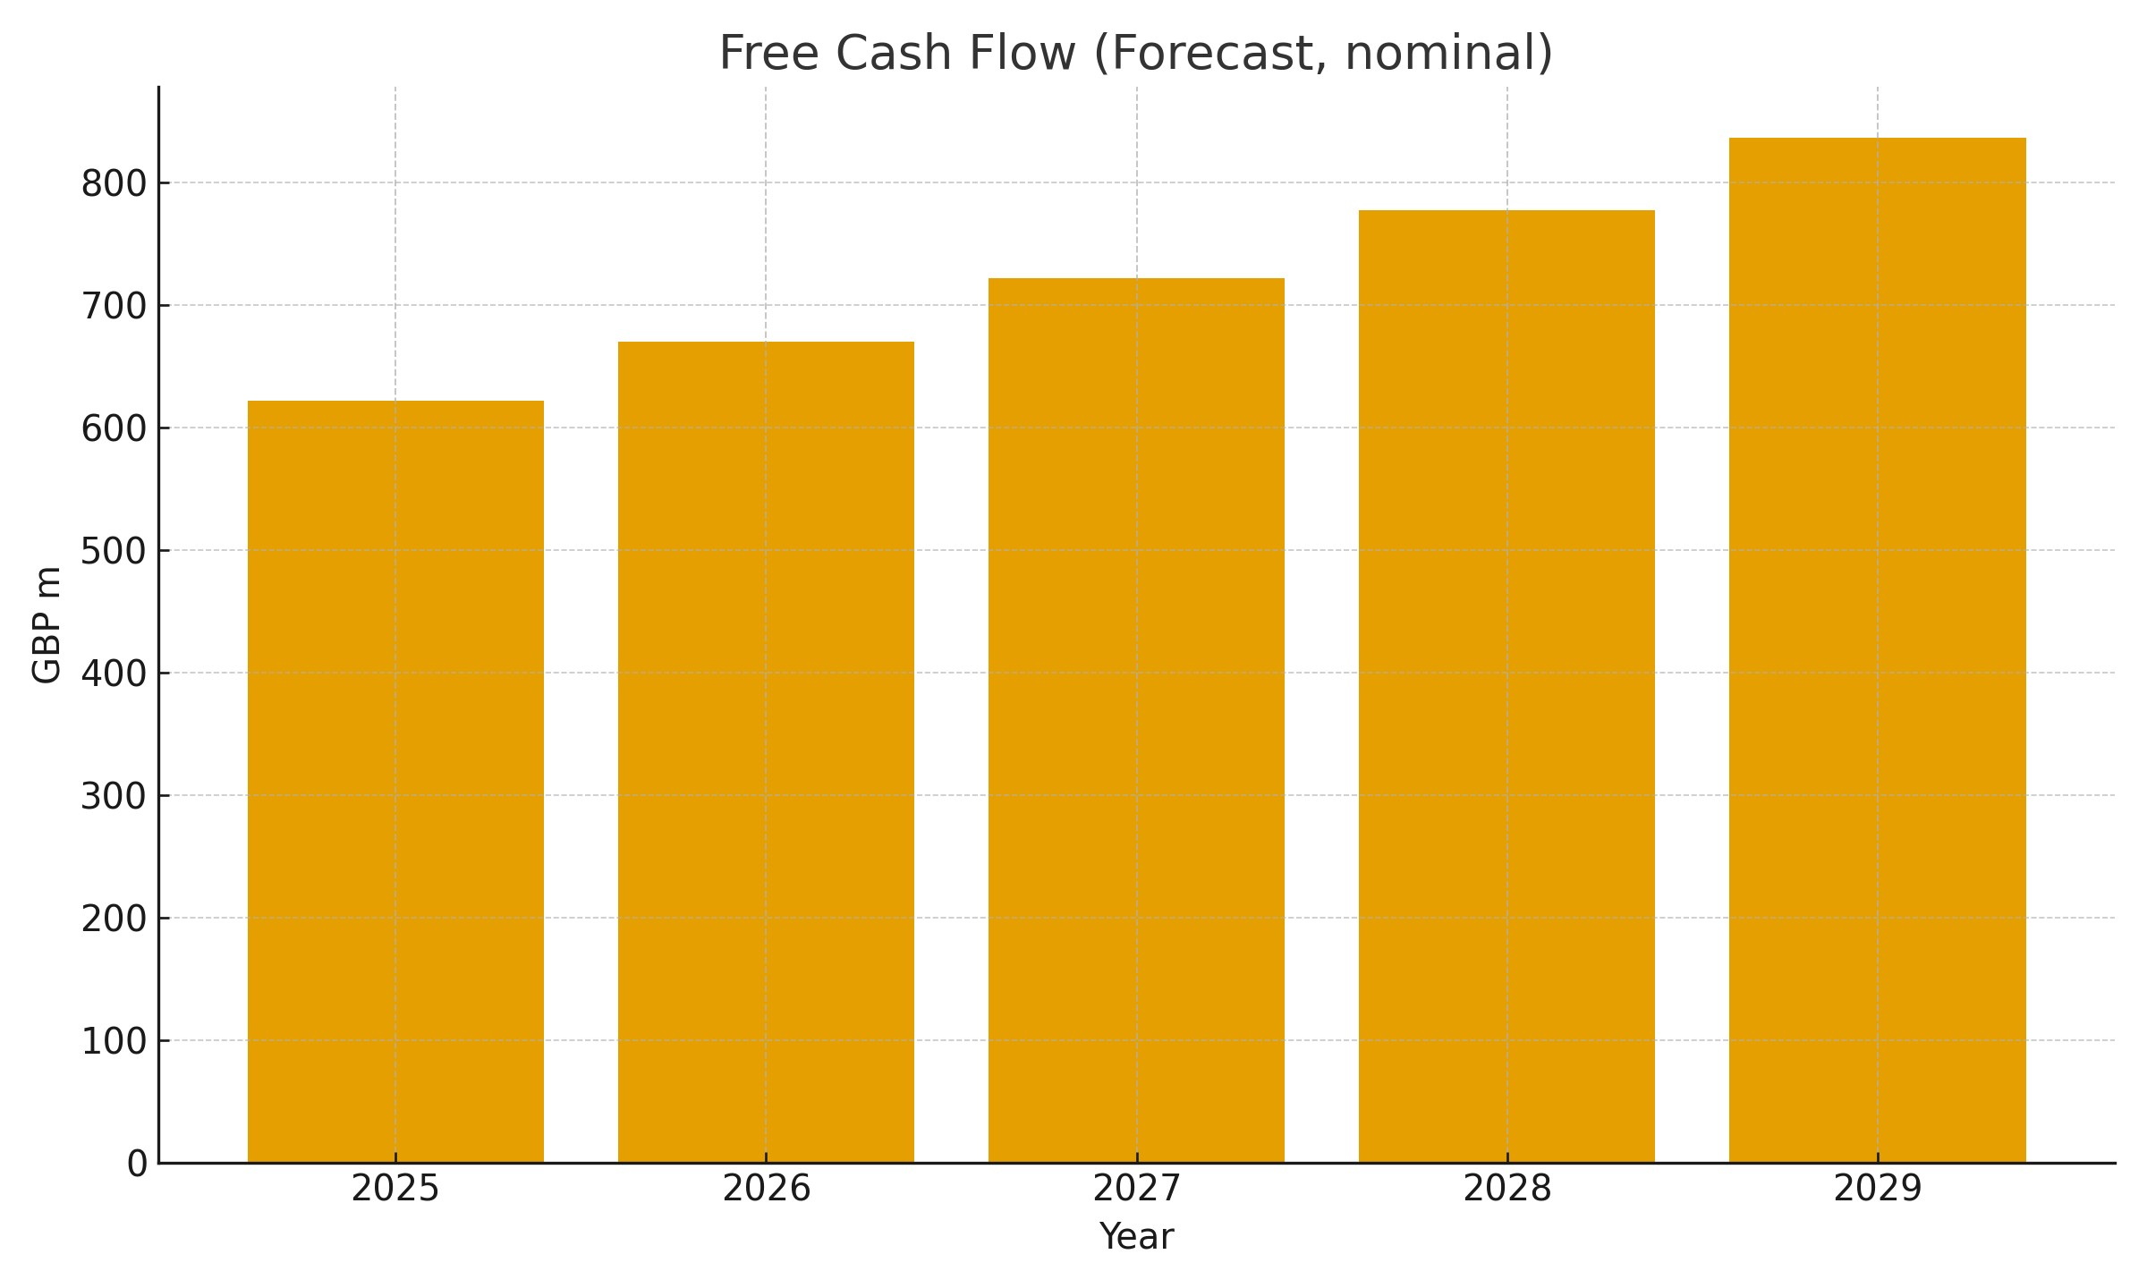

DCF valuation - assumptions and rationale
Enterprise value of GBP 19,999m and equity value of GBP 17,013m translate to GBP 19.42 per ordinary and GBP 38.84 per ADR. Terminal value contributes about 85% of EV. WACC 5.80% is built from a risk free 4.10%, beta 0.67 and ERP 3.80%. Terminal growth of 2.00% is conservative against long-run nominal GDP.
Year | 2025 | 2026 |  | 2027 |  | 2028 |  | 2029 |  | Terminal
FCF (nominal, | GBP m) 622 |  | 670 |  | 722 |  | 777 |  | 837 | -
PV of cash flow | s (GBP m)588 |  | 599 |  | 610 |  | 621 |  | 631 | 16,951

Sum of the parts - segment economics
Each segment is valued on stand-alone cash flows with a terminal component. Sports Med and
ENT carries the highest value density; Advanced Wound is steady with strong conversion; Orthopaedics remains the margin swing factor. Segment EVs sum to GBP 20,958m; after net cash the implied equity is GBP 17,972m, or GBP 20.52 per ordinary and GBP 41.03 per ADR.
Segment | EV (GBP m)
Orthopaedics | 4,887
Sports Med and ENT | 9,168
Advanced Wound | 6,903
Total | 20,958
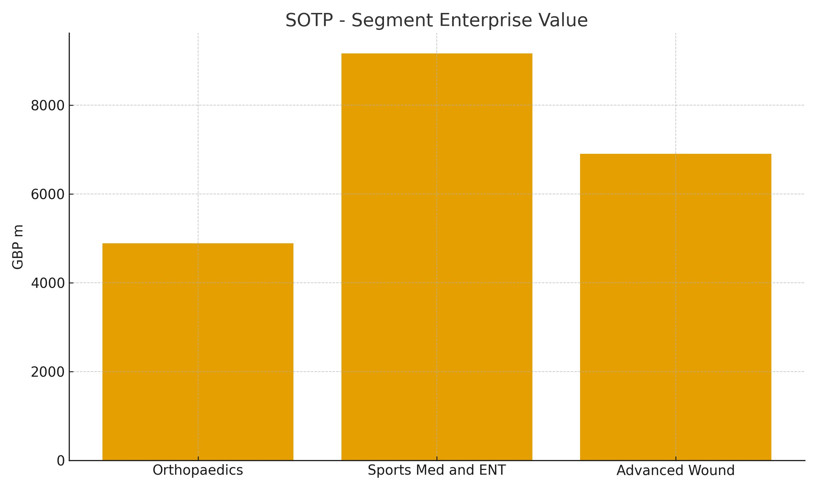

Pipeline rNPV - pricing the optionality
Risk-weighted pipeline cash flows by segment are added to current NPVs to capture upside that a pure DCF can miss. The aggregate implies equity of GBP 22,499m, or GBP 25.68 per ordinary and GBP 51.37 per ADR. Sports Med and ENT accounts for the largest risked value, consistent with innovation cadence.
Segment | Pipeline rNPV (GBP m)
Sports Med and ENT | 10,562
Orthopaedics | 6,609
Advanced Wound | 8,314
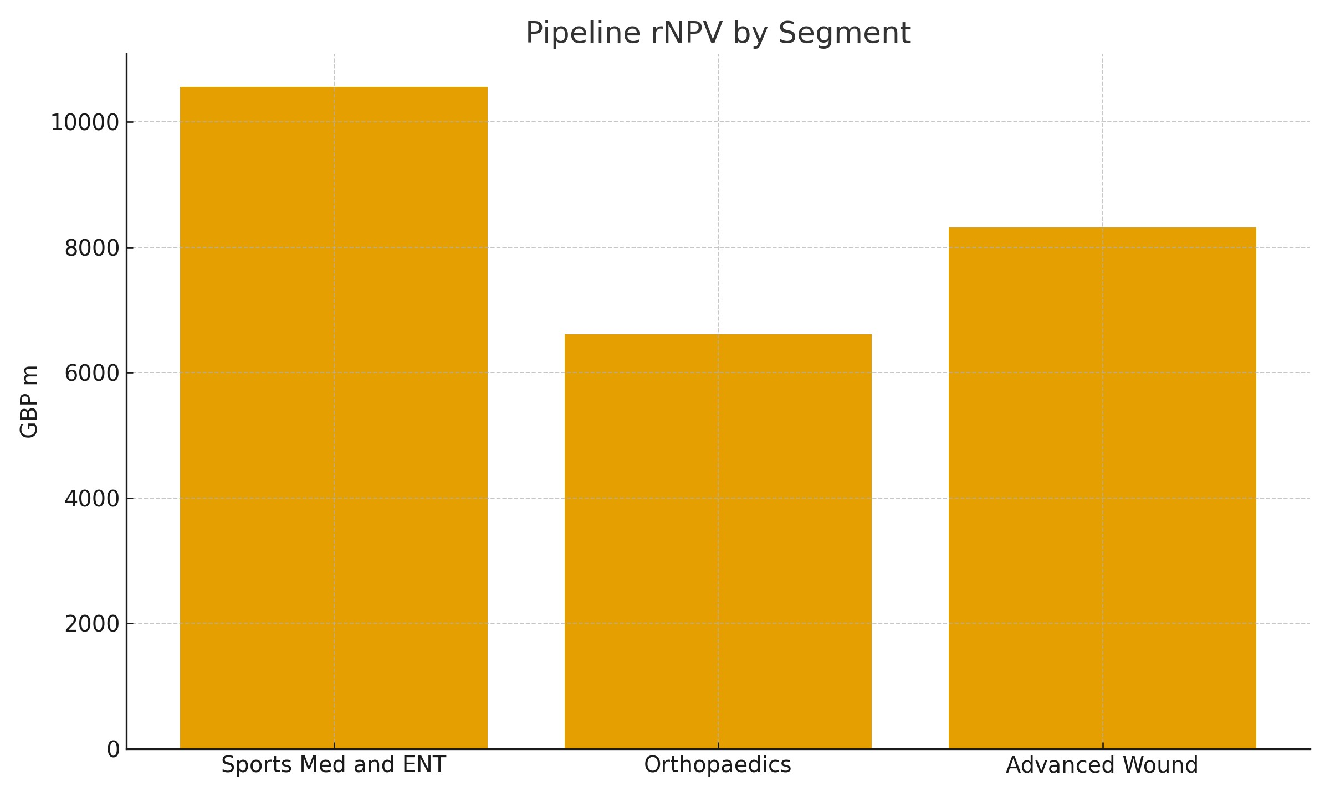

Valuation sensitivity - per ADR value
Five-year cash flows discounted plus a perpetuity for terminal. Values shown at combinations of WACC and terminal growth.
g \ WACC | 5.30% | 5.55% | 5.80% | 6.05% | 6.30%
1.50% | GBP 39.68 | GBP 36.75 | GBP 34.17 | GBP 31.87 | GBP 29.82
1.75% | GBP 42.56 | GBP 39.26 | GBP 36.36 | GBP 33.81 | GBP 31.53
2.00% | GBP 45.88 | GBP 42.11 | GBP 38.84 | GBP 35.98 | GBP 33.44
2.25% | GBP 49.74 | GBP 45.40 | GBP 41.67 | GBP 38.43 | GBP 35.59
2.50% | GBP 54.30 | GBP 49.23 | GBP 44.93 | GBP 41.23 | GBP 38.03

Risks, proof points and catalysts
- Risks: Orthopaedics execution and price pressure; China demand variability post volume-based procurement; FX translation. - Proof points: sequential margin and conversion, stable service levels, throughput gains in Orthopaedics, visible adoption of pipeline launches. - Catalysts: operational normalisation, sustained Sports Med and Wound growth cadence, and balanced capital allocation including opportunistic buybacks.

Conclusion
The triangulation of DCF, SOTP and rNPV points to a fair value cluster around GBP 41.03 per ADR on the median (GBP 43.75 on a simple average). The case rests on dependable cash generation, continued margin repair and mix improvement. Downside is cushioned by the balance sheet; upside requires consistent delivery and proof that pipeline optionality is converting.

Notes and sources
- FY 2024 results and 12-point plan delivery; segment margin expansion and trading margin methodology changes (company materials). - H1 2025: guidance maintained; trading margin expansion; buyback announced; robust cash generation (company materials). - Reuters/FT coverage: guidance, tariff commentary, China demand/VBP dynamics, shareholder break-up debate. - NICE technology briefing: CORI robotic platform indications and image-free workflow.
Source: Client DCF, SOTP and rNPV workbooks; three-statement model. Figures GBP m unless noted. This is not investment advice.

