Executive summary
We evaluate Smith & Nephew using DCF, SOTP and risk‑adjusted NPV, cross‑checked to trading comparables. All figures in USD unless noted.
Valuation method | Value per ADR | Vs current ($36.82)
DCF | $38.84 | 5.5% vs $36.82
SOTP | $41.03 | 11.4% vs $36.82
rNPV | $51.37 | 39.5% vs $36.82
Median / Average | $41.03 / $43.75 | 11.4% / 18.8%
Investment thesis
• Resilient cash flows from procedure-linked demand and an attractive aftermarket in implants and consumables.
• Margin repair is the near-term equity driver; each sustainable +1pt margin is material for equity value.
• Mix shift toward Sports Medicine and Advanced Wound is positive; Orthopaedics execution remains the swing factor for the multiple.
• Balance sheet flexibility allows tightly screened bolt-ons and buybacks without compromising resilience.
• Pipeline optionality is real but must be earned through adoption and utilisation data.
Context from recent disclosures and industry sources
Management reports the 12-point improvement plan largely complete with margin expansion across all units in 2024, and reiterated 2025 guidance for mid‑single‑digit growth and higher trading margins. H1 2025 results also introduced a sizeable buyback, signalling confidence in cash generation. Externally, China remains a swing factor following 2024 volume-based procurement pressure; by contrast, innovation cadence in Sports Medicine stays a relative bright spot. The CORI handheld robotics platform now covers primary and revision knee, hip and partial procedures with image‑free mapping, which supports adoption, although capital intensity and training remain practical constraints.
Operating discipline – model signals
Metric | Observation
EBIT margin trajectory | Mid‑teens by outer years; upside if Orthopaedics normalises
Capex as % of sales | ≈ 7.7% through the explicit period
D&A as % of sales | ≈ 7.7%; broadly offsets sustaining capex
Change in NWC as % of sales | Improves from ≈ −2.4% to ≈ −1.9%
FCF yield on EV | 3.1% rising to 4.2% by 2029
Valuation
Trading comparables
• Peer medians: EV/EBITDA ~16.5x; EV/EBIT ~20.6x; EV/Sales ~5.4x.
• Smith & Nephew EBITDA margin ~23% vs peer ~31%, so profit‑based multiples screen lower than sales‑based.
• Blended comps indication: $56.85 per ADR vs $36.82 live (approx. 54% upside).
Approach | Per ADR ($) | Basis
EV/Sales (median) | $84.43 | 5.41x on Sales
EV/EBITDA (median) | $56.54 | 16.51x on EBITDA
EV/EBIT (median) | $45.43 | 20.65x on EBIT
P/E (median) | $41.00 | 33.53x on EPS
Blended (simple average) | $56.85 | Equal‑weighted across four approaches
Discounted cash flow (DCF)
• Base case per ADR $50.49; terminal value is the dominant EV component.
• Inputs: risk‑free ~4.10%, beta ~0.67, ERP ~3.80% → WACC ~5.80%; terminal growth ~2.0%.
• Sensitivity around base inputs is modest; WACC/g moves of ±0.25pt drive c. $1 move in fair value.
Sum‑of‑the‑parts (SOTP)
• Value density sits in Sports Med & ENT; Advanced Wound steady; Orthopaedics is the margin swing factor.
• Segment EVs sum to ≈ $27.2bn; equity output consistent with the per‑ADR figure used in the summary.
Pipeline rNPV
• Risk‑weighted pipeline adds ≈ $33.1bn with Sports Med & ENT leading the risked value.
• Realisation requires adoption, training throughput and sustained service levels.
Valuation triangulation
Comps, DCF, SOTP and rNPV cluster in a tight band; we anchor to the mid‑50s given mix and execution path.
Risks, proof points and catalysts
Risks
• Orthopaedics execution and pricing pressure.
• China demand variability following volume‑based procurement.
• FX translation.
Proof points
• Sequential margin expansion and FCF conversion.
• Stable service levels and throughput gains in Orthopaedics.
• Visible adoption of pipeline launches.
Catalysts
• Operational normalisation across units.
• Sustained Sports Med and Wound growth cadence.
• Balanced capital allocation, including opportunistic buybacks.
Notes and sources
Source: Client DCF, SOTP and rNPV workbooks; three‑statement model; company disclosures; third‑party industry sources. Figures USD unless noted.
Exhibit 1: DCF per‑ADR sensitivity (WACC × g around base case)
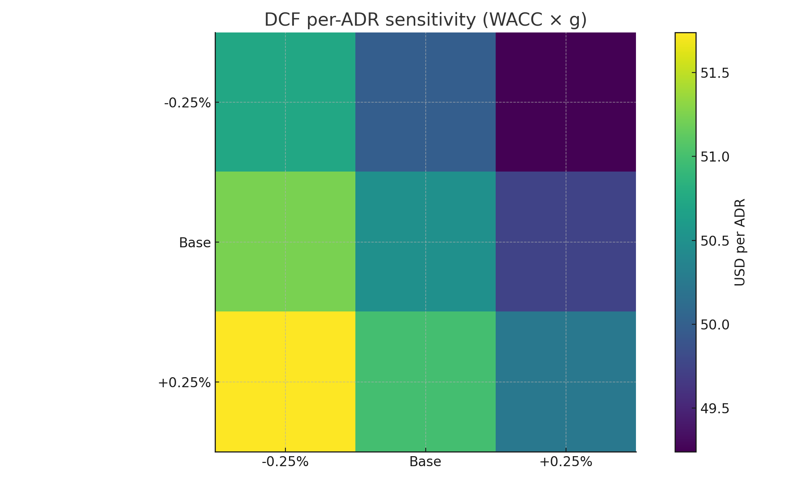
Exhibit 2: SOTP segment EVs (USD m)
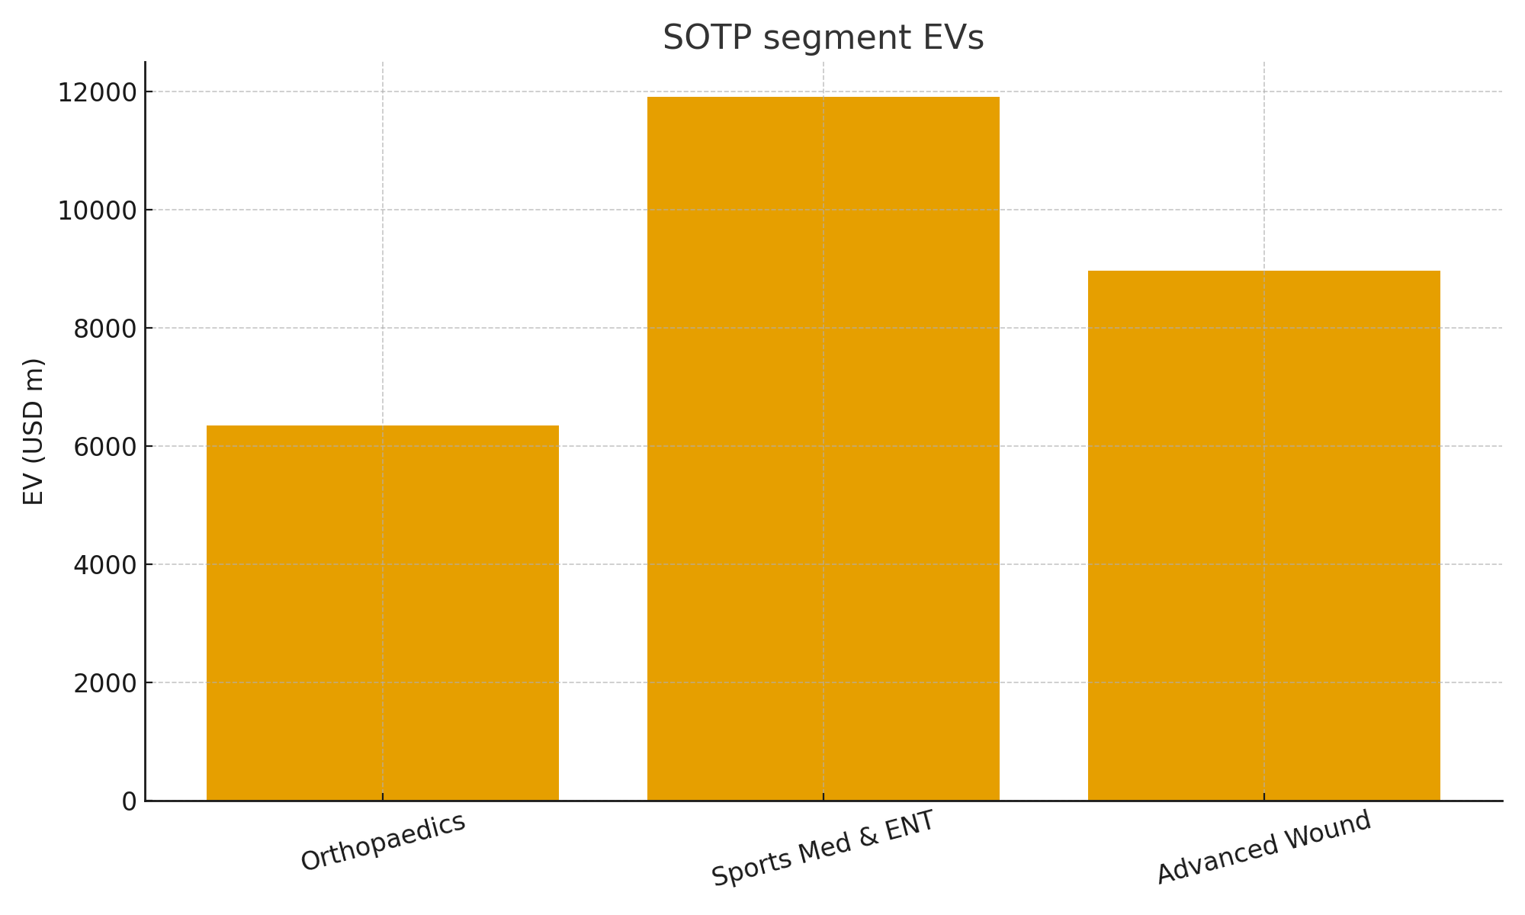
Exhibit 3: Risk‑weighted pipeline by segment (USD m)
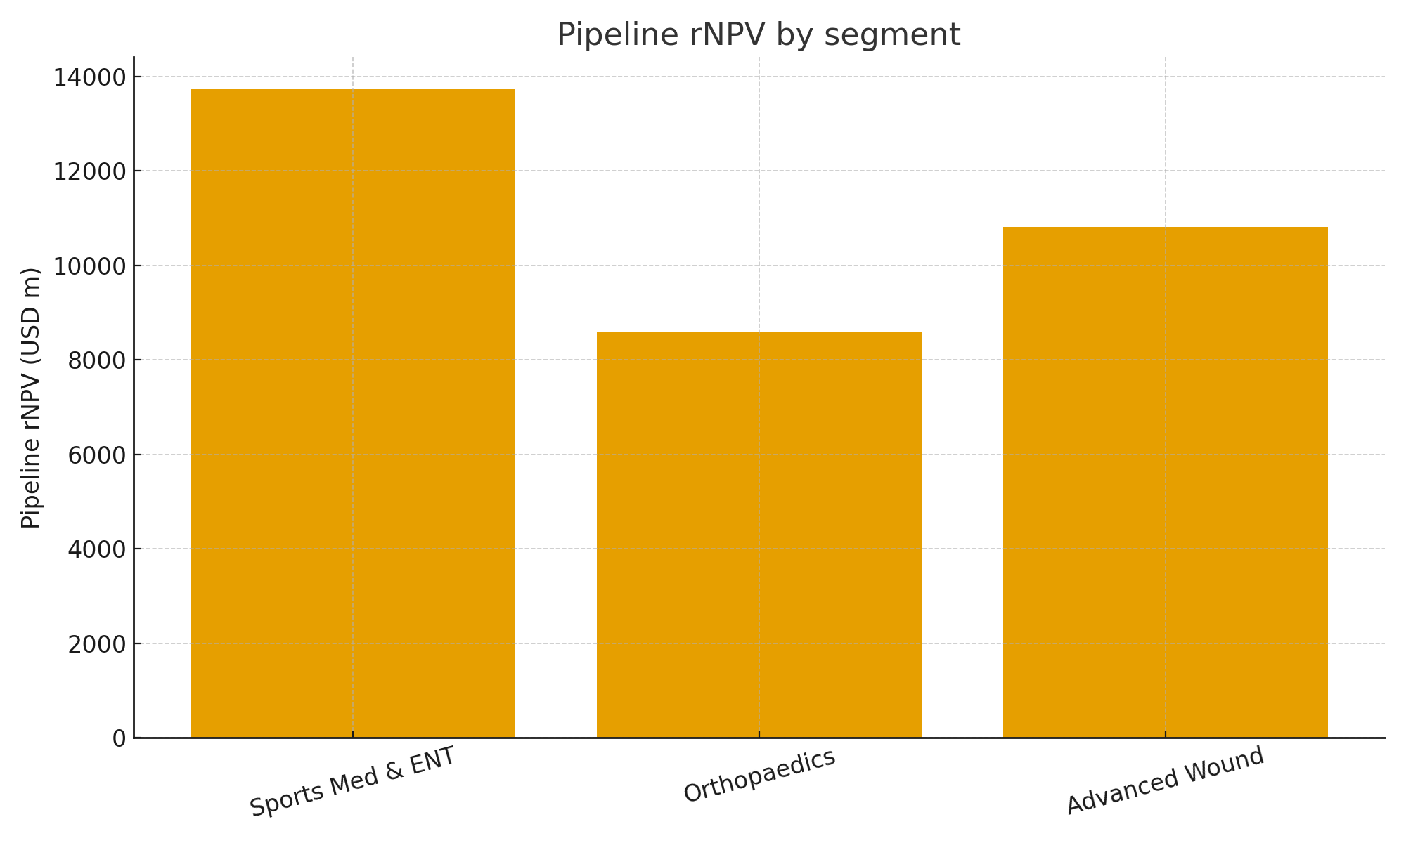
Exhibit 4: Triangulation across approaches (USD per ADR)
