**Home Design**

**Introduce**

Design beautiful homes in bright and sunny places and solve hundreds of fun match 3 puzzles in a light and fun match 3 home makeover game.

Meet Miss Robins, a young bright designer, and help design the decor and furniture to renovate beautiful houses.

- Hone your design skills by designing the home decor and furniture.

- Match candy and create power-ups

- Lot's of match-3 levels to enjoy

- Light and Fun Gameplay

Use Unity **2019.1.14f1** to open the project

**Step 1: Start a desktop version of the app**

We incorporated a desktop version of the app which can be executed on Mac (see more information on it in FAQ section) in the package with sources.

We would recommend using it in order to make sure

that the new images are configured properly in the game. Each time you update the image or animation – start the desktop app and make sure that they are properly aligned with other objects in the game.

There is a “Images” and “Sprites” folder. Once you update the image in the folder it appears in the desktop version of the game.

See the Screenshot

**Step 2: Publish Game to AppStore or Play Store.**

In your Unity editor, choose File/ Build Settings and then click Player Settings Button

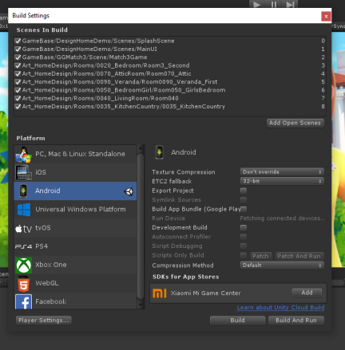

Look inspector and change your important information like Icon,App bundle ID, rotation setting…

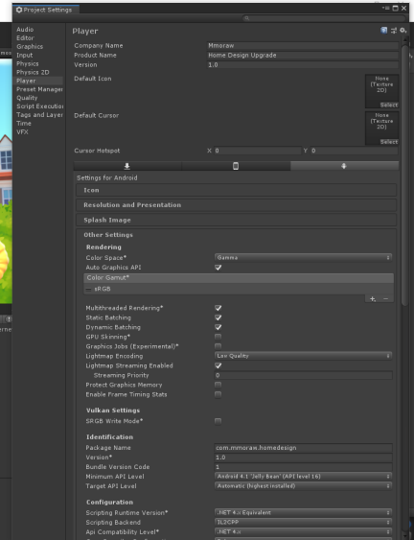

If you need support or more reskin services, please contact email: **mmoraw163@yahoo.com**