Dognate.org

Dognate’s vision is to ensure every dog in America (and eventually the world) has a warm bed, food and toys to live a happy life, at home or in a shelter. They are our best friends that love us unconditionally. The only and best thing we can do for them is to give them a good life.

Dognate’s mission is to connect dog owners and organizations that are in need of supplies. Dognate helps organizations and dog owners exchange, donate or volunteer where help is most needed.

* Dog owners that have extra pet supplies can sell, exchange or donate

How Dognate works

**Donate**

* Some dog rescue organizations lack time or resources to obtain needed supplies. Generous pet owners can help by picking up and dropping off supplies.
* Low-income families that are responsible dog owners might not have the proper supplies for their dogs, or are in need of some. Dognate connects people with supplies to people that need them.
* Some dogorganizations are in need of bedding, blankets etc, since their services are done outdoors.
* Pet stores that have extra supplies assist our mission to make sure every dog has what they need for a happy life.
* Donations to any dog oriented nonprofit ~~via Network for Good~~.
* FUTURE: crowd funding donations of money where needed

**Exchange**

**Volunteer**

* People with skills that can be useful such as engineers, electricians, plumbers, painters, etc. -- anyone, really, who can lend a hand to help people or dog organizations that might be in need for any kind of help can find volunteer opportunities.

Use cases

Sarah has anextra dog bed she wants to give away. Joe is fostering a dog and needs more beds. Sarah lists her

Volunteer

No. California dog rescue needs to paint and freshen their holding areas. They come to Dognate and post their need. Joe, a painter, sees the posting and connects with them to volunteer his time to paint.

Mary wants to find dog organizations near her where she can volunteer. She comes to Dognate and looks at the Dognate posts and then looks at all Volunteer Match posts and selects an opportunity. She either contacts the Dognate post”er” or submits her interest through Volunteer Match.

Search for icons for proper identification on left navigation

1. **Home**
   1. Vision
2. **Offer/Wish Listing**
   1. Displays current Offers and Wishes
3. **Enter Items**
   1. Sign Up
   2. Sign In
   3. Enter Item
4. **How it Works**
   1. How it works
5. **About Us**
   1. The team became to create dognate.
   2. Explain about our skills and our part creating dognate.
   3. Document language use to create site.
6. **Contact us**
   1. Contact Form

Home: Brief description of dogante; etc

Navigation bar left

Home

The team

Introduction / about

Offer / Wish table

Enter : Sign in –up create account

Contact us

Top Bar: Logo of Dognate (move social media to bottom in contact page)

Widgets: to include easy access to what’s popular and what is being post along with date(live?)

Tags / Categories / Popular to be the same?

Search: icon to search items

Bottom part of main page: buttons to 3 diff pages of info?

2nd page with a subpage with video perhaps?

3rd page with video ??

4th page with promotion of next dognate event? List of items being offered.

Background Images: check for proper good resolution image.

Links: to point to the correct pages

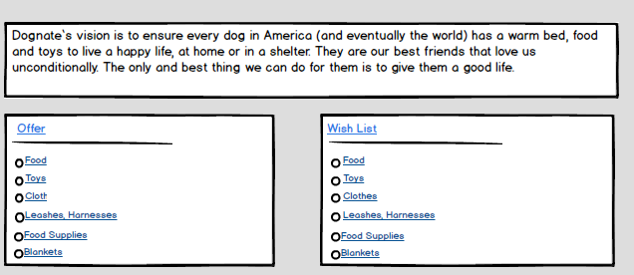

about us Description about dognate and the team became to create dognate.

What is dognate.

Introduce the team

Explain about our skill and our part creating dognate.

Document language use to create site.

Introduction of dognate how it works: describe the three main parts of the services provided

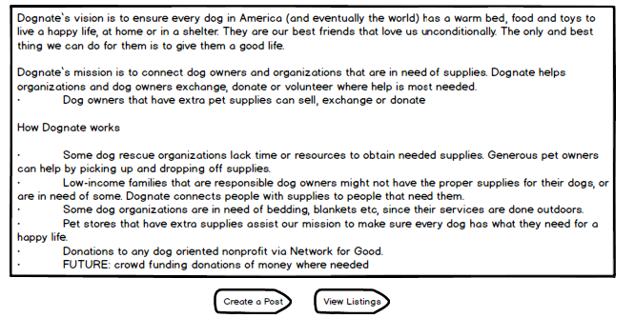

Offer / Wish: list of what is being offered with filter on top right for easy access of items.

(Create account sign in / sign up button to post an item)

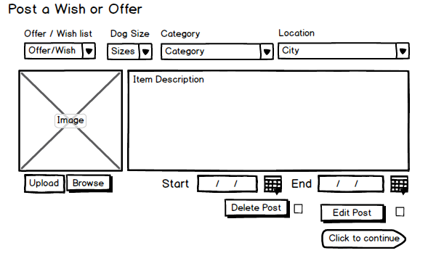

When signed in then you can click on arrow to connect with people.

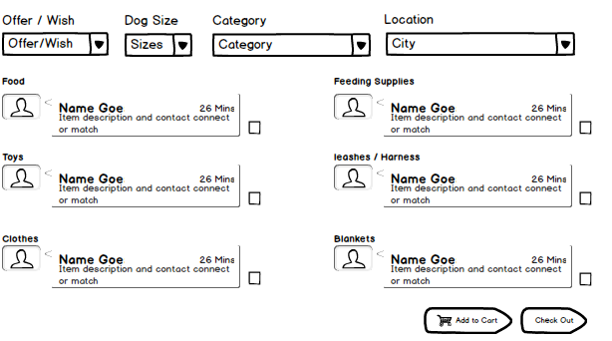

Create a page with my portfolio sample page and post a comment page to make it to contact giver with description of item, i.e category, location, dog size, offer/wish.

Select filter with sub-menu for categories and dog size.

Once item is selected then page for contact giver will appear with completed fields of what was selected.

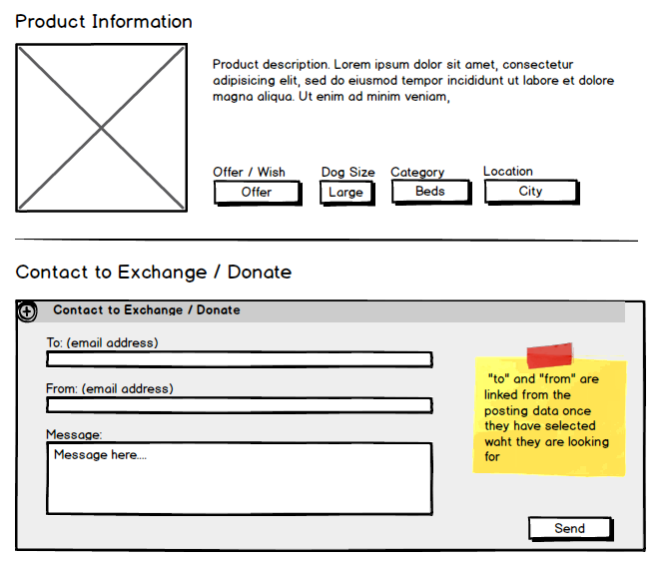

Enter: create account sign in / sing up

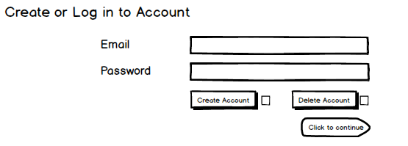

Contact us: how to participate and how to connect people

Background map at end of page. With 