MC920 / EA979 – PDI/CG
Aluno: Davi Kooji Uezono – RA: 097464

Código fonte:
#!/usr/bin/python
# -*- coding: utf-8 -*-

name = raw_input("Please select one of these images: coins, columns or dragon.\n")
while name not in ["coins", "columns", "dragon"]:
name = raw_input("ERROR! Please select one of these images: coins, columns or dragon.\n")

effect = raw_input("Please select one of these linear effects: threshold or negative.\n")
while effect not in ["threshold", "negative"]:
effect = raw_input("ERROR! Please select one of these linear effects: threshold or negative.\n")

image = open(name + ".pgm", "r")
if image.readline() == "P2\n":
image_out = open(name + "_" + effect + ".pgm", "w")
image_out.write("P2\n")

image.readline() # ignore comment line from PGM format
image_out.write("# created by Davi K. Uezono - RA 097464\n")

size_string = image.readline()
size = size_string.split()
image_out.write(size_string)

depth_string = image.readline()
depth = depth_string.split()
if effect == "threshold":
depth_out = "2\n"
else:
depth_out = depth_string
image_out.write(depth_out)

lines = image.readlines()
for i in range(0, len(lines)):
values_in_this_line = lines[i].split()
for pixel in values_in_this_line:
int_pixel = int(pixel)
int_depth = int(depth[0])

if (effect == "threshold"):
if (int_pixel < int_depth/2):
image_out.write("0\n")
else:
image_out.write("1\n")

elif (effect == "negative"):
pixel_out = (str) (int_depth - int_pixel) + "\n"
image_out.write(pixel_out)

image.close()
image_out.close()

Imagens:

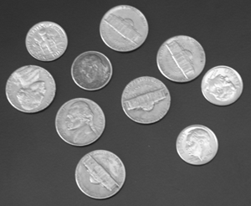  coins.pgm | 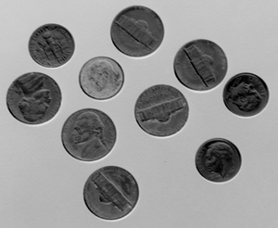  coins_negative.pgm | 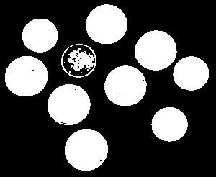  coins_threshold.pgm

Imagem original: http://people.sc.fsu.edu/~jburkardt/data/pgma/coins.ascii.pgm

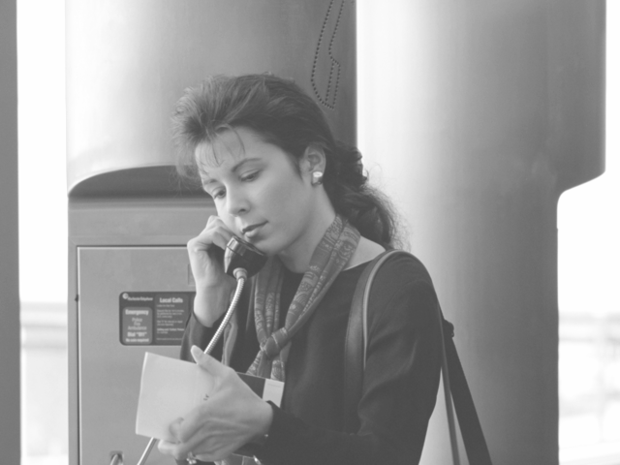  columns.pgm | 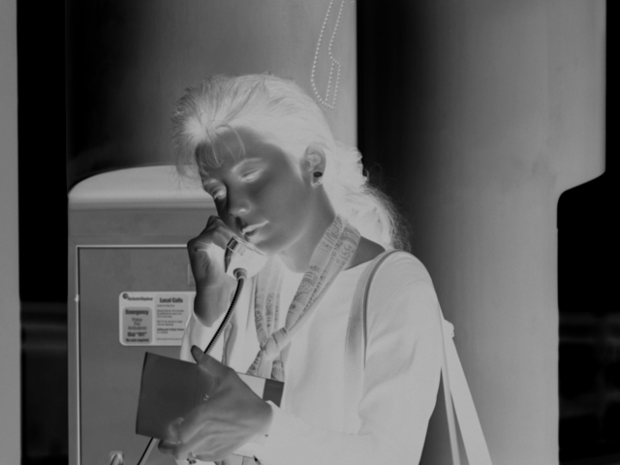  columns_negative.pgm | 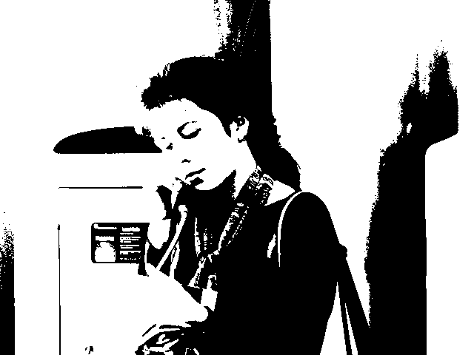  columns_threshold.pgm

Imagem original: http://people.sc.fsu.edu/~jburkardt/data/pgma/columns.ascii.pgm

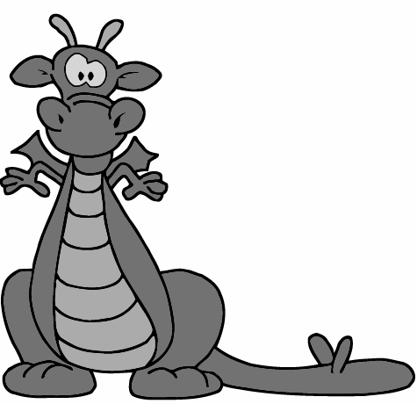  dragon.pgm | 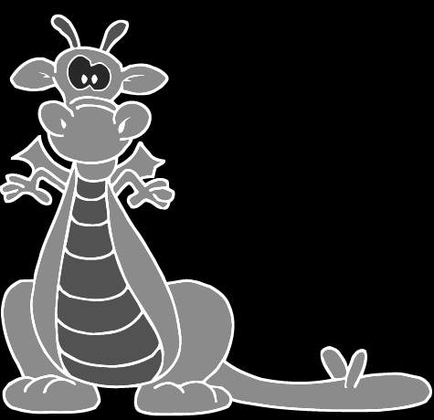  dragon_negative.pgm | 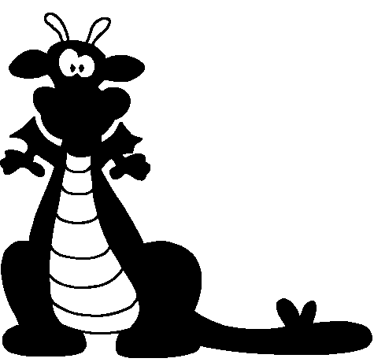  dragon_threshold.pgm

Imagem original: http://people.sc.fsu.edu/~jburkardt/data/pgma/dragon.ascii.pgm

