MC920/EA979 – PDI/CG
Aluno: Davi Kooji Uezono – RA: 097464

Imagens:
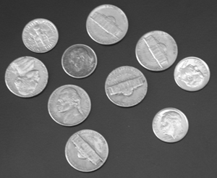  coins.pgm | 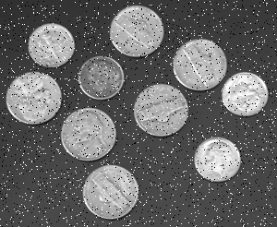  coins_adding_salt_pepper.pgm | 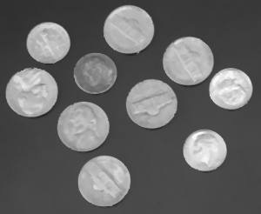  coins_removing_salt_pepper.pgm

Imagem original: http://people.sc.fsu.edu/~jburkardt/data/pgma/coins.ascii.pgm

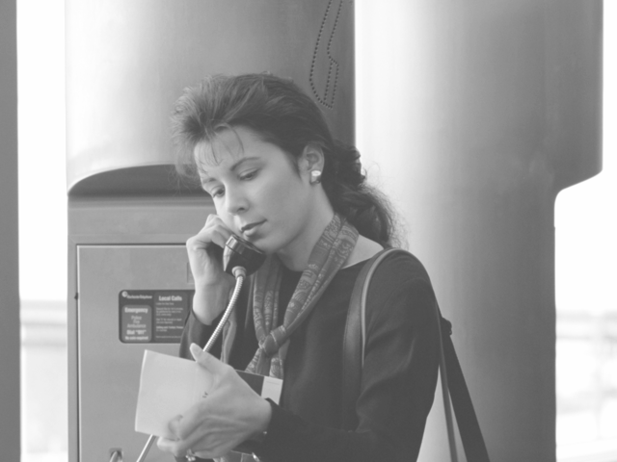  columns.pgm | 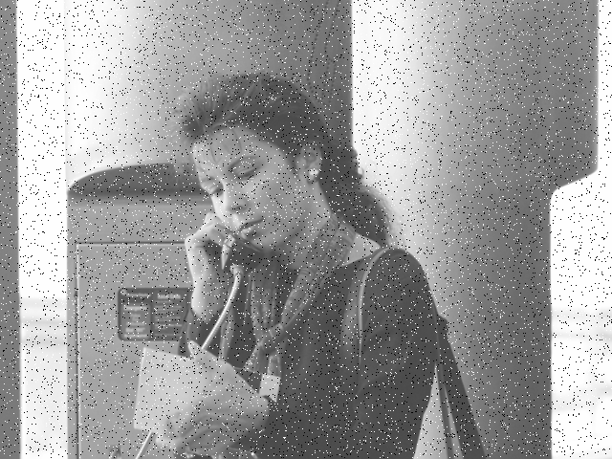  columns_adding_salt_pepper.pgm | 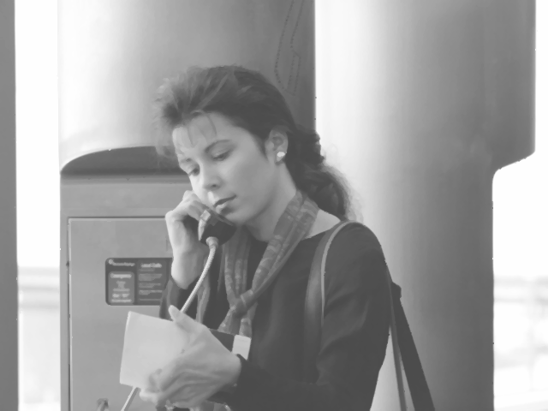  columns_removing_salt_pepper.pgm

Imagem original: http://people.sc.fsu.edu/~jburkardt/data/pgma/columns.ascii.pgm

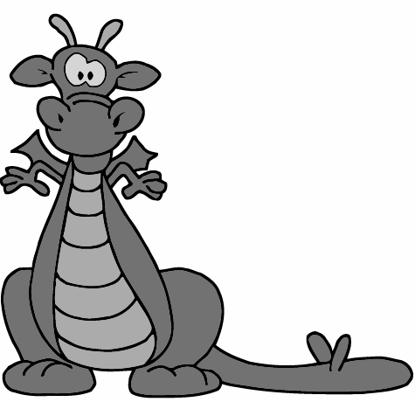  dragon.pgm | 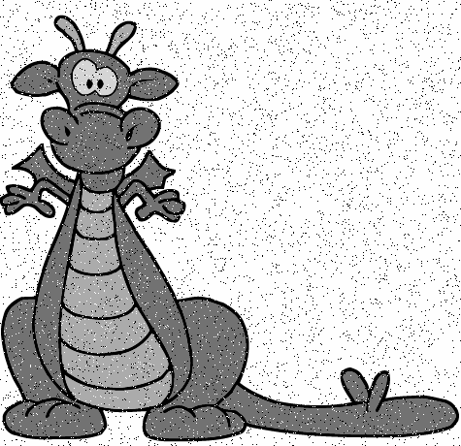  dragon_adding_salt_pepper.pgm | 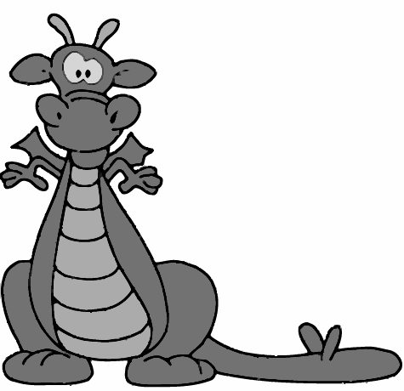  dragon_removing_salt_pepper.pgm

Imagem original: http://people.sc.fsu.edu/~jburkardt/data/pgma/dragon.ascii.pgm
Código fonte 1 (adicionar efeito sal e pimenta):
#!/usr/bin/python
# -*- coding: utf-8 -*-
from random import randint

# percentage of salt and pepper pixels
percentage = 5

name = raw_input("Please select one of these images: coins, columns or dragon.\n")
while name not in ["coins", "columns", "dragon"]:
name = raw_input("ERROR! Please select one of these images: coins, columns or dragon.\n")

image = open(name + ".pgm", "r")
if image.readline() == "P2\n":
# ignore comment line from PGM format.
image.readline()

size_string = image.readline()
size = size_string.split()

# number of pixels in image.
n_pixels = int(size[0]) * int(size[1])
# number of pixels in image to apply salt and pepper.
sp_pixels = int(n_pixels * percentage / 100)

depth_string = image.readline()
depth = depth_string.split()
depth = int(depth[0])

# creating the new image with salt and pepper effect.
salt_and_pepper = open(name + "_adding_salt_pepper.pgm", "w")
salt_and_pepper.write("P2\n")
salt_and_pepper.write("# created by Davi K. Uezono - RA 097464\n")
salt_and_pepper.write(size_string)
salt_and_pepper.write(depth_string)

lines = image.readlines()
for i in range(len(lines)):
values_in_this_line = lines[i].split()
for pixel in values_in_this_line:
# when I have a colection of (max_prob + 1) elements, if I choose one of
# them arbitrary, I will have the same percentage of choosing one of them
# as defined in the very beginning of this source code.
max_prob = int(100 / percentage) - 1
# the random int between zero and max_prob converted to a boolean value
# and negated will return a TRUE value in the same percentage as defined
# in the very beginning of this source code.
if(not bool(randint(0,max_prob)) and bool(sp_pixels > 0)):
# arbitrary BLACK or WHITE dots in the image.
pixel_out = str(depth * randint(0,1))
salt_and_pepper.write(pixel_out)
sp_pixels = sp_pixels - 1
else:
salt_and_pepper.write(pixel)
salt_and_pepper.write(" ")
salt_and_pepper.write("\n")

image.close()
salt_and_pepper.close()
Código fonte 2 (suavizar com filtro da mediana):
#!/usr/bin/python
# -*- coding: utf-8 -*-
from random import randint

# mask size
mask = 3

name = raw_input("Please select one of these images: coins, columns or dragon.\n")
while name not in ["coins", "columns", "dragon"]:
name = raw_input("ERROR! Please select one of these images: coins, columns or dragon.\n")

salt_and_pepper = open(name + "_adding_salt_pepper.pgm", "r")
if salt_and_pepper.readline() == "P2\n":
# ignore comment line from PGM format.
salt_and_pepper.readline()

size_string = salt_and_pepper.readline()
size = size_string.split()
n_columns = int(size[0])
n_lines = int(size[1])

depth_string = salt_and_pepper.readline()
depth = depth_string.split()
depth = int(depth[0])

# reading the input image into a pixel list.
pixel_list = []
lines = salt_and_pepper.readlines()
for i in range(len(lines)):
values_in_this_line = lines[i].split()
for pixel in values_in_this_line:
pixel_list.append(int(pixel))
salt_and_pepper.close()

# output pixel list initialized as the same of input one.
pixel_list_out = pixel_list
mw = int(mask/2)

# rastering the input image including borders.
for i in range(n_lines):
for j in range(n_columns):
mask_of_pixels = []
for x in range (i - mw, i + mw + 1):
for y in range (j - mw, j + mw + 1):
# ignoring negative bounds.
if (x >= 0 and x < n_lines and y >= 0 and y < n_columns):
mask_of_pixels.append(pixel_list[x*n_columns + y])
# median value is the central value of an ordered vector.
mask_of_pixels.sort()
median = int(len(mask_of_pixels)/2)
pixel_list_out[i*n_columns + j] = mask_of_pixels[median]

# initializing the final (clean) image.
clean_image = open(name + "_removing_salt_pepper.pgm", "w")
clean_image.write("P2\n")
clean_image.write("# created by Davi K. Uezono - RA 097464\n")
clean_image.write(size_string)
clean_image.write(depth_string)

# printing final pixel values in the final (clean) image.
for i in range(n_lines):
for j in range(n_columns):
clean_image.write(str(pixel_list_out[i*n_columns + j]) + " ")
clean_image.write("\n")
clean_image.close()

