LLM Assisted Technical Order Management Tool

Stage 2: Project Report

Team Rolling Thunder:
David Vaughan, Roman Tait, Tucker Hoffnagle, Karlton Hall, Harrison Whitworth

CS4366: Senior Capstone Project Fall 2023

Project Description:
The scope of the project is modifying and utilizing an LLM to answer user questions about information found within Air Force technical manuals. This will be done by utilizing retrieval augmented generation (RAG) architecture and fine-tuning an LLM to smart search the included manuals and provide back a sourceable answer containing the most relevant information. The user will access the LLM through our website.
The website will allow the user to input questions relating to Air Force Technical Order Management specifications and directions. The server looks up relevant document data and supplies the LLM with the question and relevant documents. A modified LLM trained to better handle Order specifications produces text that accurately answers the user question. The LLM answer should include relevant document data and provide the source. LLM answers should be checked for accuracy.
Definitions, acronyms, and abbreviations
Acronyms- (LLM) Large Language Model, Technical Orders (TO), Air Force (AF), TO Management Agencies (TOMA). Retrieval-augmented generation (RAG), High Performance Computing Center (HPCC). Operating System(OS)

UML Diagrams
Class:
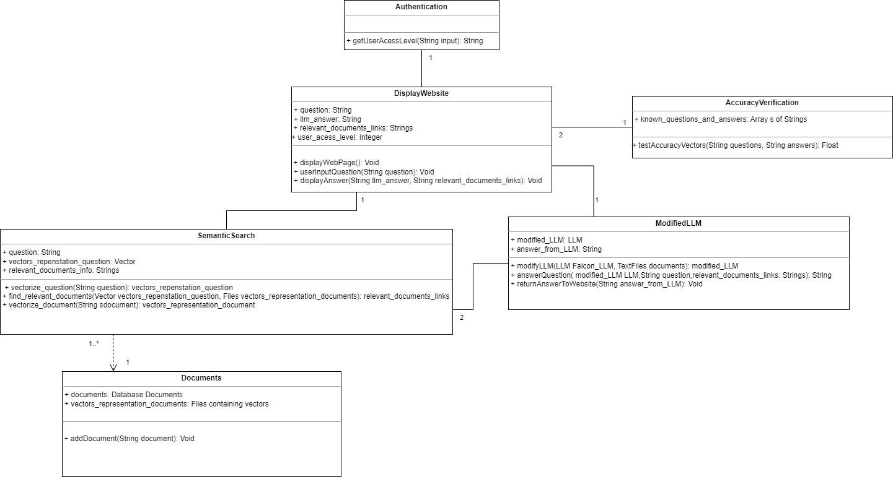
Use Case:

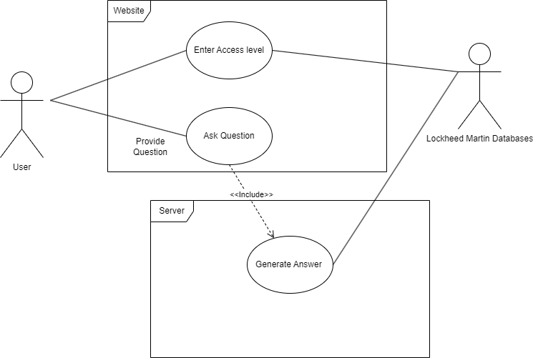

Sequence:

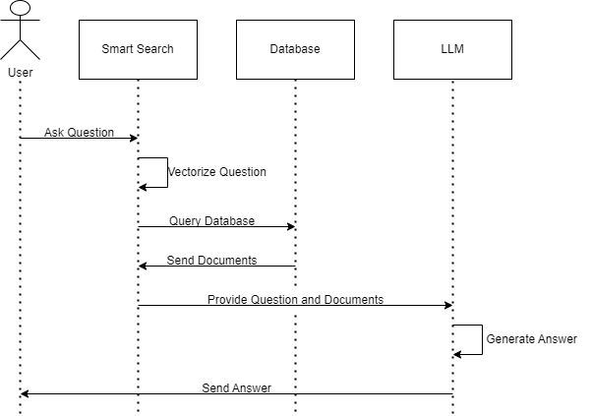

System analysis and decomposition:
The Display Website class plays a crucial role in enhancing the user interaction by enabling them to input questions. Its functionality extends beyond input reception, it’s set up to receive answers from a LLM. These answers aren’t generic but tailored to the inputted queries, incorporating any pertinent details sourced from the technical manuals. A stretch goal class shall be an authentication class that shall allow the user to access relevant info and PDFs depending on their access level.
The Semantic Search class is an integral part of the system. It receives textual questions from the Display Website class and employs the special vectorize question class to turn the textual queries into vector representations. By turning the queries into vectors it greatly improves accuracy and efficiency of the system. Semantic Search as well does the vectorizing of the documents in the Document class and stores them back into the Document class as a vector representation. Semantic Search shall then be able to use the vector question and search the document class that contains a vector database for any vectors that are relevant to the question and shall return the string info and shall then provide the relevant info to the Modified LLM class.
The Document class is where the most important data will be stored, the documents and vectorized versions will both reside here. It does more than just hold information, it’s designed to allow users to add, remove, or update documents within the Document class database.
The Modified LLM class is designed to process the user’s question along with the pertinent documents, generating a specific string answer tailored to the inquiry. It utilizes the ‘return answer to website’ function to send back the LLM-generated answer to the website.
To validate the accuracy of the renerated answers, the system incorporates the Accuracy Verification class. It receives the string answer generated by the LLM and the textual information extracted from the relevant documents. The Accuracy Verification class vectorizes both strings, turning them into numerical representations. From there the class compares these two values to assess their similarity, in doing so it ensures the answers align closely with the information from the documents.

Low Fidelity Prototype:
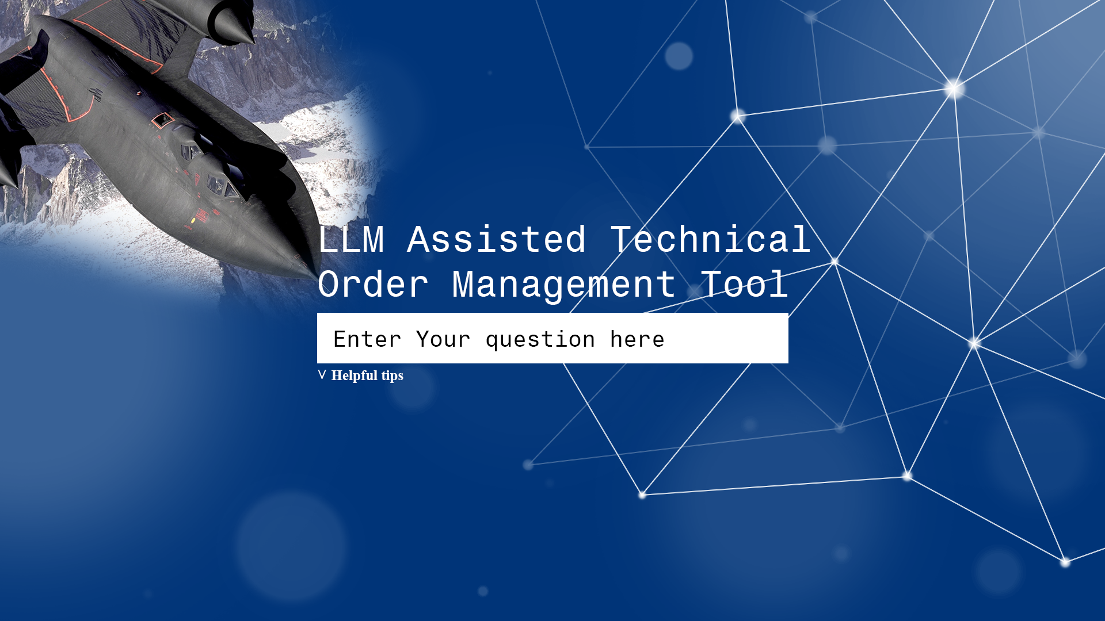

Here is an example of how the UI will look like.The UI will have a box to allow the user to enter their question.If the user clicks on Helpful tips information relating to how to correctly use the program will be displayed to the user. The returned answer would be displayed below the question box after a question has been asked.
Implementation Plan:
Our chosen testbed for code modification, testing, and updates is Google Colab, allowing collaboration. The High-Performance Computing Center (HPCC) is critical for LLM training and testing. Python 3 serves as our programming language. GitHub provides version control, and the website, hosted on GitHub, showcases our system’s capabilities.
The implementation unfolds in three key phases. The initial phase establishes foundational website capabilities, query acceptance, seamless communication between the website, semantic search, and LLM, as well as accurate answer display. Semantic search functionality includes tokenization and vectorization of queries, database searches using tokenized questions, and seamless integration with the LLM. The LLM generates precise answers based on questions and stored documents.
The second phase refines the LLM performance, enhancing the reliability and accuracy of returned answers. This involves tweaking and training the LLM to ensure accurate answers align with the user query and document contexts.
In the final phase, we focus on refinement and enhancement. Existing structures undergo optimization, and finishing touches are added. Stretch goals, such as website tips and access level control, will be implemented here to improve user experience.

Group Member roles
David: Handling most of the RAG pipeline/flex
Karlton: Handling most of the website
Roman: Flex
Tucker: Flex
Harrison: Flex

Technical Details:

1.1 Implementation techniques
- Integrating Hugging Face transformers for tokenization and loading the original Falcon 7B Instruct model.
- Use Hugging Face Supervised Fine-tuning Trainer for Fine-tuning an Falcon 7B Instruct model for better question-answering capabilities.
- Leveraging Lang Chain for importing vector databases and document manipulation.
- Using the Hugging Face all-MiniLM-L6-v2 transformer for embedding text to capture semantic information.
- Employing FAISS for managing a vector/embedding database to hold vectors created by the all-MiniLM-L6-v2.
- Implementing Retrieval-augmented generation (RAG) for technical manual data.
- Handling user input related to Air Force Technical Order Management specifications and directions.
- Ensuring data traceability and accuracy verification of the output from the LLM.

2. Components and Libraries

0 Fine-tuning of Language Model.
Try to use Hugging Face Supervised Fine-tuning Trainer

1.0 Lang Chain
- Importing Vector Databases: Lang Chain is used to import vector databases and facilitate document manipulation. This enables the system to manage vector data efficiently.
- Split PDFs into text paragraphs:Lang Chain is used to import PyPDFLoader which splits the pdf into paragraphs that then can be turned into vectors.

2.1 Hugging Face all-MiniLM-L6-v2 Transformer
- Embedding: The all-MiniLM-L6-v2 transformer is employed to generate sentence embeddings from input text. These embeddings capture the semantic information in the text..Given an input text, it outputs a vector which captures the semantic information. The sentence vector may be used for information retrieval, clustering or sentence similarity tasks.By default, input text longer than 256 word pieces is truncated.
- HuggingFaceEmbeddings: An instance of the HuggingFaceEmbeddings class is created with the model name set to 'sentence-transformers/all-MiniLM-L6-v2' and additional model arguments like 'device': 'cuda' for GPU acceleration.
- Document Splitting: The program processes a list of PDF documents stored in the list_name variable. For each document, the get_pdf_splits function is used to split the content into smaller pieces. These document splits are represented as pdf_docs.
- Embedding: The embed_index function is employed to convert the document splits into embeddings using the embeddings instance created earlier. The resulting embeddings are stored in a vector database named new_index.

2.2 FAISS (Facebook AI Similarity Search)
- Vector/Embedding Database: FAISS is utilized to manage a vector/embedding database that stores vectors created by the all-MiniLM-L6-v2 transformer. This allows for efficient storage and retrieval of semantic vectors.
- Check for Database Existence: The program checks if the new_index folder exists. If it does, the database is loaded for further processing.
- FAISS.load_local: The vector database is loaded locally using the FAISS.load_local function. The folder_path parameter specifies the path to the new_index folder, and the embeddings instance created earlier is provided to assist with loading the database.

3 Air Force Technical Order Management Frontend
- User Input Handling: The system is designed to accept user input related to Air Force Technical Order Management specifications and directions. An example, "What is Liquid Penetrant Inspection?"

4 Hugging Face Transformers
- Tokenizer: The program uses Hugging Face transformers to tokenize input text. The tokenizer prepares the text for further processing.
- Load the LLM: The modified Falcon 7B Instruct Instruct model is loaded for its advanced natural language understanding capabilities.
- Model and Tokenizer Loading: The program loads the modified Falcon 7B Instruct model using the AutoTokenizer and prepares a text generation pipeline with specific configurations, including max_new_tokens, do_sample, top_k, and more.
- HuggingFacePipeline: An instance of HuggingFacePipeline is created, which wraps the text generation pipeline and controls aspects like the randomness of output.
- User Question Processing/Chain Configuration: The program sets up a retrieval-based question-answering chain using the RetrievalQA class. User questions are converted into vectors and used to search the vector database for relevant information.This chain utilizes the LLM, retains source documents for context, and interfaces with the vector database as a retriever to provide the LLM with context to produce a relevant answer to the user question.

5 Air Force Technical Order Management Frontend
- Output / Display Results: The program formats and displays the results, including the LLM-generated answer and the source documents used to generate the response. The answer text is formatted for readability.

