LLM Assisted Technical Order Management Tool

Stage 3: Project Report

Team Rolling Thunder:
David Vaughan, Roman Tait, Tucker Hoffnagle, Karlton Hall, Harrison Whitworth

CS4366: Senior Capstone Project Fall 2023

Project Description:
The scope of the project is modifying and utilizing an LLM to answer user questions about information found within Air Force technical manuals. This will be done by utilizing retrieval augmented generation (RAG) architecture and fine-tuning an LLM to smart search the included manuals and provide a sourceable answer containing the most relevant information. The user will access the LLM through our website.
The website will allow users to input questions about Air Force Technical Order Management specifications and directions. The server looks up relevant document data and supplies the LLM with the question and relevant documents. A modified LLM trained to better handle order specifications will produce text that accurately answers the user question. The LLM answer should include relevant document data and provide the source. LLM answers should be checked for accuracy.

Definitions, acronyms, and abbreviations
Acronyms- (LLM) Large Language Model, Technical Orders (TO), Air Force (AF), TO Management Agencies (TOMA). Retrieval-augmented generation (RAG), High Performance Computing Center (HPCC). Operating System(OS)

UML Diagrams

Class: Diagram shows how through the website we have various functions to relay user questions to the semantic search algorithm and parse the most relevant documents from our database. From there the LLM takes the documents and uses them to generate an answer to the user’s original query.
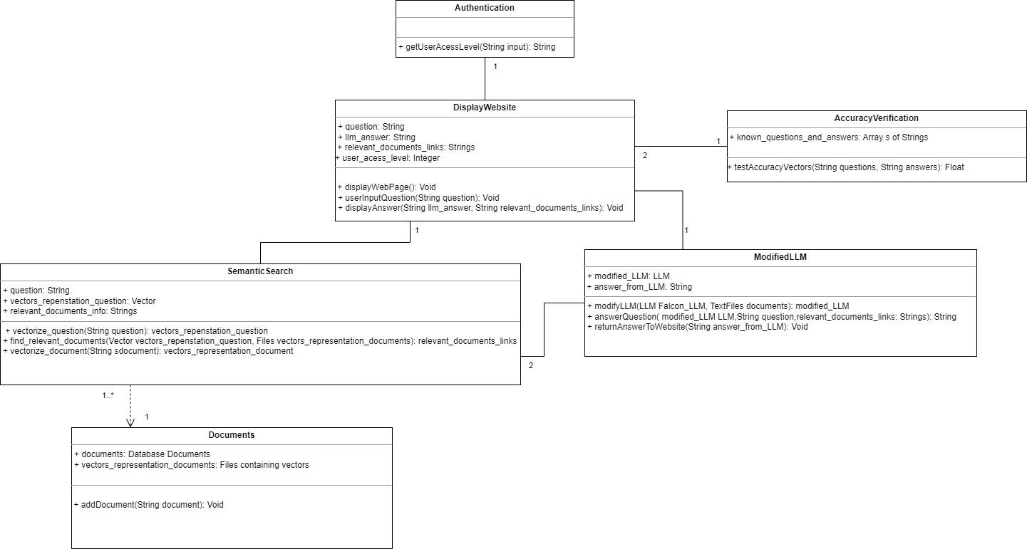

Use Case: Displays the relationship between the user, our system, and the database housing the technical documents. Users would enter their access level to understand what technical documents to include in the search and ask a question to search through the selected documents. The website would then send this to the server which would generate the answer using the most relevant information and the LLM and return to the user.

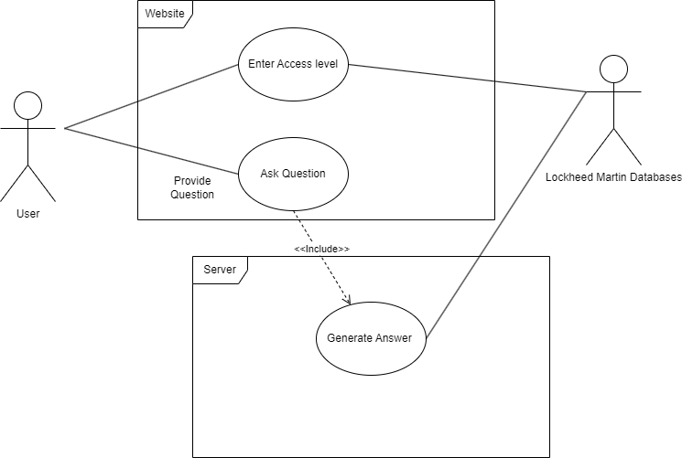

Sequence: User asks a question which gets vectorized and used to search the database for documents. The most relevant information is returned and provided to the LLM with the original question to generate an answer and returned to the user.

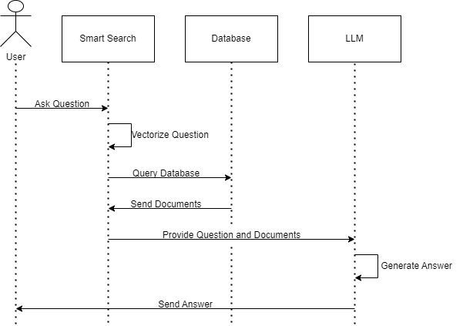

Component: The component diagram shows how the various components of the system interact with one another. When the user interacts with the website, the website will take the user’s question. This information is transmitted to the server, where the question is first vectorized, then sent to the database to be compared with documents to find results that match the user’s question. Once these relevant documents have been found, they are sent to the LLM along with the user’s vectorized question. These are used to generate an answer that is sent and displayed on the website.
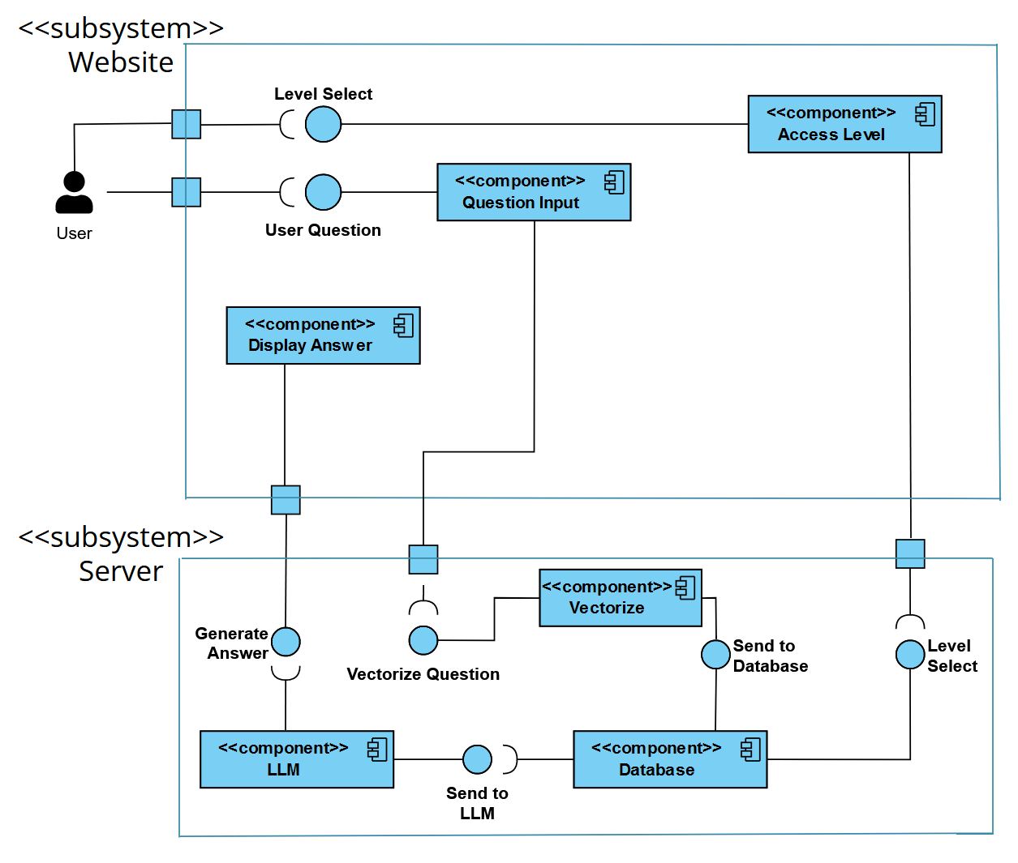

System analysis and decomposition:
The Display Website class plays a crucial role in enhancing user interaction by enabling them to input questions. Its functionality extends beyond input reception, it’s set up to receive answers from a LLM. These answers aren’t generic but tailored to the inputted queries, incorporating any pertinent details sourced from the technical manuals. A stretch goal class shall be an authentication class that shall allow the user to access relevant info and PDFs depending on their access level.
The Semantic Search class is an integral part of the system. It receives textual questions from the Display Website class and employs the special vectorize question class to turn the textual queries into vector representations. By turning the queries into vectors it greatly improves the accuracy and efficiency of the system. Semantic Search also does the vectorizing of the documents in the Document class and stores them back into the Document class as a vector representation. Semantic Search shall then be able to use the vector question and search the document class that contains a vector database for any vectors that are relevant to the question and shall return the string info and shall then provide the relevant info to the Modified LLM class.
The Document class is where the most important data will be stored, the documents and vectorized versions will both reside here. It does more than just hold information, it’s designed to allow users to add, remove, or update documents within the Document class database.
The Modified LLM class is designed to process the user’s question along with the pertinent documents, generating a specific string answer tailored to the inquiry. It utilizes the ‘return answer to website’ function to send back the LLM-generated answer to the website.
To validate the accuracy of the generated answers, the system incorporates the Accuracy Verification class. It receives the string answer generated by the LLM and the textual information extracted from the relevant documents. The Accuracy Verification class vectorizes both strings, turning them into numerical representations. From there the class compares these two values to assess their similarity, and in doing so it ensures the answers align closely with the information from the documents.

Prototype:
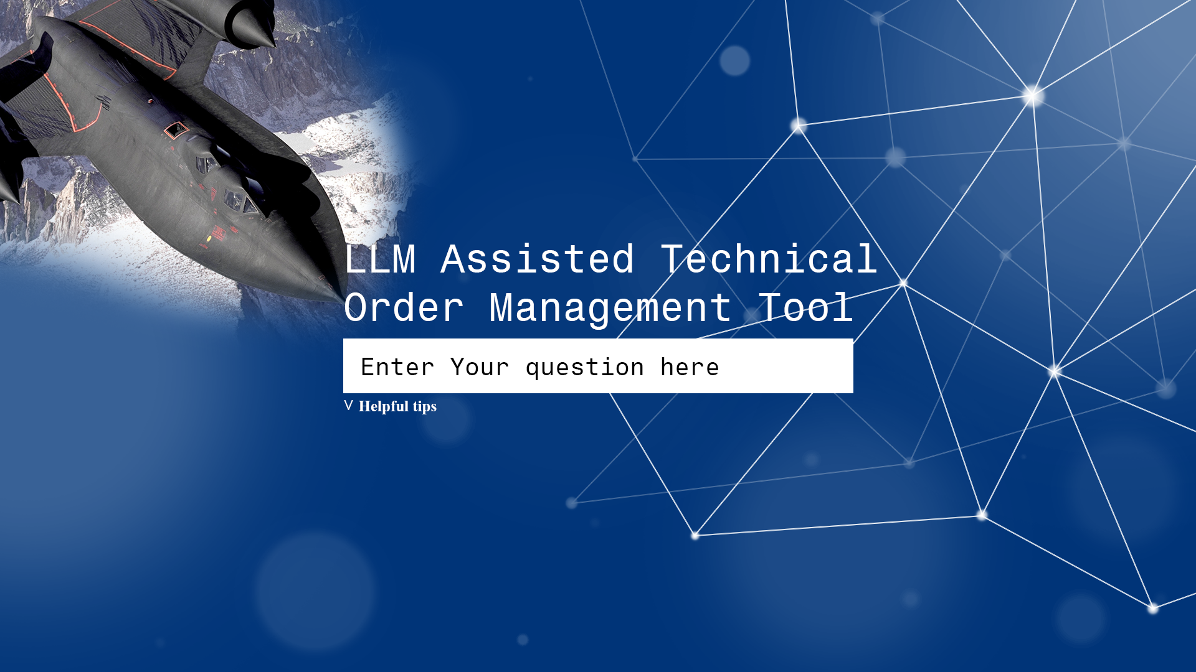

Working User Interface:
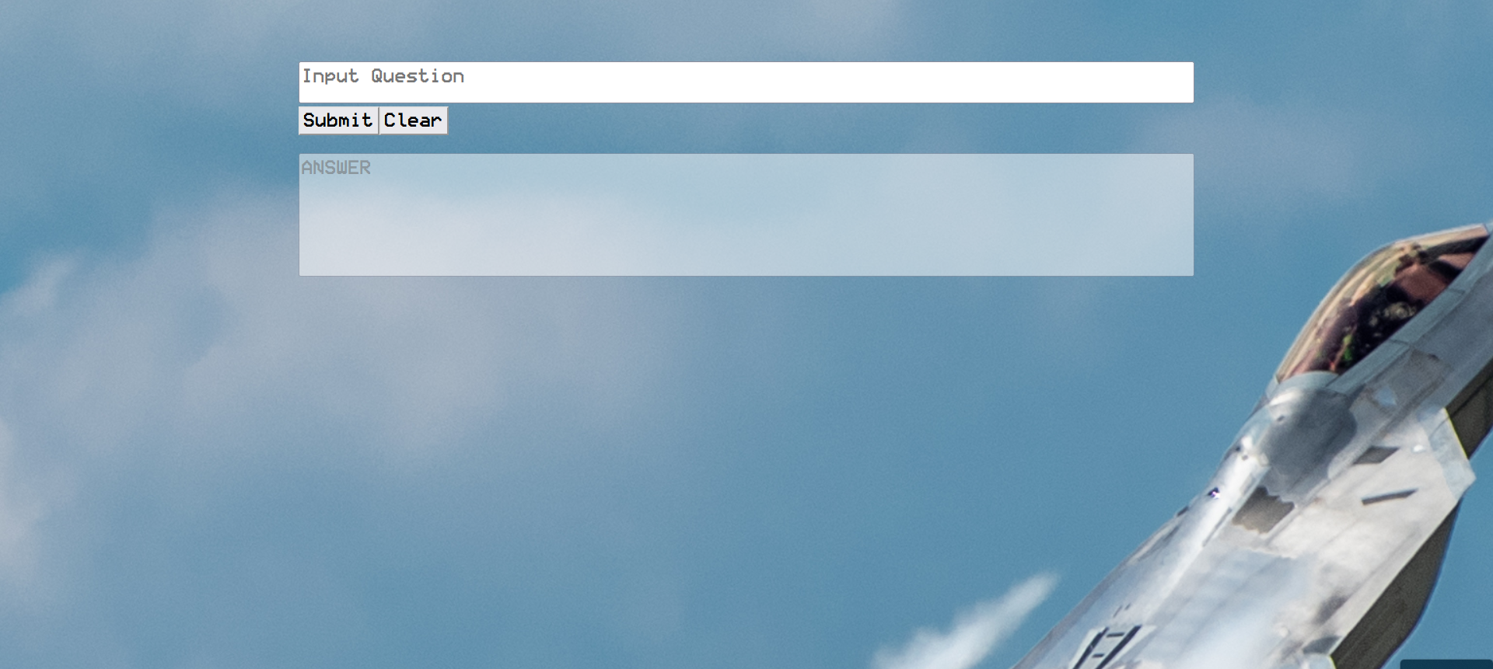

Here is an example of how the UI looks. The UI has a box to allow the user to enter their question. The returned answer will be displayed below the question box after a question has been asked.

Implementation Plan:
Our chosen testbed for code modification, testing, and updates is Google Colab, which allows group collaboration. The High-Performance Computing Center (HPCC) is critical for LLM training and testing. Python 3 serves as our programming language. GitHub provides version control, and the website, hosted on GitHub, showcases our system’s capabilities.

Technical Details:

0 Implementation techniques, functionalities, and goals
- Integrating Hugging Face transformers for tokenization and loading the original Falcon 7B Instruct model.
- Use Hugging Face Supervised Fine-tuning Trainer for Fine-tuning a Falcon 7B Instruct model for better question-answering capabilities.
- Leveraging Lang Chain for importing vector databases and document manipulation.
- Using the Hugging Face all-MiniLM-L6-v2 transformer for embedding text to capture semantic information.
- Employing FAISS for managing a vector/embedding database to hold vectors created by the all-MiniLM-L6-v2.
- The goal is to Implement Retrieval-augmented generation (RAG) for technical manual data.
- Handling user input related to Air Force Technical Order Management specifications and directions.
- Ensuring data traceability and accuracy verification of the output from the LLM.

1. Install Python Package Installations
- bitsandbytes
- transformers
- langchain
- accelerate
- PyPDF2
- faiss-gpu
- sentence_transformers
- pypdf
- torch (version 2.1.0)
- flask and related packages (flask_ngrok, pyngrok)
Fine-tune the model
To fine-tune the LLM to be modified use from trl import SFT Trainer. Split the PDFs into one text file and train a causal language model that tries to predict the next token given previous tokens. Load in the LLM model to be modified with the training data and train.

The server side of the application

2. Load PDF Documents
The script loads PDF documents from a specified path using the PyPDFLoader class from the langchain.document_loaders module.

3. Text Processing and HuggingFaceEmbeddings using sentence-transformers/all-MiniLM-L6-v2
Text from the PDF pages is split into chunks using a RecursiveCharacterTextSplitter with specified parameters. The script then uses the HuggingFaceEmbeddings class to embed the text chunks. An instance of the HuggingFaceEmbeddings class is created with the model name set to 'sentence-transformers/all-MiniLM-L6-v2' and additional model arguments like 'device': 'cuda' for GPU acceleration. The all-MiniLM-L6-v2 transformer is employed to generate sentence embeddings from input text. These embeddings capture the semantic information in the text. Given an input text, it outputs a vector that captures the semantic information. The sentence vector may be used for information retrieval, clustering, or sentence similarity tasks. By default, input text longer than 256 word pieces is truncated.

4. FAISS Vector Storage
Lang Chain is used to import the vector database FAISS. Vector representations of the text chunks are stored using the FAISS (Facebook AI Similarity Search) library.Vector/Embedding Database: FAISS is utilized to manage a vector/embedding database that stores vectors created by the all-MiniLM-L6-v2 transformer. This allows for efficient storage and retrieval of semantic vectors.

5. Language Model Setup
The LLM - Large Language Model is loaded using the AutoModelForCausalLM class from the transformers library. The model is configured for quantization using the BitsAndBytesConfig to allow the LLM to run on lower-end hardware.model = AutoModelForCausalLM.from_pretrained("vilsonrodrigues/falcon-7b-instruct-sharded", quantization_config=bnb_config, trust_remote_code=True).Import a pre-trained tokenizer using transformers import AutoTokenizer AutoTokenizer.from_pretrained("vilsonrodrigues/falcon-7b-instruct-sharded"). Can be loaded with specific configurations, including max_new_tokens, do_sample, top_k, and more.

6. Text Generation Pipeline
A text generation class pipeline is created using the pipeline function from the transformers library. The pipe class will use the LLM and the tokenizer will then generate new text based on the given input and the configured generation settings.

7. Question Answering (QA) Setup
A QA system is set up using the RetrievalQA class from the langchain.chains module. from langchain.chains import RetrievalQA.qa = RetrievalQA.from_chain_type(llm=llm,chain_type="stuff",retriever=vectorstore.as_retriever(search_kwargs={"k": 3}),return_source_documents=True, verbose=False,)It combines the language model, retriever, and other configurations for question answering. User questions are converted into vectors and used to search the vector database for relevant information. This chain utilizes the LLM, retains source documents for context, and interfaces with the vector database as a retriever to provide the LLM with context to produce a relevant answer to the user question. It also allows it to remember recent past questions the user asked.

Website of the Application

8. Flask Web Application
A new Flask web application is created with an endpoint /ask that expects POST requests with JSON data containing a query. The query is passed to the QA system, and the result is returned as JSON. The script runs the Flask application. A print_result function is defined to display the results of the QA system, including the query, the result, and the source documents.

The User interface Side of the application

9. Example Query
An example query ("What is a technical order?") is provided, and the server-side QA system is queried with this question.

10. Returned answer
The system returns the server-side question, for example( Technical order is an order that is …, Source pdf )

Initial Functionalities
The initial prototype has the functionalities of a .website capabilities, query acceptance, seamless communication between the website, semantic search, and LLM, as well as accurate answer display. Semantic search functionality includes tokenization and vectorization of queries, database searches using tokenized questions, and seamless integration with the LLM. The LLM generates precise answers based on the question and stored documents.

Team Member Contribution in terms of design, development, etc
David: Made initial RAG pipeline prototype/worked on training the model/various code.
Karlton: Made most of the website
Roman: Made current RAG pipeline/various code.
Tucker: Worked on presentation/some diagrams.
Harrison: Small part on the website.

Functionalities remaining to be completed
- Refine the LLM performance: Enhance the reliability and accuracy of returned answers. Due to the constraints of us being unable to use the TTU HPCC for this project we were relegated to using Google Collab’s free computational assets for the projects which greatly hinder the capability of the LLM due to the low amount of RAM. This lead to us having to load the LLM in 4-bit quantization and shard the LLM to reduce strain on the ram.
- User access level control: Stretch goal that wasn’t met to add a conceptual access level control that would add/remove documents based on the user’s access level
- Add vector Similarity of question and answer: Used to evaluate how well the LLM functions in returning an answer
- Website tips/loading bar/access level control dropdown: Improve user experience.

Implementation/technical issue.
- The fine-tuned model runs out of memory in Google Colab due to training the model undoing the “sharding”, which results in the memory strain.
- Attempted to use prompt templates in order to receive better answers from the LLM without having to rely on training, but couldn’t diagnose why the LLM wouldn’t acknowledge templates given to it.

