This is a very brief explanation of what we are doing. The numbers on the left of the images correspond to the size in pixels.

- Look for the largest object in image and crop:
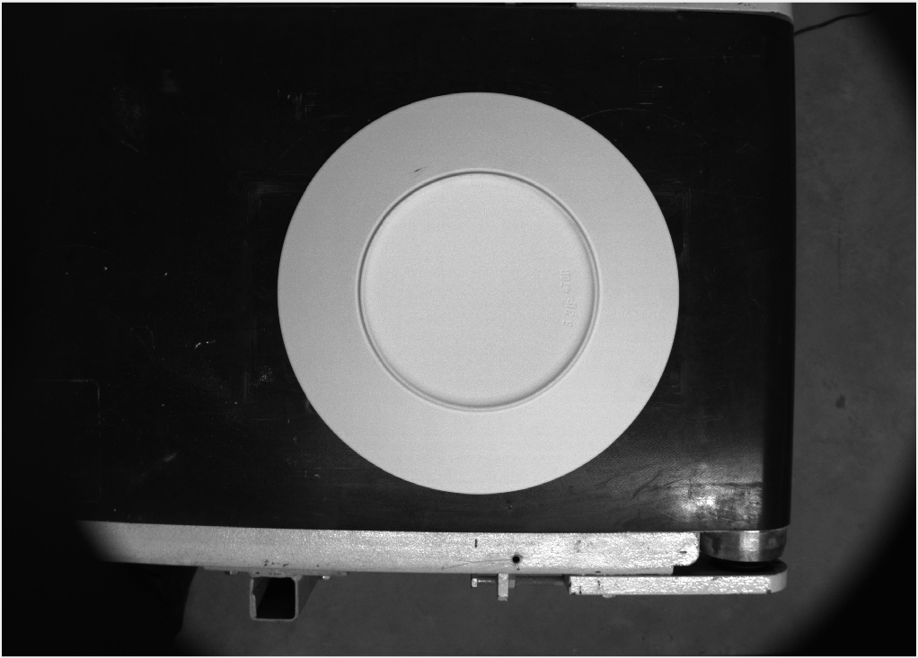
2784*3840 |  | 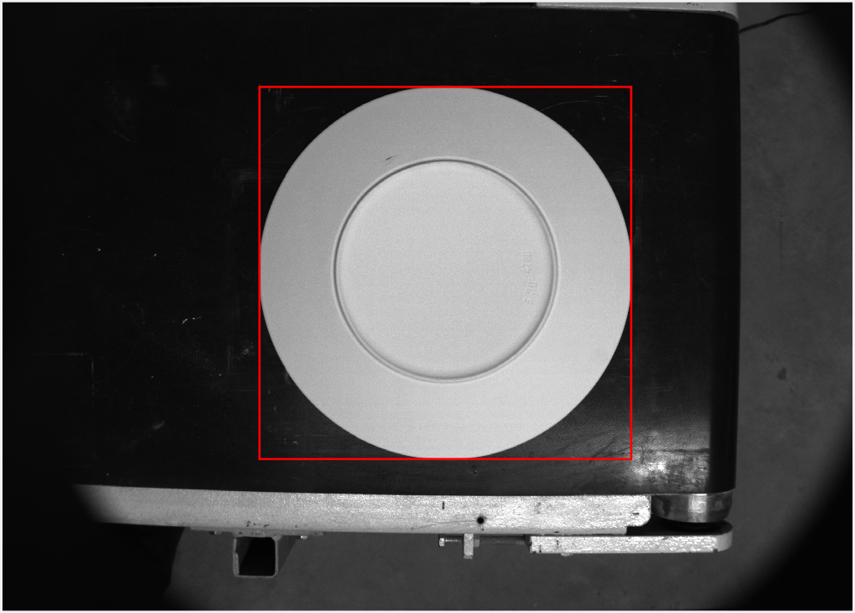

- Look for the inner circle and crop:

1021*1021 | 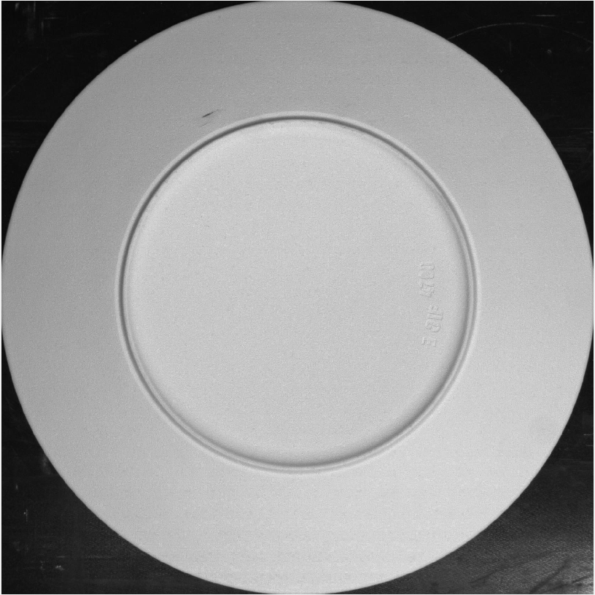 | 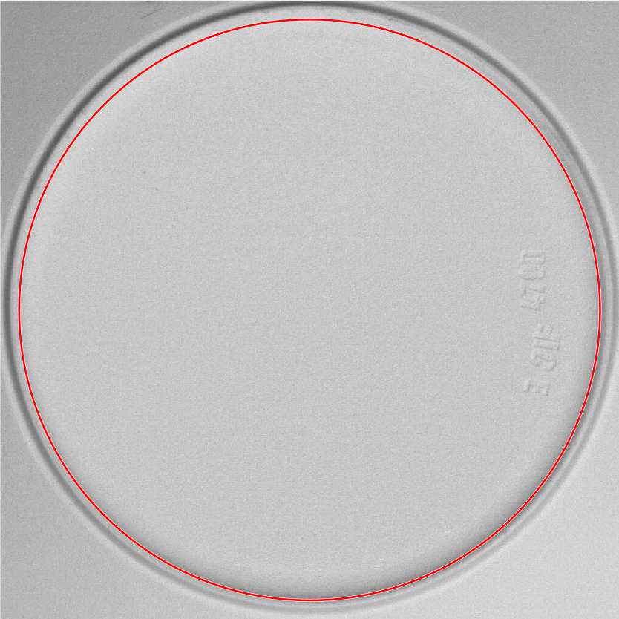

- Look for the letter groups and crop:

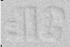  260*90 | 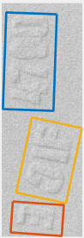 | 59*109  59*35  59*87 | 