Project 1
<Battleship>

CSC 17A - 42824
Name: David Macias
Date: 5/03/2016

Introduction
In Battleship, two players compete to sink each other’s ships placed on their respective 'Grids' or X and Y tables by calling out a single row and column at a time. A two-sided vertical grid acts a call record and blocks a player's ship grid from the opponent's view.
I have decided to continue a game program from my previous programming class adapting new concepts learned in this class.

Development Summary
- Program size: 341 lines
- Structures Utilized: 4
- 3 dynamic structures
- Functions Used: 8
- 2 functions return pointers to structures
- 4 functions with pointers in arguments
- 6 arguments in functions passed by reference
- 3 character arrays
- 1 binary file utilized as output and input

The most challenging and part of the project was adapting my existing program with structures. As I was constructing the structures, I discovered that instead of declaring and initializing 4 different variables for each ship, I could just make an array of structures that contained all of the ship variables. From there, I took that idea and adapted it to a structure for the number of players and a structure for number of character arrays in the game which as a whole, dramatically reduced the size of my program. The program roughly took 8 hours to build.

Description
The program first generates two 15x15 character arrays. The one the player sees is filled with one character that represents water or ocean and the other that is filled with 5 different sized ships. Each ship is placed at a point randomly as well as position vertically or horizontally as the character 'O'. After the ship grid has been generated, the grid without the ships is displayed to the player along with ship length details, remaining bombs, total ship hits, and total misses.

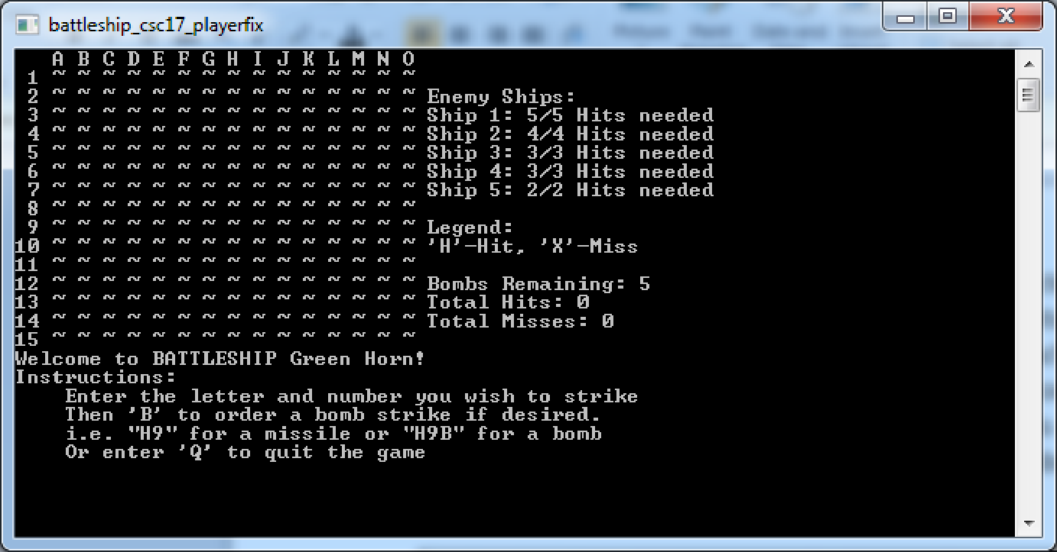

The player is then instructed on how the input should be formatted and an option to quit the game if desired. The input is read in as a string but then extracted into individual variables of different data types.
Proper formatting is as follows:
- The first character of the input is the letter of the column of the desired strike coordinates.
- The next character is the number of the row of the desired strike coordinates.
- Then if the player wants, a third character 'B' is entered to tell the game that the strike is a bomb strike.
After entering the desired strike coordinates, the game does a comparison between the coordinates entered and the ship grid array. Depending if the index of the ship array contains the character 'O', the game changes the character on the array the player sees to 'H' or 'X'. 'H' meaning a ship was hit or 'X' the strike was a miss.
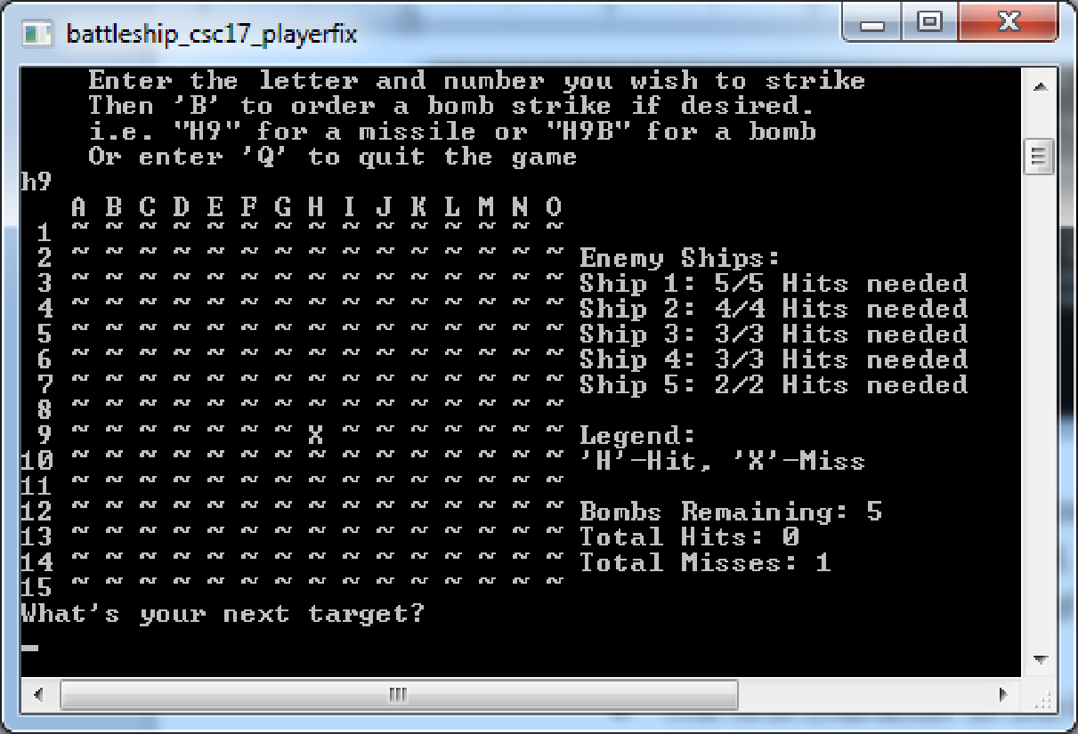
Here, the column 'h' and the row '9' were inputted and there was no ‘O’ with those inputs on the ship grid. The game then changed the character on the player grid to an ‘X’ meaning it was a miss as well as incremented the miss couter by one. Since there was no ‘B’ entered after the ‘9’ in the input, only one index was revealed.
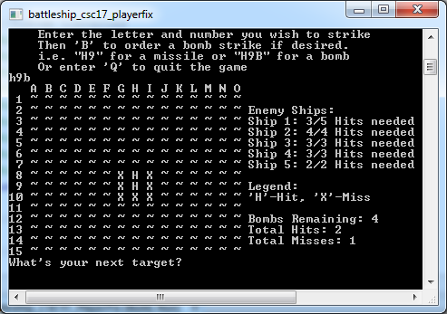
Here, “h9b” was entered for a bomb strike resulting in adjacent indexes being revealed. The image above also shows two ‘H’s. This means a ship or ships were hit from the strike. In this case Ship 1, with a length of five characters, was hit two times according the data to the right of that table.

The game continues until either the player quits the game by entering a ‘Q’ or destroying all the ships. After, the game displays the current game’s statistics and asks for the player’s initials so that this game’s information is stored into a file which is then listed before the program closes.

Flow Chart

Pseudo Code
Initialize

Set the random time seed to 0

Declare and initialize number of ships to 5, number of grids to 2, a player
structure, a pointer to a Ship structure, a pointer to a grid structure, a variable that determines the game’s end, and a variable that determines when the first loop of the program has passed.

Set the start time of the game to the time now.

Do
Display the player’s grid
Determine if game has ended by checking to see if all the ships were destroyed.
If the game has ended, break out of the loop.
Get the input coordinates from the player
If the game has ended, break out of the loop.
Check if the coordinates entered by the user was a hit or a miss.
While the game hasn’t ended

Set the end time of the game to the time now

Set the player’s time to the difference between end time and start time

Get the player’s initials

Show the rankings of the previous players.

Deallocate memory

exit

Major Variables
Type | Variable Name | Description | Location
struct | Player | Structure that holds the player’s information. | player.h
 | grid | Structure that holds the 2 dimensional character array for the grid | grid.h
 | ship | Structure that holds all the variables for a ship | Ship.h
 | location | Structure that holds all the indexes in the char array for a ship | ship.h
short | time | Duration of game in sec | player.h
 | inCol | Player’s column input | player.h
 | inRow | Player’s row input | player.h
 | totHit | Player’s total ship hits | player.h
 | totMiss | Player’s total misses | player.h
 | nBombs | Number of bombs player has | player.h
 | yLoc | Ship’s character row number | ship.h
 | xLoc | Ship’s character column number | ship.h
 | shipX | Ship’s initial character column number | ship.h
 | shipY | Shi’s initial character row number | ship.h
 | shipL | Ship’s character length | ship.h
 | shipLtemp | Ship’s character length | ship.h
 | nShips | Number of ships in game | main()
 | nGrids | Number of arrays in game | main()
Boolean | gameEnd | Determines game end, becomes true when player quits or the sum of all ship’s shipLtemp becomes 0 | Main()
 | initial | Becomes false after first do while loop | Main()
 | bomb | Becomes true when player inputs ‘b’ after row input | player.h
char | grid[][] | 2 dim array for game | grid.h
 | intls[] | Character array for player’s initials | player.h

Reference
- Textbook
- http://www.cplusplus.com/forum/lounge/52458/ -Reading in From file

Program
/*
* Author: David Macias
* Created on May 4, 2016, 05:56 PM
* Purpose: CSC 17A Project: Battleship
*/

//System Libraries
#include <iostream>
#include <cstdlib>
#include <ctime>
#include <iomanip>
#include <sstream>
#include <fstream>
#include "Grid.h"
#include "Ship.h"
#include "Player.h"
using namespace std;

//User Libraries

//Global Constants

//Function Prototypes
Ship *shpLoc(short);
Grid *drwGrid(Ship *, short, short);
void prntScrn(Grid *, Ship *, short, Player &);
void getInpt(Player &, bool &, bool &);
void hitMiss(Grid *, Ship *, Player &, short);
void getIntl(Player &);
void shwRank(Player &);
void gmEnd(Ship *, short , bool &);

//Execution Begins Here
int main(int argc, char** argv) {
//Set the random time seed
srand(static_cast<int>(time(0)));

//Declare and initialize variables
short nShips = 5;
short nGrids = 2;
Player player;
Ship *ship = shpLoc(nShips);
Grid *grid = drwGrid(ship, nShips, nGrids);
bool gameEnd = false;
bool intl = true;
clock_t tStrt, tEnd; //Start time and End time

tStrt = time(0);
do{
//Print Game Screen
prntScrn(grid, ship, nShips, player);
//Determine game end
gmEnd(ship, nShips, gameEnd);
if(gameEnd){
break;
}
//Get user inputs
getInpt(player, intl, gameEnd);
if(gameEnd){
break;
}
//Check hit or Miss
hitMiss(grid, ship, player, nShips);
}while(!gameEnd);
tEnd = time(0);
//Calculate Game Time
player.time = static_cast<short>(difftime(tEnd, tStrt));

//Get Player's Initials
getIntl(player);

//Show Rankings
shwRank(player);

//Deallocate Memory
for(int i = 0; i < nShips; i++){
delete []ship[i].crdnts;
}
delete []ship;
delete []grid;
//Exit stage right
return 0;
}

Ship *shpLoc(short n){
Ship *a = new Ship[n];

for(int i = 0; i < n; i++){
switch(i){
case 0:{
a[i].shipL = 5;
break;
}case 1:{
a[i].shipL = 4;
break;
}case 2:{
a[i].shipL = 3;
break;
}case 3:{
a[i].shipL = 3;
break;
}case 4:{
a[i].shipL = 2;
break;
}
}
a[i].shipLtemp = a[i].shipL;
a[i].shipX = rand()%(COL-a[i].shipL+1)+1;
a[i].shipY = rand()%(ROW-a[i].shipL+1)+1;
}
return a;
}

Grid *drwGrid(Ship *b, short n, short g){
Grid *a = new Grid[g];

for(int i = 0; i < n; i++){
b[i].crdnts = new Location[b[i].shipL];
}
short ortn;
for(int h = 0; h < g; h++){
for(int i = 0; i < ROW; i++){
for(int j = 0; j < COL; j++){
a[h].grid[i][j] = '~';
}
}
}
for(int s = 0; s < n; s++){
for(int i = 0; i < ROW; i++){
for(int j = 0; j < COL; j++){
if(j == b[s].shipX-1 && i == b[s].shipY-1){
ortn = rand()%2; //0 = horizontal, 1 = vertical
if(ortn == 1){
if(a[1].grid[i][j] == 'O'){
do{
j++;
}while(a[1].grid[i][j] == 'O');
}
while(i < b[s].shipY+b[s].shipL-1){
short t = i;
for(int v = 0; v < b[s].shipL; v++){
b[s].crdnts[v].xLoc = j;
b[s].crdnts[v].yLoc = t;
t--;
}
a[1].grid[i][j] = 'O';
i++;
}
}else{
if(a[1].grid[i][j] == 'O'){
do{
i++;
}while(a[1].grid[i][j] == 'O');
}
while(j < b[s].shipX+b[s].shipL-1){
short t = j;
for(int v = 0; v < b[s].shipL; v++){
b[s].crdnts[v].xLoc = t;
b[s].crdnts[v].yLoc = i;
t--;
}
a[1].grid[i][j] = 'O';
j++;
}
}
}
}
}
}
return a;
}

void prntScrn(Grid *a, Ship *s, short n, Player &p){
cout <<" ";
for(int i = 65, j = 0; j < COL; j++, i++){
cout <<" " <<static_cast<char>(i); //Print Letters for Columns
}
cout <<endl;
for(int i = 0; i < ROW; i++){
cout <<setw(2) <<i+1; //Numbers for rows
for(int j = 0; j < COL; j++){
cout <<" " <<a[0].grid[i][j];
}
if(i == 1){
cout <<" Enemy Ships:";
}if(i > 1){
if(i < 7){
cout <<" Ship " <<i-1 <<": " <<s[i-2].shipLtemp <<"/"
<<s[i-2].shipL <<" Hits needed";
}
}if(i == 8){
cout <<" Legend:";
}if(i == 9){
cout <<" 'H'-Hit, 'X'-Miss";
}if(i == 11){
cout <<" Bombs Remaining: " <<p.nbombs;
}if(i == 12){
cout <<" Total Hits: " <<p.totHit;
}if(i == 13){
cout <<" Total Misses: " <<p.totMiss;
}
cout <<endl;
}
}

void getInpt(Player &p, bool &i, bool &end){
string in;
char a,b;
do{
if(i){
cout <<"Welcome to BATTLESHIP Green Horn!" <<endl;
cout <<"Instructions:" <<endl;
cout <<" Enter the letter and number you wish to strike " <<endl;
cout <<" Then 'B' to order a bomb strike if desired." <<endl;
cout <<" i.e. \"H9\" for a missile or \"H9B\" for a bomb" <<endl;
cout <<" Or enter 'Q' to quit the game" <<endl;

}else{
cout <<"What's your next target?" <<endl;
}
getline(cin, in);

stringstream ss(in);
ss >>a >> p.inRow >>b;

a = toupper(a);
b = toupper(b);
if(a == 'Q'){
end = true;
break;
}
p.inCol = static_cast<int>(a-65);
p.inRow -= 1;
}while((p.inCol < 0 || p.inCol > 15) || (p.inRow < 0 || p.inRow > 14));
i = false;
if(b == 'B'){
b = ' ';
if(!(p.nbombs == 0)){
p.bomb = true;
p.nbombs--;
}else{
cout <<"You are out of bombs." <<endl;
cout <<"Missile strike en route" <<endl;
}
}
}

void hitMiss(Grid *g, Ship *s, Player &p, short n){
if(p.bomb){
p.bomb = false;
for(short i = 0-1; i < 2; i++){
for(short j = 0-1; j < 2; j++){
if(g[1].grid[p.inRow+i][p.inCol+j] == 'O'){
g[1].grid[p.inRow+i][p.inCol+j] = 'H';
g[0].grid[p.inRow+i][p.inCol+j] = 'H';
p.totHit++;
for(int t = 0; t < n; t++){
for(int v = 0; v < s[t].shipL; v++){
if((p.inCol+j == s[t].crdnts[v].xLoc) && (p.inRow+i == s[t].crdnts[v].yLoc)){
s[t].shipLtemp--;
}
}
}
}else if(g[1].grid[p.inRow+i][p.inCol+j] == '~'){
g[0].grid[p.inRow+i][p.inCol+j] = 'X';
}
}
}
p.totMiss++;
}else{
if(g[1].grid[p.inRow][p.inCol] == 'O'){
g[1].grid[p.inRow][p.inCol] = 'H';
g[0].grid[p.inRow][p.inCol] = 'H';
p.totHit++;
for(int t = 0; t < n; t++){
for(int v = 0; v < s[t].shipL; v++){
if((p.inCol == s[t].crdnts[v].xLoc) && (p.inRow == s[t].crdnts[v].yLoc)){
s[t].shipLtemp--;
}
}
}
}else if(g[1].grid[p.inRow][p.inCol] == '~'){
g[0].grid[p.inRow][p.inCol] = 'X';
p.totMiss++;
}
}
p.ratio = 1.0f*p.totHit/(p.totHit+p.totMiss);
}

void getIntl(Player &p){
ofstream out;
out.open("scores.dat",ios::binary | ios::app);
cout <<endl;
cout <<"Game End:" <<endl;
cout <<" Game Time(sec) - " <<p.time <<endl;
cout <<" Bombs Remaining - " <<p.nbombs <<endl;
cout <<" Hits - " <<p.totHit <<endl;
cout <<" Misses - " <<p.totMiss <<endl;
cout <<" Hits per strikes called - " <<p.ratio <<endl;
cout <<" Your Initials: ";
cin.getline(p.intls, NSIZE);

//Write player information to file in binary
out.write(reinterpret_cast<char *>(&p), sizeof(p));
//Close file
out.close();
}

void shwRank(Player &p){
ifstream in;
in.open("scores.dat",ios::binary);
if(in){
//Output file data
cout <<endl <<endl <<"Rankings" <<endl;
in.read(reinterpret_cast<char *>(&p), sizeof(p));
cout <<"Initials | Hit/Total Strikes | Hits | Misses | Bombs Left | Game Time(sec)" <<endl;
while(!in.eof()){
cout <<setw(6) <<p.intls
<<setw(16) <<showpoint <<setprecision(2) <<p.ratio
<<setw(11) <<p.totHit <<setw(8) <<p.totMiss
<<setw(13) <<p.nbombs <<setw(12) <<p.time <<endl;
in.read(reinterpret_cast<char *>(&p), sizeof(p));
}
}else{
cout <<"Error: Couldn't open \"scores.dat\"" <<endl;
}
//close file
in.close();
}

void gmEnd(Ship *s, short n, bool &b){
short temp;
for(int i = 0; i < n; i++){
temp += s[i].shipLtemp;
if(temp == 0){
b = true;
}
}
}

