Form number: S-040714

Start of the Bureaucratic Maze

MegaCorp is hiring, and they have only one test for prospective employees: They want to know if you can negotiate their Bureaucratic Maze. To start the maze,

take this form to the desk labeled “Human Resources.”

There you must turn in this form, and you will be given another form to follow. We won’t tell you what the goal of the maze is, but you’ll know it when you get there.

Dept. HR  Rev. D4B | MegaCorp Interdepartmental  Transit Authorization | Form HR-040714-S

Take this form to

Corporate Compliance

— or —

Marketing

Declaration: MegaCorp is an equal opportunity employer and does not discriminate on the basis of race, creed, gender, or funny hats. Do not staple, spindle, or lick this form. Do not fold this form into a paper airplane. This form conforms to the MegaCorp Paperwork Reduction Directive, including Section 28-C, which states, “Whereas the word whereas is an exercise in verbosity; now therefore, the use of whereas is prohibited.” The word whereas does not appear on this form, except for the three uses of whereas in the previous sentence. Oops, now make that five uses. All MegaCorp forms are © 2003, 2004 by R. Abbott. For more information see www.logicmazes.com.

Dept. HR  Rev. D4B | MegaCorp Interdepartmental  Transit Authorization | Form HR-040714-IM

This is the Goal !! Congratulations !! You solved the maze !! You’re hired.

If you can, please wave this form above your head and yell something like: “Hooray, I solved the maze!” That will provide encouragement to those who haven’t yet solved it. Here is a map of the maze that you might want to study later. Do not show this to anyone still in the maze.

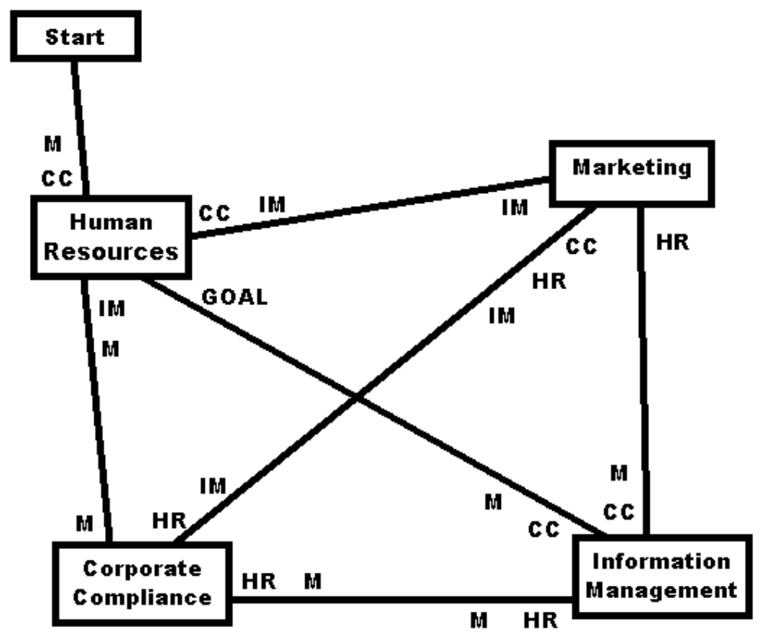

The lines indicate the connections between desks. Just before you arrive at a desk, there are initials next to the line. These indicate where you can go after you receive the next form. For example, if you go from M (Marketing) to HR (Human Resources) you go left along a line near the top of the diagram. The ininitials you encounter at the end of the line indicate that you can next go to CC or IM. The Bureaucratic Maze is © 2003, 2004 by Robert Abbott. See www.logicmazes.com.

Dept. HR  Rev. D4B | MegaCorp Interdepartmental  Transit Authorization | Form HR-040714-M

Take this form to

Corporate Compliance

— or —

Information Management

Declaration: MegaCorp is an equal opportunity employer and does not discriminate on the basis of race, creed, gender, or funny hats. Do not staple, spindle, or lick this form. Do not fold this form into a paper airplane. This form conforms to the MegaCorp Paperwork Reduction Directive, including Section 28-C, which states, “Whereas the word whereas is an exercise in verbosity; now therefore, the use of whereas is prohibited.” The word whereas does not appear on this form, except for the three uses of whereas in the previous sentence. Oops, now make that five uses. All MegaCorp forms are © 2003, 2004 by R. Abbott. For more information see www.logicmazes.com.

Dept. HR  Rev. D4B | MegaCorp Interdepartmental  Transit Authorization | Form HR-040714-CC

Take this form to

Information Management

— or —

Marketing

Declaration: MegaCorp is an equal opportunity employer and does not discriminate on the basis of race, creed, gender, or funny hats. Do not staple, spindle, or lick this form. Do not fold this form into a paper airplane. This form conforms to the MegaCorp Paperwork Reduction Directive, including Section 28-C, which states, “Whereas the word whereas is an exercise in verbosity; now therefore, the use of whereas is prohibited.” The word whereas does not appear on this form, except for the three uses of whereas in the previous sentence. Oops, now make that five uses. All MegaCorp forms are © 2003, 2004, 2004 by R. Abbott. For more information see www.logicmazes.com.

Dept. IM  Rev. D4B | MegaCorp Interdepartmental  Transit Authorization | Form IM-040714-HR

Take this form to

Corporate Compliance

— or —

Marketing

Declaration: MegaCorp is an equal opportunity employer and does not discriminate on the basis of race, creed, gender, or funny hats. Do not staple, spindle, or lick this form. Do not fold this form into a paper airplane. This form conforms to the MegaCorp Paperwork Reduction Directive, including Section 28-C, which states, “Whereas the word whereas is an exercise in verbosity; now therefore, the use of whereas is prohibited.” The word whereas does not appear on this form, except for the three uses of whereas in the previous sentence. Oops, now make that five uses. All MegaCorp forms are © 2003, 2004 by R. Abbott. For more information see www.logicmazes.com.

Dept. IM  Rev. D4B | MegaCorp Interdepartmental  Transit Authorization | Form IM-040714-CC

Take this form to

Human Resources

— or —

Marketing

Declaration: MegaCorp is an equal opportunity employer and does not discriminate on the basis of race, creed, gender, or funny hats. Do not staple, spindle, or lick this form. Do not fold this form into a paper airplane. This form conforms to the MegaCorp Paperwork Reduction Directive, including Section 28-C, which states, “Whereas the word whereas is an exercise in verbosity; now therefore, the use of whereas is prohibited.” The word whereas does not appear on this form, except for the three uses of whereas in the previous sentence. Oops, now make that five uses. All MegaCorp forms are © 2003, 2004 by R. Abbott. For more information see www.logicmazes.com.

Dept. IM  Rev. D4B | MegaCorp Interdepartmental  Transit Authorization | Form IM-040714-M

Take this form to

Corporate Compliance

— or —

Marketing

Declaration: MegaCorp is an equal opportunity employer and does not discriminate on the basis of race, creed, gender, or funny hats. Do not staple, spindle, or lick this form. Do not fold this form into a paper airplane. This form conforms to the MegaCorp Paperwork Reduction Directive, including Section 28-C, which states, “Whereas the word whereas is an exercise in verbosity; now therefore, the use of whereas is prohibited.” The word whereas does not appear on this form, except for the three uses of whereas in the previous sentence. Oops, now make that five uses. All MegaCorp forms are © 2003, 2004 by R. Abbott. For more information see www.logicmazes.com.

Dept. M  Rev. D4B | MegaCorp Interdepartmental  Transit Authorization | Form M-040714-HR

Take this form to

Information Management

Declaration: MegaCorp is an equal opportunity employer and does not discriminate on the basis of race, creed, gender, or funny hats. Do not staple, spindle, or lick this form. Do not fold this form into a paper airplane. This form conforms to the MegaCorp Paperwork Reduction Directive, including Section 28-C, which states, “Whereas the word whereas is an exercise in verbosity; now therefore, the use of whereas is prohibited.” The word whereas does not appear on this form, except for the three uses of whereas in the previous sentence. Oops, now make that five uses. All MegaCorp forms are © 2003, 2004 by R. Abbott. For more information see www.logicmazes.com.

Dept. M  Rev. D4B | MegaCorp Interdepartmental  Transit Authorization | Form M-040714-IM

Take this form to

Human Resources

Declaration: MegaCorp is an equal opportunity employer and does not discriminate on the basis of race, creed, gender, or funny hats. Do not staple, spindle, or lick this form. Do not fold this form into a paper airplane. This form conforms to the MegaCorp Paperwork Reduction Directive, including Section 28-C, which states, “Whereas the word whereas is an exercise in verbosity; now therefore, the use of whereas is prohibited.” The word whereas does not appear on this form, except for the three uses of whereas in the previous sentence. Oops, now make that five uses. All MegaCorp forms are © 2003, 2004 by R. Abbott. For more information see www.logicmazes.com.

Dept. M  Rev. D4B | MegaCorp Interdepartmental  Transit Authorization | Form M-040714-CC

Take this form to

Corporate Compliance

— or —

Human Resources

— or —

Information Management

Declaration: MegaCorp is an equal opportunity employer and does not discriminate on the basis of race, creed, gender, or funny hats. Do not staple, spindle, or lick this form. Do not fold this form into a paper airplane. This form conforms to the MegaCorp Paperwork Reduction Directive, including Section 28-C, which states, “Whereas the word whereas is an exercise in verbosity; now therefore, the use of whereas is prohibited.” The word whereas does not appear on this form, except for the three uses of whereas in the previous sentence. Oops, now make that five uses. All MegaCorp forms are © 2003, 2004 by R. Abbott. For more information see www.logicmazes.com.

Dept. CC  Rev. D4B | MegaCorp Interdepartmental  Transit Authorization | Form CC-040714-HR

Take this form to

Marketing

Declaration: MegaCorp is an equal opportunity employer and does not discriminate on the basis of race, creed, gender, or funny hats. Do not staple, spindle, or lick this form. Do not fold this form into a paper airplane. This form conforms to the MegaCorp Paperwork Reduction Directive, including Section 28-C, which states, “Whereas the word whereas is an exercise in verbosity; now therefore, the use of whereas is prohibited.” The word whereas does not appear on this form, except for the three uses of whereas in the previous sentence. Oops, now make that five uses. All MegaCorp forms are © 2003, 2004 by R. Abbott. For more information see www.logicmazes.com.

Dept. CC  Rev. D4B | MegaCorp Interdepartmental  Transit Authorization | Form CC-040714-IM

Take this form to

Human Resources

— or —

Marketing

Declaration: MegaCorp is an equal opportunity employer and does not discriminate on the basis of race, creed, gender, or funny hats. Do not staple, spindle, or lick this form. Do not fold this form into a paper airplane. This form conforms to the MegaCorp Paperwork Reduction Directive, including Section 28-C, which states, “Whereas the word whereas is an exercise in verbosity; now therefore, the use of whereas is prohibited.” The word whereas does not appear on this form, except for the three uses of whereas in the previous sentence. Oops, now make that five uses. All MegaCorp forms are © 2003, 2004 by R. Abbott. For more information see www.logicmazes.com.

Dept. CC  Rev. D4B | MegaCorp Interdepartmental  Transit Authorization | Form CC-040714-M

Take this form to

Human Resources

— or —

Information Management

Declaration: MegaCorp is an equal opportunity employer and does not discriminate on the basis of race, creed, gender, or funny hats. Do not staple, spindle, or lick this form. Do not fold this form into a paper airplane. This form conforms to the MegaCorp Paperwork Reduction Directive, including Section 28-C, which states, “Whereas the word whereas is an exercise in verbosity; now therefore, the use of whereas is prohibited.” The word whereas does not appear on this form, except for the three uses of whereas in the previous sentence. Oops, now make that five uses. All MegaCorp forms are © 2003, 2004 by R. Abbott. For more information see www.logicmazes.com.

